Sivaleela Gogineni 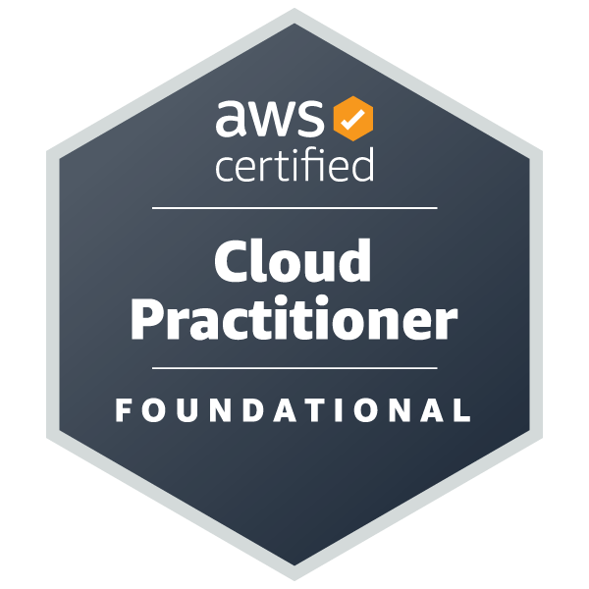
Denton, TX 76201 | (469)-927-2353| leela.java05@gmail.com

PROFESSIONAL SUMMARY
• Around 8 years of experience as a Java Full Stack Developer in building scalable web and enterprise applications.
• Strong expertise in Core Java, J2EE, Spring Boot, and Hibernate frameworks.
• Proficient in front-end technologies: Angular (v2 to v8), React.js, JavaScript, TypeScript, HTML5, and CSS3.
• Skilled in creating RESTful APIs and GraphQL services for seamless client-server interaction.
• Experienced in Microservices Architecture for modular, maintainable application development.
• Hands-on experience with Node.js for backend services and real-time applications.
• Proficient in cloud platforms: AWS, Azure, and Google Cloud Platform (GCP).
• Deep understanding of CI/CD processes using Jenkins, GitLab CI, Docker, Kubernetes, and OpenShift.
• Strong database knowledge: Oracle, PostgreSQL, MongoDB, and DynamoDB.
• Familiar with messaging systems like Kafka, RabbitMQ, and JMS for distributed systems.
• Experienced with monitoring and logging tools: ELK Stack, Grafana, Prometheus, and Splunk.
• Focused on clean, testable code using JUnit, Mockito, Jasmine, Karma, and JMeter.
• Comfortable in Agile teams with active roles in sprint planning, scrums, and retrospectives.
• Excellent problem-solving skills and a collaborative mindset; capable mentor to junior developers.
• Passionate about learning new technologies to enhance performance, code quality, and UX.
• Experienced in implementing secure authentication using OAuth2.0, JWT, and OpenID Connect.
• Adept at integrating third-party APIs, SDKs, and services, including payment gateways and cloud storage.
• Expertise in performance tuning and optimizing application load times and database queries.
• Successfully led end-to-end project lifecycles: architecture design, development, testing, and deployment.
• Strong knowledge of API documentation and testing tools like Swagger and Postman.
• Proven ability to troubleshoot production issues effectively in high-availability environments.
• Experience with version control using Git, GitHub, and Bitbucket.
• Familiar with serverless computing: AWS Lambda, API Gateway, and DynamoDB.
• Skilled in implementing Design Patterns and Software Architecture Best Practices.
• Delivered Proof-of-Concept (PoC) solutions using GraphQL and Node.js.
• Contributed to improving development processes by automating builds, tests, and deployments.
• Comfortable working in Agile, Scrum, and DevOps pipelines.

TECHNICAL SKILLS
Category | Technologies / Tools
Languages | Core Java, Java 8, Python, JavaScript, TypeScript, SQL, C, Node.js
Frontend | HTML5, CSS3, Bootstrap, Angular (2+ to 8), React.js, Redux, jQuery, XML
Backend / Java Stack | J2EE, Spring Boot, Spring MVC, Hibernate, RESTful APIs, GraphQL, Microservices
Databases | MySQL, Oracle, PostgreSQL, MongoDB, DynamoDB, NoSQL
Cloud Platforms | AWS (EC2, S3, Lambda, CloudWatch), Microsoft Azure, Google Cloud Platform (GCP)
CI/CD & DevOps | Jenkins, GitLab CI, CircleCI, Docker, Kubernetes, OpenShift, SonarQube, PCF, Bitbucket
Messaging & Streaming | Kafka, RabbitMQ, JMS (ActiveMQ, IBM MQ)
Testing Tools | JUnit, Mockito, Selenium, Jasmine, Karma, JMeter
Monitoring & Logging | ELK Stack, Grafana, Prometheus, Splunk
Version Control | Git, GitHub, Bitbucket
Project Management | JIRA, Confluence, Agile, Scrum
IDEs & Tools | IntelliJ IDEA, Eclipse, Visual Studio Code, Chrome DevTools, Maven, Gradle
Web/Application Servers | Tomcat, JBoss, Nginx

WORK EXPERIENCE

Full Stack Java Developer – FedEx January 2024 – Present |Pittsburgh, PA

Description:
Delivering scalable microservices-based solutions for logistics operations.
Responsibilities:
• Designed and developed microservices using Spring Boot and Spring Cloud Config.
• Implemented asynchronous communication using Kafka and RabbitMQ.
• Developed front-end with Angular, React, TypeScript, and Redux.
• Built RESTful APIs and GraphQL endpoints.
• Managed pipelines using Jenkins, GitLab CI, and CircleCI.
• Containerized applications using Docker, deployed via Kubernetes on AWS, Azure, GCP.
• Wrote unit and integration tests using JUnit, Mockito, and Selenium.
• Integrated OAuth 2.0 and OpenID Connect for security.
• Used Prometheus, Grafana, and ELK Stack for monitoring and alerting.
Tech Stack:
Java, Spring Boot, J2EE, React, Angular, Kafka, RabbitMQ, GraphQL, Docker, Kubernetes, CI/CD, MongoDB, AWS, Azure, GCP, JUnit.

Full Stack Java Developer – HealthEquity May 2023 – January 2024 Remote
Description:
Built scalable financial health applications integrated with cloud-native architectures.
Responsibilities:
• Developed backend services using Java 8, Spring MVC, and Spring Boot.
• Front-end development with Angular 8, TypeScript, and RESTful APIs.
• Deployed solutions on AWS Cloud and implemented serverless computing with AWS Lambda.
• Created Node.js microservices and GraphQL APIs.
• Built CI/CD pipelines with Jenkins, Docker, and OpenShift.
• Conducted testing with Jasmine, Karma, and JUnit.
Tech Stack:
Java 8, Spring Boot, Angular 8, Node.js, AWS (Lambda, EC2, CloudWatch), Jenkins, OpenShift, GraphQL, MongoDB, PostgreSQL.

Graduate Assistant – University of North Texas January 2022 – May2023

Denton, TX
Description:
Enhanced web infrastructure, UI design, and user support for educational tools.
Responsibilities:
• Maintained websites using HTML, CSS, JavaScript, and Bootstrap.
• Conducted front-end bug fixing and accessibility improvements.
• Supported users and researched new web technologies.
Tech Stack:
HTML5, CSS3, JavaScript, Bootstrap, jQuery, Chrome DevTools.

Full Stack Java Developer – Zen3 Infotech Solutions August 2018 – July 2021

Hyderabad, India
Projects: Nationwide (Insurance), Xerox (CPQ Platform).
Responsibilities:
• Built full-stack insurance modules with Java, Spring Boot, AngularJS.
• Developed microservices, integrated with AWS and JMS messaging.
• Created React components with Redux for CPQ platforms.
• Integrated Node.js services and REST APIs.
• Deployed solutions via Docker, AWS, and Jenkins.
Tech Stack:
Java, Spring Boot, AngularJS, React, Redux, Node.js, Oracle CPQ, AWS.
Junior Java Developer– Madwic Software Solutions June 2016 – August 2018
Vijayawada, India
- Documented software specifications, user manuals, and project reports to ensure effective knowledge sharing and provide references for future development and troubleshooting.
- Involved in requirements collection and analysis from the business team.
- Created design documents with Use Case Diagrams, Class Diagrams, and Sequence Diagrams using Rational Rose.
- Used Spring Framework with EJB 3.0 to create services capable of handling millions of transactions.
- Implemented the MVC architecture using Apache Struts 1.2 Framework.
- Developed Action Classes and server-side validations for account activity, payment history, and transactions.
- Built views using Struts Tags, JSTL 2.0, and Expression Language.
- Implemented Session Beans to handle business logic for fund transfers, loans, credit cards, and fixed deposit modules.
- Worked with JAXB, SAXP, and XML Schema for exporting and importing data in XML format; utilized JAXB in web services for request/response data marshalling and unmarshalling.
- Developed web service clients to consume third-party service APIs for credit card validation; used XML Web Services via SOAP for remote and global data exchange across financial institutions.
- Utilized JMS for reliable, asynchronous exchange of critical information such as payment status reports.
- Created and maintained unit test cases using JUnit.
- Developed build scripts using Apache ANT and managed builds accordingly.
- Used Log4J for logging runtime exceptions and application activities.
- Employed ClearCase for source code version control and maintenance.
- Conducted Functional, Integration, and Regression Testing to identify and resolve software bugs, ensuring high-quality deliverables.
- Assisted in troubleshooting technical issues reported by users or discovered during testing, providing solutions or effective workarounds.
- Stayed updated on emerging technologies and industry trends relevant to BHEL's projects, conducting research and proposing innovative ideas for process improvement and application enhancement.

ACADEMIC PROJECTS
• Web Application using Angular:
- Created responsive UI using HTML, CSS, JavaScript, Bootstrap, and AngularJS.
- Built Single Page Applications (SPA) with Factory, Service, and Provider patterns.
• Moving Vehicle Detection for Traffic Count:
- Developed vehicle prediction models using Python, C++, and Machine Learning techniques like Linear Regression and Random Forest.

EDUCATION
University of North Texas, Denton, TX, United States
- Masters in Computer Science
Jawaharlal Nehru Technological University, Kakinada, India
- Bachelors in Electronics Engineering

