SUHAS CHERUKURI
SENIOR DEVOPS ENGINEER
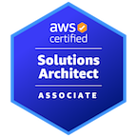
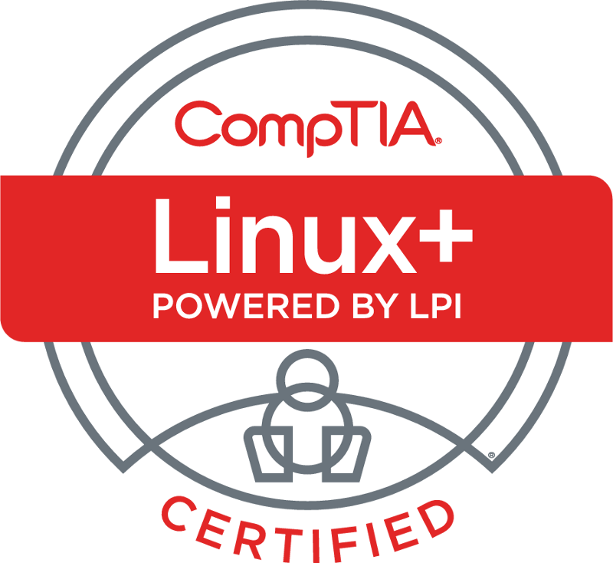
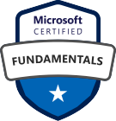
Dallas, TX || +1 (214) 663-0702 ||suhasc2205@gmail.com

PROFESSIONAL SUMMARY

Experienced DevOps Engineer with 10+ years with a comprehensive skill set in DevOps, Cloud Infrastructure, and Automation. Proven ability to independently design, implement, and manage AWS and Azure environments, ensuring seamless release processes and optimal system configurations. Adept at employing various tools, including Terraform, Jenkins, Chef, Ansible, Docker, Kubernetes, and ELK stack, to streamline deployment and orchestration. Extensive experience in scripting with Python, Shell and Bash. Proficient in managing version control systems, monitoring tools, and CI/CD pipelines. Demonstrated success in leading teams, implementing best practices, and optimizing application performance in diverse environments.
TECHNICAL SKILLS

Cloud Platforms | AWS, Azure,GCP
AWS Services | EC2, S3, Lambda, Simple Queue Service, Dynamo DB, Load Balancer, Autoscaling, Cloud Formation, Cloud Front, Route 53, API Gateway, Elastic cache, Dockers, ECS, Cloud Security, RBAC, IAM, OPA
Azure Services | Azure Virtual Machines, Azure Functions, Azure App Service, Azure Blob Storage, Azure Queue Storage, Azure Load Balancer, Azure Application Gateway, Azure Autoscale, Azure Resource Manager (ARM) Templates, Azure CDN, Azure API Management, AKS, Azure DevOps, Azure Monitor, Application Insights, Azure Active Directory
Version Controls Tools | Subversion, GitLab, GitHub, SVN, Bitbucket
Continuous Integration Tools (CI) | Jenkins, Bamboo, GitHub Actions, Argo CD, TeamCity
Build Tools | Maven, Gradle, ANT
Configuration Management Tools | Puppet, Chef, Ansible
Messaging and Streaming Platforms | Apache Kafka, RabbitMQ
Containerization Tools | Kubernetes, Docker, Openshift
Languages | HTML, SQL, UNIX, Python, Bash, YAML, Groovy, Perl
Databases | MS SQL Server, SQL Server, PostgreSQL, Oracle, MongoDB, Redis
Networking Protocols | SSH, FTP, SCP, TCP/IP, DHCP

Monitoring Tools | Splunk, CloudWatch, Nagios, Grafana, Prometheus, ELK, New Relic
Bug Tracking, Code coverage Tools | Bugzilla, SonarQube
Operating System | Windows, Linux, UNIX
Operations | Scrum, Kanban, Agile Methodologies, JIRA, Sonar, Service Now, Zendesk, Faveo

CORE COMPETENCIES






LEADERSHIP & TEAM COLLABORATION ADAPTABILITY
•
•
•
•
•
METRICS & DATA ANALYSIS TROUBLESHOOTING & DEBUGGING RELEASE PLANNING & COORDINATION
COMMUNICATION SKILLS INCIDENT MANAGEMENT




RELEASE MANAGEMENT & PLANNING RISK & DEPENDENCY MANAGEMENT
•
•
•
•

EDUCATIONAL BACKGROUND

University of Illinois Springfield, Springfield, IL Master of Science, Computer Science 2015

Jawaharlal Nehru Technological University, Hyderabad, India Bachelor of Science, Computer Science and Engineering
PROFESSIONAL EXPERIENCE

Senior DevOps Engineer Dallas, TX October 2016 – Present Copart, Inc

- Spearheaded the integration of DevOps practices into the software development lifecycle, automating build, test, and deployment processes to enhance overall efficiency.
- Established and maintained release schedules, communicating eﬀectively with stakeholders to manage expectations and minimize downtime during deployment.
- Worked with Jenkins Pipelines and expert in setting up Upstream and Downstream Jenkins Jobs.
- Configured/managed the Jenkins server for the respective builds & integrated the respective Plugins.
- Recognize, adopt, utilize and teach best practices in cloud security engineering
- Develop reference architectures and proof of concept implementations of cloud security environments
- Identifying trends in production issues and took proactive measures to prevent incidents, contributing to system stability and user satisfaction.
- Wrote Maven/Ant Scripts for Automating end-to-end build process and Shell scripts for deployments and configuration of WebLogic server for all Java applications.
- Configure and control diﬀerent AWS IaaS Solutions such as EC2 instances and creating and utilizing RDS, S3 buckets, Route s3, Cloud watch, Cloud Trail, Cloud Front, Glacier, SNS, SQS and, VPC AMIs.

- Used E2C, S3, RDS, EBS, Elastic Load Balancer, Auto scaling groups and configured Elastic Load Balancers with EC2 Auto scaling groups.
- Created alarms in CloudWatch servers for monitoring CPU utilization, Disk Usage and Server Performance and managed user accounts by using RDS, Route53 services and AWS cloud for IAM.
- Worked on integrating AWS Dynamo DB using AWS Lambda to store the values of the items and backup the Dynamo DB streams.
- Setting up and managing CI/CD pipelines using Azure DevOps for seamless application deployment. Integrating automated testing in the deployment pipeline.
- Analyzing performance metrics and optimizing resource configurations for better efficiency.
- Configuring role-based access control (RBAC) to manage permissions for Azure resources.
- Implementing a tagging strategy for better resource organization and cost management.
- Implemented and managed Active Directory infrastructure for clients, ensuring optimal user and group management, security policies, and access controls
- Design and deploy event-driven applications using Azure Functions.
- Integrate with Azure DevOps for CI/CD processes.
- Managed Kubernetes clusters and implemented Helm for deploying containerized applications to both on-premise and cloud infrastructure
- Developed PowerShell scripts to automate the onboarding and offboarding of users, manage group memberships, and apply security configurations.
- Providing security using Cloud security to scale up and innovate the customer service.
- Integrated OPA with CI/CD pipelines to automatically evaluate and enforce security policies during the deployment of infrastructure and applications.
- Created, maintained, and optimized PowerShell scripts for automating AD-related tasks such as user/group management, password resets, and reporting, which increased operational efficiency
- Utilized PowerShell to integrate with Azure Active Directory (AAD) for hybrid identity management and synchronization, enabling seamless user access across cloud and on-prem systems
- Created and maintained custom OPA policies for runtime security, network policies, and resource quotas, reducing the potential for misconfigurations in cloud-native environments.
- Organize and manage blob data (images, videos, documents) efficiently.
- Utilized IAM to automate secure access control for DevSecOps automation tools such as Jenkins, GitLab CI/CD, and Terraform, ensuring secure integration and deployment workflows.
- Worked extensively with Kubernetes for managing containerized applications and microservices, including deployment, scaling, and networking of pods and services
- Set up and managed Kubernetes clusters using OpenShift for container orchestration, improving scalability, and streamlining deployments of microservices
- Configured and managed IAM roles, policies, and service accounts in AWS IAM, Azure Active Directory (AAD), and Google Cloud IAM to secure cloud infrastructure and services.
- Implemented IAM policies to grant permissions on a need-to-know basis and avoid excessive privilege assignment.
- Designed and implemented automated PowerShell scripts to manage Active Directory objects, reducing manual intervention and ensuring quicker provisioning and deprovisioning of users
- Worked extensively with Kubernetes for managing containerized applications and microservices, including deployment, scaling, and networking of pods and services
- Developed IAM policies to mitigate security risks by limiting access to critical resources, enforcing conditional access, and ensuring separation of duties within development, testing, and production environments.
- Configure the application gateway for URL-based routing and SSL termination.
- Used Illumio to stop lateral movement and securely migrate applications to the cloud and overcome data center and cloud security challenges
- Secured cloud environments (AWS, Azure, GCP) by applying security frameworks like CIS Benchmarks and AWS Well-Architected Framework to ensure compliance and minimize vulnerabilities.
- Leveraged Terraform and AWS CloudFormation to automate infrastructure provisioning and configuration of Kubernetes clusters across multiple environments
- Created and managed CI/CD pipelines for seamless code integration, testing, and deployment in OpenShift using Jenkins and GitLab CI
- Implemented security monitoring using cloud-native tools like AWS GuardDuty, Azure Security Center, and GCP Security Command Center to detect and respond to security threats.
- Developed cloud security policies that governed encryption at rest, secure key management, and network security, ensuring regulatory compliance (e.g., GDPR, SOC 2).
- Automated cloud security audits using CloudFormation and Terraform to validate compliance and security posture continuously.
- Use Azure Monitor to track traffic patterns and health.
- Design, build and manage the ELK (Elasticsearch, Logstash, Kibana) cluster for centralized logging and search functionalities for the App.
- Created and maintained Python scripts for Automating Build and Deployment Process and Creating Web Based Application by Using Django Framework.
- Worked on AWS Lambda functions in python for AWS's Lambda which invokes python scripts to perform various transformations and analytics on large data sets.
- Integrated Active Directory with cloud platforms like AWS and Azure to ensure seamless hybrid identity management
- Implemented multi-cluster OpenShift environments across multiple regions for disaster recovery, improving application availability and minimizing service disruption during incidents.
- Managed OpenShift security configurations, including setting up RBAC, Security Context Constraints (SCC), and Service Accounts to enforce fine-grained access control and secure application deployments.
- Automated environment provisioning and configuration management using OpenShift templates and Helm charts, enabling consistent application deployment and reducing manual errors.
- Created AWS launch configurations based on customized AMI and use this launch configuration to configure auto scaling groups and implemented AWS solutions using various AWS services.
- Automated user provisioning, deprovisioning, and routine administrative tasks using PowerShell scripts
- Adopted GitOps principles to streamline infrastructure management and application deployments by storing configuration in Git repositories and using tools like ArgoCD and Flux to automate deployments.
- Implemented version-controlled infrastructure with GitOps practices, ensuring consistent and reproducible deployment configurations while enhancing collaboration between developers and operations teams.
- Managed the migration of legacy applications to Kubernetes on Google GKE, orchestrating the deployment, scaling, and management of containerized services
- Defined and implemented RBAC policies within Kubernetes clusters, ensuring that users, service accounts, and applications only have access to the resources they need based on roles and responsibilities.
- Developed PowerShell scripts to automate the onboarding and offboarding of users, manage group memberships, and apply security configurations.
- Configured RBAC in cloud environments (e.g., AWS, Azure, GCP) to enforce least privilege principles across development, staging, and production environments.
- Audited and optimized RBAC settings to ensure proper role segregation and prevent unauthorized access, integrating these settings into automated security audits.
- Configured and optimized Kubernetes and OpenShift environments, ensuring seamless orchestration of containerized workloads and management of resources
- Automated RBAC policy enforcement using GitOps, ensuring that role definitions and access controls are automatically applied and kept up-to-date across environments.
- Provided critical release communications and guidance to release teams and IT/Business leadership, ensuring compliance with production deployment criteria.
- Secured cloud-native applications and infrastructure using a combination of OPA, GitOps, and cloud-native security tools (AWS Security Hub, Azure Sentinel), ensuring policy-driven security enforcement across development and production environments.
- Automated cloud security audits and continuous policy enforcement with OPA and Terraform to ensure compliance with internal and external security standards (e.g., NIST, SOC 2) across all environments.
- Configured MaaS for automated server provisioning, including OS deployment, network configuration, and hardware inventory management, enabling rapid scaling of on-premise data centers.
- Integrated MaaS with orchestration and monitoring tools to automate provisioning, monitoring, and scaling of physical servers, enhancing infrastructure flexibility and reducing downtime during server lifecycle events.
- Developed custom scripts to synchronize NetBox with network devices and other systems (e.g., MaaS, Chef) for automatic updates to the IP address and device inventory, reducing manual configuration errors.
- Used NetBox for tracking physical and virtual infrastructure in data centers, ensuring accurate representation of racks, servers, network connections, and power feeds, improving capacity planning and fault detection.
- Enhanced network visibility and operational efficiency by implementing role-based access controls (RBAC) within NetBox to ensure appropriate access levels for team members and prevent unauthorized changes to network configurations.
- Implemented proactive monitoring procedures to identify potential issues by alerting users and technology partners and address them before they escalate, contributing to uninterrupted system operation.
- Created Docker Images by using docker files and Kubernetes to deploy Docker volumes and Deployed docker containerized apps.
- Managed Redis clustering and replication to ensure data redundancy, high availability, and fault tolerance in distributed environments.
- Developed and implemented caching strategies using Redis to offload database queries, reduce response times, and improve overall application performance.
- Set up Redis backup and recovery processes to ensure critical data is protected and can be restored in the event of system outages or failures.
- Secured Redis instances by implementing authentication and encryption mechanisms, such as enabling SSL/TLS encryption for Redis data in transit.
- Implemented OPA policies to enforce fine-grained access control and compliance rules within Kubernetes clusters and cloud infrastructure, ensuring governance across microservices environments.
- Collaborating with development teams to integrate Kafka with various applications and data stores.
- Establishing backup and recovery strategies for Kafka data, including retention policies and topic snapshots.
- Worked on Deployment Automation of microservices to pull images from a private docker registry and deploy to a Kubernetes cluster.
- Worked on establishing Kubernetes Pods and rolling updates and implemented Blue-Green and Canary Deployment methods for minimal downtime during deployment process in Tomcat servers.
- Established Automated tasks by using Ansible playbook in managed inventories, YAML files, orchestrated software upgrades, verified functionality and documented all infrastructures in version control.
- Integrated ELK (Elasticsearch, Logstash, Kibana) stack with Grafana for robust real-time data analysis and monitoring.
- Developed custom Elasticsearch queries and dashboards in Kibana to support detailed log analysis, security monitoring, and operational metrics, enhancing the team's ability to proactively detect and mitigate incidents.
- Utilized Elasticsearch for full-text search and log analysis in applications, improving performance and search capabilities while maintaining secure access control for sensitive data.
- Used Nagios as a Monitoring tool for visualizing the events and get alerts.
- Led initiatives to integrate Active Directory with Azure Active Directory, ensuring hybrid identity management and SSO functionality for employees accessing both on-premises and cloud-based resources
- Set up New Relic dashboards to provide insights into system health and performance trends, enabling teams to make data-driven decisions about infrastructure scaling and application optimization.
- Designed and implemented custom New Relic alerts to monitor critical application metrics and trigger notifications for issues such as high latency, error spikes, or system downtime.
- Developed complex SQL Queries/Procedures for both Relational and Non-Relational Databases.
- Collaborated with SRE team to create dashboards addressing technical, non-functional, and business-oriented metrics and Configured Grafana alert rules for ensuring timely responses to critical events.
- Created, maintained, and optimized PowerShell scripts for automating AD-related tasks such as user/group management, password resets, and reporting, which increased operational efficiency

BUILD RELEASE ENGINEER September 2015 – October 2016 Nemo IT Solutions, Inc Richardson, TX

  - Worked with development/testing, deployment, systems/infrastructure, and project teams to ensure continuous operation of build and test systems.
  - Managed and created Apache tomcat run environments on Linux servers and windows platforms
  - Built, managed, and continuously improved the build infrastructure for global software development.
  - Configuration Management using Subversion (SVN) and maintaining admin related files and automating the regular tasks in Subversion and streamlining the process of access to SVN
  - Managed SVN repositories for branching, merging, and tagging
  - Worked with the team to setup the CI/CD environment in Jenkins
  - Performed role as Automation Engineer for Developing Build and deploy too
  - Overseeing the continuous build, integration & testing for Java related code running on Jenkins
  - Used Maven for building the Web projects including the Webservices and created automated reports for the Builds and Test results
  - Worked on enhancements to identify fallouts and help teams to identify root causes of the problems and developed action plans to address these problems
  - Expertise in Repository Management tools Artifactory, Nexus.
  - Worked with different Bug tracking tools like JIRA.
  - Developed shell scripts for automation of the build and release process

Darita Informatics, Hyderabad, India May 2013- April 2014
Linux/DevOps Administration

- Involved in managing UNIX servers of different flavors like Red Hat Linux, Solaris, SUSE Linux and AIX.
- Involved in SUSE Linux Servers upgrades from version 10.1 to 11.3.
- Part of the team responsible for implementing IBM Wave for server automation on zLinux servers running on system z being hosted on LPAR’s.
- Involved in migrating existing applications to AWS Cloud Environment.
- Package management using RPM, YUM and Update in Red Hat Linux Installation and configuration from scratch and regular monitoring.
- Scheduled users to perform High Performance Computing activities on the Linux cluster.
- Created users, manage user permissions, maintain User and File system quota on Linux servers.
- Applied patches and supported Linux Servers with Oracle Database servers.
- Managed Disk using LVM, resized disk space when required. Managed disk space from NetApp filers
- Performed OS upgrades and Patch loading as and when required.
- Experience in using various network protocols like HTTP, UDP, FTP, and TCP/IP.
- Migrated database applications from Windows 2000 Server to Linux server.
- Experienced in Red Hat Linux package administration using YUM configuration like assigning IP addresses.

