Week-2
Develop Java Standalone Application

Step 1 : Create a new project. Select java and java application in the IDE
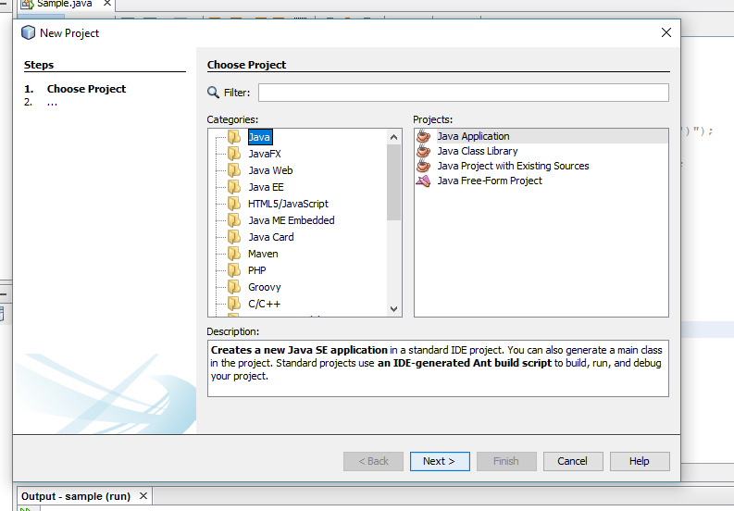
Step-2 : Copy the Sourcecode
package sample;
import java.sql.*;
import java.util.*;
public class Sample{
public static void main(String args[])
{
try
{
Class.forName("net.ucanaccess.jdbc.UcanaccessDriver");
Connection con=DriverManager.getConnection("jdbc:ucanaccess://D:\\vrsec.accdb");
Statement st=con.createStatement();
ResultSet rs=st.executeQuery("select * from it");
while(rs.next())
{

System.out.println("emp Number is:"+rs.getInt(1));
System.out.println("emp name is:"+rs.getString(2));
}
}
catch(Exception e)
{
System.out.println(e.getMessage());
}
}
}

Step-3 : Copy the data base to D-drive
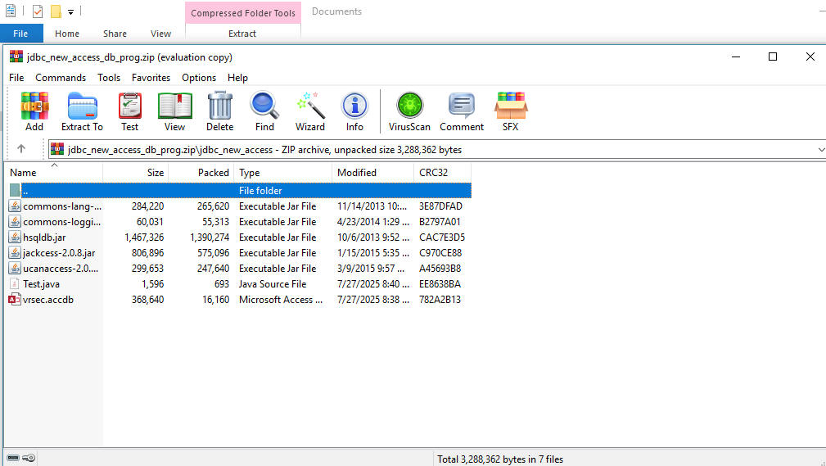
Step-4 : Add jar files. Select all the files and click open
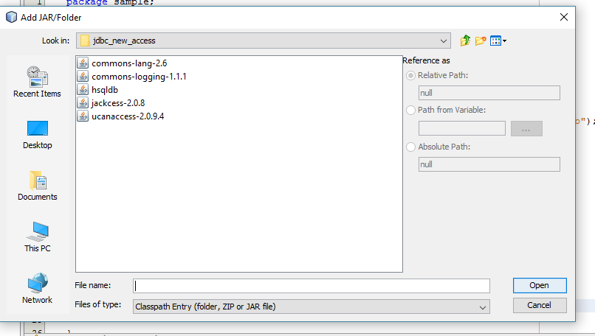
Step-5: Run the program

