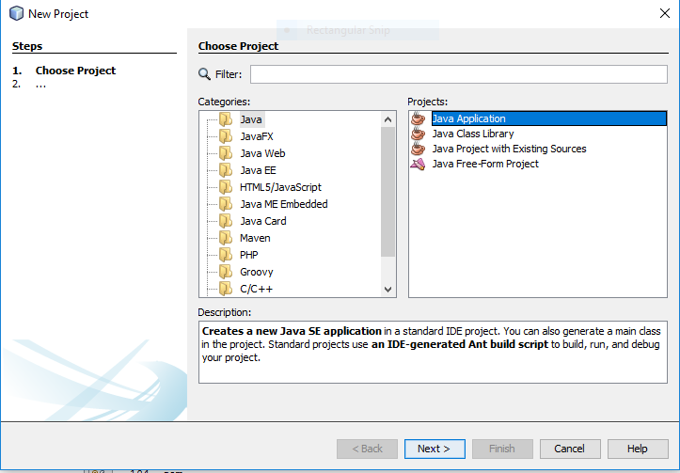
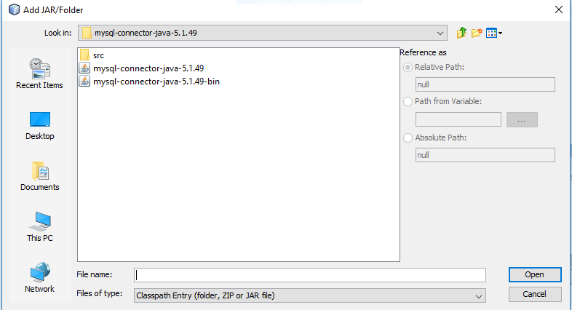
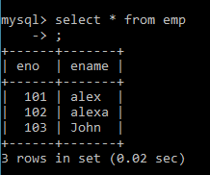
Source code:
package sql;

import java.sql.*;
import java.util.*;

public class Sql {

public static void main(String[] args) {

try{
Class.forName("com.mysql.jdbc.Driver");
Connection con=DriverManager.getConnection("jdbc:mysql://localhost:3306/it","root","");
Statement st=con.createStatement();
//int insert = st.executeUpdate("insert into employee values(11,'Yochana')");
ResultSet rs=st.executeQuery("select * from emp");
while(rs.next())
System.out.println(rs.getInt(1)+" "+rs.getString(2));
con.close();
}
catch(Exception e){
System.out.println(e);
}
}
}

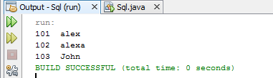

Source code:

package mysql;

import java.sql.*;
import java.util.*;

public class MySql {

public static void main(String[] args) {

try{
Class.forName("com.mysql.jdbc.Driver");
Connection con=DriverManager.getConnection("jdbc:mysql://10.0.9.22:3306/mysqldbcon","root","");
Statement st=con.createStatement();
//int insert = st.executeUpdate("insert into employee values(11,’yochana')");
ResultSet rs=st.executeQuery("select * from employee");
while(rs.next())
System.out.println(rs.getInt(1)+" "+rs.getString(2));
con.close();
catch(Exception e){
System.out.println(e);
}}}

