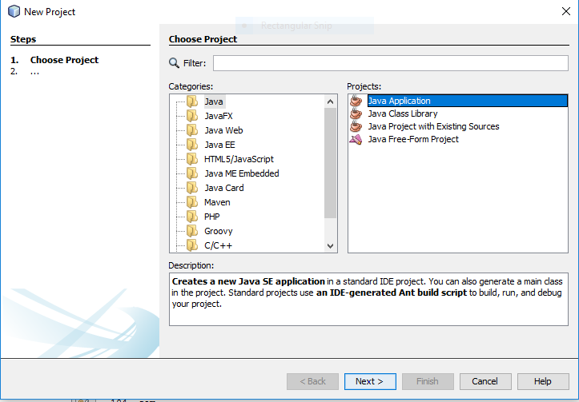

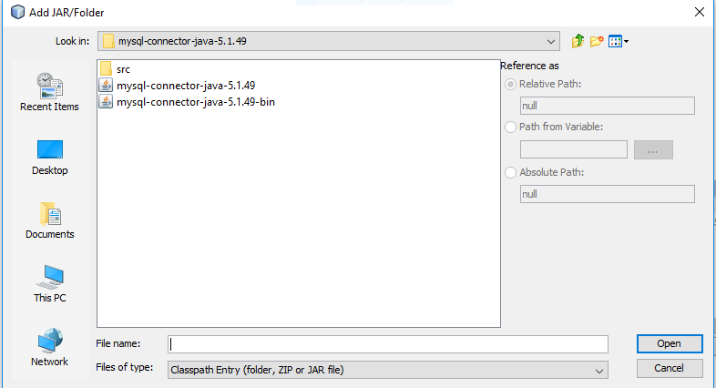
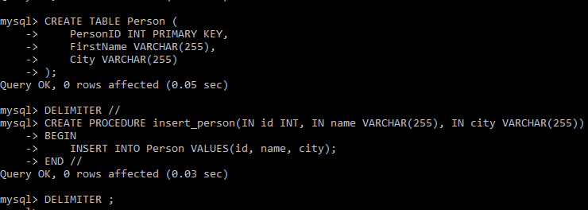
Source code :
import java.sql.*;

public class InsertPerson {
public static void main(String[] args) {
String url = "jdbc:mysql://localhost:3306/it";
String user = "root";
String pass = "";

try {
Class.forName("com.mysql.jdbc.Driver");
Connection con = DriverManager.getConnection(url, user, pass);

CallableStatement cs = con.prepareCall("{call insert_person(?,?,?)}");
cs.setInt(1, 1);
cs.setString(2, "Aarav");
cs.setString(3, "Mumbai");
cs.execute();

System.out.println("Record inserted successfully!");

con.close();
} catch (Exception e) {
e.printStackTrace();
}
}
}
Output :
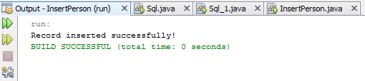

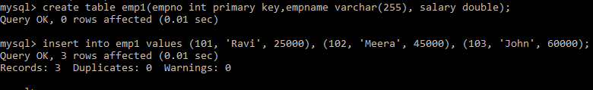
Source code :
import java.sql.*;
import java.util.*;

public class SelectEmployee {
public static void main(String[] args) {
String url = "jdbc:mysql://localhost:3306/it";
String user = "root";
String pass = "";

try (Scanner sc = new Scanner(System.in)) {
System.out.print("Enter minimum salary: ");
double x = sc.nextDouble();

Class.forName("com.mysql.jdbc.Driver");
Connection con = DriverManager.getConnection(url, user, pass);

String query = "SELECT empno, empname, salary FROM emp1 WHERE Salary > ?";
PreparedStatement ps = con.prepareStatement(query);
ps.setDouble(1, x);

ResultSet rs = ps.executeQuery();
System.out.println("EmpNo\tEmpName\tSalary");
while (rs.next()) {
System.out.println(rs.getInt(1) + "\t" + rs.getString(2) + "\t" + rs.getDouble(3));
}

con.close();
} catch (Exception e) {
e.printStackTrace();
}
}
}
Output :
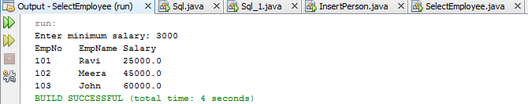
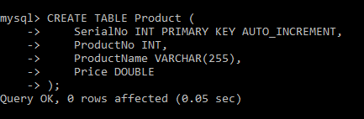
Source code :
import java.sql.*;

public class ProductCRUD {
public static void main(String[] args) {
String url = "jdbc:mysql://localhost:3306/it";
String user = "root";
String pass = "";

try {
Class.forName("com.mysql.jdbc.Driver");
Connection con = DriverManager.getConnection(url, user, pass);

// Insert record
String insertQuery = "INSERT INTO Product(ProductNo, ProductName, Price) VALUES(?,?,?)";
PreparedStatement ps = con.prepareStatement(insertQuery);
ps.setInt(1, 201);
ps.setString(2, "Laptop");
ps.setDouble(3, 55000.00);
ps.executeUpdate();
System.out.println("Product inserted successfully!");

// Display all
ResultSet rs = con.createStatement().executeQuery("SELECT * FROM Product");
System.out.println("SerialNo\tProductNo\tProductName\tPrice");
while (rs.next()) {
System.out.println(rs.getInt(1) + "\t" + rs.getInt(2) + "\t" + rs.getString(3) + "\t" + rs.getDouble(4));
}

con.close();
} catch (Exception e) {
e.printStackTrace();
}
}
}
Output :
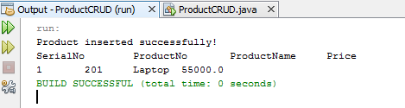
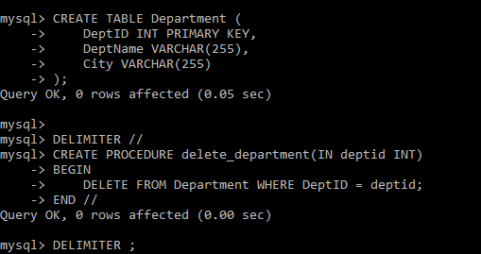
Source code :
import java.sql.*;

public class DeleteDepartment {
public static void main(String[] args) {
String url = "jdbc:mysql://localhost:3306/it";
String user = "root";
String pass = "";

try {
Class.forName("com.mysql.jdbc.Driver");
Connection con = DriverManager.getConnection(url, user, pass);

CallableStatement cs = con.prepareCall("{call delete_department(?)}");
cs.setInt(1, 1); // Example: delete department with ID=1
cs.execute();

System.out.println("Department deleted successfully!");
con.close();
} catch (Exception e) {
e.printStackTrace();
}
}
}
Output :
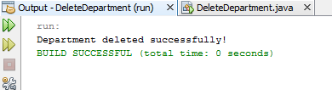
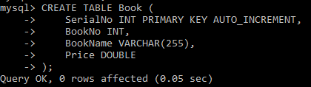
Source code :
import java.sql.*;

public class BookCRUD {
static final String URL = "jdbc:mysql://localhost:3306/it";
static final String USER = "root";
static final String PASS = "";

public static void main(String[] args) {
try {
Class.forName("com.mysql.jdbc.Driver");
Connection con = DriverManager.getConnection(URL, USER, PASS);

// INSERT
PreparedStatement ps1 = con.prepareStatement("INSERT INTO Book(BookNo, BookName, Price) VALUES(?,?,?)");
ps1.setInt(1, 301);
ps1.setString(2, "Java Fundamentals");
ps1.setDouble(3, 450.00);
ps1.executeUpdate();
System.out.println("Book inserted.");

// READ
ResultSet rs = con.createStatement().executeQuery("SELECT * FROM Book");
System.out.println("SerialNo\tBookNo\tBookName\tPrice");
while (rs.next()) {
System.out.println(rs.getInt(1) + "\t" + rs.getInt(2) + "\t" + rs.getString(3) + "\t" + rs.getDouble(4));
}

// UPDATE
PreparedStatement ps2 = con.prepareStatement("UPDATE Book SET Price=? WHERE BookNo=?");
ps2.setDouble(1, 500.00);
ps2.setInt(2, 301);
ps2.executeUpdate();
System.out.println("Book updated.");

// DELETE
PreparedStatement ps3 = con.prepareStatement("DELETE FROM Book WHERE BookNo=?");
ps3.setInt(1, 301);
ps3.executeUpdate();
System.out.println("Book deleted.");

con.close();
} catch (Exception e) {
e.printStackTrace();
}
}
}
Output :
