Date: 06-10-2025
Roll: 238W1A1291
Week-7: Cookies and Sessions
Cookies
Html:
<!doctype html>
<html lang="en">
<head>
<meta charset="utf-8" />
<title>Login</title>
</head>
<body>
<h1>Login</h1>
<form action="Cookie1" method="post">
<div>
<label for="username">Username</label><br />
<input id="username" name="username" type="text" />
</div>
<div>
<label for="password">Password</label><br />
<input id="password" name="password" type="password" />
</div>
<div>
<button type="submit">Sign in</button>
</div>
</form>
</body>
</html>

Cookie1:
package com.cookies;
import java.io.*;
import javax.servlet.*;
import javax.servlet.annotation.WebServlet;
import javax.servlet.http.*;

@WebServlet("/Cookie1")
public class Cookie1 extends HttpServlet {

@Override
protected void doPost(HttpServletRequest request, HttpServletResponse response)
throws ServletException, IOException {

response.setContentType("text/html");
PrintWriter out = response.getWriter();

String n = request.getParameter("username");
out.println("<h2>Welcome " + n + "</h2>");
Cookie ck = new Cookie("uname", n);
response.addCookie(ck);
out.println("<form action='Cookie2' method='post'>");
out.println("<input type='submit' value='Go'>");
out.println("</form>");

out.close();
}
}
Cookie2:
import java.io.*;
import javax.servlet.*;
import javax.servlet.annotation.WebServlet;
import javax.servlet.http.*;

@WebServlet("/Cookie2")
public class Cookie2 extends HttpServlet {
public void doPost(HttpServletRequest request, HttpServletResponse response){
try{
response.setContentType("text/html");
PrintWriter out = response.getWriter();

Cookie ck[]=request.getCookies();
out.print("Hello "+ck[0].getValue());

out.close();

}catch(Exception e){
System.out.println(e);
}
}
}

Output:

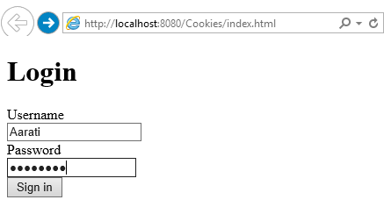
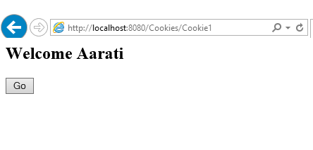
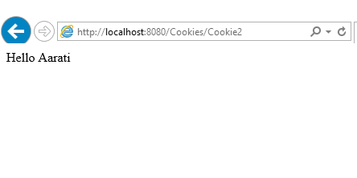

Sessions

