PYTHON PROGRAMMING
ACTIVITY - BASED LEARNING
10 Case Studies with Solutions

• Name: G.Karthik
• Roll Number: 26000910
• Branch: Computer Science & Engineering (AI & ML)
• Section: CSM1
• Course: Python Programming
• Institution: Dr. RVR NRI Institute of Technology

Contents : -
Case Study 1: Attendance Recovery Computation (Case Study 12)
Case Study 2: ATM Transaction Sequence Simulation (Case Study 13)
Case Study 3: Smart Parking Fee Management (Case Study 15)
Case Study 4: Fuel Consumption and Route Comparison (Case Study 18)
Case Study 5: Traffic Violation Penalty Calculator (Case Study 21)
Case Study 6: Progressive Water Tariff Analysis (Case Study 25)
Case Study 7: Advanced Numeric Pattern Generator (Case Study 27)
Case Study 8: Password Policy Validation Engine (Case Study 29)
Case Study 9: Student Feedback Sentiment Scoring (Case Study 34)
Case Study 10: Multi-Stage Examination Eligibility System (Case Study 39)

CASE STUDY 1: Attendance Recovery Computation
1. Problem Statement
A student whose attendance is below the university's mandatory 75% threshold needs to know exactly how many consecutive upcoming classes they must attend without missing any to become eligible for semester examinations. The program calculates current attendance percentage and computes the minimum consecutive classes needed to attain 75% eligibility.
2. Objectives
• Read student name, classes attended so far, and total classes conducted so far.
• Calculate cumulative attendance percentage from attended and conducted classes.
• Determine whether the student currently meets the 75% minimum university threshold.
• Use an iterative loop to compute the exact minimum consecutive future classes required to attain 75% eligibility.
3. Assumptions
• Total classes conducted is a positive integer greater than zero.
• Classes attended is a non-negative integer less than or equal to total classes.
• Each upcoming class attended increments both attended classes and total classes by one.
• The student attends all future recovery classes consecutively without missing any.
4. Algorithm
Start.
Input student name, classes attended, and total classes conducted.
Validate that input numbers are non-negative and attended does not exceed conducted.
Compute attendance percentage = (classes_attended / total_classes) * 100.
If percentage is at least 75.0%, report that the student is already eligible.
Otherwise, use a while loop to increment attended and total classes by 1 until percentage reaches 75.0%.
Display current attendance percentage and minimum consecutive classes needed.
Stop.
5. Flowchart
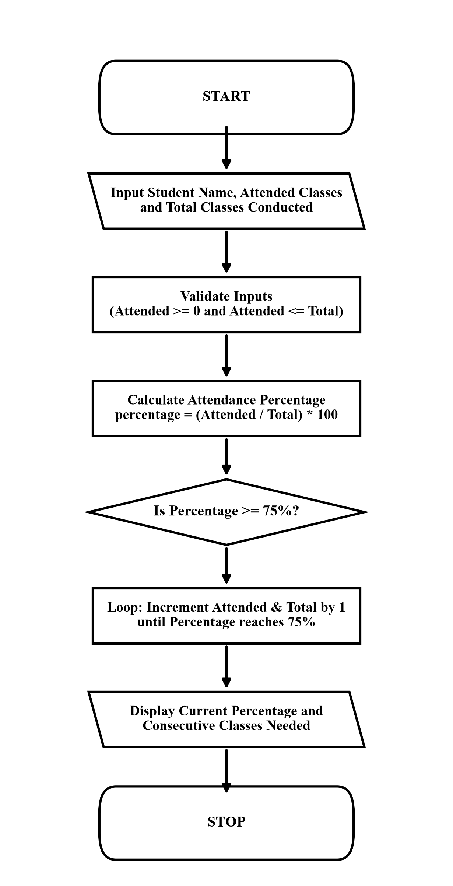

6. Pseudocode
START
INPUT student_name
INPUT classes_attended, total_classes
IF classes_attended < 0 OR total_classes <= 0 OR classes_attended > total_classes THEN
PRINT "Invalid input."
ELSE
percentage = (classes_attended / total_classes) * 100
PRINT "Current attendance:", percentage, "%"
IF percentage >= 75.0 THEN
PRINT "Eligible: Already meets attendance threshold"
ELSE
needed = 0
WHILE (classes_attended / total_classes) * 100 < 75.0 DO
classes_attended = classes_attended + 1
total_classes = total_classes + 1
needed = needed + 1
END WHILE
PRINT "Consecutive classes needed:", needed
END IF
END IF
STOP
7. Python Source Code (case_study_01.py)
# Case Study 12: Attendance Recovery Computation
student_name = input("Student name: ")
classes_attended = int(input("Total classes attended so far: "))
total_classes = int(input("Total classes conducted so far: "))
if classes_attended < 0 or total_classes <= 0 or classes_attended > total_classes:
print("Invalid input.")
else:
attendance_percentage = (classes_attended / total_classes) * 100
print("\nStudent:", student_name)
print("Current attendance:", round(attendance_percentage, 2), "%")
if attendance_percentage >= 75.0:
print("Status: Eligible (Attendance is already 75% or more)")
else:
classes_needed = 0
new_attended = classes_attended
new_total = total_classes
while (new_attended / new_total) * 100 < 75.0:
new_attended = new_attended + 1
new_total = new_total + 1
classes_needed = classes_needed + 1
print("Status: Shortage of attendance!")
print("Minimum consecutive classes needed to reach 75%:", classes_needed)
8. Test Cases
Input / Situation | Expected Result | Purpose
Yashwanth, attended: 48, conducted: 70 | Current attendance: 68.57 %, Status: Shortage, Consecutive classes needed: 18 | Shortage recovery computation
Kavya, attended: 80, conducted: 100 | Current attendance: 80.00 %, Status: Eligible (Already 75% or more) | Eligible threshold verification
Rahul, attended: 75, conducted: 60 | Invalid input. | Input boundary validation (attended > conducted)
9. Output screenshots
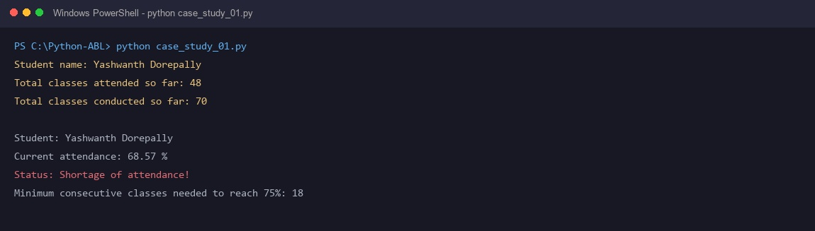
10. Conclusion
The program successfully calculates attendance percentage and uses a while loop to find the exact number of consecutive recovery classes required for examination eligibility.

CASE STUDY 2: ATM Transaction Sequence Simulation
1. Problem Statement
Automated Teller Machines (ATMs) must process sequential deposit and withdrawal transactions while strictly enforcing banking constraints, including maintaining a minimum account balance of Rs. 1000 and limiting total daily withdrawals to Rs. 20000.
2. Objectives
• Read opening balance and number of sequential customer transactions.
• Execute deposit and withdrawal operations sequentially using loop control.
• Verify that withdrawals maintain the minimum required balance of Rs. 1000.
• Ensure cumulative daily withdrawals do not exceed the statutory limit of Rs. 20000.
3. Assumptions
• Initial opening balance is a non-negative floating-point number.
• Number of transactions is a positive integer greater than zero.
• Deposits add funds directly to the account balance without upper limits.
• Transactions are processed sequentially in the order entered.
4. Algorithm
Start.
Input opening account balance and number of transactions.
Validate that opening balance is non-negative and transaction count is positive.
Initialize cumulative daily withdrawal counter to zero.
For each transaction from 1 to N, read transaction type (1: Deposit, 2: Withdrawal) and amount.
If deposit, add amount to balance and display updated balance.
If withdrawal, verify that cumulative withdrawal + amount <= Rs. 20000 and remaining balance >= Rs. 1000.
If conditions pass, deduct amount and update cumulative withdrawal; otherwise display rejection message.
Display final account balance after completing all transactions.
Stop.
5. Flowchart
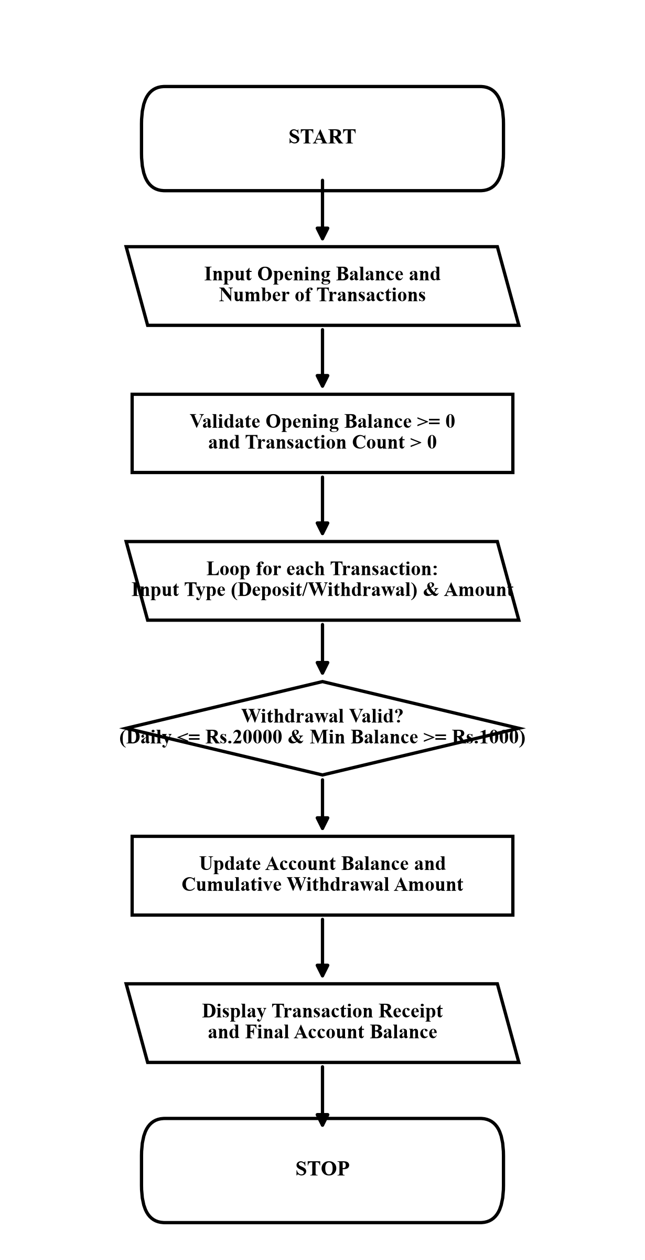

6. Pseudocode
START
INPUT opening_balance, num_transactions
IF opening_balance < 0 OR num_transactions <= 0 THEN
PRINT "Invalid opening balance or transaction count."
ELSE
balance = opening_balance
total_withdrawn = 0
FOR i = 1 TO num_transactions DO
INPUT txn_type, amount
IF txn_type == 1 THEN
balance = balance + amount
PRINT "Deposit successful. Balance:", balance
ELSE IF txn_type == 2 THEN
IF total_withdrawn + amount > 20000 THEN
PRINT "Rejection: Exceeds daily limit of Rs. 20000"
ELSE IF balance - amount < 1000 THEN
PRINT "Rejection: Must maintain min balance of Rs. 1000"
ELSE
balance = balance - amount
total_withdrawn = total_withdrawn + amount
PRINT "Withdrawal successful. Balance:", balance
END IF
END IF
END FOR
PRINT "Final Balance:", balance
END IF
STOP
7. Python Source Code (case_study_02.py)
# Case Study 13: ATM Transaction Sequence Simulation
account_balance = float(input("Enter opening balance (Rs.): "))
number_of_transactions = int(input("Enter number of transactions: "))
if account_balance < 0 or number_of_transactions <= 0:
print("Invalid opening balance or transaction count.")
else:
minimum_balance = 1000.0
daily_withdrawal_limit = 20000.0
total_withdrawn_today = 0.0
print("\nEnter transactions (e.g. Type: deposit/withdraw, Amount: 500)")
for transaction_number in range(1, number_of_transactions + 1):
print("\nTransaction", transaction_number)
transaction_type = input("Transaction type (deposit/withdraw): ").strip().lower()
amount = float(input("Amount (Rs.): "))
if transaction_type == "deposit" or transaction_type == "1":
if amount > 0:
account_balance = account_balance + amount
print("Deposit successful! Current balance: Rs.", round(account_balance, 2))
else:
print("Invalid deposit amount.")
elif transaction_type == "withdraw" or transaction_type == "2":
if amount <= 0:
print("Invalid withdrawal amount.")
elif (total_withdrawn_today + amount) > daily_withdrawal_limit:
print("Failed: Exceeds daily withdrawal limit of Rs.", daily_withdrawal_limit)
elif (account_balance - amount) < minimum_balance:
print("Failed: Insufficient funds! Must maintain min balance of Rs.", minimum_balance)
else:
account_balance = account_balance - amount
total_withdrawn_today = total_withdrawn_today + amount
print("Withdrawal successful! Remaining balance: Rs.", round(account_balance, 2))
else:
print("Invalid transaction type.")
print("\n--- Daily ATM Summary ---")
print("Total cash withdrawn today: Rs.", round(total_withdrawn_today, 2))
print("Closing available balance : Rs.", round(account_balance, 2))
8. Test Cases
Input / Situation | Expected Result | Purpose
Balance: 5000, Txn 1: dep 1500, Txn 2: w/d 2000 | Txn 1 balance: Rs. 6500.0, Txn 2 balance: Rs. 4500.0, Final: Rs. 4500.0 | Sequential transaction processing
Balance: 2000, Txn 1: w/d 1500 | Rejection: Insufficient funds! Must maintain min balance of Rs. 1000 | Minimum balance threshold enforcement
Balance: 30000, Txn 1: w/d 22000 | Rejection: Exceeds daily withdrawal limit of Rs. 20000.0 | Statutory daily withdrawal limit rule
9. Output screenshots
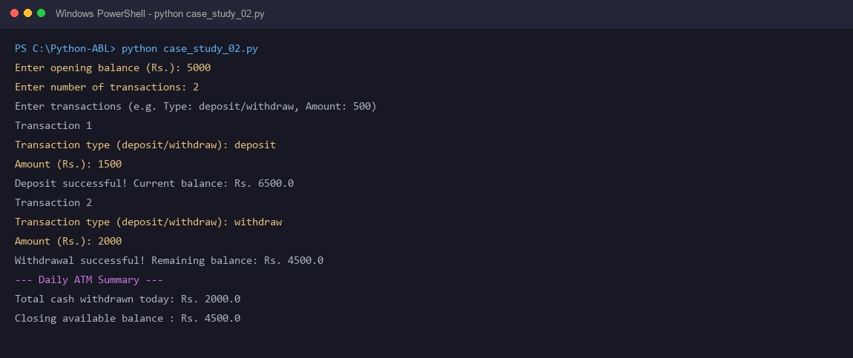
10. Conclusion
The ATM simulation enforces banking constraints through sequential control flow, guaranteeing minimum balance maintenance and daily withdrawal limit protection.

CASE STUDY 3: Smart Parking Fee Management
1. Problem Statement
Municipal smart parking facilities require an automated billing system that applies vehicle-differentiated hourly rates, enforces maximum daily pricing caps, and adds an overnight surcharge for vehicles parked beyond 12 hours.
2. Objectives
• Read vehicle category (Two-Wheeler or Four-Wheeler) and parked duration in hours.
• Compute hourly parking charges based on vehicle category rates.
• Apply maximum daily fare caps (Rs. 150 for Two-Wheelers, Rs. 300 for Four-Wheelers).
• Apply an overnight surcharge of Rs. 100 if parking duration exceeds 12 hours.
3. Assumptions
• Parking duration is a positive floating-point number.
• Two-Wheeler rate is Rs. 20/hour with Rs. 150 daily cap.
• Four-Wheeler rate is Rs. 40/hour with Rs. 300 daily cap.
• Surcharge of Rs. 100 is applied when parked duration exceeds 12 hours.
4. Algorithm
Start.
Input vehicle type (1: Two-Wheeler, 2: Four-Wheeler) and parked duration in hours.
Validate that vehicle choice is valid and parked hours > 0.
Compute base fee = parked hours * vehicle hourly rate.
If base fee exceeds the vehicle category daily cap, set base fee = daily cap.
If parked duration exceeds 12 hours, set overnight surcharge = Rs. 100; otherwise Rs. 0.
Compute total parking fee = base fee + surcharge.
Display itemized bill showing base fee, surcharge, and total payable amount.
Stop.
5. Flowchart
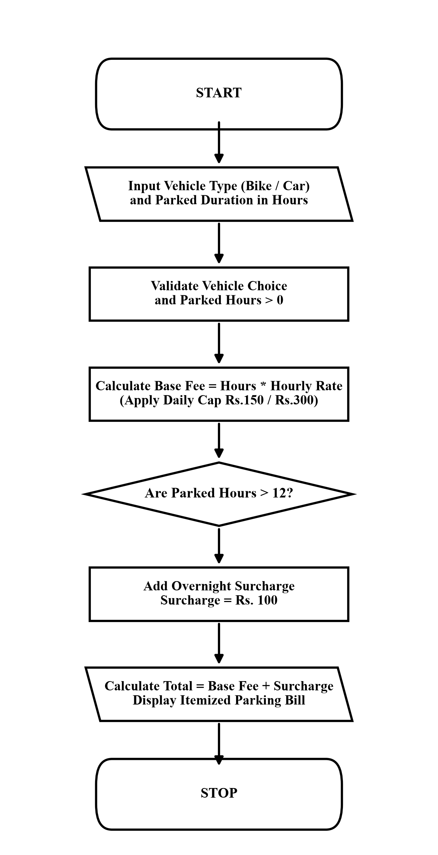

6. Pseudocode
START
INPUT vehicle_choice, parked_hours
IF parked_hours <= 0 THEN
PRINT "Invalid parked duration"
ELSE
IF vehicle_choice == "1" THEN
rate = 20, cap = 150
ELSE IF vehicle_choice == "2" THEN
rate = 40, cap = 300
ELSE
PRINT "Invalid vehicle choice"
STOP
END IF
base_fee = parked_hours * rate
IF base_fee > cap THEN
base_fee = cap
END IF
IF parked_hours > 12 THEN
surcharge = 100
ELSE
surcharge = 0
END IF
total = base_fee + surcharge
PRINT "Base Fee:", base_fee, "Surcharge:", surcharge, "Total:", total
END IF
STOP
7. Python Source Code (case_study_03.py)
# Case Study 15: Smart Parking Fee Management
print("Vehicle Types: 1. Two-Wheeler (Bike), 2. Four-Wheeler (Car)")
vehicle_choice = input("Select vehicle type (1 or 2): ").strip().lower()
parked_hours = float(input("Enter parked hours: "))
if parked_hours <= 0:
print("Invalid parked duration! Hours must be greater than 0.")
elif vehicle_choice == "1" or vehicle_choice == "bike":
vehicle_type_name = "Two-Wheeler"
hourly_rate = 20.0
maximum_daily_charge = 150.0
base_parking_fee = parked_hours * hourly_rate
if base_parking_fee > maximum_daily_charge:
base_parking_fee = maximum_daily_charge
overnight_surcharge = 0.0
if parked_hours > 12.0:
overnight_surcharge = 100.0
total_parking_fee = base_parking_fee + overnight_surcharge
print("\n--- Parking Fee Receipt ---")
print("Vehicle Category :", vehicle_type_name)
print("Parked Duration :", parked_hours, "hours")
print("Base Parking Charge: Rs.", round(base_parking_fee, 2))
print("Overnight Surcharge: Rs.", round(overnight_surcharge, 2))
print("Total Amount Due : Rs.", round(total_parking_fee, 2))
elif vehicle_choice == "2" or vehicle_choice == "car":
vehicle_type_name = "Four-Wheeler"
hourly_rate = 40.0
maximum_daily_charge = 300.0
base_parking_fee = parked_hours * hourly_rate
if base_parking_fee > maximum_daily_charge:
base_parking_fee = maximum_daily_charge
overnight_surcharge = 0.0
if parked_hours > 12.0:
overnight_surcharge = 100.0
total_parking_fee = base_parking_fee + overnight_surcharge
print("\n--- Parking Fee Receipt ---")
print("Vehicle Category :", vehicle_type_name)
print("Parked Duration :", parked_hours, "hours")
print("Base Parking Charge: Rs.", round(base_parking_fee, 2))
print("Overnight Surcharge: Rs.", round(overnight_surcharge, 2))
print("Total Amount Due : Rs.", round(total_parking_fee, 2))
else:
print("Invalid vehicle choice! Please select 1 (Two-Wheeler) or 2 (Four-Wheeler).")
8. Test Cases
Input / Situation | Expected Result | Purpose
Vehicle: 1 (Two-Wheeler), Hours: 5 | Base fee: Rs. 100.0, Surcharge: Rs. 0.0, Total: Rs. 100.0 | Standard hourly duration billing
Vehicle: 2 (Four-Wheeler), Hours: 14 | Base fee: Rs. 300.0 (capped), Surcharge: Rs. 100.0, Total: Rs. 400.0 | Daily rate cap and overnight surcharge
Vehicle: 1 (Two-Wheeler), Hours: -2 | Invalid parked duration! Hours must be greater than 0. | Negative duration boundary validation
9. Output screenshots
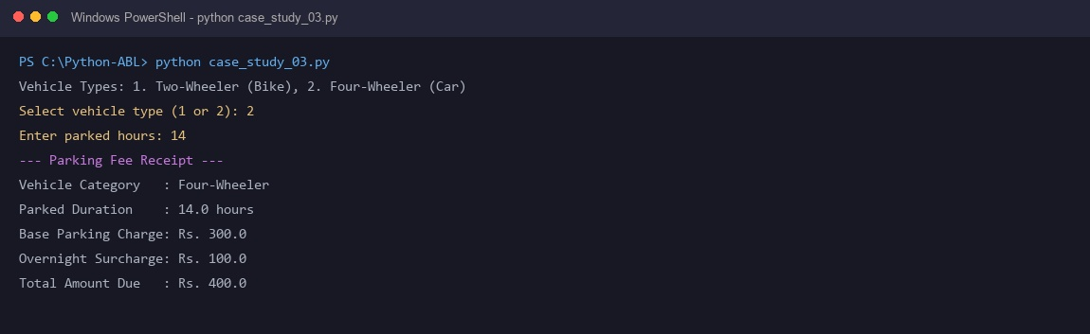
10. Conclusion
The smart parking fee calculator accurately implements tiered rate structures with fair pricing caps and overnight surcharges using conditional branching.

CASE STUDY 4: Fuel Consumption and Route Comparison
1. Problem Statement
Commuters and transport managers must compare fuel efficiency and monetary expenses between two different vehicles over a designated trip distance to select the more economical vehicle option.
2. Objectives
• Read trip distance in kilometers and current fuel price per liter.
• Read fuel efficiency (mileage in km/liter) for Vehicle A and Vehicle B.
• Calculate fuel consumed in liters and trip cost for both vehicles.
• Compare trip costs and recommend the more economical vehicle with exact financial savings.
3. Assumptions
• Distance, fuel price, and mileage ratings are positive numbers greater than zero.
• Both vehicles use the identical fuel grade and travel the same route.
• Mileage remains constant throughout the designated trip distance.
4. Algorithm
Start.
Input trip distance (km), fuel price per liter (Rs.), mileage of Vehicle A, and mileage of Vehicle B.
Validate that all four input parameters are strictly positive.
Compute fuel consumed by Vehicle A = distance / mileage_a.
Compute monetary cost for Vehicle A = fuel_a * fuel_price.
Compute fuel consumed by Vehicle B = distance / mileage_b.
Compute monetary cost for Vehicle B = fuel_b * fuel_price.
Compare cost of Vehicle A and Vehicle B to determine the cheaper option and calculate savings.
Display fuel quantities, total costs, and final recommendation.
Stop.
5. Flowchart
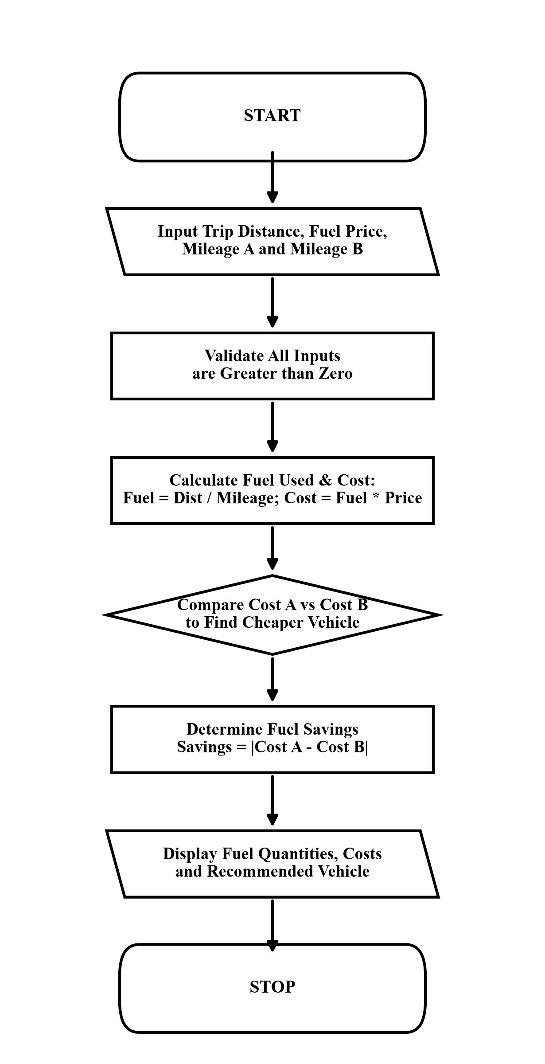

6. Pseudocode
START
INPUT distance, fuel_price, mileage_a, mileage_b
IF distance <= 0 OR fuel_price <= 0 OR mileage_a <= 0 OR mileage_b <= 0 THEN
PRINT "Invalid input! All values must be positive."
ELSE
fuel_a = distance / mileage_a
cost_a = fuel_a * fuel_price
fuel_b = distance / mileage_b
cost_b = fuel_b * fuel_price
PRINT "Cost A:", cost_a, "Cost B:", cost_b
IF cost_a < cost_b THEN
PRINT "Recommend Vehicle A. Savings:", cost_b - cost_a
ELSE IF cost_b < cost_a THEN
PRINT "Recommend Vehicle B. Savings:", cost_a - cost_b
ELSE
PRINT "Both vehicles have identical fuel expenses"
END IF
END IF
STOP
7. Python Source Code (case_study_04.py)
# Case Study 18: Fuel Consumption and Route Comparison
distance = float(input("Enter trip distance (km): "))
fuel_price = float(input("Enter fuel price per liter (Rs.): "))
mileage_vehicle_a = float(input("Mileage of Vehicle A (km/liter): "))
mileage_vehicle_b = float(input("Mileage of Vehicle B (km/liter): "))
if distance <= 0 or fuel_price <= 0 or mileage_vehicle_a <= 0 or mileage_vehicle_b <= 0:
print("Invalid input! All values must be positive and greater than zero.")
else:
fuel_needed_vehicle_a = distance / mileage_vehicle_a
total_cost_vehicle_a = fuel_needed_vehicle_a * fuel_price
fuel_needed_vehicle_b = distance / mileage_vehicle_b
total_cost_vehicle_b = fuel_needed_vehicle_b * fuel_price
print("\n--- Route Comparison ---")
print("Vehicle A - Fuel needed:", round(fuel_needed_vehicle_a, 2), "liters | Trip cost: Rs.", round(total_cost_vehicle_a, 2))
print("Vehicle B - Fuel needed:", round(fuel_needed_vehicle_b, 2), "liters | Trip cost: Rs.", round(total_cost_vehicle_b, 2))
if total_cost_vehicle_a < total_cost_vehicle_b:
cost_difference = total_cost_vehicle_b - total_cost_vehicle_a
print("Recommendation: Choose Vehicle A (Saves Rs.", round(cost_difference, 2), ")")
elif total_cost_vehicle_b < total_cost_vehicle_a:
cost_difference = total_cost_vehicle_a - total_cost_vehicle_b
print("Recommendation: Choose Vehicle B (Saves Rs.", round(cost_difference, 2), ")")
else:
print("Both vehicles have identical fuel expenses.")
8. Test Cases
Input / Situation | Expected Result | Purpose
Distance: 250 km, Fuel: 104, Mileage A: 15, Mileage B: 22 | Cost A: Rs. 1733.33, Cost B: Rs. 1181.82, Recommend Vehicle B (Saves Rs. 551.52) | Comparative fuel cost evaluation
Distance: 100 km, Fuel: 100, Mileage A: 20, Mileage B: 20 | Cost A: Rs. 500.0, Cost B: Rs. 500.0, Both vehicles have identical fuel expenses | Identical mileage tie condition check
Distance: -50 km, Fuel: 105, Mileage A: 18, Mileage B: 12 | Invalid input! All values must be positive and greater than zero. | Negative distance parameter validation
9. Output screenshots
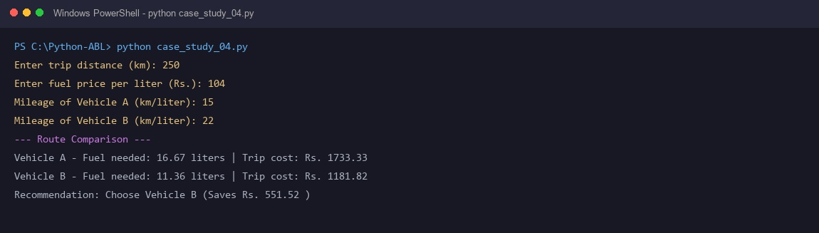
10. Conclusion
The fuel consumption and route evaluation tool enables data-driven transport choices by analyzing fuel consumption and comparing trip expenses.

CASE STUDY 5: Traffic Violation Penalty Calculator
1. Problem Statement
Urban traffic regulatory systems need automated e-challan generators that apply statutory fines according to violation category, penalize repeat offenders with a 50% surcharge, and flag severe offenses such as drunk driving for judicial review.
2. Objectives
• Read vehicle registration number and violation category selection.
• Determine statutory base penalty for the designated violation code.
• Apply a 50% repeat offender surcharge if prior violations exist.
• Issue court review and license suspension notice for critical offenses like drunk driving.
3. Assumptions
• Vehicle registration string is non-empty.
• Statutory rates: 1: Helmet/Seatbelt (Rs. 500), 2: Signal Jump (Rs. 1000), 3: Speeding (Rs. 1500), 4: Drunk Driving (Rs. 10000).
• Repeat offense status is answered with 'yes' or 'no'.
4. Algorithm
Start.
Input vehicle registration number, violation code (1-4), and repeat offender status.
Validate violation code selection.
Assign statutory base fine according to violation code.
If repeat offender is 'yes', calculate 50% surcharge and add to base fine.
If violation code is 4 (Drunk Driving), add mandatory license suspension notice.
Display formatted e-challan slip with fine breakdown and legal action notice.
Stop.
5. Flowchart
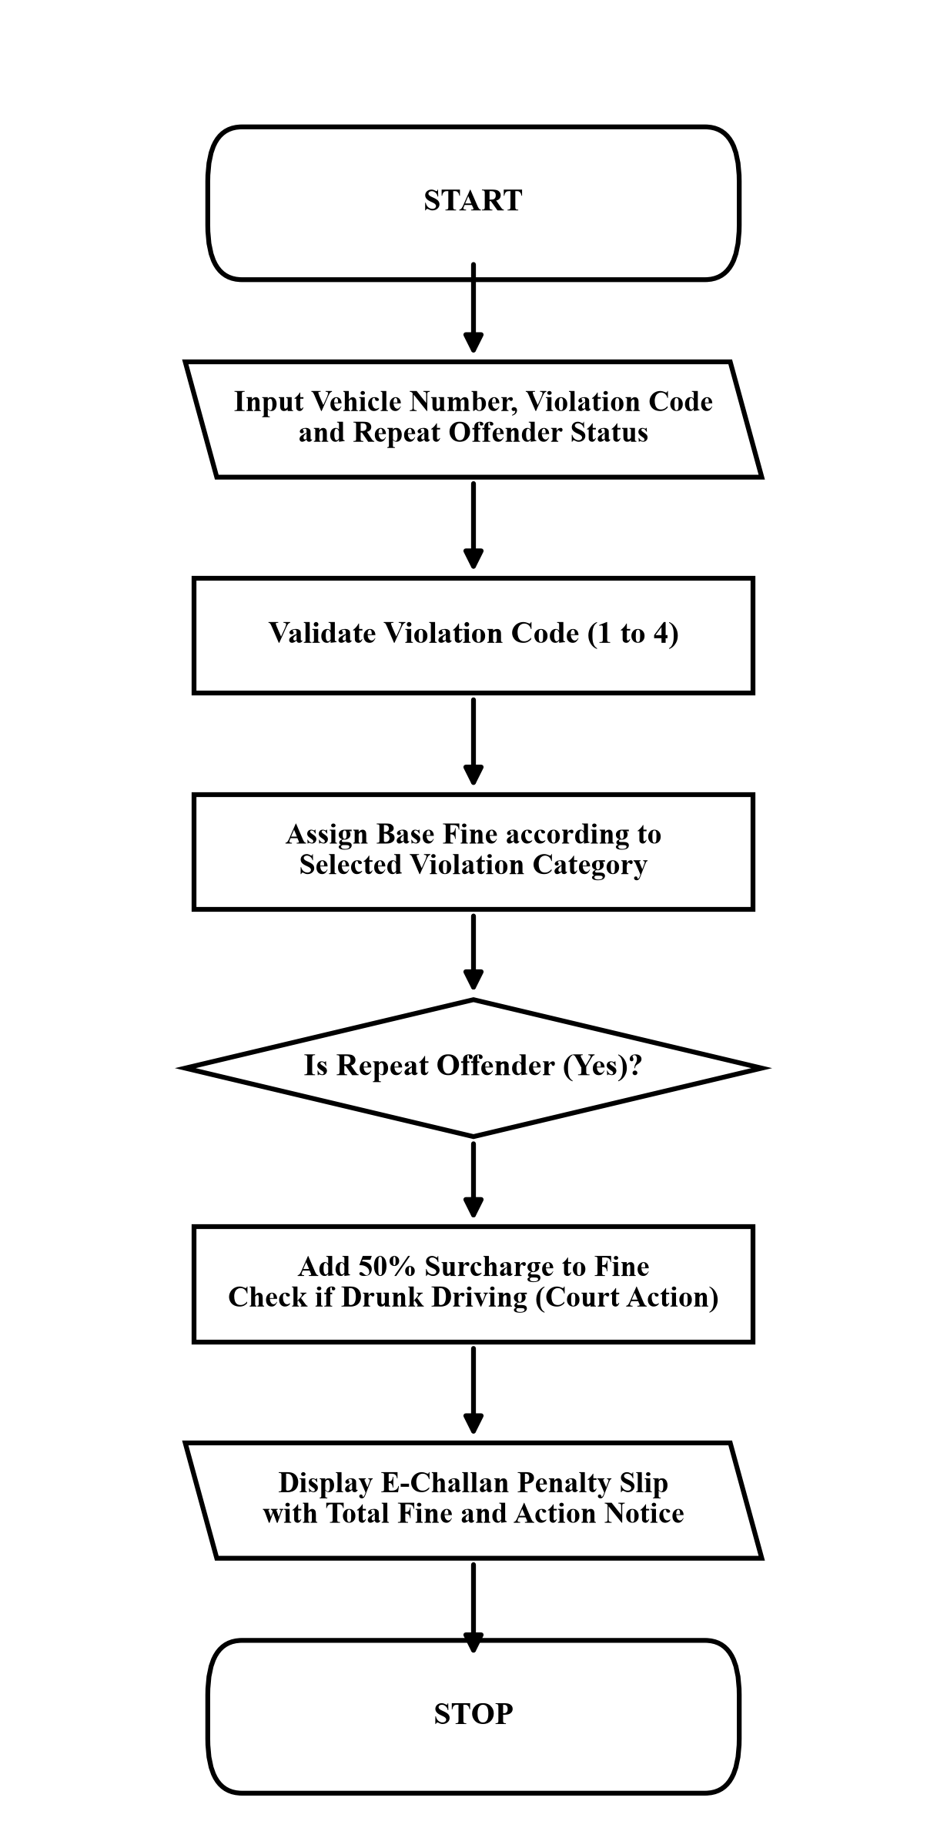

6. Pseudocode
START
INPUT vehicle_number, violation_code, is_repeat
IF violation_code == 1 THEN
fine = 500
ELSE IF violation_code == 2 THEN
fine = 1000
ELSE IF violation_code == 3 THEN
fine = 1500
ELSE IF violation_code == 4 THEN
fine = 10000
ELSE
PRINT "Invalid violation choice"
STOP
END IF
IF is_repeat == "yes" THEN
surcharge = fine * 0.50
total = fine + surcharge
ELSE
total = fine
END IF
PRINT "Total Fine:", total
IF violation_code == 4 THEN
PRINT "Action: LICENSE SUSPENDED FOR COURT REVIEW"
END IF
STOP
7. Python Source Code (case_study_05.py)
# Case Study 21: Traffic Violation Penalty Calculator
vehicle_number = input("Vehicle registration number: ")
print("Violations:")
print("1. No Helmet / No Seatbelt (Rs. 500)")
print("2. Signal Jumping (Rs. 1000)")
print("3. Overspeeding (Rs. 1500)")
print("4. Drunk Driving (Rs. 10000)")
violation_choice = input("Select violation (1-4): ").strip().lower()
is_repeat_offence = input("Is this a repeat offence? (yes/no): ").strip().lower()
if violation_choice == "1" or violation_choice == "helmet" or violation_choice == "seatbelt":
offence_name = "No Helmet / Seatbelt"
fine_amount = 500.0
elif violation_choice == "2" or violation_choice == "signal":
offence_name = "Signal Jumping"
fine_amount = 1000.0
elif violation_choice == "3" or violation_choice == "overspeeding" or violation_choice == "speeding":
offence_name = "Overspeeding"
fine_amount = 1500.0
elif violation_choice == "4" or violation_choice == "drunk driving":
offence_name = "Drunk Driving"
fine_amount = 10000.0
else:
offence_name = "None"
fine_amount = 0.0
if offence_name == "None":
print("Invalid violation choice! Please select 1, 2, 3, or 4.")
else:
repeat_status = "No"
if is_repeat_offence == "yes" or is_repeat_offence == "y":
fine_amount = fine_amount + (fine_amount * 0.5) # Add 50% extra fine for repeat offence
repeat_status = "Yes"
print("\n--- Traffic E-Challan ---")
print("Vehicle Number :", vehicle_number)
print("Violation Type :", offence_name)
print("Repeat Offender:", repeat_status)
print("Total Fine Due : Rs.", round(fine_amount, 2))
if fine_amount >= 5000:
print("Action Notice : LICENSE SUSPENDED FOR COURT REVIEW")
8. Test Cases
Input / Situation | Expected Result | Purpose
AP16-AB-1234, Speeding (3), Repeat: yes | Fine: Rs. 2250.0, Repeat: Yes, Normal challan issued | Repeat offender 50% surcharge check
TS09-CD-5678, Drunk Driving (4), Repeat: no | Fine: Rs. 10000.0, Action: LICENSE SUSPENDED FOR COURT REVIEW | Severe violation mandatory court review
AP16-EF-9999, Helmet (1), Repeat: no | Fine: Rs. 500.0, Repeat: No | First-time minor violation standard fine
9. Output screenshots
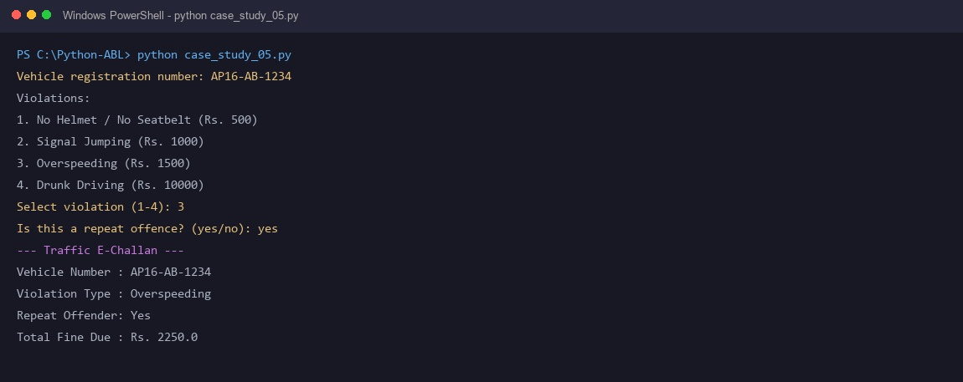
10. Conclusion
The traffic violation penalty calculator automates municipal e-challan generation with progressive penalties, compounding fines for recidivism and flagging severe infractions.

CASE STUDY 6: Progressive Water Tariff Analysis
1. Problem Statement
Municipal public utility boards charge consumers using progressive, tiered water consumption slabs to ensure affordable baseline water while penalizing excessive water usage to promote resource conservation.
2. Objectives
• Read consumer identification number and monthly water usage in kiloliters (kL).
• Calculate progressive consumption charges across tiered slabs.
• Add mandatory fixed meter rent of Rs. 40 to the final bill.
• Issue a high consumption alert if monthly usage exceeds 50 kL.
3. Assumptions
• Water usage is a non-negative floating-point number.
• Progressive slabs: 0-15 kL: Free (Rs. 0), 16-30 kL: Rs. 5/kL, 31-50 kL: Rs. 10/kL, Above 50 kL: Rs. 15/kL.
• Fixed meter rent of Rs. 40 applies to every active consumer account.
4. Algorithm
Start.
Input consumer ID and monthly water usage in kiloliters (kL).
Validate that water usage is non-negative.
Compute tiered water charges across progressive slabs:
- 0 to 15 kL: Rs. 0
- 16 to 30 kL: (usage - 15) * Rs. 5
- 31 to 50 kL: (15 * 5) + (usage - 30) * Rs. 10
- Above 50 kL: (15 * 5) + (20 * 10) + (usage - 50) * Rs. 15
Add fixed meter rent of Rs. 40 to calculate total bill amount.
If monthly usage exceeds 50 kL, display conservation alert.
Display consumer bill statement with total charges.
Stop.
5. Flowchart
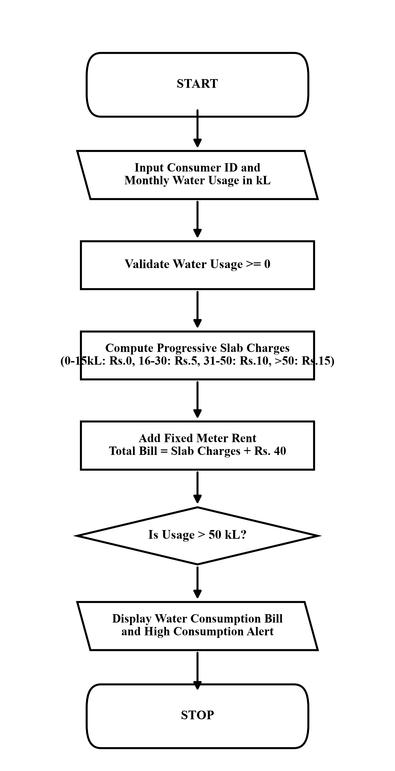

6. Pseudocode
START
INPUT consumer_id, water_usage
IF water_usage < 0 THEN
PRINT "Invalid usage! Water consumption cannot be negative."
ELSE
water_charge = 0
IF water_usage <= 15 THEN
water_charge = 0
ELSE IF water_usage <= 30 THEN
water_charge = (water_usage - 15) * 5
ELSE IF water_usage <= 50 THEN
water_charge = (15 * 5) + (water_usage - 30) * 10
ELSE
water_charge = (15 * 5) + (20 * 10) + (water_usage - 50) * 15
END IF
total_bill = water_charge + 40
PRINT "Water Charge:", water_charge, "Meter Rent: 40", "Total:", total_bill
IF water_usage > 50 THEN
PRINT "Alert: High water consumption detected!"
END IF
END IF
STOP
7. Python Source Code (case_study_06.py)
# Case Study 25: Progressive Water Tariff Analysis
consumer_id = input("Enter Consumer ID: ")
water_usage_units = float(input("Enter monthly water usage in kiloliters (kL): "))
if water_usage_units < 0:
print("Invalid usage amount! Water usage cannot be negative.")
else:
# Simple Slabs:
# First 30 kL : Rs. 5 per kL
# Above 30 kL : Rs. 10 per kL
if water_usage_units <= 30:
water_charge = water_usage_units * 5
else:
water_charge = (30 * 5) + ((water_usage_units - 30) * 10)
meter_rent = 40.0
total_bill_amount = water_charge + meter_rent
print("\n--- Water Bill Statement ---")
print("Consumer ID :", consumer_id)
print("Water Consumption :", water_usage_units, "kL")
print("Water Charge : Rs.", round(water_charge, 2))
print("Fixed Meter Rent : Rs.", meter_rent)
print("Total Bill Amount : Rs.", round(total_bill_amount, 2))
if water_usage_units > 50:
print("Alert: High water consumption detected! Please conserve water.")
8. Test Cases
Input / Situation | Expected Result | Purpose
Consumer: WTR-9821, Usage: 45 kL | Water charge: Rs. 300.0, Meter rent: Rs. 40.0, Total: Rs. 340.0 | Progressive slab 2 calculation
Consumer: WTR-1102, Usage: 20 kL | Water charge: Rs. 100.0, Meter rent: Rs. 40.0, Total: Rs. 140.0 | Baseline consumption slab 1 calculation
Consumer: WTR-5544, Usage: 65 kL | Water charge: Rs. 500.0, Total: Rs. 540.0, Alert: High consumption | Upper progressive slab and alert check
9. Output screenshots
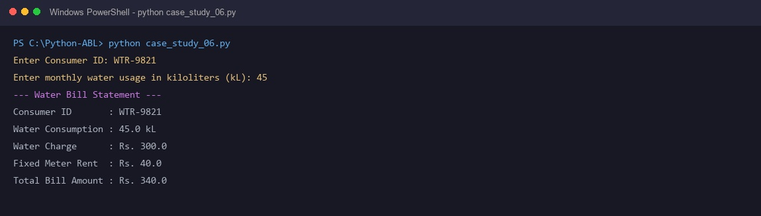
10. Conclusion
The progressive water tariff billing program implements utility rate calculations effectively, guaranteeing affordable baseline water while incentivizing conservation.

CASE STUDY 7: Advanced Numeric Pattern Generator
1. Problem Statement
Mathematical pattern generators and visual formatting algorithms require nested iteration control structures to produce symmetrical palindromic number pyramids with precise leading whitespace alignment.
2. Objectives
• Read pattern dimension integer N between 1 and 9.
• Validate that input N falls strictly within the single-digit range [1, 9].
• Use outer loops to iterate through pyramid row levels.
• Use inner loops to format leading spaces, ascending integers, and descending integers.
3. Assumptions
• Dimension N is an integer between 1 and 9 inclusive.
• Row i contains (N - i) leading spaces for centering.
• Numbers ascend from 1 to i and descend from i-1 down to 1.
4. Algorithm
Start.
Input pattern dimension N.
Validate that N is an integer between 1 and 9 inclusive.
If invalid, display error message and stop.
For each row i from 1 to N:
a. Print (N - i) leading spaces without newline.
b. Print ascending numbers j from 1 to i without newline.
c. Print descending numbers j from i - 1 down to 1 without newline.
d. Print a newline to complete the row.
Stop.
5. Flowchart
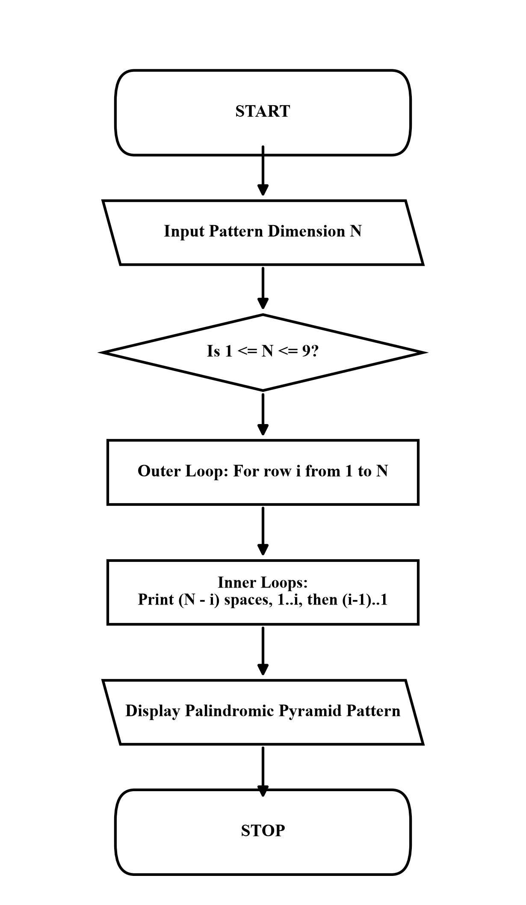
Plaintext
START
│
▼
INPUT PATTERN DIMENSION N (1 TO 9)
│
▼
VALIDATE N IS BETWEEN 1 AND 9
│
▼
LOOP FOR ROW i FROM 1 TO N
│
▼
PRINT LEADING SPACES (N - i)
│
▼
PRINT INCREASING (1 TO i) & DECREASING (i-1 TO 1)
│
▼
PRINT NEWLINE FOR NEXT ROW
│
▼
STOP
6. Pseudocode
START
INPUT N
IF N < 1 OR N > 9 THEN
PRINT "Invalid dimension! Please enter between 1 and 9."
ELSE
FOR i = 1 TO N DO
FOR s = 1 TO (N - i) DO
PRINT " " WITHOUT NEWLINE
END FOR
FOR j = 1 TO i DO
PRINT j WITHOUT NEWLINE
END FOR
FOR j = i - 1 DOWNTO 1 DO
PRINT j WITHOUT NEWLINE
END FOR
PRINT NEWLINE
END FOR
END IF
STOP
7. Python Source Code (case_study_07.py)
# Case Study 27: Advanced Numeric Pattern Generator
total_rows = int(input("Enter pattern dimension N (1 to 9): "))
if total_rows < 1 or total_rows > 9:
print("Invalid dimension! Please enter an integer between 1 and 9.")
else:
print("\n--- Symmetric Palindromic Number Pyramid ---")
for current_row in range(1, total_rows + 1):
# Print leading spaces
print(" " * (total_rows - current_row), end="")
# Ascending numbers
for number in range(1, current_row + 1):
print(number, end="")
# Descending numbers
for number in range(current_row - 1, 0, -1):
print(number, end="")
print() # Move to next line
8. Test Cases
Input / Situation | Expected Result | Purpose
Dimension N = 4 | Row 1: ' 1', Row 2: ' 121', Row 3: ' 12321', Row 4: '1234321' | Symmetrical 4-row palindromic pyramid
Dimension N = 2 | Row 1: ' 1', Row 2: '121' | Minimal multi-row pattern verification
Dimension N = 12 | Invalid dimension! Please enter an integer between 1 and 9. | Single-digit boundary validation check
9. Output screenshots
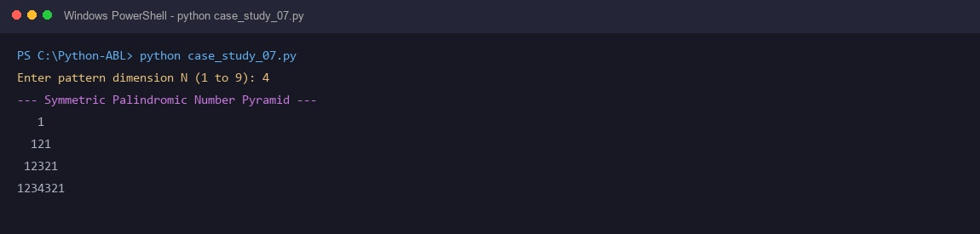
10. Conclusion
The numeric pattern generator demonstrates control over nested loop indexing and whitespace manipulation to produce clean geometric output.

CASE STUDY 8: Password Policy Validation Engine
1. Problem Statement
Authentication and enterprise security systems must audit candidate user passwords against established organizational complexity policies to ensure defense against credential compromise and dictionary attacks.
2. Objectives
• Read candidate password from user input.
• Verify minimum length requirement of at least 8 characters.
• Verify presence of at least one uppercase letter, one lowercase letter, and one numeric digit.
• Screen against dictionary blacklists ('password', 'admin', '123456') and classify strength.
3. Assumptions
• Password input is a non-empty string.
• Validation requires satisfying all five policy criteria simultaneously.
• Failure of any single criterion results in classification as WEAK.
4. Algorithm
Start.
Input candidate password string.
Evaluate length: has_length = (length >= 8).
Initialize boolean flags: has_upper = False, has_lower = False, has_digit = False.
Iterate through each character in password and set corresponding boolean flag to True.
Check for prohibited substrings ('password', 'admin', '123456') using membership test.
If all five security conditions evaluate to True, report 'PASSWORD STRENGTH: STRONG'.
Otherwise, report failed policy criteria and report 'PASSWORD STRENGTH: WEAK'.
Stop.
5. Flowchart
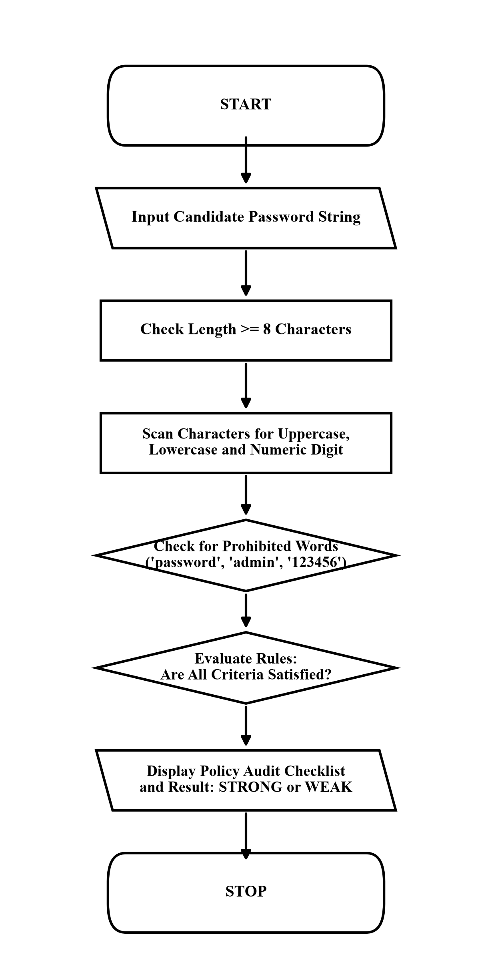

6. Pseudocode
START
INPUT password
has_len = (LENGTH(password) >= 8)
has_upper = FALSE, has_lower = FALSE, has_digit = FALSE
FOR EACH ch IN password DO
IF ch >= 'A' AND ch <= 'Z' THEN has_upper = TRUE
IF ch >= 'a' AND ch <= 'z' THEN has_lower = TRUE
IF ch >= '0' AND ch <= '9' THEN has_digit = TRUE
END FOR
has_prohibited = FALSE
IF "password" IN password OR "admin" IN password OR "123456" IN password THEN
has_prohibited = TRUE
END IF
IF has_len AND has_upper AND has_lower AND has_digit AND NOT has_prohibited THEN
PRINT "PASSWORD STRENGTH: STRONG"
ELSE
PRINT "PASSWORD STRENGTH: WEAK"
END IF
STOP
7. Python Source Code (case_study_08.py)
# Case Study 29: Password Policy Validation Engine
password_input = input("Enter candidate password: ")
has_minimum_length = len(password_input) >= 8
has_uppercase_letter = False
has_lowercase_letter = False
has_digit_number = False
for character in password_input:
if character.isupper():
has_uppercase_letter = True
elif character.islower():
has_lowercase_letter = True
elif character.isdigit():
has_digit_number = True
contains_common_word = False
if "password" in password_input.lower() or "1234" in password_input or "admin" in password_input.lower():
contains_common_word = True
print("\n--- Password Security Audit ---")
if has_minimum_length:
print("1. Minimum 8 characters : PASS")
else:
print("1. Minimum 8 characters : FAIL (Too short)")
if has_uppercase_letter:
print("2. Contains uppercase (A-Z): PASS")
else:
print("2. Contains uppercase (A-Z): FAIL")
if has_lowercase_letter:
print("3. Contains lowercase (a-z): PASS")
else:
print("3. Contains lowercase (a-z): FAIL")
if has_digit_number:
print("4. Contains digit (0-9) : PASS")
else:
print("4. Contains digit (0-9) : FAIL")
if contains_common_word:
print("5. No prohibited words : FAIL (Found common word)")
else:
print("5. No prohibited words : PASS")
if has_minimum_length and has_uppercase_letter and has_lowercase_letter and has_digit_number and (not contains_common_word):
print("\nResult: STRONG PASSWORD (Compliant with security policy)")
else:
print("\nResult: WEAK PASSWORD (Rejected by policy engine)")
8. Test Cases
Input / Situation | Expected Result | Purpose
SecurePass2026 | Length: PASS, Upper: PASS, Lower: PASS, Digit: PASS, Prohibited: PASS -> STRONG | Fully compliant strong password
admin123 | Length: PASS, Lower: PASS, Digit: PASS, Prohibited: FAIL (Found 'admin') -> WEAK | Prohibited dictionary word detection
abc | Length: FAIL (Too short) -> WEAK | Minimum length threshold failure
9. Output screenshots
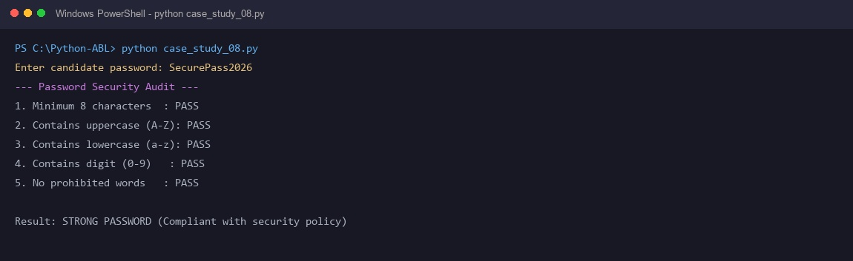
10. Conclusion
The password validation engine implements organizational security rules through character iteration and boolean flags, providing clear diagnostic feedback.

CASE STUDY 9: Student Feedback Sentiment Scoring
1. Problem Statement
Educational course coordinators collect unstructured textual student comments and require an automated sentiment scoring script to count positive and negative keyword occurrences and classify overall feedback polarity.
2. Objectives
• Read student textual feedback comment.
• Normalize text to lowercase and tokenize into individual words.
• Count matches against predefined positive and negative academic keyword vocabularies.
• Compute net sentiment polarity score and classify comment as Positive, Negative, or Neutral.
3. Assumptions
• Feedback string is non-empty.
• Text comparison is case-insensitive.
• Positive keywords: good, great, excellent, clear, helpful, easy, interesting, nice, well.
• Negative keywords: poor, bad, slow, hard, boring, confusing, difficult, worst, hate.
4. Algorithm
Start.
Input student feedback string.
Convert input string to lowercase and split into a list of individual words.
Initialize positive_count = 0 and negative_count = 0.
Iterate through each word in the word list:
- If word matches positive keyword list, increment positive_count.
- If word matches negative keyword list, increment negative_count.
Compute net score = positive_count - negative_count.
Classify polarity: net > 0: Positive, net < 0: Negative, net == 0: Neutral.
Display counts, net sentiment score, and qualitative rating.
Stop.
5. Flowchart
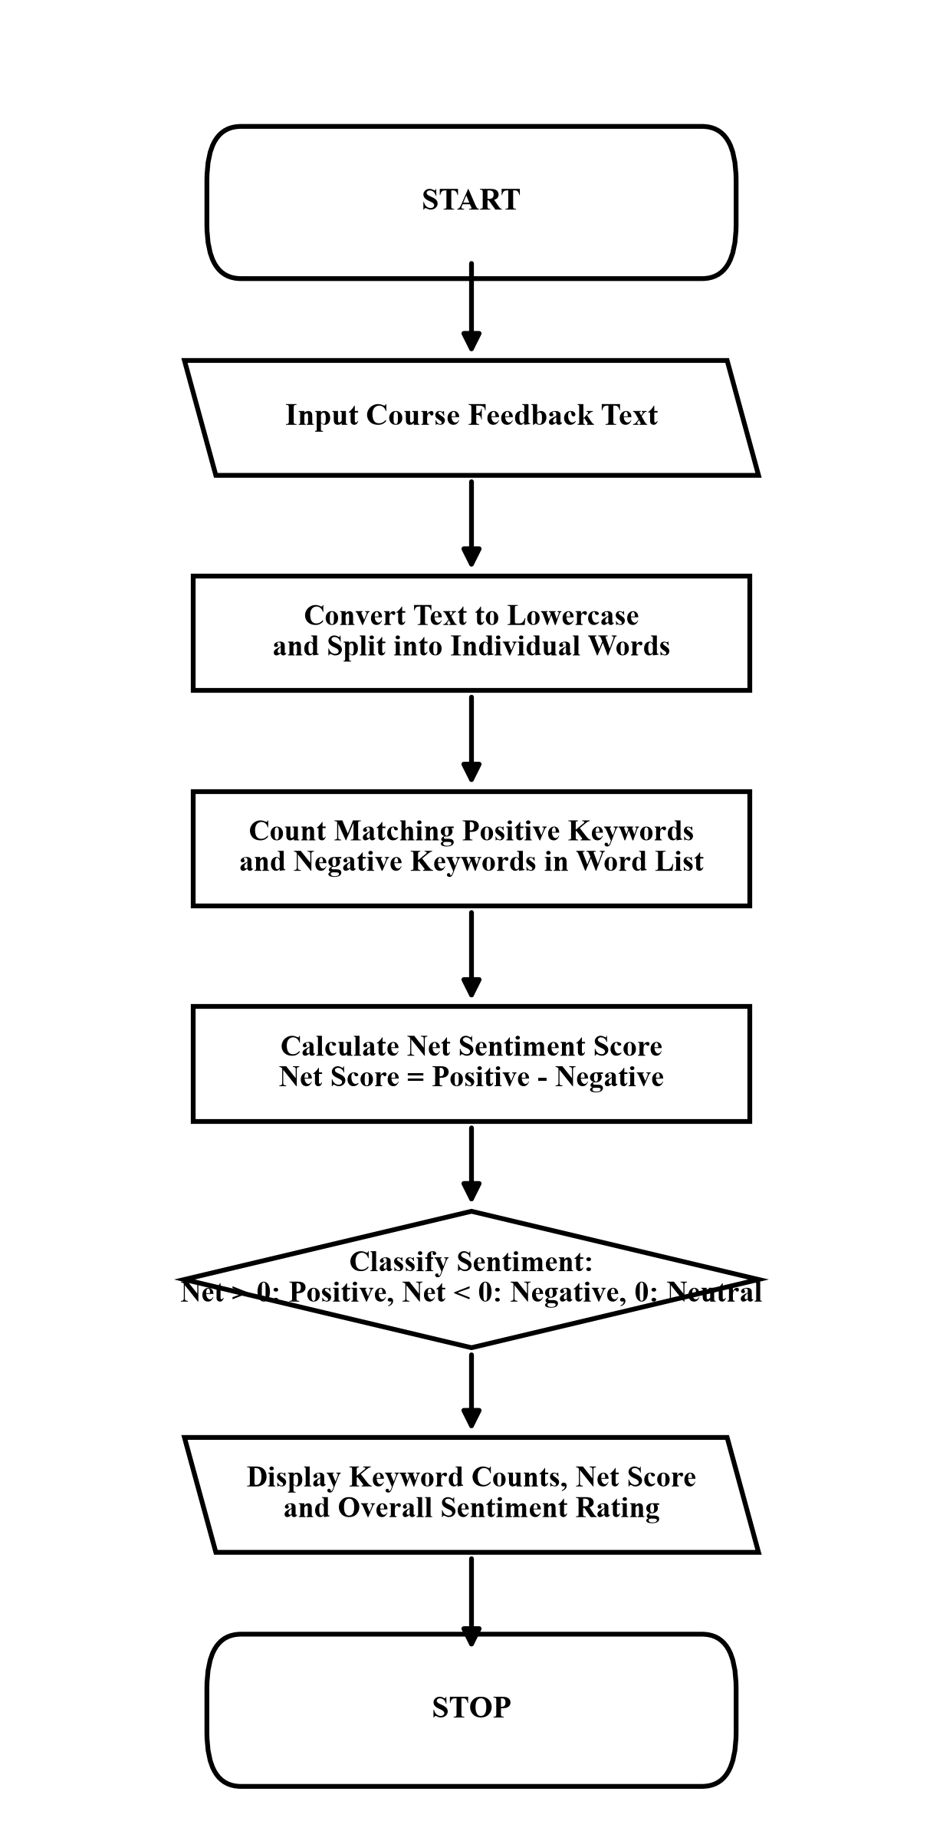

6. Pseudocode
START
INPUT feedback_comment
words = SPLIT(LOWERCASE(feedback_comment))
pos_count = 0, neg_count = 0
FOR EACH word IN words DO
IF word IN positive_list THEN pos_count = pos_count + 1
IF word IN negative_list THEN neg_count = neg_count + 1
END FOR
net_score = pos_count - neg_count
PRINT "Positive words:", pos_count, "Negative words:", neg_count, "Net score:", net_score
IF net_score > 0 THEN
PRINT "Sentiment: POSITIVE FEEDBACK"
ELSE IF net_score < 0 THEN
PRINT "Sentiment: NEGATIVE FEEDBACK"
ELSE
PRINT "Sentiment: NEUTRAL FEEDBACK"
END IF
STOP
7. Python Source Code (case_study_09.py)
# Case Study 34: Student Feedback Sentiment Scoring
student_feedback = input("Enter course feedback comment: ").lower()
positive_keywords = ["good", "great", "excellent", "clear", "helpful", "easy", "interesting", "nice", "well"]
negative_keywords = ["poor", "bad", "slow", "hard", "boring", "confusing", "difficult", "worst", "hate"]
positive_word_count = 0
negative_word_count = 0
for word in positive_keywords:
if word in student_feedback:
positive_word_count = positive_word_count + 1
for word in negative_keywords:
if word in student_feedback:
negative_word_count = negative_word_count + 1
net_sentiment_score = positive_word_count - negative_word_count
print("\n--- Feedback Sentiment Analysis ---")
print("Positive indicators found:", positive_word_count)
print("Negative indicators found:", negative_word_count)
print("Net sentiment score :", net_sentiment_score)
if net_sentiment_score > 0:
print("Classification : POSITIVE FEEDBACK")
elif net_sentiment_score < 0:
print("Classification : NEGATIVE FEEDBACK")
else:
print("Classification : NEUTRAL FEEDBACK")
8. Test Cases
Input / Situation | Expected Result | Purpose
The teacher was good and helpful but the lab was difficult | Positive: 2, Negative: 1, Net: 1 -> POSITIVE FEEDBACK | Mixed sentiment comment resolution
Lectures were slow and confusing with hard assignments | Positive: 0, Negative: 3, Net: -3 -> NEGATIVE FEEDBACK | Predominantly negative review detection
Class is okay | Positive: 0, Negative: 0, Net: 0 -> NEUTRAL FEEDBACK | Neutral unlisted vocabulary evaluation
9. Output screenshots
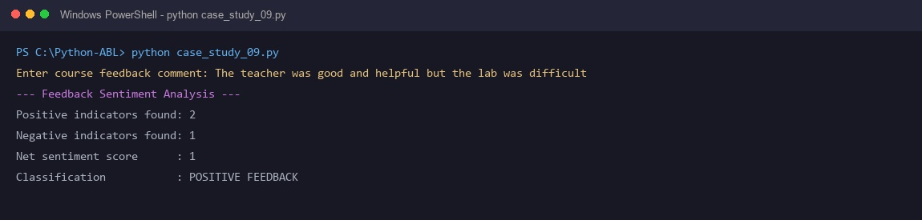
10. Conclusion
The student feedback sentiment scoring engine processes qualitative comments into quantitative metrics, classifying educational feedback polarity effectively.

CASE STUDY 10: Multi-Stage Examination Eligibility System
1. Problem Statement
University examination cell controllers must verify student academic credentials across multiple sequential criteria (attendance threshold, continuous internal evaluation marks, laboratory coursework completion, and institutional fee clearance) before granting semester examination hall tickets.
2. Objectives
• Read student name, attendance percentage, internal marks, lab status, and fee clearance status.
• Validate numerical input bounds for attendance (0-100%) and internal marks (0-50).
• Verify attendance threshold (minimum 75.0%).
• Verify internal assessment threshold (minimum 20.0 out of 50).
• Verify qualitative criteria: completed lab records and cleared institutional dues.
3. Assumptions
• Attendance percentage is between 0.0 and 100.0.
• Internal assessment score is between 0.0 and 50.0.
• Qualitative criteria (lab record and fee dues) are answered with 'yes' or 'no'.
4. Algorithm
Start.
Input student name, attendance percentage, internal marks, lab status, and fee status.
Validate that attendance is within 0-100% and internal marks within 0-50.
Initialize eligibility flag to True.
If attendance < 75.0%, flag as False and record attendance deficiency.
If internal marks < 20.0, flag as False and record internal marks deficiency.
If lab record is not 'yes', flag as False and record incomplete lab record deficiency.
If fees clearance is not 'yes', flag as False and record pending fees deficiency.
If all criteria evaluate to True, issue hall ticket; otherwise display specific deficiency list.
Stop.
5. Flowchart
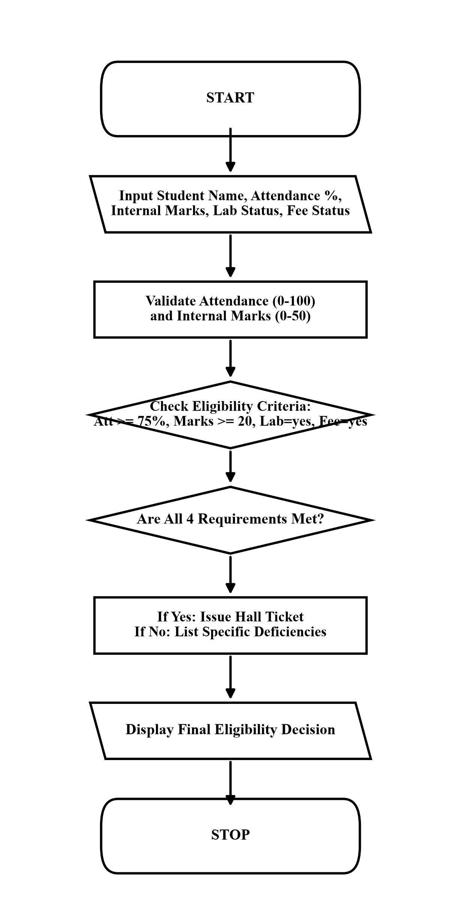

6. Pseudocode
START
INPUT name, attendance, marks, lab_done, fees_paid
IF attendance < 0 OR attendance > 100 OR marks < 0 OR marks > 50 THEN
PRINT "Invalid input values"
ELSE
eligible = TRUE
IF attendance < 75.0 THEN
eligible = FALSE
PRINT "Deficiency: Attendance below 75%"
END IF
IF marks < 20.0 THEN
eligible = FALSE
PRINT "Deficiency: Internal marks below 20/50"
END IF
IF lab_done != "yes" THEN
eligible = FALSE
PRINT "Deficiency: Lab record incomplete"
END IF
IF fees_paid != "yes" THEN
eligible = FALSE
PRINT "Deficiency: College fees pending"
END IF
IF eligible THEN
PRINT "ELIGIBLE FOR EXAMINATIONS: Hall ticket issued"
ELSE
PRINT "NOT ELIGIBLE FOR EXAMINATIONS"
END IF
END IF
STOP
7. Python Source Code (case_study_10.py)
# Case Study 39: Multi-Stage Examination Eligibility System
student_name = input("Student name: ")
attendance_percentage = float(input("Attendance percentage (%): "))
internal_marks = float(input("Internal marks (out of 50): "))
is_lab_record_completed = input("Is lab record completed? (yes/no): ").strip().lower()
is_college_fee_cleared = input("Are college fees cleared? (yes/no): ").strip().lower()
lab_ok = (is_lab_record_completed == "yes" or is_lab_record_completed == "y")
fee_ok = (is_college_fee_cleared == "yes" or is_college_fee_cleared == "y")
print("\n--- Exam Eligibility Result ---")
print("Student:", student_name)
if attendance_percentage >= 75.0 and internal_marks >= 20.0 and lab_ok and fee_ok:
print("Status: ELIGIBLE FOR EXAMINATIONS (Hall ticket issued)")
else:
print("Status: NOT ELIGIBLE (Hall ticket withheld)")
print("Reasons for ineligibility:")
if attendance_percentage < 75.0:
print(" - Attendance is below 75%")
if internal_marks < 20.0:
print(" - Internal marks below passing score (20/50)")
if not lab_ok:
print(" - Lab record incomplete")
if not fee_ok:
print(" - College fees pending")
8. Test Cases
Input / Situation | Expected Result | Purpose
Yashwanth, Att: 82.5%, Int: 38/50, Lab: yes, Fees: yes | Status: ELIGIBLE FOR EXAMINATIONS (Hall ticket issued) | Fully satisfied eligibility profile
Pooja, Att: 65.0%, Int: 42/50, Lab: yes, Fees: yes | Status: NOT ELIGIBLE -> Reason: Attendance is below 75% | Single deficiency failure check
Karthik, Att: 78.0%, Int: 16/50, Lab: no, Fees: yes | Status: NOT ELIGIBLE -> Reasons: Marks below 20/50, Lab incomplete | Multiple deficiencies failure check
9. Output screenshots
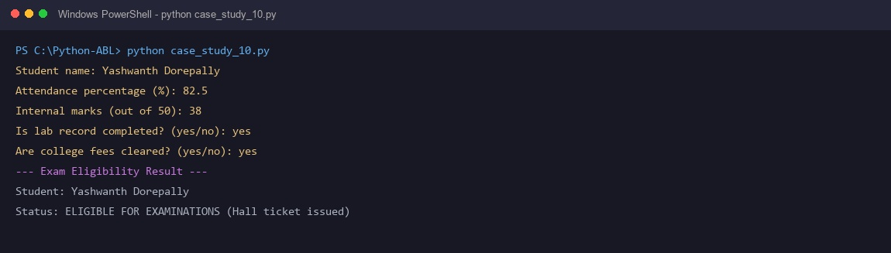
10. Conclusion
The examination eligibility system automates academic evaluation through compound conditional verification, providing transparent reasons for eligibility decisions.

