Unit Test Report

**Unit**: Register New User

**Source File**: /hospital/hms/register.php

**Date**: October 30, 2023

**Engineers**: Sai Mukthive, Srikanth Guttikonda, Goutham Bommu, Sai Gunturu

**Automated Test Code:**

*<?php*

*function register_user($con, $full_name, $address, $city, $gender, $email, $password) {*

*$hashed_password = md5($password);*

*$query = $con->query("INSERT INTO users(fullname, address, city, gender, email, password) VALUES('$full_name', '$address', '$city', '$gender', '$email', '$hashed_password')");*

*if ($query) {*

*return "Successfully Registered. You can login now";*

*} else {*

*return "Registration failed.";*

*}*

*}*

*use PHPUnit\Framework\TestCase;*

*class RegisterUserTest extends TestCase*

*{*

*private $db_conn_mock;*

*protected function setUp(): void*

*{*

*// Mock the mysqli object*

*$this->db_conn_mock = $this->getMockBuilder(mysqli::class)*

*->disableOriginalConstructor()*

*->getMock();*

*}*

*public function testRegisterUser()*

*{*

*// Mock the mysqli_query method to simulate successful registration*

*$this->db_conn_mock->expects($this->once())*

*->method('query')*

*->willReturn(true);*

*$message = register_user($this->db_conn_mock, "John Doe", "123 Main St", "Springfield", "Male", "john.doe@example.com", "password123");*

*$this->assertEquals("Successfully Registered. You can login now", $message);*

*echo("Test 1: User added successfully \n");*

*}*

*public function testUnsuccessfulRegisterUser()*

*{*

*// Mock the mysqli_query method to simulate successful registration*

*$this->db_conn_mock->expects($this->once())*

*->method('query')*

*->willReturn(false);*

*$message = register_user($this->db_conn_mock, "John Doe", "123 Main St", "Springfield", "Male", "john.doe@example.com", "password123");*

*$this->assertEquals("Registration failed.", $message);*

*echo("Test 2: Error adding user \n");*

*}*

*}*

*?>*

**Inputs:**

Database Connection: Mocked MySQli connection

User Details: Full Name, Address, City, Gender, Email, Password

**Expected Outputs:**

**a) Successful registration:**

Message: "Successfully Registered. You can login now."

**b) Unsuccessful registration:**

Message: "Registration failed."

**Actual Outputs:**

After executing the test, the function returned the expected message based on the success or failure of the user registration.

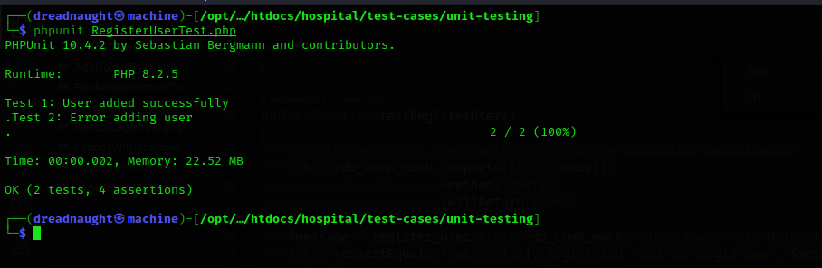

**Test Methodology:**

**Method:**

Mocking and Unit Testing.

**Description:**

The register_user function adds a new user's details to the system and provide a feedback message reflecting the success or failure of the registration process. To facilitate testing, the MySQLi connection was mocked.

The test case verifies the function's ability to register a user successfully and, in turn, generate the expected success message. Mocking is pivotal in isolating the function from external dependencies, guaranteeing that any anomalies detected during testing are purely attributable to the function's internal logic and not from external factors.