**Project Description**

APSCHE SMARTINTERNZ INTERNSHIP PROJECT

FRONTEND DEVELOPMENT

College: Aditya College of Engineering

Project Title: Todo App

Team Id: LTVIP2023TMID04194

Faculty Mentor(s) Name: Kotikalapudi Chandra Sekhar

**Team:**

|  |  |
| --- | --- |
| Roll Number | Name |
| 20MH1A04E3(TL) | Gurram Balaji |
| 20MH1A04E4 | Guttula Venkanna Babu |
| 20MH1A04F3 | Kodavati Sai Sandeep |
| 20MH1A04G6 | Naradasu Durga Babu |

**Course:** B.Tech

**Branch**: Eletronics And Communication Engineering

**Category:**Front End Developer

**Skills Required:**

HTML,

CSS,

Bootstrap

**Project Description:**

The Todo App is a web application that allows users to create and manage their daily tasks or to-do lists. Users can add new tasks, mark tasks as completed, and delete tasks. The app provides a user-friendly interface and uses JavaScript, HTML, CSS, and Bootstrap for its implementation.

**Technical Architecture:**

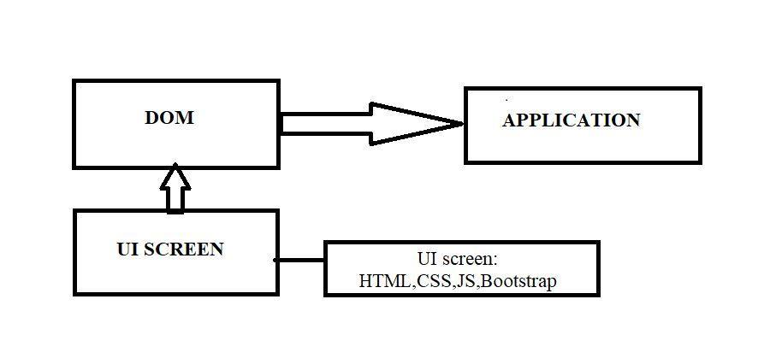

**Project Objectives:**

By the end of this project, you will:

1. Create a responsive and interactive user interface using HTML, CSS, and Bootstrap.

2. Implement functionality to add, complete, and delete tasks using JavaScript.

3. Provide filtering options to view tasks based on their status.