Clearly define a problem or an idea of your choice, where you would need to leverage the Foursquare location data to solve or execute. Remember that data science problems always target an audience and are meant to help a group of stakeholders solve a problem, so make sure that you explicitly describe your audience and why they would care about your problem.

This submission will eventually become your **Introduction/Business Problem** section in your final report. So I recommend that you push the report (having your Introduction/Business Problem section only for now) to your Github repository and submit a link to it.

1. **Introduction**

To open a restaurant, location is the No.1 question to ask. It is even more important to open a Chinese restaurant in the Los Andreas area, where the ethical demography is broadly spreading-out in the Northwestern suburban.

Location is important for a simple reason, reducing the fatality risk. The restaurant business has a high failure rate. Around 60 percent of new restaurants failed within the first year. And nearly 80 percent closed door before their fifth anniversary.

We need to identify the best location where optimized conditions exist to sustain a healthy business. There are many factors to consider, such as sufficient parking space, accessibility, visibility, etc…In this study, to gain perspective into the location choice, we will focus on only two metrics we think effect most:

* Ethical Population: There shall be a plural Chines-Americans living in the nearby communities to maintain the foot traffics.
* Competition: There shall not be too many niche restaurants operating in the same area, so generate enough revenue to offset fixed cost and realize sizable profit.

1. **Business Problem**

We are commisioned to identify the best location to open a Chinese restaurant in the Los Angeles area. The community shall have a high Chinese American population, and the Chinese cuisine establishment competition is modulated. Let us look into those two areas in more details.

**2.1 Chinese-American populations in Los Angeles Area**

LA is one of the three [metropolitan areas](https://en.wikipedia.org/wiki/Metropolitan_Statistical_Area) with the largest Chinese-American populations, according to the recent Census estimates.

The [Greater New York](https://en.wikipedia.org/wiki/New_York_metropolitan_area) [Combined Statistical Area](https://en.wikipedia.org/wiki/Combined_Statistical_Area) has 735,019 Chinese-American people, the [San Jose-San Francisco-Oakland](https://en.wikipedia.org/wiki/San_Francisco_Bay_Area) Combined Statistical Area has 629,243 Chinese-American people, and the [Greater Los Angeles](https://en.wikipedia.org/wiki/Greater_Los_Angeles_area) Combined Statistical Area has about 566,968 Chinese-American people. In the post-1965 era, first- and second-generation immigrants include those from [Mainland China](https://en.wikipedia.org/wiki/Mainland_China), [Hong Kong](https://en.wikipedia.org/wiki/Hong_Kong), [Macau](https://en.wikipedia.org/wiki/Macau), and [Taiwan](https://en.wikipedia.org/wiki/Taiwan). Also included in the Chinese-American population enumeration are [ethnic Chinese from Malaysia](https://en.wikipedia.org/wiki/Malaysian_Chinese) and [Vietnam](https://en.wikipedia.org/wiki/Hoa_people) who might identify themselves as Chinese.

The Los Angeles County city of [Acadia](https://en.wikipedia.org/wiki/Monterey_Park,_California), with 26,229 Chinese American, has the highest percentage of Chinese-Americans of any municipality, at 45.6% of its total population. The [San Gabriel Valley](https://en.wikipedia.org/wiki/San_Gabriel_Valley) region of [Los Angeles County](https://en.wikipedia.org/wiki/Los_Angeles_County) is the single largest concentration of combined Chinese and Taiwanese Americans in the country, having a collections of U.S. suburbs with large foreign-born Chinese-speaking populations, ranging from working-class individuals residing in [Rosemead](https://en.wikipedia.org/wiki/Rosemead,_CA) and [El Monte](https://en.wikipedia.org/wiki/El_Monte,_CA) to wealthier immigrants living in [Arcadia](https://en.wikipedia.org/wiki/Arcadia,_CA), [San Marino](https://en.wikipedia.org/wiki/San_Marino,_CA), and [Diamond Bar](https://en.wikipedia.org/wiki/Diamond_Bar,_CA), reflecting their general affluence and propensity for [professional](https://en.wikipedia.org/wiki/Professional) occupations.

The majority of the Chinese-American population of more than 400,000 in [Los Angeles County](https://en.wikipedia.org/wiki/Los_Angeles_County) lives within the [San Gabriel Valley](https://en.wikipedia.org/wiki/San_Gabriel_Valley), which is particularly noted for cities that have a large Chinese-American ethnic plurality. The following cities have the highest percentage of Chinese-Americans in [Greater Los Angeles](https://en.wikipedia.org/wiki/Greater_Los_Angeles_Area). Those cities are the potential candidates to launch a Chinese restaurant business.

*Table 1: Chinese-American Population by Municity in LA*

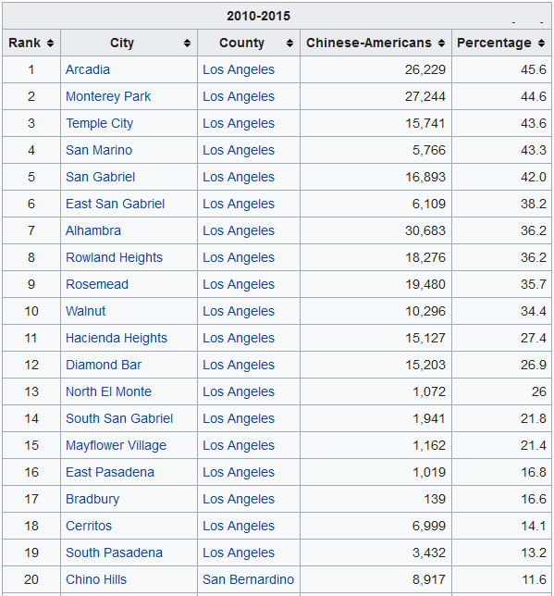

**2.2 Chinese Restauran Business in Los Angeles Area**

The Chinese Restauran Business in Los Angeles Area can be characterized in the following two ways: (1). More variety of Chinese dishes are served among fiece competition; (2). Upscale new restaurants established recently to attrace the new affluent generation of Chinese Americans as well as non-Chinese ethical clients.

**Variety:** Los Angeles, with one of the largest ethical Chinese populations outside Asia, is widely regarded as an epicenter for Chinese cuisine. Although the best Chinese restaurants are mostly concentrated in the ethnic enclaves of the San Gabriel Valley, there are increasingly more in neighborhoods throughout L.A., from historic Chinatown to the Westside.

Los Angeles has the most diverse population of Chinese, which makes all the difference in the dining scene. With the one-menu-feed-all style Chinese restaturants still going strong, newly established Chinese restaurants are more focusing on the differentiations. The Los Angeles Chinese food scene is incredibly diverse. Of the 34 official provincial-level administrative units in China, 21 of them are represented in restaurants in the greater Los Angeles area. Some offers the foods mainly found in the north of China with tons of wheat, while others serve Southerners mainly with rice. One can find not only the spicy food in Chinese southwest oriented restaurant, but also the moderated tastes only slightly using chili pepper.

**Upscale**: For a very long time the Chinese food in America is the synonymous of cheap food with fried noodles and sticky-sweet meat nuggets. People thought the Chinese food is quick and greasy, and shouldn’t cost very much. Not any more. The new generation of Asian American chefs in California today are challenging the long-standing styrotype, and coming up with new looks and new tastes, as a result, new value. Other than the famous P F Chang, many upscale and fancy Chinese restaurants are established. Actually, the No.1 ranked Chinese resaturant in the US is Chengdu Taste, as expected, located in LA. The evolution is not only limited to the food itself, but also other elements typically absent from traditional Chinese restaurants — tasting menus, emphasis on service, luxe decor, innovative cocktail menus and wine pairings — all are showing up in the upscale Chinese restaurants. This new shift can be found in the LA downtown as well as the San Gabriel Valley westward. The change is not a simply Western focus, but more about the future of the Chinese cuisine. This young generation of chefs is combining childhood nostalgia with professional culinary chops, local ingredients and fine dining mores. Those new upscale Chinese restaurants propel the perception and acceptance of Chinese cooking into new directions and into new neighborhoods, generating new markets.

As we can tell from above discussion, Chinese Restaurants are facing firece competitions. To gain an edge, one have to differnciate. The business owners are innovating to break the mold to survice and make a profit. Location selection becoming more important to alleviate the risks.