**Молдавский государственный университет**

**Факультет математики и информатики**

**Департамент Информатики**

**УПРАЖНЕНИЕ 1**

**Возведение в степень по модулю,**

**Нахождение обратного по модулю,**

**Операции сложения и умножения в поле Галуа**

**Выполнил**: Гуцу Даниил.

**Группа:** IA2102

**Проверила:** др.,Чербу О.

Кишинев, 2023

**КИШИНЕВ – 2023**

# Алгоритм Exponentierea modulară

**Algoritmul:**

z=1;

**for** i =s-1 **downto** 0 **do**

z= z2 **mod** n

**if** ci =1 **then** z=z*x **mod** n

**[Prelegerea 10 RSA] pag 3**

## **Exemplul practic:**

2311^1571mod 2501= 152

**c** = 1571

**x** = 2311

**n** = 2501

(1571)10 = (11000100011)2 = Ci

|  |  |  |
| --- | --- | --- |
| i | ci | Z=1 |
| 10 | **1** | **z= z2 mod n** = 12 mod 2501=1 * 2311 mod 2501 = **2311** |
| 9 | **1** | **z= z2 mod n** = 23112 mod 2501 = 1086 * 2311 mod 2501 = **1243** |
| 8 | **0** | **z= z2 mod n** = 12432 mod 2501 = **1932** |
| 7 | 0 | **z= z2 mod n** 19322 mod 2501 = **1132** |
| 6 | 0 | **z= z2 mod n** 11322 mod 2501 = **912** |
| 5 | 1 | **z= z2 mod n** 9122 mod 2501 = 1412 * 2311 mod 2501 = **1828** |
| 4 | 0 | **z= z2 mod n** 18282 mod 2501 = **248** |
| 3 | 0 | **z= z2 mod n** 2482 mod 2501 = **1480** |
| 2 | 0 | **z= z2 mod n** 14802 mod 2501 = **2025** |
| 1 | 1 | **z= z2 mod n** 20252 mod 2501 = 1486 * 2311 mod 2501 = **273** |
| 0 | 1 | **z= z2 mod n** 2732 mod 2501 = 2000 * 2311 mod 2501 = **152** |

## Код программы:

import java.util.Scanner;  
  
  
public class BigPow {  
  
 public static void main(String[] args) {  
 System.*out*.println("Grad mare cu modulo");  
 System.*out*.println("a ^ k mod n (unde k - numar mare)");  
 System.*out*.println("Introduce a k n: ");  
  
 long a = *readLong*();  
 long k = *readLong*();  
 long n = *readLong*();  
  
 System.*out*.println("Resultat: " + *pow_mod*(a, k, n));  
 }  
  
 */** a ^ k mod n */* public static long pow_mod(long a, long k, long n) {  
 long b = 1;  
 while (k > 0) {  
 if (k % 2 == 0) {  
 k /= 2;  
 a = (a * a) % n;  
 } else {  
 k--;  
 b = (b * a) % n;  
 }  
 System.*out*.println(b);  
 }  
 return b;  
 }  
  
 public static long readLong() {  
 return new Scanner(System.*in*).nextLong();  
 }  
}

### Вывод программы:

Grad mare cu modulo

a ^ k mod n (unde k - numar mare)

Introduce a k n:

2311

1571

2501

Resultat: 152

# **Algoritmul extins Euclid.**

## **Algoritmul utilizat pentru calculul inversei unui numar mare modulo (b^(-1)mod n)**

## **Exemplul practic nr. 1:**

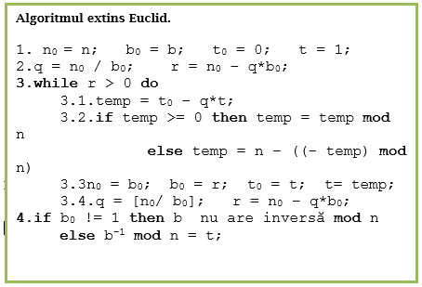

|  |  |  |  |  |  |  |  |
| --- | --- | --- | --- | --- | --- | --- | --- |
|  | n0 | b0 | q | r | t0 | t | temp |
| 1 | 2699 | 1777 | 1 | 922 | 0 | 1 | 2698 |
| 2 | 5177 | 922 | 2 | 855 | 1 | 2698 | 2 |
| 3 | 922 | 855 | 1 | 67 | 2698 | 2 | 2696 |
| 4 | 855 | 67 | 12 | 51 | 2 | 2696 | 38 |
| 5 | 67 | 51 | 1 | 16 | 2696 | 38 | 2658 |
| 6 | 51 | 16 | 3 | 3 | 38 | 2658 | 161 |
| 7 | 16 | 3 | 5 | 1 | 2658 | 161 | **1853** |
| 8 | 3 | 1 | 3 | 0 | 161 | 1853 |  |

## Код программы:

import java.io.BufferedReader;  
import java.io.IOException;  
import java.io.InputStreamReader;  
  
public class AvMinus1ModP {  
 public static void main(String[] args) {  
 int b = 0, n = 0, n0 = 0, b0 = 0, q = 0, r = 1, t0 = 0, t = 0, temp = 0;  
  
 System.*out*.println(" b^-1 mod n ");  
 System.*out*.print("Introduce b (-1): ");  
 BufferedReader b1 = new BufferedReader(new InputStreamReader(System.*in*));  
 String inp = "";  
 try {  
 inp = b1.readLine();  
 } catch (IOException e) {  
  
 }  
  
 if (inp.equals("")) {  
 System.*out*.println("Nu era introdus nimic.");  
 System.*exit*(0);  
 }  
  
 b = Integer.*parseInt*(inp);  
  
 System.*out*.print("Introduce n: ");  
 try {  
 inp = b1.readLine();  
 } catch (IOException e) {  
  
 }  
  
 if (inp.equals("")) {  
 System.*out*.println("Nu era introdus nimic.");  
 System.*exit*(0);  
 }  
  
 n = Integer.*parseInt*(inp);  
  
 if (b <= 1 || n <= 0) {  
 System.*out*.println("b si n trebuie sa fie mai mari decit 0.");  
 System.*exit*(0);  
 }  
  
 // ################################################  
  
 System.*out*.println("b = " + Integer.*toString*(b) + ", n = "  
 + Integer.*toString*(n) + "\n");  
  
 n0 = n;  
 b0 = b;  
 t0 = 0;  
 t = 1;  
 q = n0 / b0;  
 r = n0 - (q * b0);  
  
 System.*out*.println("n0\tb0\tq\tr\tt0\tt\ttemp\n");  
  
 while (r > 0) {  
 temp = t0 - q * t;  
 if (temp >= 0)  
 temp = temp % n;  
 else  
 temp = n - ((-temp) % n);  
  
 System.*out*.println(n0 + "\t" + b0 + "\t" + q + "\t" + r + "\t" + t0  
 + "\t" + t + "\t" + temp);  
  
 n0 = b0;  
 b0 = r;  
 t0 = t;  
 t = temp;  
 q = n0 / b0;  
 r = n0 - (q * b0);  
 }  
 System.*out*.println(n0 + "\t" + b0 + "\t" + q + "\t" + r + "\t" + t0  
 + "\t" + t);  
 if (b0 != 1)  
 System.*out*.println("b nu are mod n");  
 else  
 System.*out*.println("Raspuns: " + t);  
 }  
}

## Вывод программы:

Introduce b (-1): 1777

Introduce n: 2699

b = 1777, n = 2699

n0 b0 q r t0 t temp

2699 1777 1 922 0 1 2698

1777 922 1 855 1 2698 2

922 855 1 67 2698 2 2696

855 67 12 51 2 2696 38

67 51 1 16 2696 38 2658

51 16 3 3 38 2658 161

16 3 5 1 2658 161 1853

3 1 3 0 161 1853

Raspuns: 1853

# Операции в поле Галуа

## Теоретическая часть

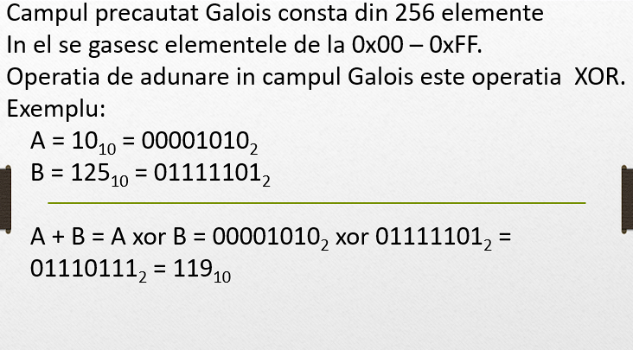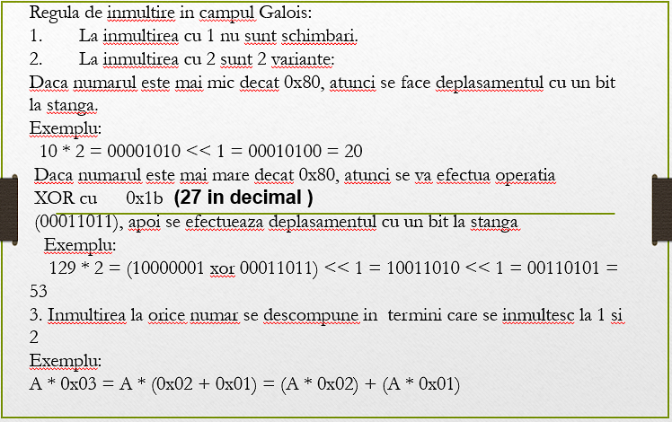

## Код программы:

import java.util.InputMismatchException;  
import java.util.Scanner;  
  
public class GaloisField {  
 public static void main(String[] args) {  
 Scanner scanner = new Scanner(System.*in*);  
 try {  
 System.*out*.println("Enter two numbers: ");  
 int a = scanner.nextInt();  
 int b = scanner.nextInt();  
 System.*out*.println("a add b = " + *add*(a, b));  
 System.*out*.println("Double of 10 = " + *doubleValue*(10));  
 System.*out*.println("a multiply b = " + *multiply*(a, b));  
 } catch (InputMismatchException e) {  
 System.*out*.println("Invalid input. Please enter integers only.");  
 }  
 }  
  
 public static int add(int a, int b) {  
 return (a ^ b) & 0xFF;  
 }  
  
 public static int multiply(int a, int b) {  
 int result = (b & 1) == 1 ? a : 0;  
 while (b > 1) {  
 a = *doubleValue*(a);  
 b >>= 1;  
 result = ((b & 1) == 1) ? *add*(a, result) : result;  
 }  
 return result;  
 }  
  
 private static int doubleValue(int a) {  
 return (a < 0x80) ? (a << 1) : *add*((a << 1), 0x1b) ^ 1;  
 }  
}

## Вывод программы:

Enter two numbers:

23

129

a add b = 150

Double of 10 = 20

a multiply b = 105