**CS410 FALL 2023 PROJECT Progress Report “Textual Spotlight”**

**Team Members:** Hermann Rosch, Sudeshna Pal, Ahmad Barqawitz   
**Team Captain:** Hermann Rosch   
**Team Name:** Insightful Highlighters   
**Project Name:** Textual Spotlight

**Introduction**

"Textual Spotlight" is a Chrome extension tailored for contextual text understanding using various LLMs/AI models. Even though it was originally planned with a Python backend for text processing, the project pivoted to utilize the Intelli Node backend for AI model requests and interactions; this shift has streamlined the development process, focusing on core functionalities of text processing and evaluation directly within the Chrome extension.

**1) Completed Tasks**

* **Chrome Extension Development:**
  + Developed the core components: background.js, contentScript.js, popup.html, popup.js, and popup.css.
  + Functionality includes user text selection on web pages and interaction with a popup that displays the selected text and offers different AI model options (OpenAI, Meta, Cohere) for text processing actions.
  + Built functions to interact with the Intelli Node backend for AI model responses.
  + Designed a simple UI for selecting AI models and executing actions like **Explain**, **Summarize**, and **Paraphrase**.

Below are some pictures of the current Textual Spotlight extension; it showcases highlighting a piece of text from the Wikipedia Chess article and then getting an "explanation" from the OpenAI GPT-4 model: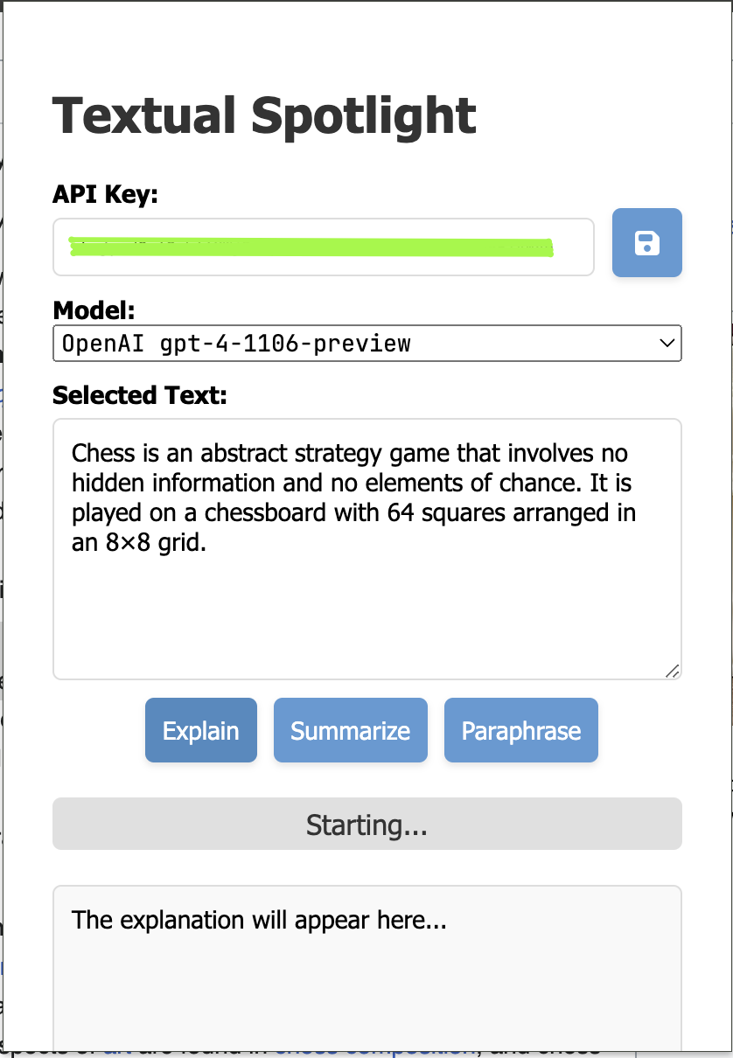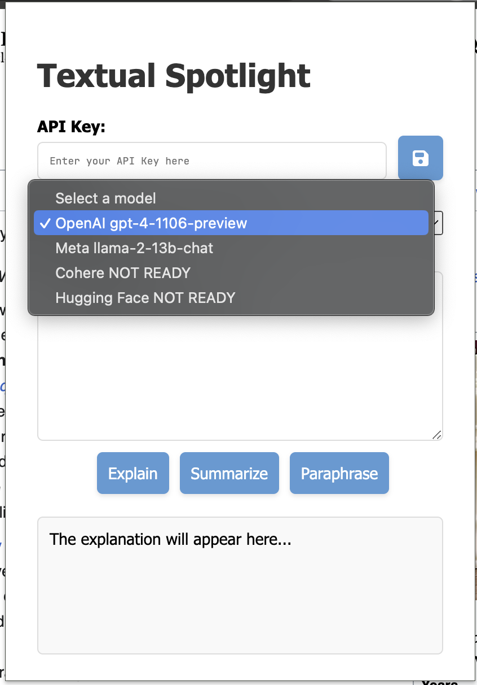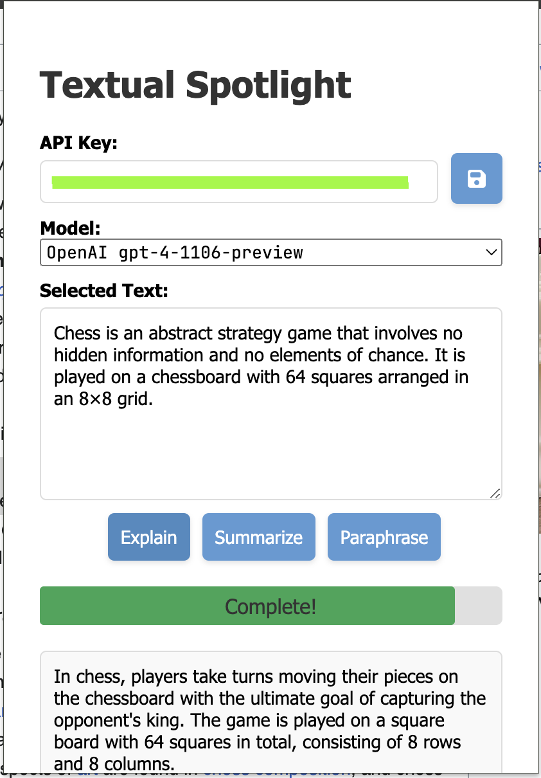

**2) Pending Tasks**

* **VSM and Cosine Similarity Implementation:**
  + Embed the ***Vector Space Model (VSM)*** and ***Cosine Similarity*** in popup.js to compare user-selected text with AI model responses semantically; this is the main feature of the extension, aimed at providing users with a clear understanding of how the AI model's response relates to their selected text in terms of semantic similarity.
  + The implementation involves breaking down the selected text and AI response into vectors and computing similarity scores, which will be displayed alongside the AI response for user reference.
* **Additional Feature Development:**
  + **Semantic Search Feature (*Potential Improvement*):** Intended to allow users to input a query and find semantically related segments in highlighted text using cosine similarity; this feature is considered a *potential enhancement* to the main usage of the extension and may be implemented based on development progress and feasibility.
* **User Interface and User Experience Improvements:**
  + Aim to refine the UI/UX, focusing on intuitive interaction and seamless experience after adding the new features.
* **Testing and Documentation:**
  + Comprehensive testing with various web articles text and different edge cases of user scenarios is planned. We are also updating documentation to reflect the current functionalities and usage of the extension accurately.

**3) Challenges Faced**

* **Algorithm Integration:**
  + Integrating VSM and Cosine Similarity in a browser extension has been challenging, particularly in maintaining the extension's responsiveness and ensuring the accuracy of text analysis.
  + The complexity lies in processing and vectorizing text within the constraints of a browser extension while delivering real-time feedback.
* **User-Centric Design:**
  + Striving to develop additional features like ***Semantic Search***without overloading the extension or complicating the user experience.

**4) Future Work to complete before Project Deadline:**

* Implement ***VSM*** and ***Cosine Similarity*** as soon as possible to provide insightful AI model interactions because the subsequent features build upon VSM.
* After successfully implementing *VSM* and *Cosine Similarity*, if time and resources permit, we plan to explore the development and integration of the ***Semantic Search***feature as a possible enhancement for the Chrome extension.
* Finish the testing process with various web article’s text optimization for performance and usability.
* Update the documentation to reflect the extension's new functionalities and final usage accurately.

**END OF “Textual Spotlight” PROJECT PROGRESS REPORT**