Shanqing Gu

*MSDS6390: Assignment_01*

*Due Date: 09/02/2018*

**Assignment 1: Painting Recreation**

Using Processing's 2D primitive functions, recreate a painting by an artist connected to the Bauhaus, Suprematist, or Modernist movements. Please select a painting that you find engaging and be prepared to discuss what you find engaging. Also discuss the re-creation process, including your honest assessment of the experience.

**Painting Recreation Process:**

1. The original paint is from website: <https://assets.saatchiart.com/saatchi/820158/art/3262689/2332576-VSLUHHTS-7.jpg>

The original paint can also be found from website: <https://www.saatchiart.com/art/Collage-Suprematist-Composition-Homage-to-Malevich/820158/3071930/view>

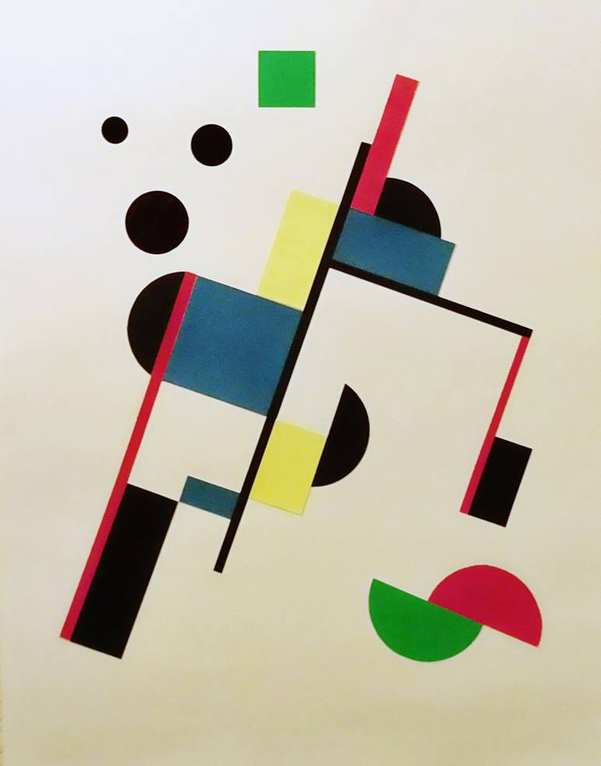

1. Use ImageJ (<https://imagej.nih.gov/ij/>) to measure the object positions after rotation

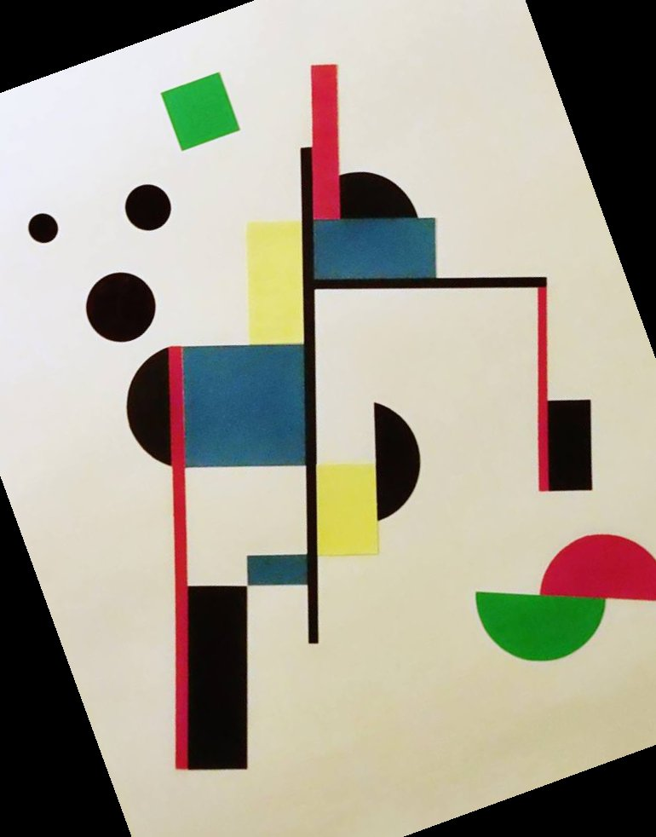

1. Use online tool to get object RGB values (<https://imagecolorpicker.com>)
2. Setup the exact painting size as the original (750, 950)
3. Paint all the objects with the corresponding positions and colors with 2D primitive functions (the green box was drawn in the end because of rotation function).
4. Rotate back the re-created painting to its original orientation.
5. Adjust the painting positions with translate function.

|  |  |
| --- | --- |
| Original Image | Recreated Image |
|  |  |

**The Experience Assessment:**

The rotation of original painting makes the recreation easier, especially for the object position measurement. With the help of color selector and ImageJ, the recreation takes less time than expected. The translate and rotate commands are great to help accomplish this painting recreation. The lesson is one has to be creative for visualization of information.