Uber SQL Questions & Answers
Table Name: uber_requests

1. Total Number of Requests
SELECT COUNT(*) AS total_requests
FROM uber_requests;
Output : 6745

2. Total Completed Trips
SELECT COUNT(*) AS completed_trips
FROM uber_requests
WHERE status='Trip Completed';
Output: 2831

3. Total Cancelled Trips
SELECT COUNT(*) AS cancelled_trips
FROM uber_requests
WHERE status='Cancelled';
Output: 1264

4. Total No Cars Available
SELECT COUNT(*) AS no_cars_available
FROM uber_requests
WHERE status='No Cars Available';
Output: 2650

5. Count Requests by Pickup Point
SELECT pickup_point,
COUNT(*) AS total_requests
FROM uber_requests
GROUP BY pickup_point;
Output: 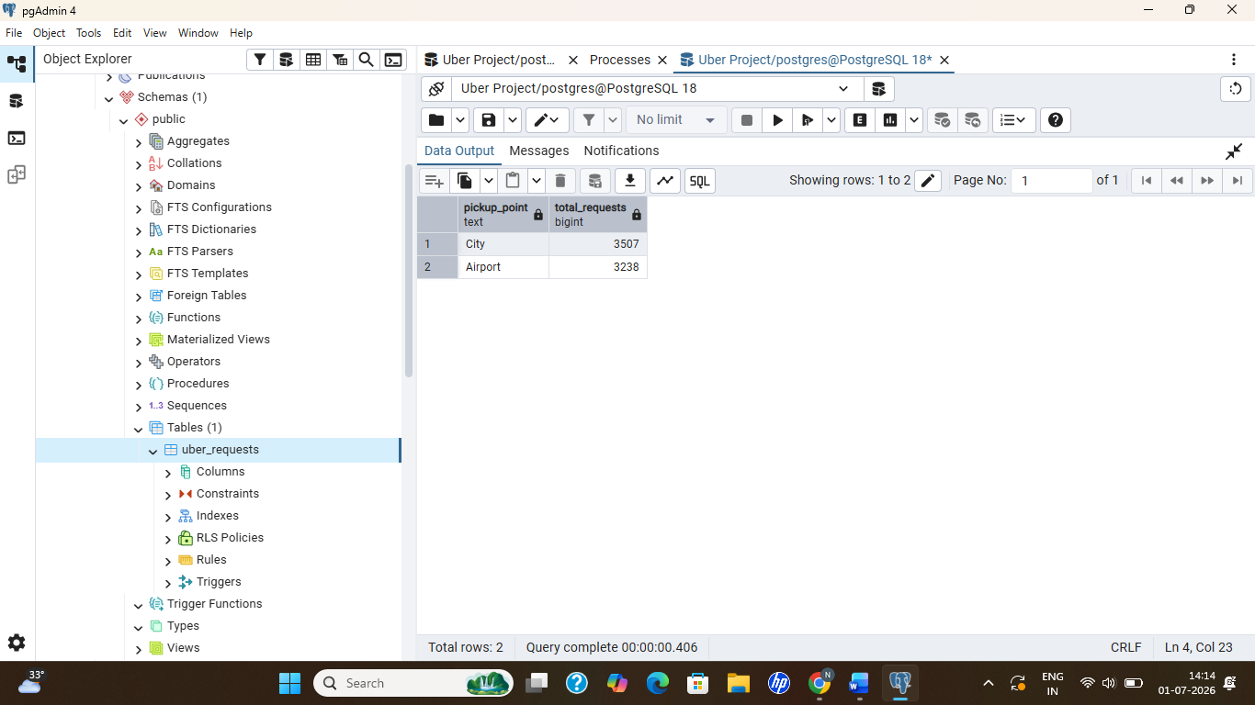

6. Count Requests by Status
SELECT status,
COUNT(*) AS total
FROM uber_requests
GROUP BY status;
Output: 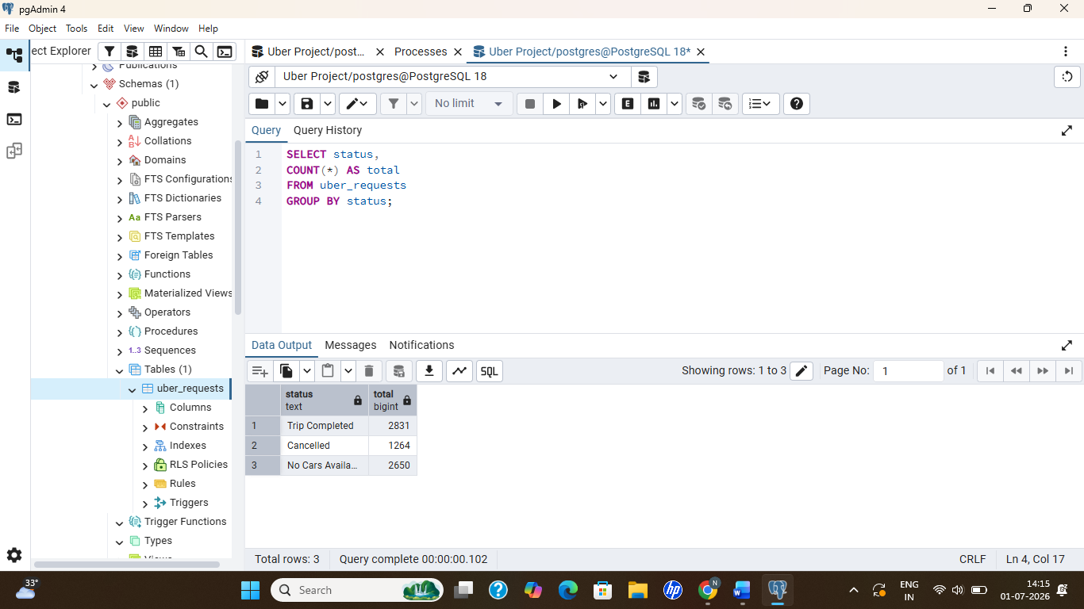

7. Count Requests by Driver
SELECT driver_id,
COUNT(*) AS total_trips
FROM uber_requests
WHERE driver_id<>'NA'
GROUP BY driver_id
ORDER BY total_trips DESC;
Output :
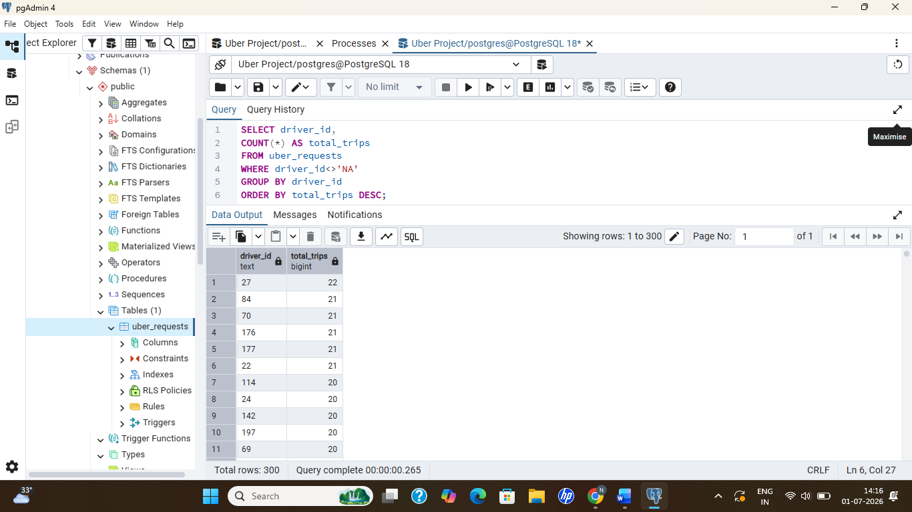

8. Top 10 Drivers
SELECT driver_id,
COUNT(*) AS completed_trips
FROM uber_requests
WHERE status='Trip Completed'
AND driver_id<>'NA'
GROUP BY driver_id
ORDER BY completed_trips DESC
LIMIT 10;
Output: 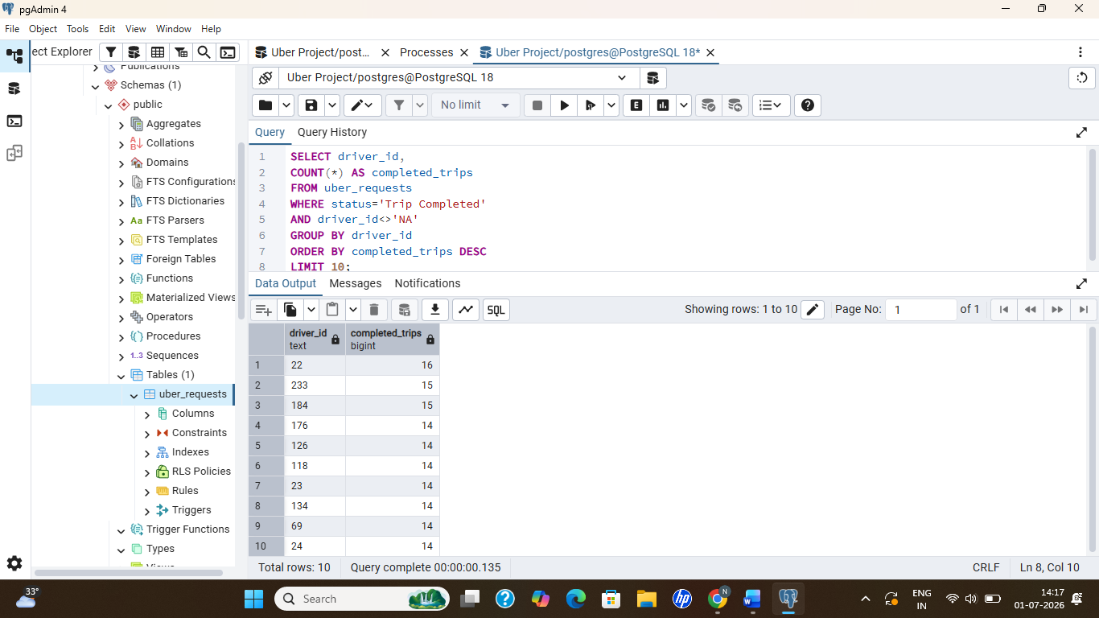

9. Airport Requests
SELECT COUNT(*)
FROM uber_requests
WHERE pickup_point='Airport';
Output: 3238

10. City Requests
SELECT COUNT(*)
FROM uber_requests
WHERE pickup_point='City';
Output: 3507

