实验八 51单片机中断作业2

一、实验目的
请将附件给出的Proteus图用51单片机完成一个用16*16LED显示多组字符串的功能。
1、设置6个字符串（包括纯中文字符串及英文字符串，中文字符串大于4个字符，英文字符串大于8个字符）缓冲区为DISPBUFF[]。
2、用取字模软件取出相应的LED显示的字模。
3、用图中按键实现6个字符串的切换。采用外部中断方式。按键不按时，用51单片机定时中断实现40秒一次切换6个字符串。
4、显示采用左移的方式一列列左移出显示，后面的字符跟着一列列移入。直到所有字符显示完成。停顿一定时间后再从头开始。
按要求上交实验报告（几种字符串的对应Proteus仿真截图一定要有）。

二、实验步骤
1、中断相关设置
本次仿真的中断设置和单片机中断作业1中的中断设置基本相同。需要两个外部中断用于开关中断和一个定时器中断。结合中断控制寄存器IE和外部中断方式选择寄存器TCON的相关结构设置可以得到各位的取值：一个定时器中断，两个外部中断需要将IE中的EA、EX1、ET0、EX0设为1。外部中断选择下降沿触发，所以TCON寄存器中的IT1和IT0都设置为1。故设置初始值如下：
IE = 0x87; 1000 0111.-->开总中断，开中断INT1,T0,INT0
TCON =0x15;0001 0101-->中断INT0和INT1选择下降沿触发，定时器T0启动工作。
由于51单片机不能一下定时40s，所以考虑定时50ms，再计数，每到800次算作40s。时钟频率为12MHZ，所以设置计时器初始值如下：
TMOD = 0x01; //工作模式1
TH0=-50000/256; //一次计数中断为50ms，需要中断800次到达40s
TL0=-50000%256;
2、程序实现思路
作业附件中给出了相应的汉字和字符显示程序，因此主要考虑程序逻辑设计即可。首先熟悉使用汉字取模软件，得到要输出的汉字，本次仿真以“武汉一定加油呀”为例，利用软件取模如下图所示：
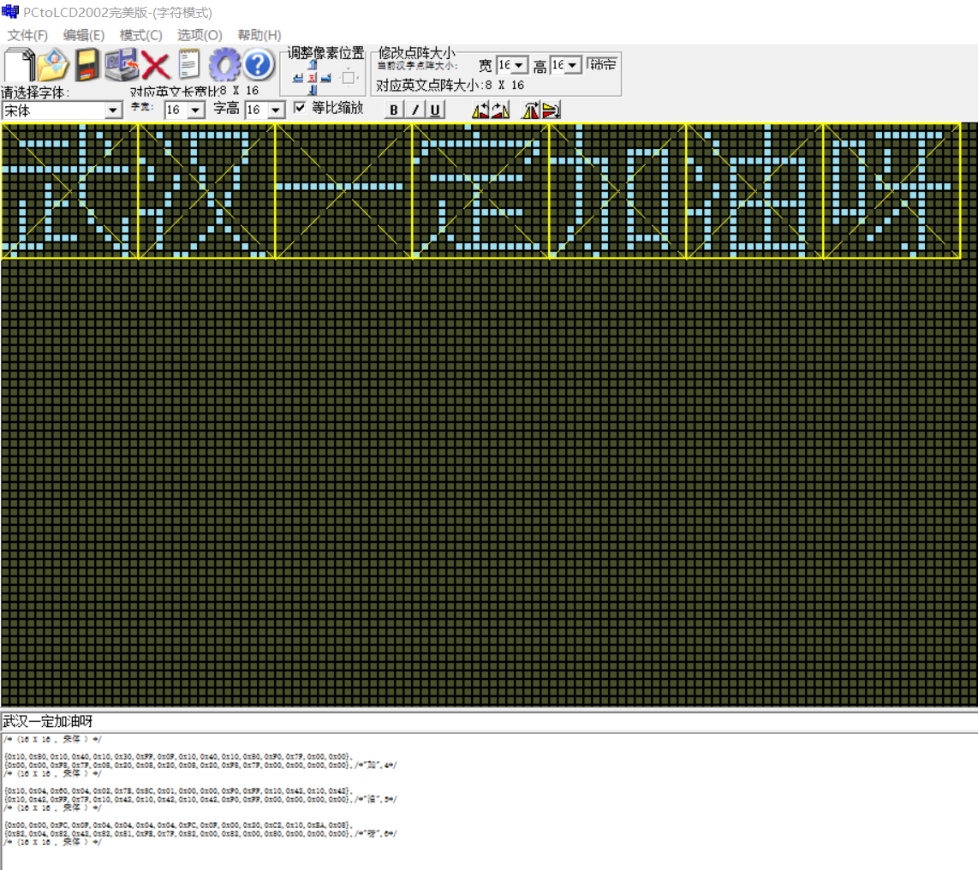
最终由该软件可以导出相应的字符数组，具体结果见源程序HANZI.H。
接着是中断服务程序的设计：题目要求设置六个字符串，这里设置一个全中文字符串“武汉一定加油呀”和五个字符字符串。Display()子程序实现显示字符。Mode变量用来表示开关mode是否打开，add变量用来表示开关ADD状态，来控制输出字符串。相应的中断服务程序如下：
1、int timer0() interrupt 1 //定时器0中断
该定时器中断处理函数需要处理的是：初始化定时器初值、中断次数加一、中断次数达到800时add加1、调用字符清零程序来准备下一字符串的输出。其具体实现见源代码。
2、int MODE1() interrupt 0 //外部mode中断
Mode按钮中断时表示按键状态发生改变，其中若状态转变成1，即字符串改变通过定时器，则需要初始化定时器初值。具体实现见源代码。
3、int ADD1() interrupt 2 //外部中断,ADD按钮改变ADD的值
Add按钮实现字符串切换功能，当mode值为1时，即开关调整字符串改变，此时需要增加add的值来切换字符串，同时调用字符清零程序来准备下一字符串的输出。其具体实现见源代码。
将上述中断程序和main()函数和显示函数组合起来即可实现实验要求功能，完整代码见源代码。

三、实验结果
1、编译成功界面、调试界面
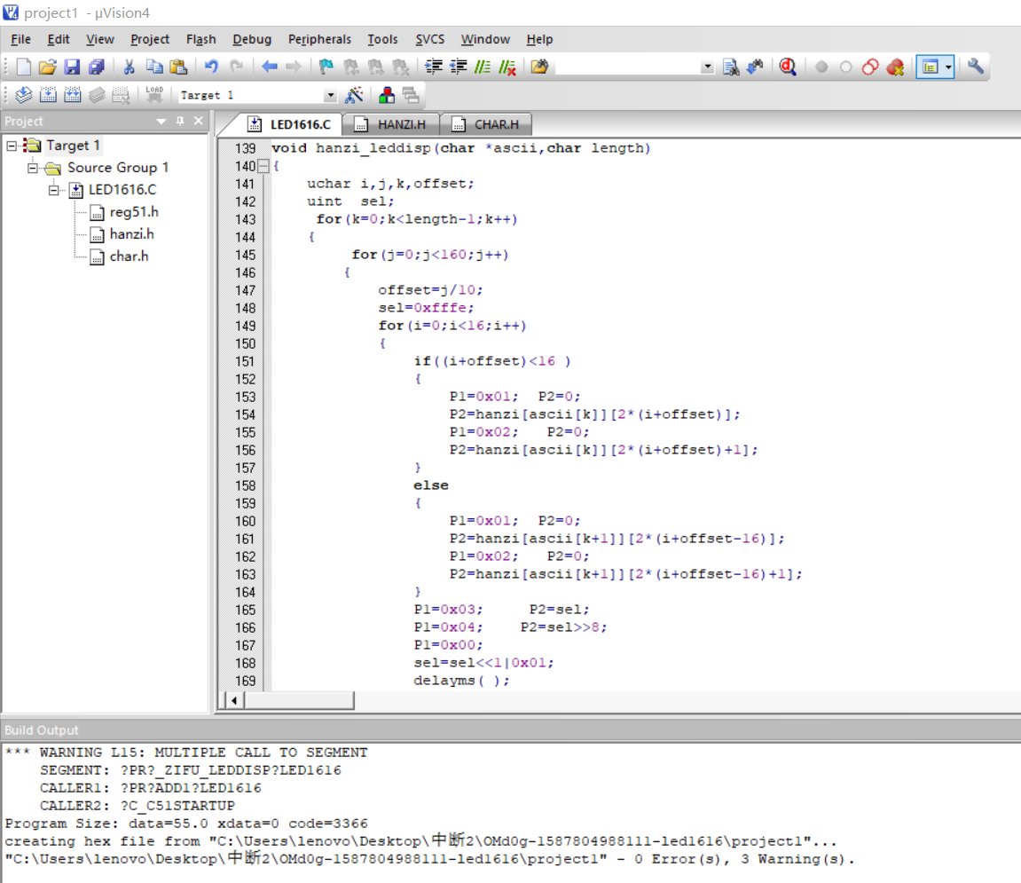
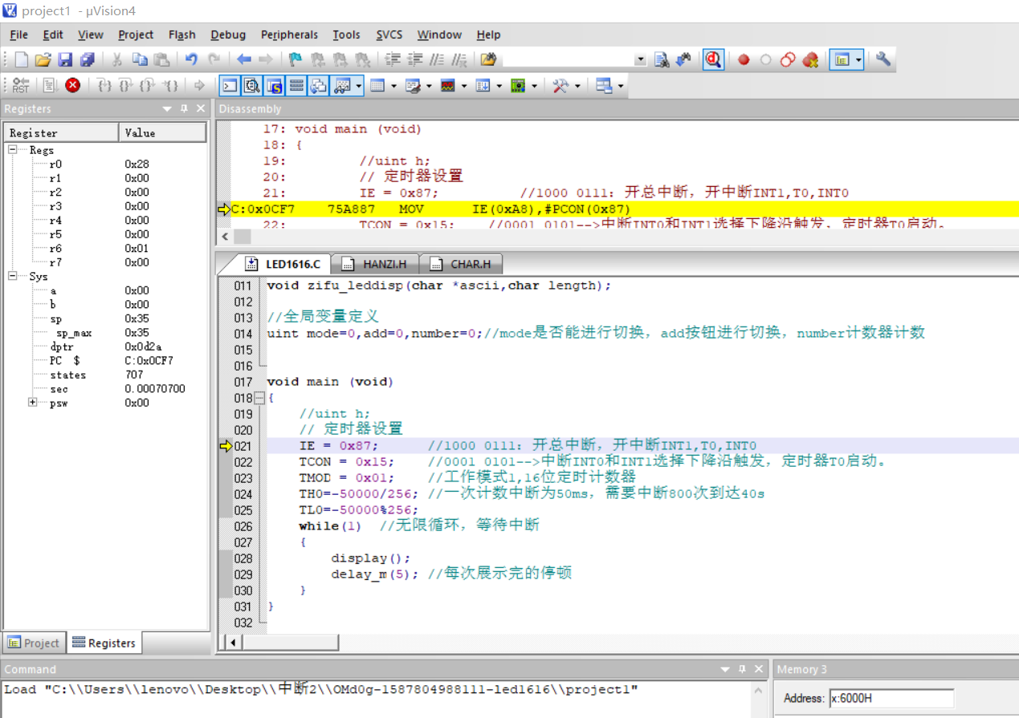

2、Proteus仿真结果

Proteus整体仿真截图如下所示：(默认初始显示“武汉一定加油呀”)
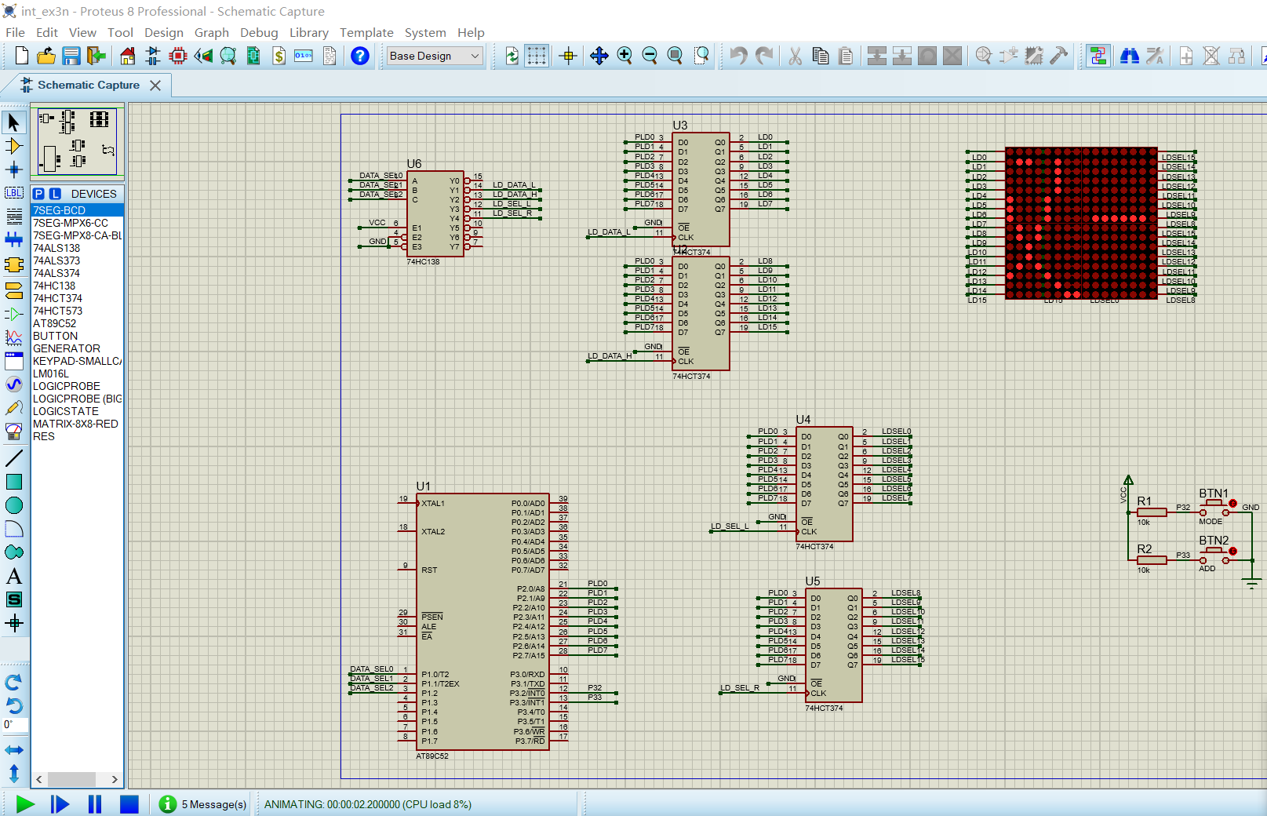

定时器40s自动转换成下一字符串（"I-LOVE-YOU!"）
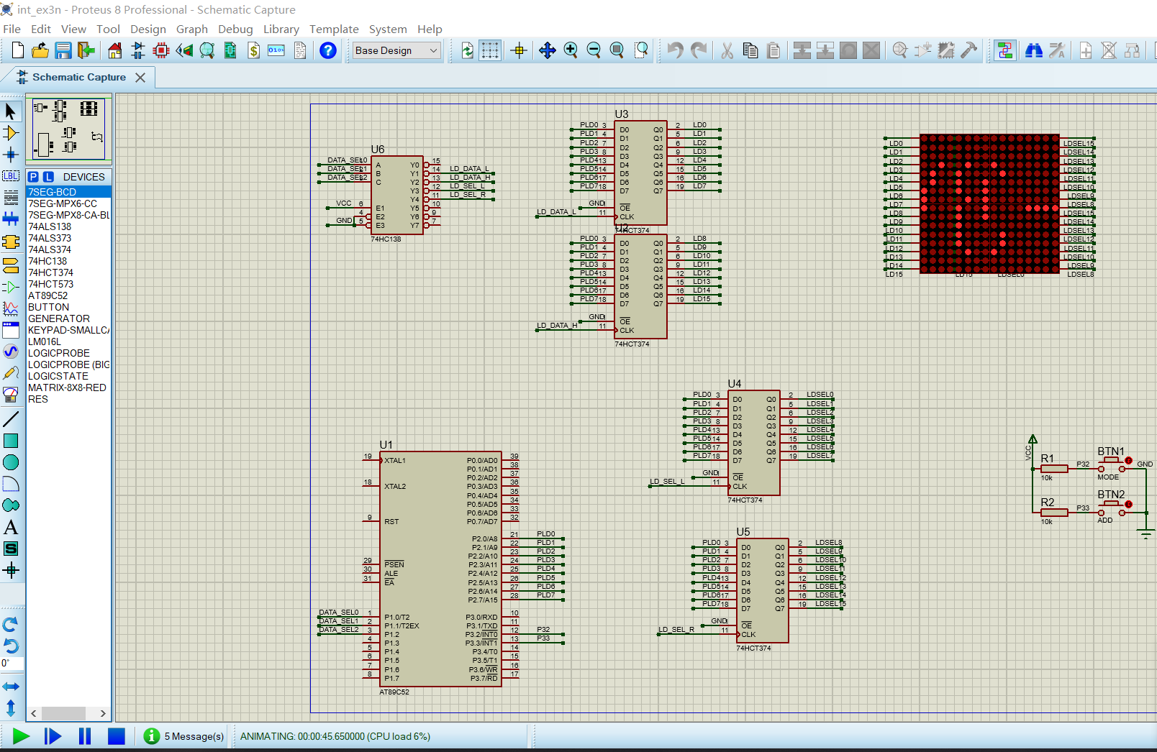

通过按键控制六个字符串依次显示：“武汉一定加油呀”、“I-LOVE-YOU!”、“HUST-NIUBI”“WUHAN-JIAYOU”“DANPIANJI”“ZHONGGUO-NIUBI”。以及每个字符串结束停顿时间、字符串变化时缓冲输出。
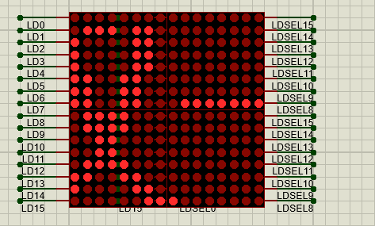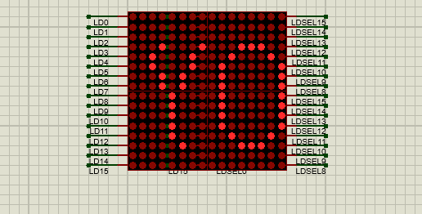
“武汉一定加油呀” “I-LOVE-YOU!”
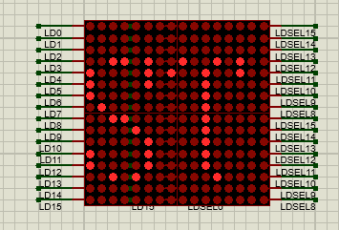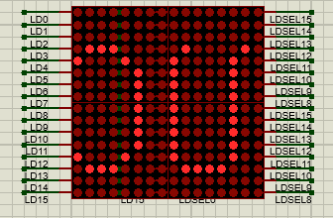
“HUST-NIUBI” “WUHAN-JIAYOU”
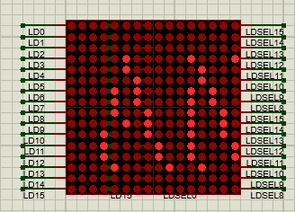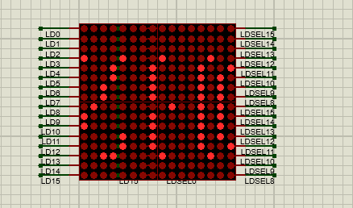
“DANPIANJI” “ZHONGGUO-NIUBI”
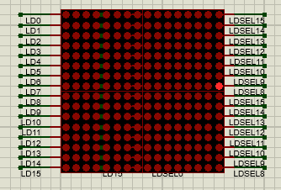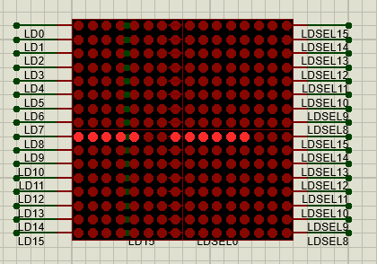
字符串结束停顿时间 转换字符串时缓冲输出

四、实验总结
该实验通过采用中断实现字符串的输出显示，通过本次实验掌握了外部中断的使用以及定时器、计数器的使用。同时增强了自己的编程能力。当然本次实验也遇到了不少问题。比如最开始不同字符串转换时总是遇到本次字符串输出完毕之后才能转化的情况。后来在定时器中断和外部中断处理函数中加入缓冲字符“--”的输出，使得字符串的转变可以直接按键之后改变，而不必等待本次字符串全部输出之后才能改变。同时本次实验也让自己对51单片机的掌握更上一层楼，在仿真中发现单片机的更多用处和乐趣！了解到日常生活中的许多东西都是单片机的影子，屏幕的显示便是其中之一。

四、程序源代码
1、LED1616.c文件
#include<reg51.h>
#include"hanzi.h"
#include"char.h"

//函数声明
void delayms (void); /* 函数说明 */
void delay_m(unsigned int n); //延时ns
void display(void);
void hanzi_leddisp(char *ascii,char length);
uchar DISPBUFF[10]={0,1,2,3,4,5,6,7,8,9};
void zifu_leddisp(char *ascii,char length);

//全局变量定义
uint mode=0,add=0,number=0;//mode是否能进行切换，add按钮进行切换，number计数器计数

void main (void)
{
//uint h;
// 定时器设置
IE = 0x87; //1000 0111：开总中断，开中断INT1,T0,INT0
TCON = 0x15; //0001 0101-->中断INT0和INT1选择下降沿触发，定时器T0启动。
TMOD = 0x01; //工作模式1,16位定时计数器
TH0=-50000/256; //一次计数中断为50ms，需要中断800次到达40s
TL0=-50000%256;
while(1) //无限循环，等待中断
{
display();
delay_m(5); //每次展示完的停顿
}
}

void display(void)
{

if(add == 0)//第一个字符串
{
hanzi_leddisp(DISPBUFF,7);
delayms();
}
else if(add == 1)//第二个字符串
{
zifu_leddisp("I-LOVE-YOU!",11);
delayms();
}
else if(add == 2)//第三个字符串
{
zifu_leddisp("HUST-NIUBI",10);
delayms();
}
else if(add == 3)//第四个字符串
{
zifu_leddisp("WUHAN-JIAYOU",12);
delayms();
}
else if(add == 4)//第五个字符串
{
zifu_leddisp("DANPIANJI",9);
delayms();
}
else if(add == 5)//第六个字符串
{
zifu_leddisp("ZHONGGUO-NIUBI",14);
delayms();
}

}

//延时n秒,具体精确也不确定
void delay_m(unsigned int n)
{
unsigned int i=0,j=0;
for(i=0;i<n;i++)
for(j=0;j<21738;j++);
}

//中断处理程序
int timer0() interrupt 1 //定时器0中断
{
TH0=-50000/256; //一次计数中断为50ms，需要中断800次到达40s
TL0=-50000%256; //中断时设置初始值
number++; //中断次数加1

if(number == 800) //40s，切换下一个字符
{
number = 0; //计数值设为0
if(mode == 0) //不处于按钮调整
{
hanzi_leddisp(DISPBUFF,0);
zifu_leddisp("--",2); //显示字符清零，准备进入下一个字符串
if(add ==5 ) add=0;
else add++;
}
}
}

int MODE1() interrupt 0 //外部mode中断
{
if(mode == 1)//中断时要变为0，此时按钮add不可用
{
mode = 0;//切换为定时器40s改变一次字符串

//定时器初始化
TH0=-50000/256; //一次计数中断为50ms，需要中断800次到达40s
TL0=-50000%256; //中断时设置初始值
number = 0; //中断次数加1
}
else mode = 1; //切换为按钮改变字符串

}

//没有将显示字符的函数放在中断处理函数中，考虑到显示时间较长，这样的话下一次add可能无法触发中断
int ADD1() interrupt 2 //外部中断,ADD按钮改变ADD的值
{
if(mode == 1) //允许按钮改变字符
{
if(add <5) add++;
else add = 0;

//add按钮改变字符串，先清空显示字符。
zifu_leddisp("--",2); //显示字符清零，准备进入下一个字符串
}
}

// 延时函数
void delayms (void) /* 延时 */
{
uchar i;
for (i=200;i>0;i--){;}
}

// 输入汉字字符串和长度，显示汉字。
void hanzi_leddisp(char *ascii,char length)
{
uchar i,j,k,offset;
uint sel;
for(k=0;k<length-1;k++)
{
for(j=0;j<160;j++)
{
offset=j/10;
sel=0xfffe;
for(i=0;i<16;i++)
{
if((i+offset)<16 )
{
P1=0x01; P2=0;
P2=hanzi[ascii[k]][2*(i+offset)];
P1=0x02; P2=0;
P2=hanzi[ascii[k]][2*(i+offset)+1];
}
else
{
P1=0x01; P2=0;
P2=hanzi[ascii[k+1]][2*(i+offset-16)];
P1=0x02; P2=0;
P2=hanzi[ascii[k+1]][2*(i+offset-16)+1];
}
P1=0x03; P2=sel;
P1=0x04; P2=sel>>8;
P1=0x00;
sel=sel<<1|0x01;
delayms( );
}
}
}
}

//输入字母字符串和长度，显示字符串
void zifu_leddisp(char *ascii,char length)
{
uchar i,j,k,offset;
uint sel;
for(k=0;k<length/2;k++)
{
for(j=0;j<160;j++)
{
offset=j/20;
sel=0xfffe;
for(i=0;i<16;i++)
{
if(i<8)
{
if((i+offset)<8 )
{
P1=0x01; P2=0;
P2=zifu[ascii[2*k]-32][2*(i+offset)];
P1=0x02; P2=0;
P2=zifu[ascii[2*k]-32][2*(i+offset)+1];
}
else
{
P1=0x01; P2=0;
P2=zifu[ascii[2*k+1]-32][2*(i+offset-8)];
P1=0x02; P2=0;
P2=zifu[ascii[2*k+1]-32][2*(i+offset-8)+1];
}
}
else
{
if((i+offset-8)<8 )
{
P1=0x01; P2=0;
P2=zifu[ascii[2*k+1]-32][2*(i+offset-8)];
P1=0x02; P2=0;
P2=zifu[ascii[2*k+1]-32][2*(i+offset-8)+1];
}
else
{
P1=0x01; P2=0;
P2=zifu[ascii[2*k+2]-32][2*(i+offset-8-8)];
P1=0x02; P2=0;
P2=zifu[ascii[2*k+2]-32][2*(i+offset-8-8)+1];
}
}
P1=0x03; P2=sel;
P1=0x04; P2=sel>>8;
P1=0x00;
sel=sel<<1|0x01;
delayms( );
}
}
}
}

2、头文件HANZI.H
#define uchar unsigned char
#define uint unsigned int
uchar code hanzi[7][32]=
{ //武(0) 汉(1) 一(2) 定(3) 加(4) 油(5) 呀(6)
{0x20,0x40,0x20,0xC0,0x24,0x7E,0x24,0x40,0x24,0x40,0xA4,0x3F,0x24,0x22,0x24,0x22,0x20,0x20,0xFF,0x03,0x20,0x0C,0x22,0x10,0x2C,0x20,0x20,0x40,0x20,0xF8,0x00,0x00},/*"武",0*/
/* (16 X 16 , 宋体 ) */

{0x10,0x04,0x60,0x04,0x02,0x7C,0x0C,0x03,0xC0,0x80,0x02,0x80,0x1E,0x40,0xE2,0x20,0x02,0x13,0x02,0x0C,0x02,0x13,0xE2,0x20,0x1E,0x40,0x00,0x80,0x00,0x80,0x00,0x00},/*"汉",1*/
/* (16 X 16 , 宋体 ) */

{0x80,0x00,0x80,0x00,0x80,0x00,0x80,0x00,0x80,0x00,0x80,0x00,0x80,0x00,0x80,0x00,0x80,0x00,0x80,0x00,0x80,0x00,0x80,0x00,0x80,0x00,0x80,0x00,0x80,0x00,0x00,0x00},/*"一",2*/
/* (16 X 16 , 宋体 ) */

{0x10,0x80,0x0C,0x40,0x44,0x20,0x44,0x1E,0x44,0x20,0x44,0x40,0x45,0x40,0xC6,0x7F,0x44,0x44,0x44,0x44,0x44,0x44,0x44,0x44,0x44,0x44,0x14,0x40,0x0C,0x40,0x00,0x00},/*"定",3*/
/* (16 X 16 , 宋体 ) */

{0x10,0x80,0x10,0x40,0x10,0x30,0xFF,0x0F,0x10,0x40,0x10,0x80,0xF0,0x7F,0x00,0x00,0x00,0x00,0xF8,0x7F,0x08,0x20,0x08,0x20,0x08,0x20,0xF8,0x7F,0x00,0x00,0x00,0x00},/*"加",4*/
/* (16 X 16 , 宋体 ) */

{0x10,0x04,0x60,0x04,0x02,0x7E,0x8C,0x01,0x00,0x00,0xF0,0xFF,0x10,0x42,0x10,0x42,0x10,0x42,0xFF,0x7F,0x10,0x42,0x10,0x42,0x10,0x42,0xF0,0xFF,0x00,0x00,0x00,0x00},/*"油",5*/
/* (16 X 16 , 宋体 ) */

{0x00,0x00,0xFC,0x0F,0x04,0x04,0x04,0x04,0xFC,0x0F,0x00,0x20,0xC2,0x10,0xBA,0x08,0x82,0x04,0x82,0x42,0x82,0x81,0xFE,0x7F,0x82,0x00,0x82,0x00,0x80,0x00,0x00,0x00},/*"呀",6*/
/* (16 X 16 , 宋体 ) */
};

3、头文件CHAR.H(与老师给出一样)
#define uchar unsigned char
#define uint unsigned int

uchar code zifu[94][16]=

{{0x00,0x00,0x00,0x00,0x00,0x00,0xF8,0x33,0x00,0x00,0x00,0x00,0x00,0x00,0x00,0x00},/*"!",0*/
/* (8 X 16 , 宋体 ) */

{0x00,0x00,0x10,0x00,0x0C,0x00,0x02,0x00,0x10,0x00,0x0C,0x00,0x02,0x00,0x00,0x00},/*""",1*/
/* (8 X 16 , 宋体 ) */

{0x00,0x00,0x40,0x04,0xC0,0x3F,0x78,0x04,0x40,0x04,0xC0,0x3F,0x78,0x04,0x00,0x00},/*"#",2*/
/* (8 X 16 , 宋体 ) */

{0x00,0x00,0x70,0x18,0x88,0x20,0x88,0x20,0xFC,0xFF,0x08,0x21,0x30,0x1E,0x00,0x00},/*"$",3*/
/* (8 X 16 , 宋体 ) */

{0xF0,0x00,0x08,0x31,0xF0,0x0C,0x80,0x03,0x60,0x1E,0x18,0x21,0x00,0x1E,0x00,0x00},/*"%",4*/
/* (8 X 16 , 宋体 ) */

{0x00,0x1E,0xF0,0x21,0x08,0x23,0x88,0x2C,0x70,0x19,0x00,0x27,0x00,0x21,0x00,0x10},/*"&",5*/
/* (8 X 16 , 宋体 ) */

{0x00,0x00,0x12,0x00,0x0E,0x00,0x00,0x00,0x00,0x00,0x00,0x00,0x00,0x00,0x00,0x00},/*"'",6*/
/* (8 X 16 , 宋体 ) */

{0x00,0x00,0x00,0x00,0x00,0x00,0xE0,0x07,0x18,0x18,0x04,0x20,0x02,0x40,0x00,0x00},/*"(",7*/
/* (8 X 16 , 宋体 ) */

{0x00,0x00,0x02,0x40,0x04,0x20,0x18,0x18,0xE0,0x07,0x00,0x00,0x00,0x00,0x00,0x00},/*")",8*/
/* (8 X 16 , 宋体 ) */

{0x40,0x02,0x40,0x02,0x80,0x01,0xF0,0x0F,0x80,0x01,0x40,0x02,0x40,0x02,0x00,0x00},/*"*",9*/
/* (8 X 16 , 宋体 ) */

{0x00,0x00,0x00,0x01,0x00,0x01,0x00,0x01,0xE0,0x0F,0x00,0x01,0x00,0x01,0x00,0x01},/*"+",10*/
/* (8 X 16 , 宋体 ) */

{0x00,0x00,0x00,0x90,0x00,0x70,0x00,0x00,0x00,0x00,0x00,0x00,0x00,0x00,0x00,0x00},/*",",11*/
/* (8 X 16 , 宋体 ) */

{0x00,0x00,0x00,0x01,0x00,0x01,0x00,0x01,0x00,0x01,0x00,0x01,0x00,0x01,0x00,0x00},/*"-",12*/
/* (8 X 16 , 宋体 ) */

{0x00,0x00,0x00,0x30,0x00,0x30,0x00,0x00,0x00,0x00,0x00,0x00,0x00,0x00,0x00,0x00},/*".",13*/
/* (8 X 16 , 宋体 ) */

{0x00,0x00,0x00,0x60,0x00,0x18,0x00,0x07,0xC0,0x00,0x38,0x00,0x04,0x00,0x00,0x00},/*"/",14*/
/* (8 X 16 , 宋体 ) */

{0x00,0x00,0xE0,0x0F,0x10,0x10,0x08,0x20,0x08,0x20,0x10,0x10,0xE0,0x0F,0x00,0x00},/*"0",15*/
/* (8 X 16 , 宋体 ) */

{0x00,0x00,0x00,0x00,0x10,0x20,0x10,0x20,0xF8,0x3F,0x00,0x20,0x00,0x20,0x00,0x00},/*"1",16*/
/* (8 X 16 , 宋体 ) */

{0x00,0x00,0x70,0x30,0x08,0x28,0x08,0x24,0x08,0x22,0x08,0x21,0xF0,0x30,0x00,0x00},/*"2",17*/
/* (8 X 16 , 宋体 ) */

{0x00,0x00,0x30,0x18,0x08,0x20,0x08,0x21,0x08,0x21,0x88,0x22,0x70,0x1C,0x00,0x00},/*"3",18*/
/* (8 X 16 , 宋体 ) */

{0x00,0x00,0x00,0x06,0x80,0x05,0x40,0x24,0x30,0x24,0xF8,0x3F,0x00,0x24,0x00,0x24},/*"4",19*/
/* (8 X 16 , 宋体 ) */

{0x00,0x00,0xF8,0x19,0x88,0x20,0x88,0x20,0x88,0x20,0x08,0x11,0x08,0x0E,0x00,0x00},/*"5",20*/
/* (8 X 16 , 宋体 ) */

{0x00,0x00,0xE0,0x0F,0x10,0x11,0x88,0x20,0x88,0x20,0x90,0x20,0x00,0x1F,0x00,0x00},/*"6",21*/
/* (8 X 16 , 宋体 ) */

{0x00,0x00,0x18,0x00,0x08,0x00,0x08,0x3E,0x88,0x01,0x68,0x00,0x18,0x00,0x00,0x00},/*"7",22*/
/* (8 X 16 , 宋体 ) */

{0x00,0x00,0x70,0x1C,0x88,0x22,0x08,0x21,0x08,0x21,0x88,0x22,0x70,0x1C,0x00,0x00},/*"8",23*/
/* (8 X 16 , 宋体 ) */

{0x00,0x00,0xF0,0x01,0x08,0x12,0x08,0x22,0x08,0x22,0x10,0x11,0xE0,0x0F,0x00,0x00},/*"9",24*/
/* (8 X 16 , 宋体 ) */

{0x00,0x00,0x00,0x00,0x00,0x00,0xC0,0x30,0xC0,0x30,0x00,0x00,0x00,0x00,0x00,0x00},/*":",25*/
/* (8 X 16 , 宋体 ) */

{0x00,0x00,0x00,0x00,0x00,0x00,0x80,0xE0,0x00,0x00,0x00,0x00,0x00,0x00,0x00,0x00},/*";",26*/
/* (8 X 16 , 宋体 ) */

{0x00,0x00,0x00,0x01,0x80,0x02,0x40,0x04,0x20,0x08,0x10,0x10,0x08,0x20,0x00,0x00},/*"<",27*/
/* (8 X 16 , 宋体 ) */

{0x00,0x00,0x40,0x02,0x40,0x02,0x40,0x02,0x40,0x02,0x40,0x02,0x40,0x02,0x00,0x00},/*"=",28*/
/* (8 X 16 , 宋体 ) */

{0x00,0x00,0x08,0x20,0x10,0x10,0x20,0x08,0x40,0x04,0x80,0x02,0x00,0x01,0x00,0x00},/*">",29*/
/* (8 X 16 , 宋体 ) */

{0x00,0x00,0x70,0x00,0x48,0x00,0x08,0x30,0x08,0x37,0x88,0x00,0x70,0x00,0x00,0x00},/*"?",30*/
/* (8 X 16 , 宋体 ) */

{0xC0,0x07,0x30,0x18,0xC8,0x27,0x28,0x28,0xE8,0x2F,0x10,0x28,0xE0,0x17,0x00,0x00},/*"@",31*/
/* (8 X 16 , 宋体 ) */

{0x00,0x20,0x00,0x3C,0xC0,0x23,0x38,0x02,0xE0,0x02,0x00,0x27,0x00,0x38,0x00,0x20},/*"A",32*/
/* (8 X 16 , 宋体 ) */

{0x08,0x20,0xF8,0x3F,0x88,0x20,0x88,0x20,0x88,0x20,0x70,0x11,0x00,0x0E,0x00,0x00},/*"B",33*/
/* (8 X 16 , 宋体 ) */

{0xC0,0x07,0x30,0x18,0x08,0x20,0x08,0x20,0x08,0x20,0x08,0x10,0x38,0x08,0x00,0x00},/*"C",34*/
/* (8 X 16 , 宋体 ) */

{0x08,0x20,0xF8,0x3F,0x08,0x20,0x08,0x20,0x08,0x20,0x10,0x10,0xE0,0x0F,0x00,0x00},/*"D",35*/
/* (8 X 16 , 宋体 ) */

{0x08,0x20,0xF8,0x3F,0x88,0x20,0x88,0x20,0xE8,0x23,0x08,0x20,0x10,0x18,0x00,0x00},/*"E",36*/
/* (8 X 16 , 宋体 ) */

{0x08,0x20,0xF8,0x3F,0x88,0x20,0x88,0x00,0xE8,0x03,0x08,0x00,0x10,0x00,0x00,0x00},/*"F",37*/
/* (8 X 16 , 宋体 ) */

{0xC0,0x07,0x30,0x18,0x08,0x20,0x08,0x20,0x08,0x22,0x38,0x1E,0x00,0x02,0x00,0x00},/*"G",38*/
/* (8 X 16 , 宋体 ) */

{0x08,0x20,0xF8,0x3F,0x08,0x21,0x00,0x01,0x00,0x01,0x08,0x21,0xF8,0x3F,0x08,0x20},/*"H",39*/
/* (8 X 16 , 宋体 ) */

{0x00,0x00,0x08,0x20,0x08,0x20,0xF8,0x3F,0x08,0x20,0x08,0x20,0x00,0x00,0x00,0x00},/*"I",40*/
/* (8 X 16 , 宋体 ) */

{0x00,0xC0,0x00,0x80,0x08,0x80,0x08,0x80,0xF8,0x7F,0x08,0x00,0x08,0x00,0x00,0x00},/*"J",41*/
/* (8 X 16 , 宋体 ) */

{0x08,0x20,0xF8,0x3F,0x88,0x20,0xC0,0x01,0x28,0x26,0x18,0x38,0x08,0x20,0x00,0x00},/*"K",42*/
/* (8 X 16 , 宋体 ) */

{0x08,0x20,0xF8,0x3F,0x08,0x20,0x00,0x20,0x00,0x20,0x00,0x20,0x00,0x30,0x00,0x00},/*"L",43*/
/* (8 X 16 , 宋体 ) */

{0x08,0x20,0xF8,0x3F,0xF8,0x01,0x00,0x3E,0xF8,0x01,0xF8,0x3F,0x08,0x20,0x00,0x00},/*"M",44*/
/* (8 X 16 , 宋体 ) */

{0x08,0x20,0xF8,0x3F,0x30,0x20,0xC0,0x00,0x00,0x07,0x08,0x18,0xF8,0x3F,0x08,0x00},/*"N",45*/
/* (8 X 16 , 宋体 ) */

{0xE0,0x0F,0x10,0x10,0x08,0x20,0x08,0x20,0x08,0x20,0x10,0x10,0xE0,0x0F,0x00,0x00},/*"O",46*/
/* (8 X 16 , 宋体 ) */

{0x08,0x20,0xF8,0x3F,0x08,0x21,0x08,0x01,0x08,0x01,0x08,0x01,0xF0,0x00,0x00,0x00},/*"P",47*/
/* (8 X 16 , 宋体 ) */

{0xE0,0x0F,0x10,0x10,0x08,0x28,0x08,0x28,0x08,0x30,0x10,0x50,0xE0,0x4F,0x00,0x00},/*"Q",48*/
/* (8 X 16 , 宋体 ) */

{0x08,0x20,0xF8,0x3F,0x88,0x20,0x88,0x00,0x88,0x03,0x88,0x0C,0x70,0x30,0x00,0x20},/*"R",49*/
/* (8 X 16 , 宋体 ) */

{0x00,0x00,0x70,0x38,0x88,0x20,0x08,0x21,0x08,0x21,0x08,0x22,0x38,0x1C,0x00,0x00},/*"S",50*/
/* (8 X 16 , 宋体 ) */

{0x18,0x00,0x08,0x00,0x08,0x20,0xF8,0x3F,0x08,0x20,0x08,0x00,0x18,0x00,0x00,0x00},/*"T",51*/
/* (8 X 16 , 宋体 ) */

{0x08,0x00,0xF8,0x1F,0x08,0x20,0x00,0x20,0x00,0x20,0x08,0x20,0xF8,0x1F,0x08,0x00},/*"U",52*/
/* (8 X 16 , 宋体 ) */

{0x08,0x00,0x78,0x00,0x88,0x07,0x00,0x38,0x00,0x0E,0xC8,0x01,0x38,0x00,0x08,0x00},/*"V",53*/
/* (8 X 16 , 宋体 ) */

{0x08,0x00,0xF8,0x03,0x00,0x3E,0xF8,0x01,0x00,0x3E,0xF8,0x03,0x08,0x00,0x00,0x00},/*"W",54*/
/* (8 X 16 , 宋体 ) */

{0x08,0x20,0x18,0x30,0x68,0x2C,0x80,0x03,0x80,0x03,0x68,0x2C,0x18,0x30,0x08,0x20},/*"X",55*/
/* (8 X 16 , 宋体 ) */

{0x08,0x00,0x38,0x00,0xC8,0x20,0x00,0x3F,0xC8,0x20,0x38,0x00,0x08,0x00,0x00,0x00},/*"Y",56*/
/* (8 X 16 , 宋体 ) */

{0x10,0x20,0x08,0x38,0x08,0x26,0x08,0x21,0xC8,0x20,0x38,0x20,0x08,0x18,0x00,0x00},/*"Z",57*/
/* (8 X 16 , 宋体 ) */

{0x00,0x00,0x00,0x00,0x00,0x00,0xFE,0x7F,0x02,0x40,0x02,0x40,0x02,0x40,0x00,0x00},/*"[",58*/
/* (8 X 16 , 宋体 ) */

{0x00,0x00,0x04,0x00,0x38,0x00,0xC0,0x01,0x00,0x06,0x00,0x38,0x00,0xC0,0x00,0x00},/*"\",59*/
/* (8 X 16 , 宋体 ) */

{0x00,0x00,0x02,0x40,0x02,0x40,0x02,0x40,0xFE,0x7F,0x00,0x00,0x00,0x00,0x00,0x00},/*"]",60*/
/* (8 X 16 , 宋体 ) */

{0x00,0x00,0x00,0x00,0x04,0x00,0x02,0x00,0x02,0x00,0x04,0x00,0x00,0x00,0x00,0x00},/*"^",61*/
/* (8 X 16 , 宋体 ) */

{0x00,0x80,0x00,0x80,0x00,0x80,0x00,0x80,0x00,0x80,0x00,0x80,0x00,0x80,0x00,0x80},/*"_",62*/
/* (8 X 16 , 宋体 ) */

{0x00,0x00,0x02,0x00,0x02,0x00,0x04,0x00,0x00,0x00,0x00,0x00,0x00,0x00,0x00,0x00},/*"`",63*/
/* (8 X 16 , 宋体 ) */

{0x00,0x00,0x00,0x19,0x80,0x24,0x80,0x24,0x80,0x12,0x00,0x3F,0x00,0x20,0x00,0x00},/*"a",64*/
/* (8 X 16 , 宋体 ) */

{0x10,0x00,0xF0,0x3F,0x00,0x11,0x80,0x20,0x80,0x20,0x00,0x11,0x00,0x0E,0x00,0x00},/*"b",65*/
/* (8 X 16 , 宋体 ) */

{0x00,0x00,0x00,0x0E,0x00,0x11,0x80,0x20,0x80,0x20,0x80,0x20,0x00,0x11,0x00,0x00},/*"c",66*/
/* (8 X 16 , 宋体 ) */

{0x00,0x00,0x00,0x1F,0x80,0x20,0x80,0x20,0x80,0x20,0x90,0x10,0xF0,0x3F,0x00,0x20},/*"d",67*/
/* (8 X 16 , 宋体 ) */

{0x00,0x00,0x00,0x1F,0x80,0x24,0x80,0x24,0x80,0x24,0x80,0x24,0x00,0x17,0x00,0x00},/*"e",68*/
/* (8 X 16 , 宋体 ) */

{0x00,0x00,0x80,0x20,0x80,0x20,0xE0,0x3F,0x90,0x20,0x90,0x20,0x20,0x00,0x00,0x00},/*"f",69*/
/* (8 X 16 , 宋体 ) */

{0x00,0x00,0x00,0x6B,0x80,0x94,0x80,0x94,0x80,0x94,0x80,0x93,0x80,0x60,0x00,0x00},/*"g",70*/
/* (8 X 16 , 宋体 ) */

{0x10,0x20,0xF0,0x3F,0x00,0x21,0x80,0x00,0x80,0x00,0x80,0x20,0x00,0x3F,0x00,0x20},/*"h",71*/
/* (8 X 16 , 宋体 ) */

{0x00,0x00,0x80,0x20,0x98,0x20,0x98,0x3F,0x00,0x20,0x00,0x20,0x00,0x00,0x00,0x00},/*"i",72*/
/* (8 X 16 , 宋体 ) */

{0x00,0x00,0x00,0xC0,0x00,0x80,0x80,0x80,0x98,0x80,0x98,0x7F,0x00,0x00,0x00,0x00},/*"j",73*/
/* (8 X 16 , 宋体 ) */

{0x10,0x20,0xF0,0x3F,0x00,0x24,0x00,0x06,0x80,0x29,0x80,0x30,0x80,0x20,0x00,0x00},/*"k",74*/
/* (8 X 16 , 宋体 ) */

{0x00,0x00,0x10,0x20,0x10,0x20,0xF8,0x3F,0x00,0x20,0x00,0x20,0x00,0x00,0x00,0x00},/*"l",75*/
/* (8 X 16 , 宋体 ) */

{0x80,0x20,0x80,0x3F,0x80,0x20,0x80,0x00,0x80,0x3F,0x80,0x20,0x80,0x00,0x00,0x3F},/*"m",76*/
/* (8 X 16 , 宋体 ) */

{0x80,0x20,0x80,0x3F,0x00,0x21,0x80,0x00,0x80,0x00,0x80,0x20,0x00,0x3F,0x00,0x20},/*"n",77*/
/* (8 X 16 , 宋体 ) */

{0x00,0x00,0x00,0x1F,0x80,0x20,0x80,0x20,0x80,0x20,0x80,0x20,0x00,0x1F,0x00,0x00},/*"o",78*/
/* (8 X 16 , 宋体 ) */

{0x80,0x80,0x80,0xFF,0x00,0x91,0x80,0x20,0x80,0x20,0x00,0x11,0x00,0x0E,0x00,0x00},/*"p",79*/
/* (8 X 16 , 宋体 ) */

{0x00,0x00,0x00,0x0E,0x00,0x11,0x80,0x20,0x80,0x20,0x00,0x91,0x80,0xFF,0x00,0x80},/*"q",80*/
/* (8 X 16 , 宋体 ) */

{0x80,0x20,0x80,0x20,0x80,0x3F,0x00,0x21,0x80,0x20,0x80,0x00,0x80,0x01,0x00,0x00},/*"r",81*/
/* (8 X 16 , 宋体 ) */

{0x00,0x00,0x00,0x33,0x80,0x24,0x80,0x24,0x80,0x24,0x80,0x24,0x80,0x19,0x00,0x00},/*"s",82*/
/* (8 X 16 , 宋体 ) */

{0x00,0x00,0x80,0x00,0x80,0x00,0xE0,0x1F,0x80,0x20,0x80,0x20,0x00,0x10,0x00,0x00},/*"t",83*/
/* (8 X 16 , 宋体 ) */

{0x80,0x00,0x80,0x1F,0x00,0x20,0x00,0x20,0x00,0x20,0x80,0x10,0x80,0x3F,0x00,0x20},/*"u",84*/
/* (8 X 16 , 宋体 ) */

{0x80,0x00,0x80,0x03,0x80,0x0C,0x00,0x30,0x80,0x0C,0x80,0x03,0x80,0x00,0x00,0x00},/*"v",85*/
/* (8 X 16 , 宋体 ) */

{0x80,0x01,0x80,0x0E,0x00,0x30,0x80,0x0C,0x80,0x07,0x00,0x38,0x80,0x06,0x80,0x01},/*"w",86*/
/* (8 X 16 , 宋体 ) */

{0x00,0x00,0x80,0x20,0x80,0x31,0x80,0x0E,0x00,0x2E,0x80,0x31,0x80,0x20,0x00,0x00},/*"x",87*/
/* (8 X 16 , 宋体 ) */

{0x80,0x00,0x80,0x81,0x80,0x86,0x00,0x78,0x00,0x18,0x80,0x06,0x80,0x01,0x80,0x00},/*"y",88*/
/* (8 X 16 , 宋体 ) */

{0x00,0x00,0x80,0x21,0x80,0x30,0x80,0x2C,0x80,0x22,0x80,0x21,0x80,0x30,0x00,0x00},/*"z",89*/
/* (8 X 16 , 宋体 ) */

{0x00,0x00,0x00,0x00,0x00,0x00,0x00,0x00,0x00,0x01,0xFC,0x3E,0x02,0x40,0x02,0x40},/*"{",90*/
/* (8 X 16 , 宋体 ) */

{0x00,0x00,0x00,0x00,0x00,0x00,0x00,0x00,0xFF,0xFF,0x00,0x00,0x00,0x00,0x00,0x00},/*"|",91*/
/* (8 X 16 , 宋体 ) */

{0x02,0x40,0x02,0x40,0xFC,0x3E,0x00,0x01,0x00,0x00,0x00,0x00,0x00,0x00,0x00,0x00},/*"}",92*/
/* (8 X 16 , 宋体 ) */

{0x00,0x00,0x02,0x00,0x01,0x00,0x02,0x00,0x02,0x00,0x04,0x00,0x02,0x00,0x00,0x00},/*"~",93*/
/* (8 X 16 , 宋体 ) */};

