Coverage
- Run 6 models one strong and one weak from OpenAI, Claude, Gemini:
  - Noam Yehezkel - should choose models, for Gemini it will be interesting to use the same models used for the swarm to see if they “overfit”)
Gemini flash 3.7 - same as swarm
Gemini Pro 3.1 - current strong
Claude Opus 5.5 - current leading Opus
Claude Haiku 4.5 - small high-throughput
GPT 6 Astra - complex reasoning?
GPT o 4 mini

- Each model should have access to the language specs md as well as the glossary RAG and md file - just like translators in the swarm
- We will test the ability to translate unseen data items from the same datasets (the test splits). For that we will call translators through different LLMs (for Gemini use same proxy, but for OpenAI and Claude use direct API keys).
- We will present translation success rate for each model, and number of missing symbols per failed translation on average - will be presented for each model (arranged by companies) in a table
- Between coverage and determinism - we will use the following visualization - subplot for each model, each axis will be a dataset, and the plots will present success rates over each dataset, besides looking at language performance we could compare models language compatibility
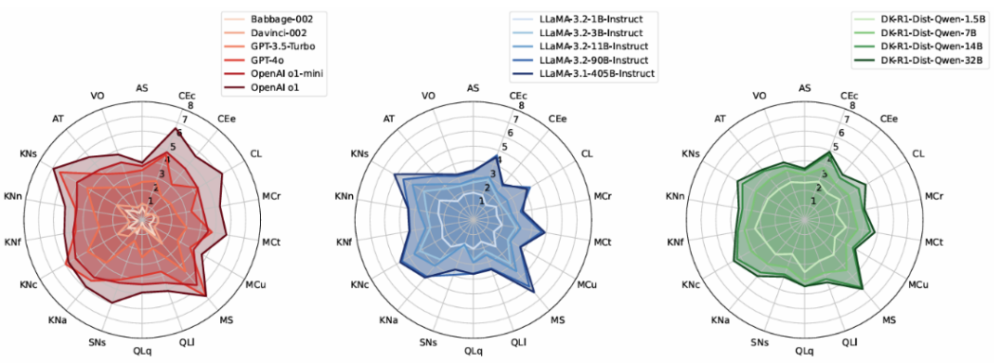

Determinism
- We will use same model & data (& data access) setup
  - Each translator will translate the items 3 times iid
- We will work with JS Divergence:
  - across all runs per model, we will estimate P(symbol | model), P(symbol_type | model)
  - We will calculate JS divergence between every pair of models, out of the possible pairings: weaker model and stronger model of the same company, 2 weaker models from different companies, 2 stronger models from different companies
  - For same-model divergence we will calculate harmonic average of JS divergence per model: for each data item that it translated 3 times, we will calculate the harmonic average of JS Divergence per 2 runs of the same model on the same data item (average over 3 pairs per model per data item). Afterwards, we will calculate harmonic average
- WE NEED MORE GRAPHS HEREEEE!!!!!!
- We will add a qualitative analysis by Claude addressing the following questions:
  - Are there parts of speech, language specs or symbol types that are used in particular models more than others?
  - Are there symbol groups certain models avoid using?
  - In complex texts, are there repetitive structural patterns that certain models prefer or avoid?
  - For translation differences, give common examples of differences that appeared

Expressivity
- We will use same models, data and data access setup
- We will let translator agents translate data from natural language to BrainCode and then independently vice versa - so in the end we will have the original data item and its translation back to natural language from BrainCode to compare.
  - Noam Yehezkel Do we want to only use the same model to both directions each run, or do we want to include runs that use different models to translate to BrainCode, and other ones to the translation back to natural language?
- Both, use matrix design with 6x6 options
- We will use BLEU and/or ROUGE, in addition to word-level Levenshtein Distance, to analyze input-output differences - present all model results in a table - we need to look it up to implement, and consider presenting the formula in the paper or appendix Noam Yehezkel

Improvement - we will need a different model-data-setup here
- We will choose several reasoning benchmarks with different task types (to examine reasoning-task decomposition using BrainCode) Noam Yehezkel
  - For each benchmark, we will choose 3-4 model-benchmark pairings where the models had a relatively poor performance across the benchmark Noam Yehezkel (could be one model per benchmark for 3 benchmarks or any other arrangement, we could use the existing SWE bench as one of the benchmarks but we still need to look for models with low performance on it)
  - We should check that the models have a large enough context window to use BrainCode specs and glossary
- We will test their success over the benchmarks / benchmark samples (depending on benchmark size) ourselves, and afterwards we will do the same examination, but ask them to translate the task to BrainCode first and approach the language specs and glossary if needed. We will check if it raises the performance of each model across it’s paired benchmark.
- If we see improvement, we could try running the model-benchmark pairings several times in each setup (with & without BrainCode) and perform a t-test.

Overall runs:
1-3) For Gemini models, run translators over 48 data items (8 of each dataset from the test split), 3 times each - overall 288 translators. For expressivity, have translators of the same models translate back. This part applies for Gemini models only, other models don’t take part in expressivity.
For OpenAI, Claude models (4 models) run translators over 18 data items (3 of each dataset from the test split, matching the ones Gemini models used), 3 times each - overall 216 translators.

