**Deep Learning project proposal**

**Students:**

Tomer Habusha 305229353 tomerhabusha@gmail.com

Guy Davidi 205493448 guydavidi@mail.tau.ac.il

**Paper**:

DeepDPM: Deep ClusteringWith an Unknown Number of Clusters

Ronen, M., Finder, S. E., & Freifeld, O. (2022). DeepDPM: Deep Clustering With an Unknown Number of Clusters. *arXiv preprint arXiv:2203.14309*.‏

Most deep-clustering methods are parametric and require a predefined and fixed number of clusters, denoted by K. Using the wrong K can have a significant negative effect on parametric methods. **This article proposes a nonparametric method for deep-clustering that does not require K in advance as it infers it during the learning**. The method proposed combines DPM (Dirichlet Process Mixture) and DL (Deep Learning) and is called DeepDPM.

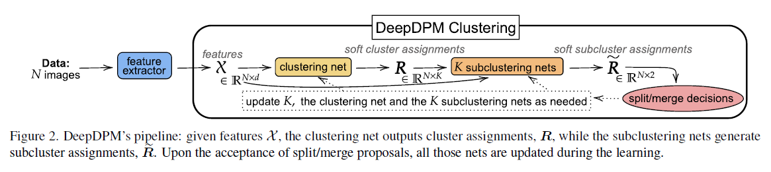**The advantage of the system** is its adaptivity and flexibility. The algorithm allows K to change while the system is learning, and obviating the need to repeatedly train deep parametric methods for model selection. This inference algorithm is comprised of four major steps: feature extractor, cluster net, K sub clustering net and split or merge decisions as described in figure.

The algorithm is fully implemented in the **GitHub source**: https://github.com/BGU-CS-VIL/DeepDPM with some familiar libraries like pytorch_lightning and Sklearn. **The datasets** we will use are MNIST, USPS, Fashion-MNIST, ImageNet Dataset. **To evaluate our results**, we will use ACC (clustering accuracy), NMI (normalized mutual information) and ARI (adjust rand index) parameters.

**We are examining two research directions:** adapting DeepDPM to streaming data other then dealing with a fixed dataset. Also, we will try to change main parameters (for example: changing merge/split method or loss function) in a way that will improve the results.