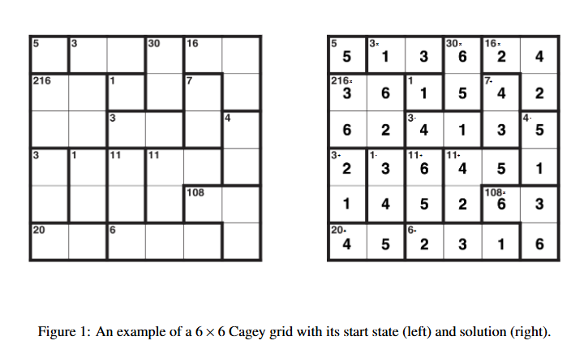
Variables:
One for each cell – Cell(row,col) = number
One for each cage – Cage(num,target) = operation
Variable: {name, Domain [1-6, or +-/*], curr_Domain = [3-5, *+]

Constraints:
For each row – alldif
For each column – alldif
For each cage: exists order of numbers such that operation = result
Constraint: {name, scope [Cage(1,5),Cell(1,1)], tuples[ (cage(1,5),+) , (cell(1,1),5) ]

CSP:
List of vars
List of constraints

