**南京航空航天大学**

《程序设计》课程设计报告

**客房管理系统**

学号：071830118

姓名：顾尧

日期：2020-05-20

指导老师：郑洪源

目录

1. 需求分析…………………………………………………………3
2. 系统总框图……………………………………………………4-5
3. 每个模块设计分析……………………………………………6-14
4. 所有类及定义的函数说明…………………………………15-19
5. 特色函数算法………………………………………………20-23
6. 存在的不足与对策………………………………………………23
7. 使用说明……………………………………………………24-28
8. 程序源代码…………………………………………………29-66

# 需求分析

编写一个客房管理系统，该系统提供键盘式的功能选择。功能包括：客人入住办理；客人退房办理；显示所有房间信息；显示所有空闲房间信息；显示所有已入住房间信息；显示所有客人信息；输入房间号和价格区间查询房间信息；输入客人姓名或身份证号查询客人信息；修改房间价格，房间类型，房间号等功能。

其中所有房间信息和顾客信息存入文件中。运行各功能模块时能给出提示信息帮助管理员完成操作，当管理员的输入不合法时给出相应的提示信息，并回到从新输入界面。程序运行出错时能给出相应的提示信息。

开发平台：vs2010

# 系统总框图

客房管理系统类图:

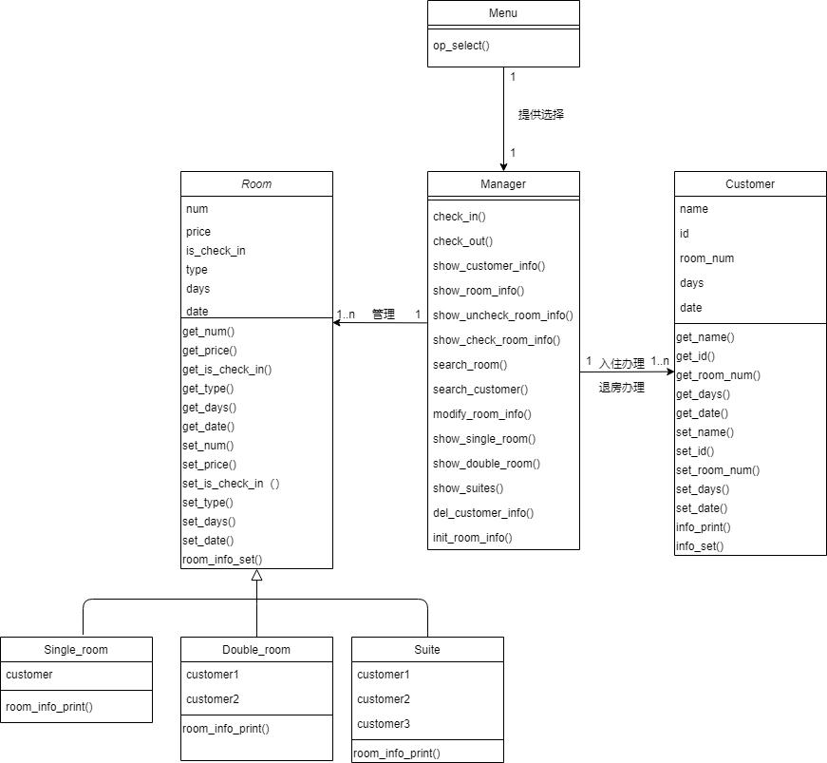

Main（）函数中函数的调用关系:

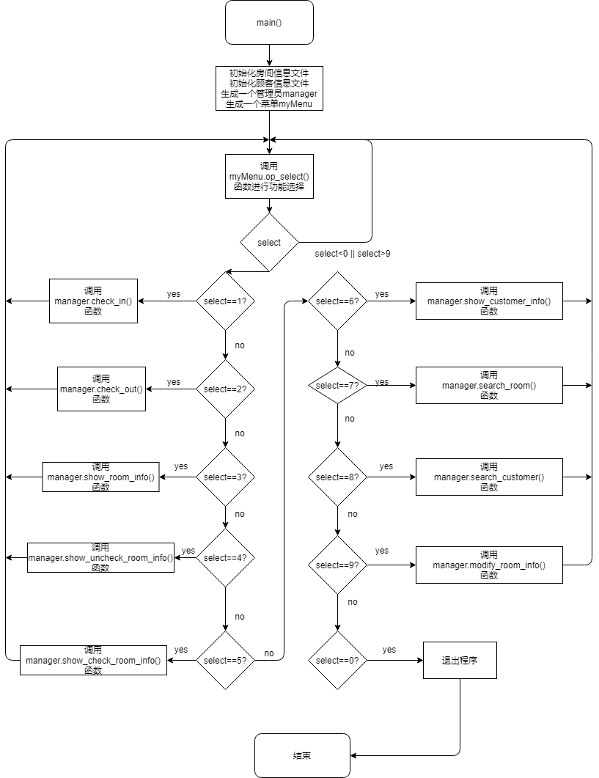

# 每个模块设计分析

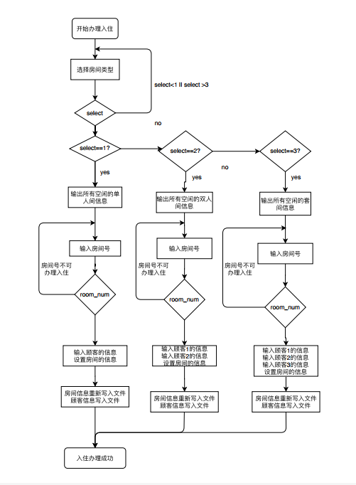**入住办理模块：**

**退房办理模块：**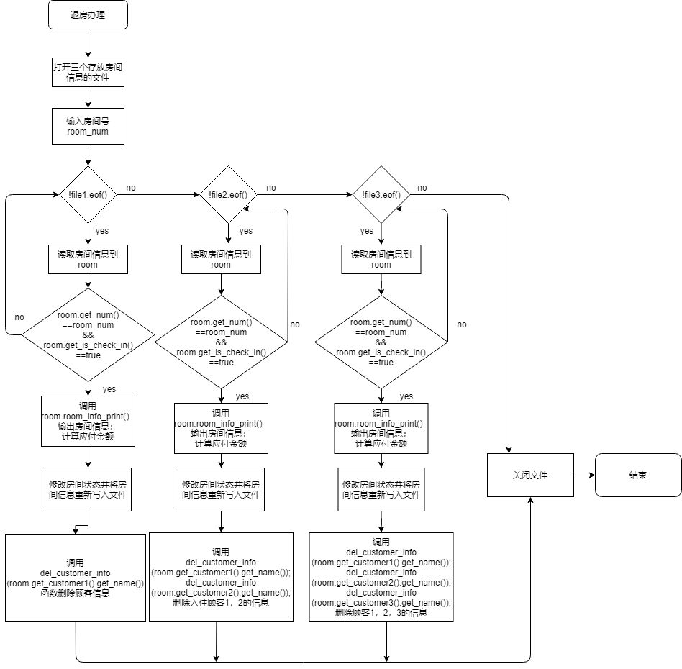

**显示所有房间信息模块：**

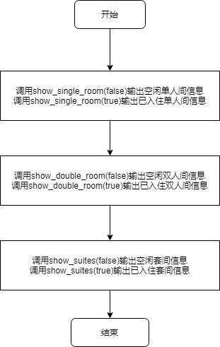

**显示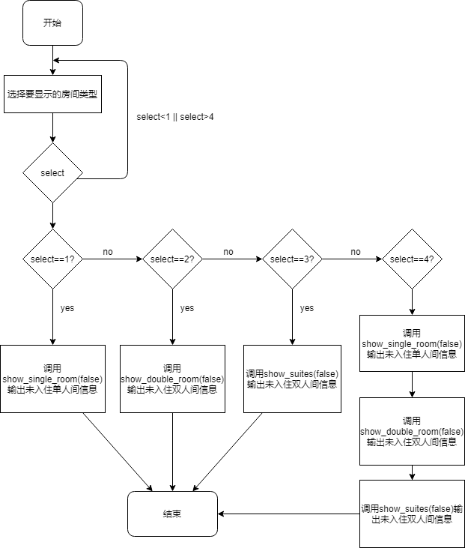空闲房间信息模块：**

**显示已入住房间信息模块：**

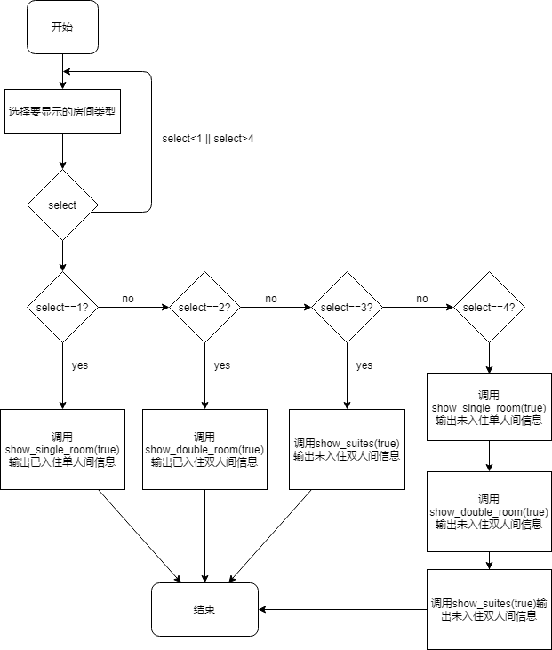

**所有顾客信息输出模块：**

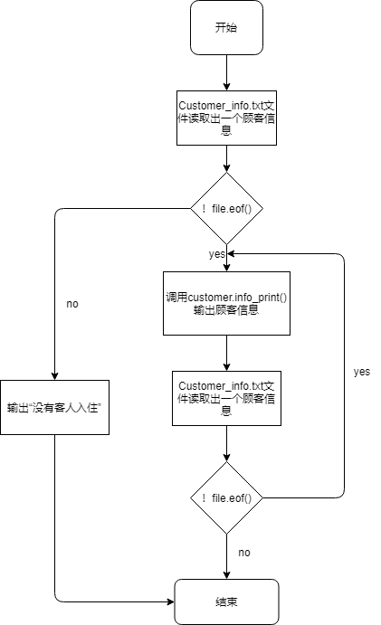

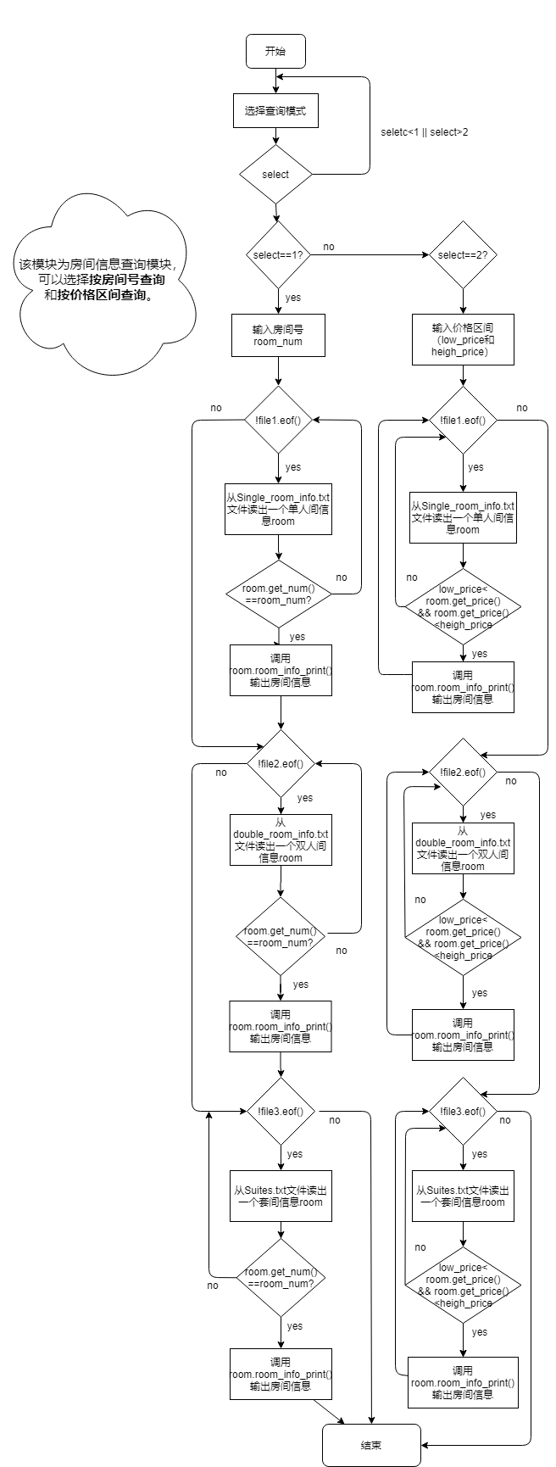**房间信息查询模块：**

**顾客信息查询模块：**

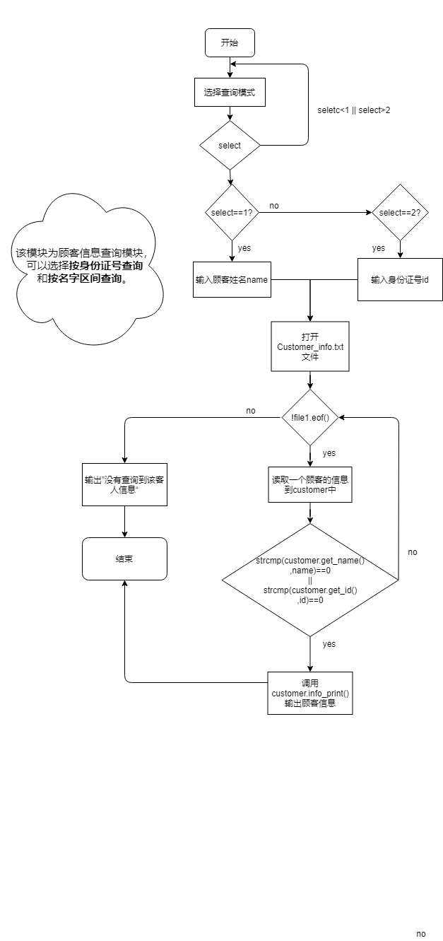

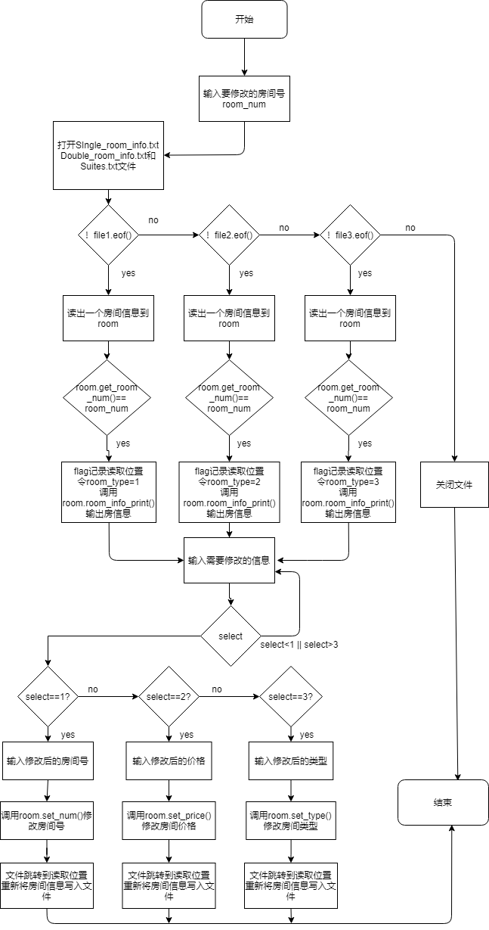**修改房间信息模块：**

# 所有类的定义和函数说明

**Menu类**：

class Menu{

public:

int op_select();

};

说明：该类只有一个函数op_select(),这个函数在main函数中被循环调用，用于输出操作的提示信息和清除屏幕上的内容。直到选择退出才退出该函数同时退出客房管理统。

**Customer类**：

class Customer

{

private:

char name[10]; //姓名

char id[19]; //身份证号

int room_num; //入住房间编号

int days; //入住天数

time_t date; //入住日期

public:

char* get_name();

char* get_id();

int get_room_num();

int get_days();

time_t get_date();

void set_name(char* name);

void set_id(char* id);

void set_room_num(int room_num);

void set_days(int days);

void set_date(time_t &date);

void info_print();

void info_set(char *name,char *id,int room_num,int days,time_t& date);

};

说明：该类表示顾客，用于存放办理入住时需要登记的信息和顾客入住后的房间号(room_num),入住天数(days),和办理入住时的日期(date)。char* get_name()函数用于获取顾客的姓名；char* get_id()函数用于获取顾客的身份证号；int get_room_num()用于获取顾客的房间号；int get_days()函数用于获取顾客办理入住的天数；time_t get_date()用于获取顾客入住的日期。void set_name(char* name)。后面对应的set函数用于对各属性的设置。void info_print()函数用于打印顾客的信息；void info_set(char *name,char *id,int room_num,int days,time_t& date)函数用于一次性设置顾客对象的所有属性。

**Room类**：

class Room{ //父类

protected:

int num; //房间编号

int price; //价格

bool is_check_in; //是否已有人入住

int type; //房间类型（经济间，标准间，豪华间)

int days; //入住天数

time_t date; //入住日期

public:

int get_num();

int get_price();

bool get_is_check_in();

int get_type();

int get_days();

time_t& get_date();

void set_num(int num);

void set_price(int price);

void set_is_check_in(bool check);

void set_type(int type);

void set_days(int days);

void set_date(time_t& date);

void room_info_set(int num,int price,bool is_check_in,int type);

};

说明：该类作为所有房间的父类，所有属性都为 protected类型，方便其子类的访问。int get_num()函数用于获取房间编号；int get_price()函数用于获取房价价格；bool get_is_check_in()函数用于获取房间的状态，如果为true表示已有人入住，反之表示房间为空闲状态；int get_type()函数用于获取房间的类型，返回0表示房间为经济间，1表示标准间，2表示豪华间；int get_days()函数用于获取房间中顾客入住的天数；time_t& get_date()函数用于获取顾客入住的时间。void room_info_set(int num,int price,bool is_check_in,int type)函数用于对num,price,is_check_in,type这几个基本信息的设置（这些信息在没有客人入住的时候就已经可以知道）。对应得后面以set开头的函数就是对房间的各个属性进行设置。

**Single_room类**:

class Single_room:public Room//单人间

{

private:

Customer customer;

public:

void set_cutomer(Customer& customer);

Customer& get_customer();

void room_info_print();

};

说明：该类表示单人间，是Room的子类，继承了Room类的所有属性和函数。同时子类比父类多了一个customer属性，customer用于存放入住的客人的信息。Customer& get_customer()函数用于返回一个Customer类型的对象，该对象存放了入住该房间的客人的信息。void set_cutomer(Customer& customer)函数用于设置该房间入住客人的信息。void room_info_print()函数用于将该单人间的信息打印出来，如果已有顾客入住，就将入住顾客的基本信息也一起打印出来。

**Double_room类**：

class Double_room:public Room

{

private:

Customer customer1; //入住顾客1

Customer customer2; //入住顾客2

public:

void set_cutomer1(Customer& customer1);

void set_cutomer2(Customer& customer2);

Customer& get_customer1();

Customer& get_customer2();

void room_info_print();

};

说明：该类表示的是双人间，同样是Room类的子类。其实例化的对象存放的是双人间的信息，由于是双人间，所以比单人间多了一个Customer类，用于存放入住顾客2的信息。其它函数功能分别为customer1,customer2这两个对象的获取和设置。void room_info_print()函数用于打印该房间的相关信息。

**Suite类**：

class Suite:public Room

{

private:

Customer customer1;

Customer customer2;

Customer customer3;

public :

void set_cutomer1(Customer& customer1);

void set_cutomer2(Customer& customer2);

void set_cutomer3(Customer& customer3);

Customer& get_customer1();

Customer& get_customer2();

Customer& get_customer3();

void room_info_print();

};

说明：该类表示套间，其实例化的的对象用于存放套间的信息。由于套间入住的顾客较多，所以其Customer类型的对象有3个，用于存放入住的顾客的信息。函数分别为对customer1,customer2和customer3这三个对象的获取和设置。void room_info_print()函数用于输出该套间的信息和入住的3个对象的信息

**Manager类**：

class Manager

{

public:

void check_in(); //客人入住办理

void check_out(); //客人退房办理

void show_customer_info(); //展示所有顾客的信息

void show_room_info(); //展示所有房间的信息

void show_uncheck_room_info(); //展示空闲的房间的信息

void show_check_room_info(); //展示所有已入住的房间的信息

void search_room(); //输入房间号，查询房间号信息

void search_customer(); //输入客人姓名，查询客人信息

void modify_room_info(); //修改房间价格

void del_customer_info(char* name);

void show_single_room(bool check_in); //显示单人间房间的信息

void show_double_room(bool check_in); //显示双人间房间的信息

void show_suites(bool check_in); //显示套间的房间信息

void init_room_info(); //初始化(文件)数据库

};

说明：该类表示管理员。

check_in()函数实现客人的入住办理；

check_out()函数实现客人的退房办理；

show_customer_info()实现所有入住的客人的信息的打印；show_room_info()实现所有房间的信息的打印；show_uncheck_room_info()函数实现所有空闲房间的信息打印；show_check_room_info()函数实现所有已有顾客入住的房间的信息的打印；search_room()函数用于输入房间号或价格区间查找符合的房间的信息；search_customer()函数用于输入顾客的姓名或身份证号查找该顾客的信息；modify_room_info()函数用于对空闲的房间的信息进行修改，可以修改的房间信息为房间号，价格，和房间的类型；

del_customer_info(char* name)函数用于删除入住顾客的信息，在管理员给顾客进行退房办理时调用；

show_single_room(bool check_in)函数根据check_in的值输出符合的单人间的信息，如果check_in==true则输出所有已有顾客入住的单人间的信息，如果check_in==false则输出空闲的单人间的房间的信息。

show_double_room(bool check_in)和上述一致，根据check_in的值输出符合的双人间的信息。

show_suites(bool check_in)用于输出相应的套间的信息。

init_room_info()函数用于管理员进入系统时将单人间，双人间，套间的信息初始化并写入相应的文件。

# 特色函数算法

特色算法1：

void Manager::del_customer_info(char *name)

{

fstream file1("Customer_info.txt",ios::in|ios::out);

if(!file1)

{

cout<<"客人信息数据库访问失败";

exit(0);

}

fstream file2("temp.txt",ios::out);//文件不存在会自动生成

if(!file2)

{

cout<<"临时文件生成失败！";

exit(0);

}

file1.clear();

file1.seekg(0,ios::beg);

Customer customer;

file1.read((char*)&customer,sizeof(customer));

while(!file1.eof())

{

if(strcmp(customer.get_name(),name)!=0)

{

file2.write((char*)&customer,sizeof(customer));

}

file1.read((char*)&customer,sizeof(customer));

}

file1.close();

file2.close();

remove("Customer_info.txt");

rename("temp.txt","Customer_info.txt");

}

函数说明：该函数实现的是将某个客人的信息从存放客人信息的文件中删除。一般的做法是将文件中的所有信息读入到链表或数组中，然后对链表或数组进行遍历，将不需要删除的信息以覆盖的方式重新写入到文件中去。这样做的缺点是需要花费O(n)的空间复杂度来存放文件的数据。我的做法是使用fstream file2("temp.txt",ios::out)语句来创建一个空的临时文件。然后对存放顾客信息的文件(Customer_info.txt)进行顺序读取，如果不是要删除的信息就写入到临时文件中(temp.txt)。当Customer_info.txt文件中的数据读取完后，temp.txt文件中保存的就是删除指定信息后的数据。最后使用remove("Customer_info.txt")将原来的Customer_info.txt文件删除，再用rename("temp.txt","Customer_info.txt")将临时文件temp.txt的名字修改为Customer_info.txt。这样就实现了在O(1)的空间复杂度内实现了对顾客信息的删除。

特色算法2：

fstream file1("Single_room_info.txt",ios::in|ios::out);

if(!file1)

{

cout<<"单人间数据库访问失败!";

exit(0);

}

Single_room room;

do{

cout<<"输入房间号：";

cin>>room_num;

file1.clear(); //将文件的状态初始化

file1.seekg(0L,ios::beg);//跳转到文件开头

while(!file1.eof())

{

flag=file1.tellg(); //得到文件位置指针，便于数据的修改

file1.read((char*)&room,sizeof(room));

if(room.get_num()==room_num && room.get_is_check_in()==false) //查找到该房间号

{

search=true;

break;

}

}

if(!search)

{

cout<<"房间号错误或该房间已有顾客入住!请从新输入房间号"<<endl;

}

}while(!search);//对每次输入的房间号进行检查，看是否存在和空闲

cout<<"输入顾客姓名：";

cin>>name;

cout<<"输入身份证号：";

cin>>id;

cout<<"输入入住天数：";

cin>>days;

date=time(0);

Customer customer;

customer.info_set(name,id,room_num,days,date);

room.set_days(days);

room.set_is_check_in(true);

room.set_cutomer(customer);

room.set_date(date);

fstream file2("Customer_info.txt",ios::in|ios::out|ios::app);

if(!file2)

{

cout<<"客人信息数据库访问失败";

exit(0);

}

file1.seekp(flag,ios::beg);

file1.write((char*)&room,sizeof(room)); //重新写入房间信息

file2.write((char*)&customer,sizeof(customer)); //写入客人信息

file1.close();

file2.close();

cout<<"入住办理成功！"<<endl;

函数说明：上述代码段是Manager::check_in()函数中的一部分，该函数实现客人的入住办理。客人入住办理时需要输入房间号，然后查询这个房间号是否存在或是否已经有人入住。如果存在且没有人入住就输入客人的信息。最后修改房间的信息重新写入到文件中，同时将客人的信息写入到文件中。

}

}while(!search);//对每次输入的房间号进行检查，看是否存在和空闲

cout<<"输入顾客姓名：";

cin>>name;

cout<<"输入身份证号：";

cin>>id;

cout<<"输入入住天数：";

cin>>days;

date=time(0);

Customer customer;

customer.info_set(name,id,room_num,days,date);

room.set_days(days);

room.set_is_check_in(true);

room.set_cutomer(customer);

room.set_date(date);

fstream file2("Customer_info.txt",ios::in|ios::out|ios::app);

if(!file2)

{

cout<<"客人信息数据库访问失败";

exit(0);

}

file1.seekp(flag,ios::beg);

file1.write((char*)&room,sizeof(room)); //重新写入房间信息

file2.write((char*)&customer,sizeof(customer)); //写入客人信息

file1.close();

file2.close();

cout<<"入住办理成功！"<<endl;

但是如果输入的房间号不对，就查询不到符合的信息。所以这里加了一个do{}while()循环来重复输入直到房间号可以办理入住。但是对于新输入的房间号进行查询时，发现即使输入的房间号是正确的，也会提示房间号不能办理入住。这是因为第一次查询结束后，文件的指针到了文件的末尾。所以总是查询不到输入的房间的信息，要想解决这个问题可以在每一次读完文件之后将文件关闭，第二次要读的时候再重新打开（重新打开文件时，文件指针在文件开始出）。但是这样重复的关闭和打开文件，程序的开销就会增大，为了解决这个问题。我在每次对文件读写之前使用了file1.clear()函数，这个函数清除了文件中指针的状态，然后再用file1.seekg(0L,ios::beg)函数将文件位置指针跳转到文件的开始处。这样就避免了每次从文件头开始访问之前都要重新打开文件。

同时在读取到符合的房间信息的时候用flag=file1.tellg()语句将读取到这个房间信息的位置记录了下来，对房间的信息进行修改过后，再使用file1.seekp(flag,ios::beg)语句将写入指针跳转到刚才的位置，最后在这个位置重新写入房间的信息file1.write((char*)&room,sizeof(room))。这样写入会用新的房间信息覆盖原来的房间信息，就实现了房间信息的修改。这样做就不用将整个文件的数据读到链表进行修改后再写入，减少了时间和空间的开销。

# 存在的不足与对策

|  |  |
| --- | --- |
| **不足** | **对策** |
| 不够美观，依然停留在控制台界面 | 自学图形界面 |
| modify_room_info()函数只实现了对房间的一些基本信息的修改。有些修改需要同时修改存放房间数据的文件和存放顾客数据的文件，这部分内容较为复杂没有实现。 | 继续编程补充相应的功能 |
| 输入数据时不能判断数据是否合法，可能导致程序出错。比如输入身份证号时输入的位数大于了19位程序就会出错。 | 继续对代码进行优化，当  输入数据不合法时给出提示信息 |

# 

# 使用说明

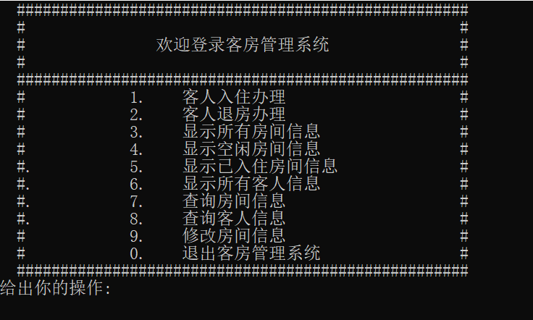使用vs2010打开项目“客房管理系统2.0”点击运行即可运行。程序运行后，会输出如图所示的功能选项。选择对应的数字后就可以进行操作。房间信息在程序启动时已经写入到文件中，不需要手动输入。

客人入住办理功能演示：

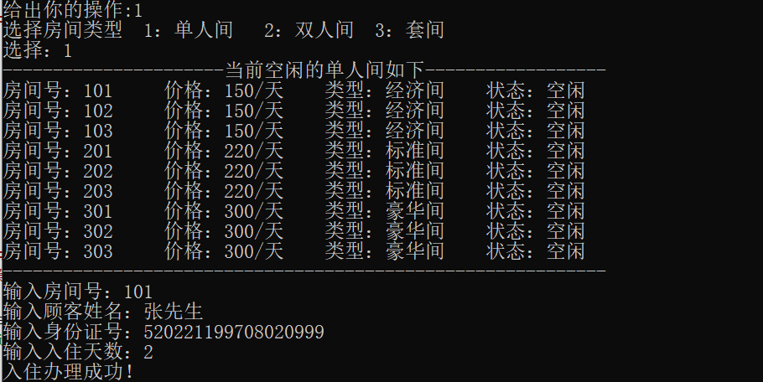

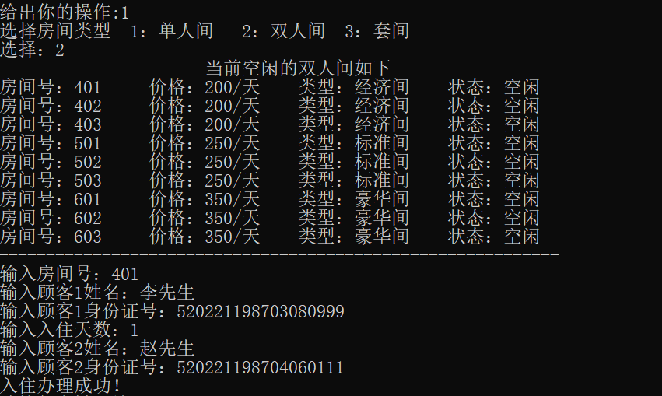

显示所有房间信息功能演示**：**

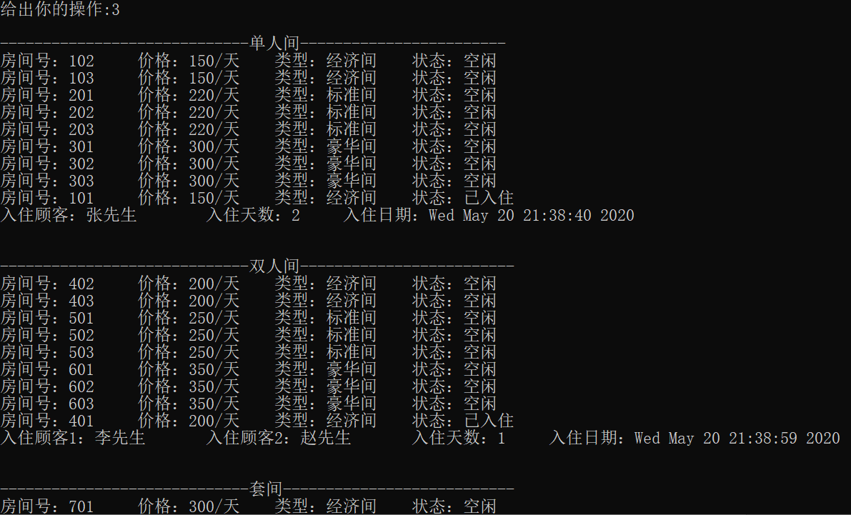

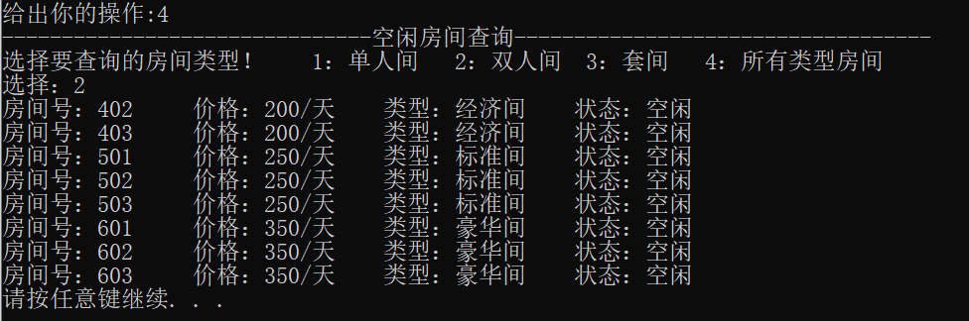显示所有空闲房间功能演示：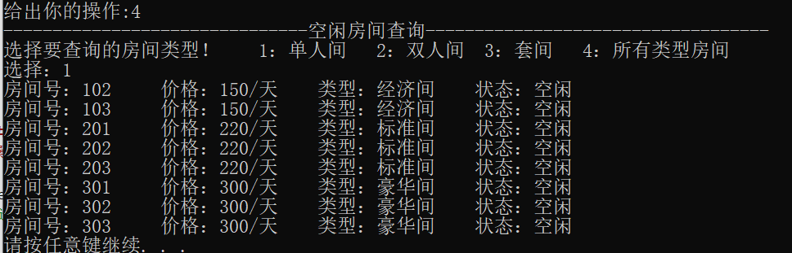

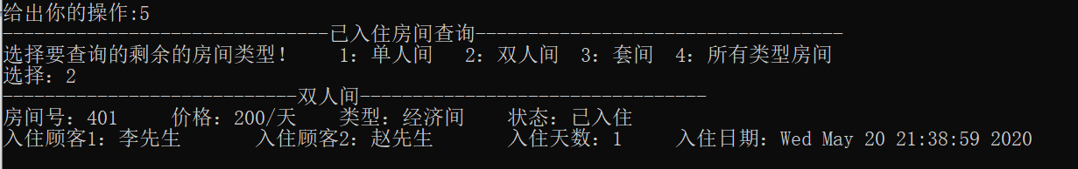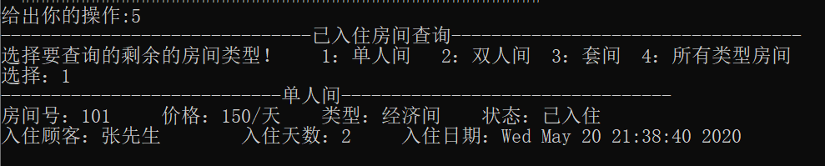显示已入住房间信息功能演示：

显示所有顾客信息功能演示：

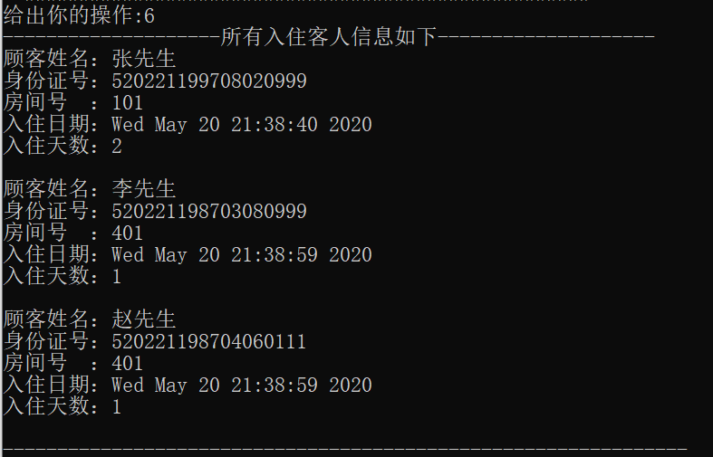

查询房间信息功能演示：

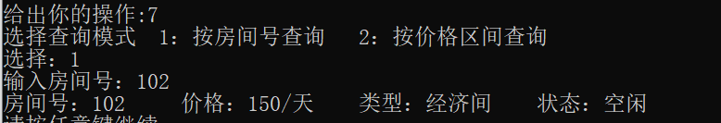

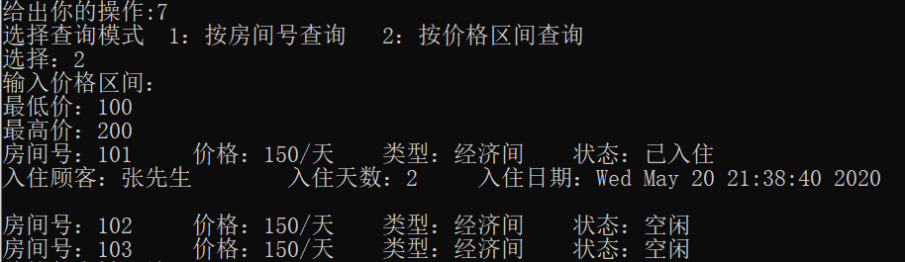

查询客人信息功能演示：

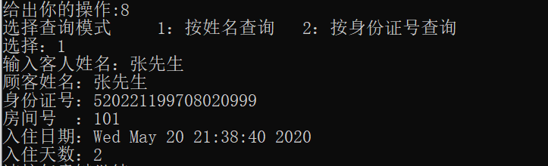

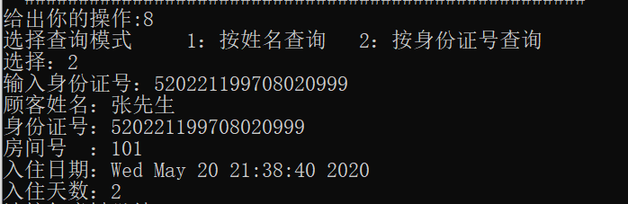

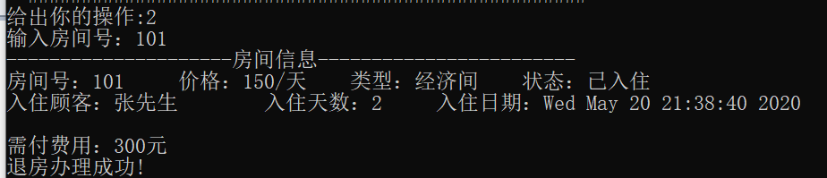客人退房办理功能演示：

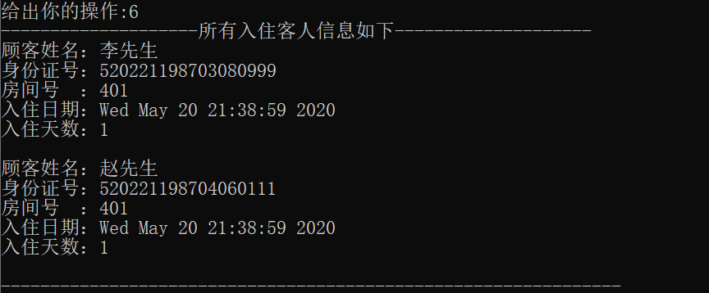

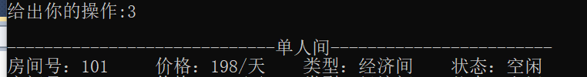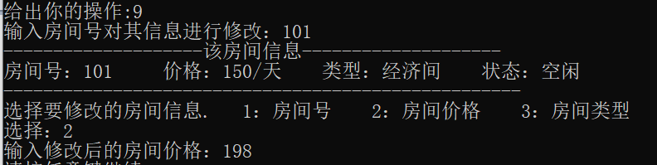房间信息修改功能演示：

# 程序源代码

**Main.c**

#include "Menu.h"

#include "Manager.h"

#include "Customer.h"

#include <fstream>

int main()

{

Menu myMenu;

Manager manager;

manager.init_room_info();

while(1)

{

switch(myMenu.op_select())

{

case 1:

manager.check_in();//客人入住办理

system("pause");

break;

case 2:

manager.check_out();//客人退房办理

system("pause");

break;

case 3:

manager.show_room_info();//显示所有房间信息

system("pause");

break;

case 4:

manager.show_uncheck_room_info();//显示未入住房间信息

system("pause");

break;

case 5:

manager.show_check_room_info();//显示已入住房间信息

system("pause");

break;

case 6:

manager.show_customer_info();//显示所有客人信息

system("pause");

break;

case 7:

manager.search_room();//查询房间信息

system("pause");

break;

case 8:

manager.search_customer();//查询客人信息

system("pause");

break;

case 9:

manager.modify_room_info();//修改房间信息

system("pause");

break;

case 0:

exit(0);

}

}

return 0;

}

**Menu.h**

#ifndef MENU_H

#define MENU_H

#include <iostream>

using namespace std;

class Menu{

public:

int op_select();

};

#endif

**Memu.cpp**

#include "Menu.h"

int Menu::op_select()

{

int select;

do

{

system("cls");

cout<<" ####################################################\n";

cout<<" # #\n";

cout<<" # 欢迎登录客房管理系统 #\n";

cout<<" # #\n";

cout<<" ####################################################\n";

cout<<" # 1. 客人入住办理 #\n";

cout<<" # 2. 客人退房办理 #\n";

cout<<" # 3. 显示所有房间信息 #\n";

cout<<" # 4. 显示空闲房间信息 #\n";

cout<<" #. 5. 显示已入住房间信息 #\n";

cout<<" #. 6. 显示所有客人信息 #\n";

cout<<" #. 7. 查询房间信息 #\n";

cout<<" #. 8. 查询客人信息 #\n";

cout<<" # 9. 修改房间信息 #\n";

cout<<" # 0. 退出客房管理系统 #\n";

cout<<" ####################################################\n";

cout<<"给出你的操作:";

cin>>select;

}while(select<0 || select>9);

return select;//返回选择的功能

}

**Customer.h**

#ifndef CUSTOMER_H

#define CUSTOMER_H

#include <ctime>

class Customer

{

private:

char name[10];

char id[19]; //身份证号

int room_num; //入住房间编号

int days; //入住天数

time_t date; //入住日期

public:

char* get_name();

char* get_id();

int get_room_num();

int get_days();

time_t get_date();

void set_name(char* name);

void set_id(char* id);

void set_room_num(int room_num);

void set_days(int days);

void set_date(time_t &date);

void info_print();

void info_set(char *name,char *id,int room_num,int days,time_t& date);

};

#endif

**Customer.cpp**

#include "Customer.h"

#include <iostream>

using namespace std;

char* Customer::get_name()

{

return this->name;

}

char* Customer::get_id()

{

return this->id;

}

int Customer::get_room_num()

{

return this->room_num;

}

int Customer::get_days()

{

return this->days;

}

time_t Customer::get_date()

{

return this->date;

}

void Customer::set_name(char *name)

{

strcpy(this->name,name);

}

void Customer::set_id(char *id)

{

strcpy(this->id,id);

}

void Customer::set_days(int days)

{

this->days=days;

}

void Customer::set_room_num(int room_num)

{

this->room_num=room_num;

}

void Customer::set_date(time_t &date)

{

this->date=date;

}

void Customer::info_set(char *name,char *id,int room_num,int days,time_t& date)

{

strcpy(this->name,name);

strcpy(this->id,id);

this->room_num=room_num;

this->days=days;

this->date=date;

}

void Customer::info_print()

{

cout<<"顾客姓名："<<this->name<<endl;

cout<<"身份证号："<<this->id<<endl;

cout<<"房间号 ："<<this->room_num<<endl;

cout<<"入住日期："<<ctime(&(this->date));

cout<<"入住天数："<<this->days<<endl;

}

**Room.h**

#ifndef ROOM_H

#define ROOM_H

#include <iostream>

using namespace std;

#include "Customer.h"

enum{ECONOMY_ROOM,STANDARD_ROOM,DELUXE_ROOM};//房间的类型

#define UNCHECK false

#define CHECK true

class Room{ //父类

protected:

int num; //房间编号

int price; //价格

bool is_check_in; //是否已有人入住

int type; //房间类型（经济间，标准间，豪华间)

int days; //入住天数

time_t date; //入住日期

public:

int get_num();

int get_price();

bool get_is_check_in();

int get_type();

int get_days();

time_t& get_date();

void set_num(int num);

void set_price(int price);

void set_is_check_in(bool check);

void set_type(int type);

void set_days(int days);

void set_date(time_t& date);

void room_info_set(int num,int price,bool is_check_in,int type);

};

#endif

**Room.cpp**

#include "Room.h"

#include <fstream>

int Room::get_num()

{

return this->num;

}

int Room::get_price()

{

return this->price;

}

bool Room::get_is_check_in()

{

return this->is_check_in;

}

int Room::get_days()

{

return this->days;

}

void Room::set_num(int num)

{

this->num=num;

}

void Room::set_price(int price)

{

this->price=price;

}

void Room::set_type(int type)

{

this->type=type;

}

void Room::set_days(int days)

{

this->days=days;

}

void Room::set_is_check_in(bool check)

{

this->is_check_in=check;

}

void Room::set_date(time_t& date)

{

this->date=date;

}

time_t& Room::get_date()

{

return this->date;

}

void Room::room_info_set(int num,int price,bool is_check_in,int type)

{

this->num=num;

this->price=price;

this->is_check_in=is_check_in;

this->type=type;

}

**Single_room.h**

#ifndef SINGLE_ROOM_H

#define SINGLE_ROOM_H

#include "Room.h"

class Single_room:public Room//派生类

{

private:

Customer customer;

public:

void set_cutomer(Customer& customer);

Customer& get_customer();

//void room_info_set(int num,int price,bool is_check_in,int type);

void room_info_print();//

};

#endif

**Single_room.cpp**

#include "Single_room.h"

void Single_room::set_cutomer(Customer& customer)

{

this->customer=customer;

}

Customer& Single_room::get_customer()

{

return this->customer;

}

void Single_room::room_info_print()

{

cout<<"房间号："<<this->num<<"\t";

cout<<"价格："<<this->price<<"/天"<<"\t";

switch(this->type)

{

case 0:

cout<<"类型：经济间"<<"\t";

break;

case 1:

cout<<"类型：标准间"<<"\t";

break;

case 2:

cout<<"类型：豪华间"<<"\t";

break;

}

if(is_check_in)

{

cout<<"状态：已入住"<<endl;

cout<<"入住顾客："<<this->customer.get_name()<<"\t";

cout<<"入住天数："<<this->days<<"\t";

cout<<"入住日期："<<ctime(&(this->date));

}

else

{

cout<<"状态：空闲"<<"\t";

}

cout<<endl;

}

**Double_room.h**

#include "Room.h"

class Double_room:public Room

{

private:

Customer customer1; //入住顾客1

Customer customer2; //入住顾客2

public:

void set_cutomer1(Customer& customer1);

void set_cutomer2(Customer& customer2);

Customer& get_customer1();

Customer& get_customer2();

//void room_info_set(int num,int price,bool is_check_in,int type);

void room_info_print();

};

**Double_room.cpp**

#include "Double_room.h"

void Double_room::set_cutomer1(Customer& customer1)

{

this->customer1=customer1;

}

void Double_room::set_cutomer2(Customer& customer2)

{

this->customer2=customer2;

}

Customer& Double_room::get_customer1()

{

return this->customer1;

}

Customer& Double_room::get_customer2()

{

return this->customer2;

}

void Double_room::room_info_print()

{

cout<<"房间号："<<this->num<<"\t";

cout<<"价格："<<this->price<<"/天"<<"\t";

switch(this->type)

{

case 0:

cout<<"类型：经济间"<<"\t";

break;

case 1:

cout<<"类型：标准间"<<"\t";

break;

case 2:

cout<<"类型：豪华间"<<"\t";

break;

}

if(is_check_in)

{

cout<<"状态：已入住"<<endl;

cout<<"入住顾客1："<<this->customer1.get_name()<<"\t";

cout<<"入住顾客2："<<this->customer2.get_name()<<"\t";

cout<<"入住天数："<<this->days<<"\t";

cout<<"入住日期："<<ctime(&(this->date));

}

else

{

cout<<"状态：空闲"<<"\t";

}

cout<<endl;

}

**Suite.h**

#include "Room.h"

#include "Customer.h"

class Suite:public Room

{

private:

Customer customer1;

Customer customer2;

Customer customer3;

public :

void set_cutomer1(Customer& customer1);

void set_cutomer2(Customer& customer2);

void set_cutomer3(Customer& customer3);

Customer& get_customer1();

Customer& get_customer2();

Customer& get_customer3();

//void room_info_set(int num,int price,bool is_check_in,int type);

void room_info_print();

};

**Suite.cpp**

#include "Suite.h"

void Suite::set_cutomer1(Customer& customer1)

{

this->customer1=customer1;

}

void Suite::set_cutomer2(Customer& customer2)

{

this->customer2=customer2;

}

void Suite::set_cutomer3(Customer& customer3)

{

this->customer2=customer3;

}

Customer& Suite::get_customer1()

{

return this->customer1;

}

Customer& Suite::get_customer2()

{

return this->customer2;

}

Customer& Suite::get_customer3()

{

return this->customer3;

}

void Suite::room_info_print()

{

cout<<"房间号："<<this->num<<"\t";

cout<<"价格："<<this->price<<"/天"<<"\t";

switch(this->type)

{

case 0:

cout<<"类型：经济间"<<"\t";

break;

case 1:

cout<<"类型：标准间"<<"\t";

break;

case 2:

cout<<"类型：豪华间"<<"\t";

break;

}

if(is_check_in)

{

cout<<"状态：已入住"<<endl;

cout<<"入住顾客1："<<this->customer1.get_name()<<"\t";

cout<<"入住顾客2："<<this->customer2.get_name()<<"\t";

cout<<"入住顾客3："<<this->customer3.get_name()<<"\t";

cout<<"入住天数："<<this->days<<"\t";

cout<<"入住日期："<<ctime(&(this->date));

}

else

{

cout<<"状态：空闲"<<"\t";

}

cout<<endl;

}

**Manager.h**

#ifndef MANAGER_H

#define MANAGER_H

class Manager

{

public:

void check_in(); //客人入住办理

void check_out(); //客人退房办理

void show_customer_info(); //展示所有顾客的信息

void show_room_info(); //展示所有房间的信息

void show_uncheck_room_info(); //展示空闲的房间的信息

void show_check_room_info(); //展示所有已入住的房间的信息

void search_room(); //输入房间号，查询房间号信息

void search_customer(); //输入客人姓名，查询客人信息

void modify_room_info(); //修改房间价格

void del_customer_info(char* name);

void show_single_room(bool check_in); //显示单人间房间的信息

void show_double_room(bool check_in); //显示双人间房间的信息

void show_suites(bool check_in); //显示套间的房间信息

void init_room_info(); //初始化(文件)数据库

};

#endif

**Manager.cpp**

#include "Manager.h"

#include "Customer.h"

#include "Room.h"

#include "Single_room.h"

#include "Double_room.h"

#include "Suite.h"

#include <fstream>

#include <iostream>

using namespace std;

/*客人入住办理*/

void Manager::check_in()

{

cout<<"选择房间类型 1：单人间 2：双人间 3：套间"<<endl;

int select;

do{

cout<<"选择：";

cin>>select;

}while(select<1 || select>3);

int room_num;

char name[10];

char id[19];

int days;

time_t date;

bool search=false;

streampos flag; //相对起点的位置

switch(select)

{

case 1:

{

cout<<"----------------------当前空闲的单人间如下------------------"<<endl;

this->show_single_room(UNCHECK); //显示空闲的单人间信息

cout<<"------------------------------------------------------------"<<endl;

fstream file1("Single_room_info.txt",ios::in|ios::out);

if(!file1)

{

cout<<"单人间数据库访问失败!";

exit(0);

}

Single_room room;

do{

cout<<"输入房间号：";

cin>>room_num;

file1.clear(); //将文件的状态初始化

file1.seekg(0L,ios::beg);//跳转到文件开头

while(!file1.eof())

{

flag=file1.tellg(); //得到文件位置指针，便于数据的修改

file1.read((char*)&room,sizeof(room));

if(room.get_num()==room_num && room.get_is_check_in()==false) //查找到该房间号

{

search=true;

break;

}

}

if(!search)

{

cout<<"房间号错误或该房间已有顾客入住!请从新输入房间号"<<endl;

}

}while(!search);//对每次输入的房间号进行检查，看是否存在和空闲

cout<<"输入顾客姓名：";

cin>>name;

cout<<"输入身份证号：";

cin>>id;

cout<<"输入入住天数：";

cin>>days;

date=time(0);

Customer customer;

customer.info_set(name,id,room_num,days,date);

room.set_days(days);

room.set_is_check_in(true);

room.set_cutomer(customer);

room.set_date(date);

fstream file2("Customer_info.txt",ios::in|ios::out|ios::app);

if(!file2)

{

cout<<"客人信息数据库访问失败";

exit(0);

}

file1.seekp(flag,ios::beg);

file1.write((char*)&room,sizeof(room)); //重新写入房间信息

file2.write((char*)&customer,sizeof(customer)); //写入客人信息

file1.close();

file2.close();

cout<<"入住办理成功！"<<endl;

break;

}

case 2:

{

cout<<"----------------------当前空闲的双人间如下------------------"<<endl;

this->show_double_room(UNCHECK);

cout<<"------------------------------------------------------------"<<endl;

fstream file1("Double_room_info.txt",ios::in|ios::out);

if(!file1)

{

cout<<"双人间数据库访问失败!";

exit(0);

}

Double_room room;

do{

cout<<"输入房间号：";

cin>>room_num;

file1.clear(); //将文件的状态初始化

file1.seekg(0L,ios::beg);//跳转到文件开头

while(!file1.eof())

{

flag=file1.tellg(); //得到文件位置指针，便于数据的修改

file1.read((char*)&room,sizeof(room));

if(room.get_num()==room_num && room.get_is_check_in()==false) //查找到该房间号

{

search=true;

break;

}

}

if(!search)

{

cout<<"房间号错误或该房间已有顾客入住!请从新输入房间号"<<endl;

}

}while(!search); //对每次输入的房间号进行检查，看是否存在或空闲

cout<<"输入顾客1姓名：";

cin>>name;

cout<<"输入顾客1身份证号：";

cin>>id;

cout<<"输入入住天数：";

cin>>days;

date=time(0);

Customer customer1;

customer1.info_set(name,id,room_num,days,date);//顾客1信息设置

cout<<"输入顾客2姓名：";

cin>>name;

cout<<"输入顾客2身份证号：";

cin>>id;

Customer customer2;

customer2.info_set(name,id,room_num,days,date);//顾客2信息设置

room.set_days(days);

room.set_is_check_in(true);

room.set_cutomer1(customer1);

room.set_cutomer2(customer2);

room.set_date(date);//房间信息设置

fstream file2("Customer_info.txt",ios::in|ios::out|ios::app);

if(!file2)

{

cout<<"客人信息数据库访问失败";

exit(0);

}

file1.seekp(flag,ios::beg);

file1.write((char*)&room,sizeof(room)); //重新写入房间信息

file2.write((char*)&customer1,sizeof(customer1));//写入顾客1信息

file2.write((char*)&customer2,sizeof(customer2));//写入顾客2信息

file1.close();

file2.close();

cout<<"入住办理成功！"<<endl;

break;

}

case 3:

{

cout<<"----------------------当前空闲的套间如下------------------"<<endl;

this->show_suites(UNCHECK);

cout<<"------------------------------------------------------------"<<endl;

fstream file1("Suites.txt",ios::in|ios::out);

if(!file1)

{

cout<<"套间数据库访问失败!";

exit(0);

}

Suite room;

do{

cout<<"输入房间号：";

cin>>room_num;

file1.clear(); //将文件的状态初始化

file1.seekg(0L,ios::beg);//跳转到文件开头

while(!file1.eof())

{

flag=file1.tellg(); //得到文件位置指针，便于数据的修改

file1.read((char*)&room,sizeof(room));

if(room.get_num()==room_num && room.get_is_check_in()==false) //查找到该房间号

{

search=true;

break;

}

}

if(!search)

{

cout<<"房间号错误或该房间已有顾客入住!请从新输入房间号"<<endl;

}

}while(!search);//对每次输入的房间号进行检查，看是否存在和空闲

cout<<"输入顾客1姓名：";

cin>>name;

cout<<"输入顾客1身份证号：";

cin>>id;

cout<<"输入入住天数：";

cin>>days;

date=time(0);

Customer customer1;

customer1.info_set(name,id,room_num,days,date);//顾客1信息设置

cout<<"输入顾客2姓名：";

cin>>name;

cout<<"输入顾客2身份证号：";

cin>>id;

Customer customer2;

customer2.info_set(name,id,room_num,days,date);//顾客2信息设置

cout<<"输入顾客3姓名：";

cin>>name;

cout<<"输入顾客3身份证号：";

cin>>id;

Customer customer3;

customer3.info_set(name,id,room_num,days,date);//顾客3信息设置

room.set_days(days);

room.set_is_check_in(true);

room.set_cutomer1(customer1);

room.set_cutomer1(customer2);

room.set_cutomer3(customer3);

room.set_date(date);//房间信息设置

fstream file2("Customer_info.txt",ios::in|ios::out|ios::app);

if(!file2)

{

cout<<"客人信息数据库访问失败";

exit(0);

}

file1.seekp(flag,ios::beg);

file1.write((char*)&room,sizeof(room)); //重新写入房间信息

file2.write((char*)&customer1,sizeof(customer1));//写入客人1信息

file2.write((char*)&customer2,sizeof(customer2));//写入客人2信息

file2.write((char*)&customer3,sizeof(customer3));//写入客人3信息

file1.close();

file2.close();

cout<<"入住办理成功！"<<endl;

break;

}

}

}

/*客人退房办理*/

void Manager::check_out()

{

fstream file1("Single_room_info.txt",ios::in|ios::out);

if(!file1)

{

cout<<"单人间数据库访问失败";

exit(0);

}//打开单人间数据库

fstream file2("Double_room_info.txt",ios::in|ios::out);

if(!file2)

{

cout<<"双人间数据库访问失败";

exit(0);

}//打开双人间数据库

fstream file3("Suites.txt",ios::in|ios::out);

if(!file3)

{

cout<<"双人间数据库访问失败";

exit(0);

}//打开套间数据库

int room_num;

cout<<"输入房间号：";

cin>>room_num;

bool search=false;

streampos flag;

while(!file1.eof())

{

Single_room room;

flag=file1.tellg();

file1.read((char*)&room,sizeof(room));

if(room.get_num()==room_num && room.get_is_check_in()==true)

{

search=true;

cout<<"---------------------房间信息------------------------"<<endl;

room.room_info_print();

cout<<"需付费用："<<room.get_price() *room.get_days()<<"元"<<endl;

room.set_is_check_in(false);

room.set_days(0);

del_customer_info(room.get_customer().get_name());

//顾客信息删除

file1.seekp(flag,ios::beg);

file1.write((char*)&room,sizeof(room));

cout<<"退房办理成功!"<<endl;

break;

}

}

while(!file2.eof())

{

Double_room room;

flag=file1.tellg();

file2.read((char*)&room,sizeof(room));

if(room.get_num()==room_num && room.get_is_check_in()==true)

{

search=true;

cout<<"---------------------房间信息------------------------"<<endl;

room.room_info_print();

cout<<"需付费用："<<room.get_price() *room.get_days()<<"元"<<endl;

room.set_is_check_in(false);

room.set_days(0);

del_customer_info(room.get_customer1().get_name());

del_customer_info(room.get_customer2().get_name());

//顾客信息删除

file1.seekp(flag,ios::beg);

file1.write((char*)&room,sizeof(room));

cout<<"退房办理成功!"<<endl;

break;

}

}

while(!file3.eof())

{

Suite room;

flag=file1.tellg();

file3.read((char*)&room,sizeof(room));

if(room.get_num()==room_num && room.get_is_check_in()==true)

{

search=true;

cout<<"---------------------房间信息------------------------"<<endl;

room.room_info_print();

cout<<"需付费用："<<room.get_price() *room.get_days()<<"元"<<endl;

room.set_is_check_in(false);

room.set_days(0);

del_customer_info(room.get_customer1().get_name());

del_customer_info(room.get_customer2().get_name());

del_customer_info(room.get_customer3().get_name());

//顾客信息删除

file1.seekp(flag,ios::beg);

file1.write((char*)&room,sizeof(room));

cout<<"退房办理成功!"<<endl;

break;

}

}

if(search==false)

{

cout<<"房间号错误或该房间没有人入住!"<<endl;

}

file1.close();

file2.close();

file3.close();

}

/*显示所有房间信息*/

void Manager::show_room_info()

{

cout<<endl<<"-----------------------------单人间------------------------"<<endl;

this->show_single_room(false);

this->show_single_room(true);

cout<<endl<<"-----------------------------双人间-------------------------"<<endl;

this->show_double_room(false);

this->show_double_room(true);

cout<<endl<<"-----------------------------套间---------------------------"<<endl;

this->show_suites(false);

this->show_suites(true);

}

/*显示所有未入住房间信息*/

void Manager::show_uncheck_room_info()

{

cout<<"-------------------------------空闲房间查询-----------------------------------"<<endl;

cout<<"选择要查询的房间类型！ 1：单人间 2：双人间 3：套间 4：所有类型房间"<<endl;

int select;

do

{

cout<<"选择：";

cin>>select;

}while(select<1 || select>4);

switch(select)

{

case 1:

{

this->show_single_room(false);

break;

}

case 2:

{

this->show_double_room(false);

break;

}

case 3:

{

this->show_suites(false);

break;

}

case 4:

{

cout<<"----------------------------单人间-------------------------"<<endl;

this->show_single_room(false);

cout<<"----------------------------双人间-------------------------"<<endl;

this->show_double_room(false);

cout<<"----------------------------套间---------------------------"<<endl;

this->show_suites(false);

break;

}

}

}

/*显示所有已入住房间信息*/

void Manager::show_check_room_info()//展示所有已入住的房间

{

cout<<"-------------------------------已入住房间查询-----------------------------------"<<endl;

cout<<"选择要查询的剩余的房间类型！ 1：单人间 2：双人间 3：套间 4：所有类型房间"<<endl;

int select;

do

{

cout<<"选择：";

cin>>select;

}while(select<1 || select>4);

switch(select)

{

case 1:

{

cout<<"----------------------------单人间---------------------------------"<<endl;

this->show_single_room(true);

break;

}

case 2:

{

cout<<"----------------------------双人间---------------------------------"<<endl;

this->show_double_room(true);

break;

}

case 3:

{

this->show_suites(true);

break;

}

case 4:

{

cout<<"----------------------------单人间---------------------------------"<<endl;

this->show_single_room(true);

cout<<"----------------------------双人间---------------------------------"<<endl;

this->show_double_room(true);

cout<<"----------------------------套间-----------------------------------"<<endl;

this->show_suites(true);

break;

}

}

}

/*显示所有客人信息*/

void Manager::show_customer_info()

{

int num=0;

cout<<"--------------------所有入住客人信息如下--------------------"<<endl;

fstream file("Customer_info.txt",ios::in|ios::out);

if(!file)

{

cout<<"用户信息数据库访问失败";

exit(0);

}

Customer customer;

file.clear();

file.seekg(0,ios::beg);

file.read((char*)&customer,sizeof(customer));

while(!file.eof())

{

customer.info_print();

cout<<endl;

file.read((char*)&customer,sizeof(customer));

num++;

}

if(num==0)

{

cout<<"暂且没有客人入住"<<endl;

}

cout<<"---------------------------------------------------------------"<<endl;

file.close();

}

/*输入房间号或价格，查询符合的房间信息*/

void Manager::search_room()

{

int select;

do

{

cout<<"选择查询模式 1：按房间号查询 2：按价格区间查询"<<endl;

cout<<"选择：";

cin>>select;

}while(select<1 || select>2);

fstream file1("Single_room_info.txt",ios::in|ios::out);

if(!file1)

{

cout<<"单人间数据库访问失败";

exit(0);

}//打开单人间数据库

fstream file2("Double_room_info.txt",ios::in|ios::out);

if(!file2)

{

cout<<"双人间数据库访问失败";

exit(0);

}//打开双人间数据库

fstream file3("Suites.txt",ios::in|ios::out);

if(!file3)

{

cout<<"双人间数据库访问失败";

exit(0);

}//打开套间数据库

switch(select)

{

case 1://按房间号查询

{

int room_num;

cout<<"输入房间号：";

cin>>room_num;

while(!file1.eof())

{

Single_room room;

file1.read((char*)&room,sizeof(room));

if(room.get_num()==room_num)

{

room.room_info_print();

break;

}

}

while(!file2.eof())

{

Double_room room;

file2.read((char*)&room,sizeof(room));

if(room.get_num()==room_num)

{

room.room_info_print();

break;

}

}

while(!file3.eof())

{

Suite room;

file3.read((char*)&room,sizeof(room));

if(room.get_num()==room_num)

{

room.room_info_print();

break;

}

}

break;

}

case 2://按价格区间查询

{

int low_price;

int heigh_price;

cout<<"输入价格区间："<<endl;

cout<<"最低价：";

cin>>low_price;

cout<<"最高价：";

cin>>heigh_price;

while(!file1.eof())

{

Single_room room;

file1.read((char*)&room,sizeof(room));

if(low_price<room.get_price() && room.get_price()<heigh_price)

{

room.room_info_print();

}

}

while(!file2.eof())

{

Double_room room;

file2.read((char*)&room,sizeof(room));

if(low_price<room.get_price() && room.get_price()<heigh_price)

{

room.room_info_print();

}

}

while(!file3.eof())

{

Suite room;

file3.read((char*)&room,sizeof(room));

if(low_price<room.get_price() && room.get_price()<heigh_price)

{

room.room_info_print();

}

}

break;

}

}

file1.close();

file2.close();

file3.close();

}

/* 输入客人姓名或身份证号，查询客人信息*/

void Manager::search_customer()

{

int select;

char name[10];

char id[19];

do

{

cout<<"选择查询模式 1：按姓名查询 2：按身份证号查询"<<endl;

cout<<"选择：";

cin>>select;

}while(select<1 || select>2);

if(select==1)

{

cout<<"输入客人姓名：";

cin>>name;

}

else

{

cout<<"输入身份证号：";

cin>>id;

}

fstream file("Customer_info.txt",ios::in|ios::out);

if(!file)

{

cout<<"客人信息数据库访问失败"<<endl;

exit(0);

}

bool flag=false;//标记是否查询到

file.clear();

file.seekg(0,ios::beg);

while(!file.eof())

{

Customer customer;

file.read((char *)&customer,sizeof(customer));

if(strcmp(name,customer.get_name())==0 || strcmp(id,customer.get_id())==0)

{

customer.info_print();

flag=true;

break;

}

}

if(!flag)

{

cout<<"没有查询到该客人的信息！"<<endl;

}

file.close();

}

void Manager::del_customer_info(char *name)

{

fstream file1("Customer_info.txt",ios::in|ios::out);

if(!file1)

{

cout<<"客人信息数据库访问失败";

exit(0);

}

fstream file2("temp.txt",ios::out);//文件不存在会自动生成

if(!file2)

{

cout<<"临时文件生成失败！";

exit(0);

}

file1.clear();

file1.seekg(0,ios::beg);

Customer customer;

file1.read((char*)&customer,sizeof(customer));

while(!file1.eof())

{

if(strcmp(customer.get_name(),name)!=0)

{

file2.write((char*)&customer,sizeof(customer));

}

file1.read((char*)&customer,sizeof(customer));

}

file1.close();

file2.close();

remove("Customer_info.txt");

rename("temp.txt","Customer_info.txt");

}

/*修改房间信息*/

void Manager::modify_room_info()

{

int room_num;

cout<<"输入房间号对其信息进行修改：";

cin>>room_num;

fstream file1("Single_room_info.txt",ios::in|ios::out);

if(!file1)

{

cout<<"单人间数据库访问失败";

exit(0);

}//打开单人间数据库

fstream file2("Double_room_info.txt",ios::in|ios::out);

if(!file2)

{

cout<<"双人间数据库访问失败";

exit(0);

}//打开双人间数据库

fstream file3("Suites.txt",ios::in|ios::out);

if(!file3)

{

cout<<"套间数据库访问失败";

exit(0);

}//打开套间数据库

fstream file4("Customer_info.txt",ios::in|ios::out);

if(!file4)

{

cout<<"顾客信息数据库访问失败";

exit(0);

}

streampos flag1,flag2,flag3; //用于标记三个文件中读到符合的房间信息的位置

int room_type=0; //用于标记输入的房间号属于什么类型的房间，

Single_room room1;

Double_room room2;

Suite room3;

while(!file1.eof())

{

flag1=file1.tellg();

file1.read((char*)&room1,sizeof(room1));

if(room1.get_num()==room_num && room1.get_is_check_in()==false)

{

room_type=1;

cout<<"--------------------该房间信息--------------------"<<endl;

room1.room_info_print();

cout<<"----------------------------------------------------"<<endl;

break;

}

}

while(!file2.eof())

{

flag2=file2.tellg();

file2.read((char*)&room2,sizeof(room2));

if(room2.get_num()==room_num && room1.get_is_check_in()==false)

{

room_type=2;

cout<<"--------------------该房间信息--------------------"<<endl;

room2.room_info_print();

cout<<"----------------------------------------------------"<<endl;

break;

}

}

while(!file3.eof())

{

flag3=file2.tellg();

file3.read((char*)&room3,sizeof(room3));

if(room3.get_num()==room_num && room1.get_is_check_in()==false)

{

room_type=3;

cout<<"--------------------该房间信息--------------------"<<endl;

room3.room_info_print();

cout<<"----------------------------------------------------"<<endl;

break;

}

}

if(room_type==0)

{

cout<<"没有查找到该房间的信息，请核对输入是否正确"<<endl;

return;

}

cout<<"选择要修改的房间信息. 1：房间号 2：房间价格 3：房间类型 "<<endl;

int select; //要修改的内容

int num; //修改后的房间号

int type; //修改后的类型

int price; //修改后的价格

do

{

cout<<"选择：";

cin>>select;

}while(select<1 || select>5);

switch(select)

{

case 1:

{

cout<<"输入修改后的房间号：";

cin>>num;

if(room_type==1)

{

room1.set_num(num);

file1.seekp(flag1,ios::beg);

file1.write((char*)&room1,sizeof(room1));

}

if(room_type==2)

{

room2.set_num(num);

file2.seekp(flag2,ios::beg);

file2.write((char*)&room2,sizeof(room2));

}

if(room_type==3)

{

room3.set_num(num);

file3.seekp(flag3,ios::beg);

file3.write((char*)&room3,sizeof(room3));

}

cout<<"修改成功！"<<endl;

break;

}

case 2:

{

cout<<"输入修改后的房间价格：";

cin>>price;

if(room_type==1)

{

room1.set_price(price);

file1.seekp(flag1,ios::beg);

file1.write((char*)&room1,sizeof(room1));

}

if(room_type==2)

{

room2.set_price(price);

file2.seekp(flag2,ios::beg);

file2.write((char*)&room2,sizeof(room2));

}

if(room_type==3)

{

room3.set_price(price);

file3.seekp(flag3,ios::beg);

file3.write((char*)&room3,sizeof(room3));

}

break;

}

case 3:

{

cout<<"输入修改后的房间类型： 0：经济间 1：标准间 2：豪华间" ;

cin>>type;

if(room_type==1 && type>=0 && type<=2)

{

room1.set_type(type);

file1.seekp(flag1,ios::beg);

file1.write((char*)&room1,sizeof(room1));

}

if(room_type==2 && type>=0 && type<=2)

{

room2.set_type(type);

file2.seekp(flag2,ios::beg);

file2.write((char*)&room2,sizeof(room2));

}

if(room_type==3 && type>=0 && type<=2)

{

room3.set_type(type);

file3.seekp(flag3,ios::beg);

file3.write((char*)&room3,sizeof(room3));

}

break;

}

}

file1.close();

file2.close();

file3.close();

file4.close();

}

/*初始化房间信息*/

void Manager::init_room_info()

{

remove("Customer_info.txt"); //删除旧的用户信息文件

fstream file("Customer_info.txt",ios::out); //创建新的空白用户信息文件

if(!file)

{

cout<<"客人数据文件创建失败";

exit(0);

}

fstream file1("Single_room_info.txt",ios::in|ios::out);

fstream file2("Double_room_info.txt",ios::in | ios::out);

fstream file3("Suites.txt",ios::in|ios::out);

if(!file1 || !file2 || !file3)

{

cout<<"房间信息初始化失败";

exit(0);

}

Single_room room1;

int num=100;

int price=150;

for(int i=1;i<=3;i++)

{

room1.room_info_set(num+i,price,UNCHECK,ECONOMY_ROOM);//

file1.write((char*)&room1,sizeof(room1));

}//单人间，经济间

num=200;

price=220;

for(int i=1;i<=3;i++)

{

room1.room_info_set(num+i,price,UNCHECK,STANDARD_ROOM);//

file1.write((char*)&room1,sizeof(room1));

}//单人间，标准间

num=300;

price=300;

for(int i=1;i<=3;i++)

{

room1.room_info_set(num+i,price,UNCHECK,DELUXE_ROOM);//

file1.write((char*)&room1,sizeof(room1));

}//单人间，豪华间

Double_room room2;

num=400;

price=200;

for(int i=1;i<=3;i++)

{

room2.room_info_set(num+i,price,UNCHECK,ECONOMY_ROOM);

file2.write((char*)&room2,sizeof(room2));

}//双人间，经济间

num=500;

price=250;

for(int i=1;i<=3;i++)

{

room2.room_info_set(num+i,price,UNCHECK,STANDARD_ROOM);

file2.write((char*)&room2,sizeof(room2));

}//双人间，标准间

num=600;

price=350;

for(int i=1;i<=3;i++)

{

room2.room_info_set(num+i,price,UNCHECK,DELUXE_ROOM);

file2.write((char*)&room2,sizeof(room2));

}//双人间，豪华间

Suite room3;

num=700;

price=300;

for(int i=1;i<=3;i++)

{

room3.room_info_set(num+i,price,UNCHECK,ECONOMY_ROOM);

file3.write((char*)&room3,sizeof(room3));

}//套间，经济间

num=800;

price=350;

for(int i=1;i<=3;i++)

{

room3.room_info_set(num+i,price,UNCHECK,STANDARD_ROOM);

file3.write((char*)&room3,sizeof(room3));

}//套间，标准间

num=900;

price=400;

for(int i=1;i<=3;i++)

{

room3.room_info_set(num+i,price,UNCHECK,DELUXE_ROOM);

file3.write((char*)&room3,sizeof(room3));

}//套间，豪华间

file1.close();

file2.close();

file3.close();

}

//按照房间的类型和状态列出符合的房间信息

void Manager::show_single_room(bool check_in)

{

Single_room room1;

fstream file1("Single_room_info.txt",ios::in|ios::out);

if(!file1)

{

cout<<"单人间数据库访问失败!";

exit(0);

}

file1.read((char*)&room1,sizeof(room1));

while(!file1.eof())

{

if(room1.get_is_check_in()==check_in)

{

room1.room_info_print();

}

file1.read((char*)&room1,sizeof(room1));//

}

file1.close();

}

void Manager::show_double_room(bool check_in)

{

Double_room room2;

fstream file2("Double_room_info.txt",ios::in|ios::out);

if(!file2)

{

cout<<"双人间数据库访问失败！";

exit(0);

}

file2.read((char*)&room2,sizeof(room2));

while(!file2.eof())

{

if(room2.get_is_check_in()==check_in)

{

room2.room_info_print();

}

file2.read((char*)&room2,sizeof(room2));

}

file2.close();

}

void Manager::show_suites(bool check_in)

{

Suite room3;

fstream file3("Suites.txt",ios::in|ios::out);

if(!file3)

{

cout<<"套间数据库访问失败！";

exit(0);

}

file3.read((char *)&room3,sizeof(room3));

while(!file3.eof())

{

if(room3.get_is_check_in()==check_in)

{

room3.room_info_print();

}

file3.read((char *)&room3,sizeof(room3));

}

file3.close();

}