**Start ORDS from SQL Developer:**

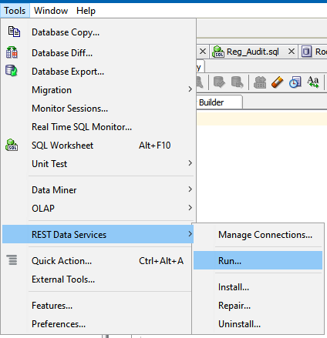

**Then specify the ords.war file location (not the one in SQL Dev.)**

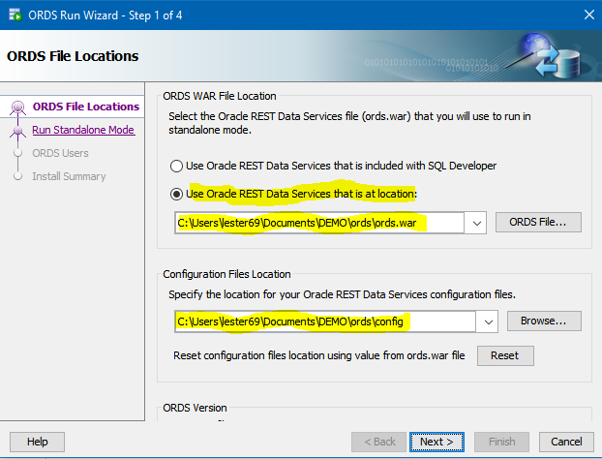

**We will always be running in standalone mode. You can use any unused port. You will need to manually enter (or paste) the images directory of APEX images:**

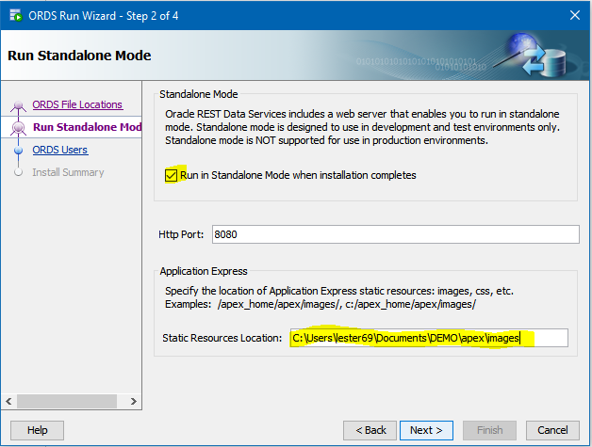

**Finish:**

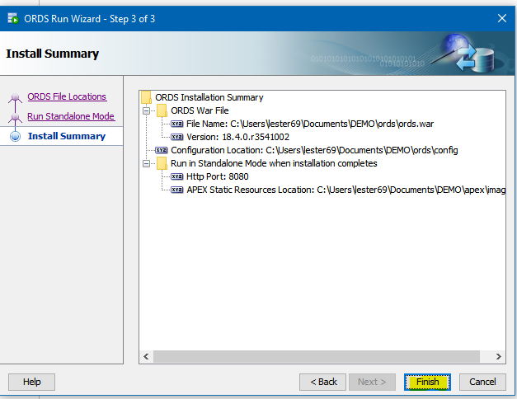

**If you get strange errors, you will need to use a separate copy of SQL Developer.**

**If all is well:**

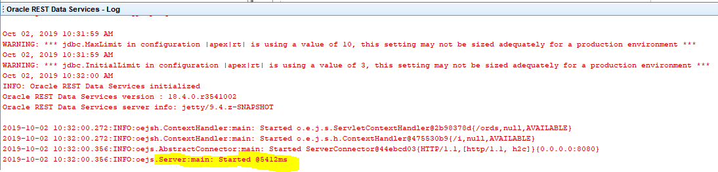

**The red square means it is running. It is also a kill button to terminate the process. It needs to stay alive as long as you are using APEX.**

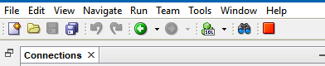

**Now go to:**

<http://localhost:8080/ords/apex_admin>

**If you get this error:**

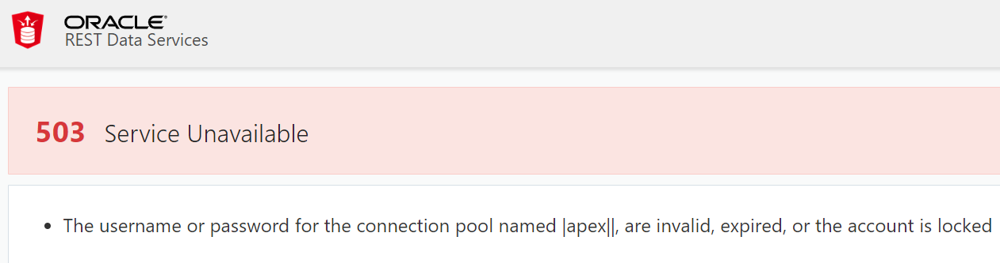

**Run this again:**

ALTER USER APEX_PUBLIC_USER IDENTIFIED BY ****** ACCOUNT UNLOCK;

**You should be able to log into APEX ADMIN (using the ADMIN credentials set earlier):**

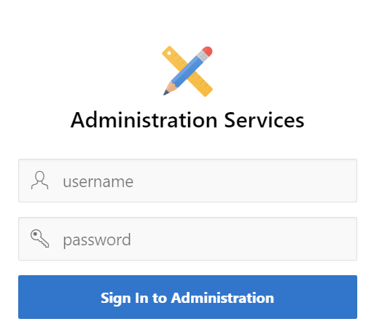

**This is where you will set up your workspace and user settings. You can name the workspace anything you want; it will still accept imports from any other workspace.**

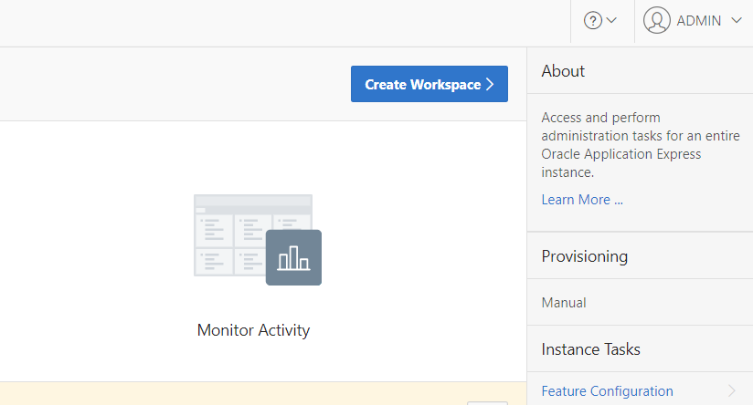

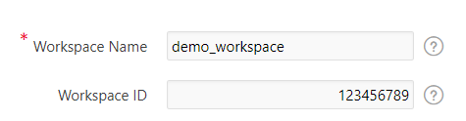

**Use the REG_TOOLS schema for the workspace (password is SYS password for PDB).**

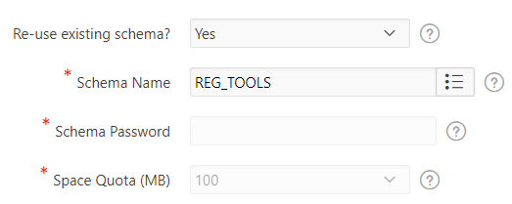

**This will be APEX ADMIN:**

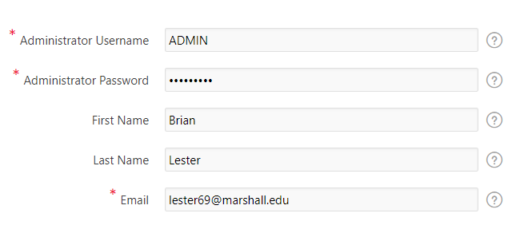

**For the rest of the ADMIN stuff, you can check Oracle documentation.**

**Sign out and go to:**

<http://localhost:8080/ords/>

**Sign in with APEX credentials:**

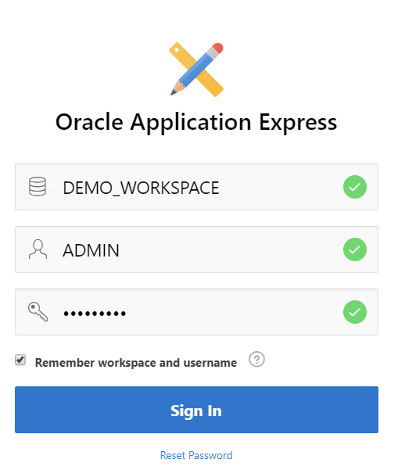

**You are required to change password (I just add “12” to old one). Your APEX ADMIN password will still be the old one; this is for the workspace:**

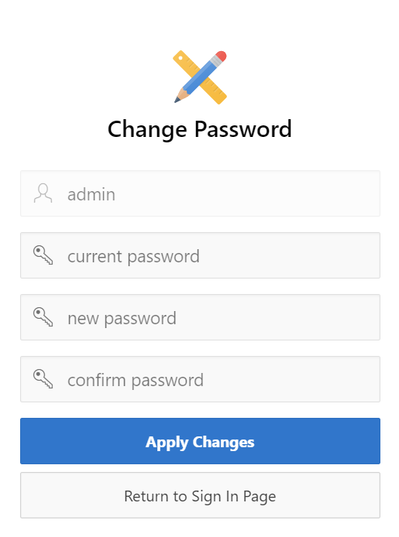

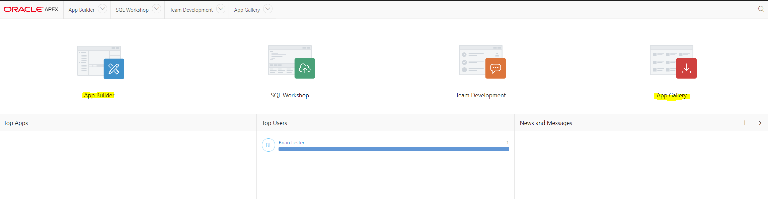

**I recommend installing some of the sample apps so that you can see how they work.**

**Have fun!**