Cyber Exercise

The Mexican drug cartel includes the most dangerous people that Center-America has ever known. These people need to get arrested, and it has to happen now.

You are chosen to develop a top-secret program that can get data regarding almost any dangerous target, using one piece of info – the target’s phone number.

Once you have the phone number, which you discovered with the help of your intelligence officer, you can simply input the number, click “send” and get all the data you need regarding the relevant target.

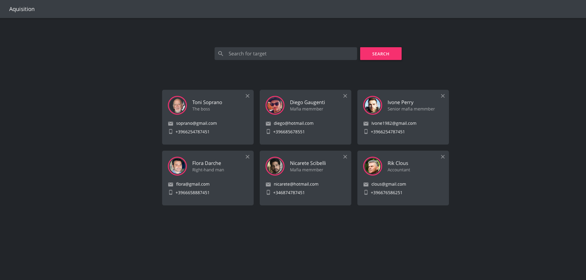

The Mexicans need to get the program ASAP.

The requirements are:

1. A text input that gets a phone number and a “send” button.  
   **Pay attention: the document shows the text “Search for target” and “Search” – the correct text is “Enter a phone number” and “Send”**
2. Once you clicked on the “send” button, a request to the server is dispatched.
3. The server can either return the needed target, or return an error that the target is not found.
4. If you get a target – you add it to the list of surveillance, below the input (attached image).
5. The list contains all the targets, up to 3 targets per line.
6. Each target tile consists of the following info:
   1. Image
   2. Name
   3. Description
   4. Email address
   5. Phone number
7. The tile also has a “remove” button (top right icon) which removes our target from list of surveillance.

Important notes:

1. You do not need to implement the server’s logic. Use server/server.js file.
2. The app should be “pixel perfect”. This means exactly like the design shows. Colors, margins, font sizes etc.
3. Icons are the only part where it doesn’t have to be exactly the same. You can find and implement the icons using “font-awesome” library – google it.
4. Use react best practices and conventions. Read the documentation. It has everything you might need.
5. Have fun and good luck!