KHev Website layouts and Tasks
Inhalt

1 Aim 4
2 General requirements for layouts and scripts 4
3 Layouts 4
3.1 Main menu template 4
3.2 Member registration 5
3.3 Members list 6
3.4 Tutorials list 7
3.5 Events layout 7
3.6 Challenges layout 8
3.7 Sante 2-0 & Handball layout 9
3.8 Projects layout 10
3.9 Jobs & Hiwi layout 11
3.10 Deuils & Veillees layout 12
4 Tests 13
5 Deadline 13

Abbildungsverzeichnis

Figure 3-1: Main menu template layout 5
Figure 3-2: Member registration form layout 5
Figure 3-3: Members list layout 6
Figure 3-4: Tutorials list layout 7
Figure 3-5: Soiree de Gala layout 8
Figure 3-6: Challenges layout 9
Figure 3-7: Sante 2-0 layout 10
Figure 3-8: Projects list layout 11
Figure 3-9: Jobs & Hiwi layout 12
Figure 3-10: Deuils & Veillees layout 13

Version
Version | Date | Author | Comment
1.0 | 21.10.2016 | Guy Watcho | Initial Version

Aim
The aim of the document is to describe all layouts that will be used in the final website of our community. For each layout we will create a task and assign it to a developer. This also will allow each team member to participate on the development of our website (end product) first release. Later we will also use redmine system to easily manage our tasks, features and releases.

General requirements for layouts and scripts

- The layout must be conformed to HTML5 standards and CSS3.
- The html tags must use only CSS user defined classes. No inline style is allowed
- It should be possible to display each layout in 3 different languages (French, English and German). French will be the default language. An example of layout design will be also provided.
- All JavaScript codes must be saved in the corresponding file. Only inline script for global variables will be allowed. It will good to have an Object Oriented script.
- The layouts should be simple and responsive.
- Each input field and useful labels must have a unique Id.

Layouts
Please note that all layouts provided to not include the main menu (which already has been designed).

Main menu template
The following picture shows you the already designed main menu template of the website. This is just a TEST page!!

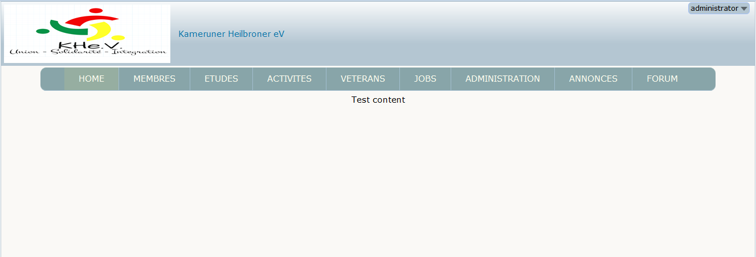
Figure 3-1: Main menu template layout

Member registration
This layout will provide a registration form the members.
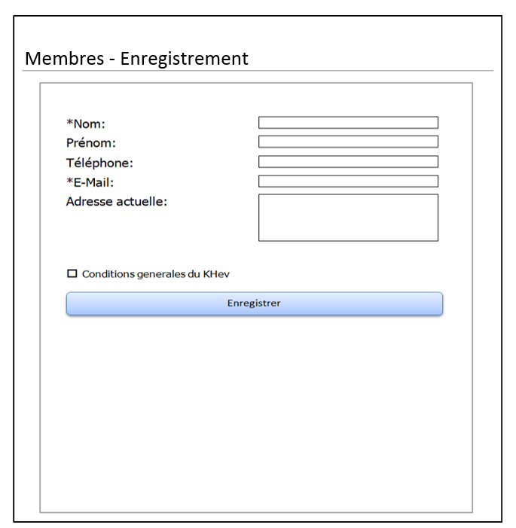
Figure 3-2: Member registration form layout
This Task is assigned to: Yannick C.

Members list
This layout will provide the list of all members of our association. By clicking on the member item, the member details will be displayed on the left panel. All data must be loaded dynamically.

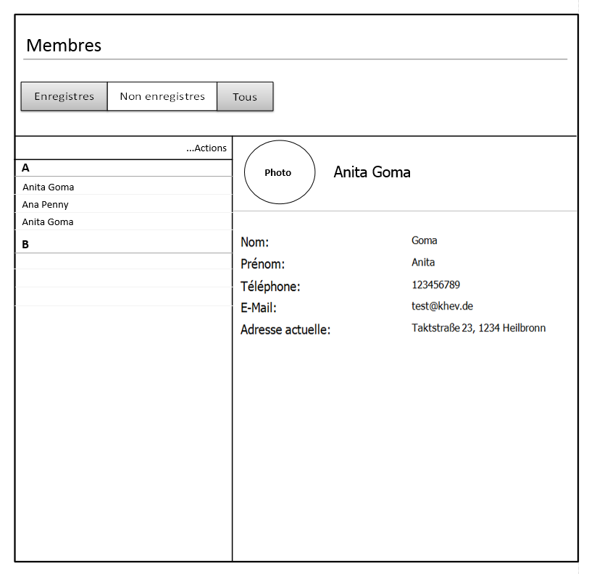
Figure 3-3: Members list layout
This Task is assigned to: Guy Watcho

Tutorials list
This layout will provide the list of available tutorials. The list displayed is dynamic.
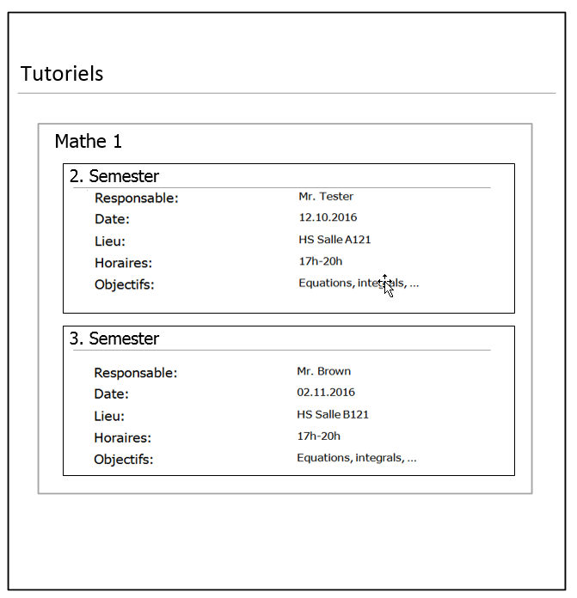
Figure 3-4: Tutorials list layout
This Task is assigned to: Yannick Ceutche

Events layout

This layout will provide the view of all events (Soire de Gala, Remise diplomes, etc…). There will be a possibility for the users to comment each picture. All data must be loaded dynamically.

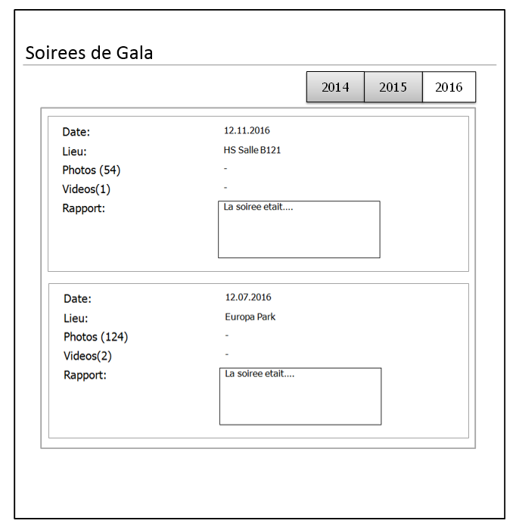
Figure 3-5: Soiree de Gala layout
This Task is assigned to: Guy Watcho

Challenges layout
This layout will provide the view of all Challenges to which we participated (summary, financial reports, pictures…). All data must be loaded dynamically.

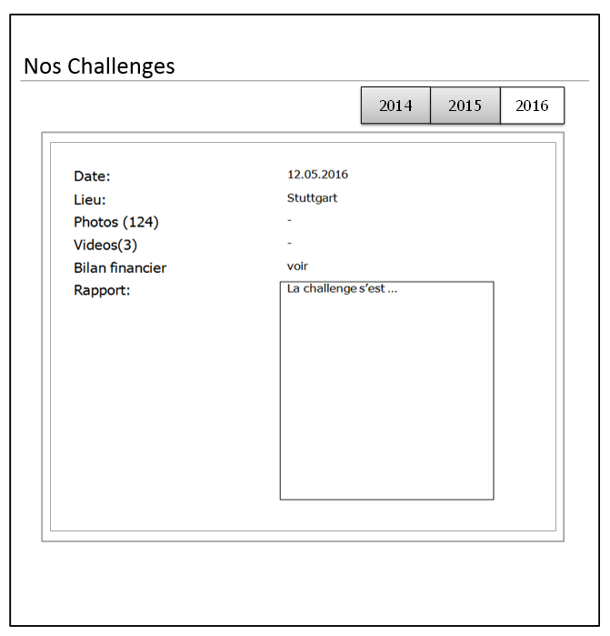
Figure 3-6: Challenges layout
This Task is assigned to: Guy Watcho

Sante 2-0 & Handball layout
This layout will provide the view of our “Sante 2-0” and girl Handball.

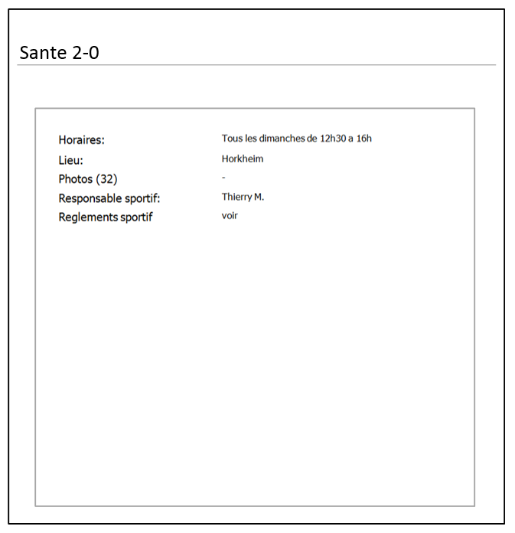
Figure 3-7: Sante 2-0 layout
This Task is assigned to: Berthol Talla

Projects layout
This layout will provide the view of all Projects we have realized or which are still going on (summary, financial reports, pictures…)

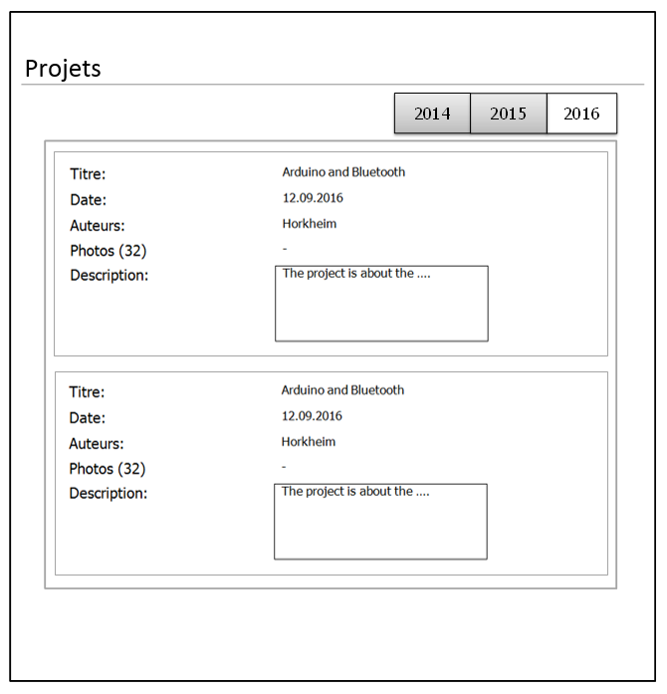
Figure 3-8: Projects list layout
This Task is assigned to: Guy Watcho

Jobs & Hiwi layout
This layout will provide the view of all job offers (Werkstudent, Hiwi, etc..) published by the members.

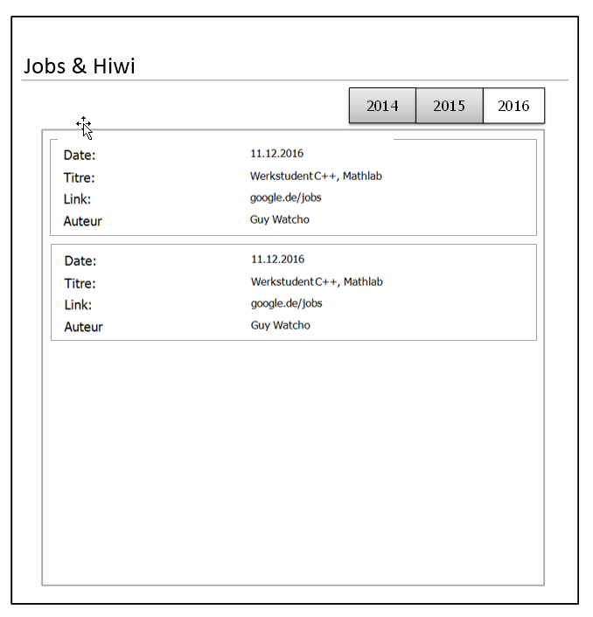
Figure 3-9: Jobs & Hiwi layout
This Task is assigned to: Berthold T.

Deuils & Veillees layout
This layout will provide the view of all mourning events, concerts, rooms or flats offer (Death, etc..) published by the members.

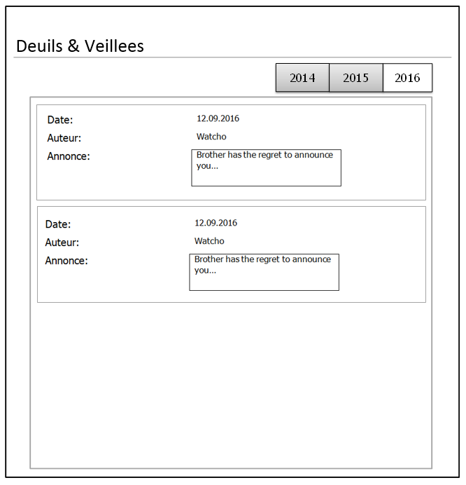
Figure 3-10: Deuils & Veillees layout
This Task is assigned to: Fofie

Tests
When the design and layouts will be assembled, the final test (ONLY usability) of the whole website will be done (if possible) by Christelle D.

Deadline
Please note that due to development and tests restrictions, it will be preferable to submit all your layouts and codes before 04.11.2016. We plan to go live before the end of the year.
N.B: Please those members who do not have enough time now to handle their tasks, please let me know as soon as possible.
Thanks you!

