User Service

Start Kafka

4. Your configuration should look like this
I would use:
process.roles=broker,controller
node.id=1

listeners=PLAINTEXT://:9092,CONTROLLER://:9093
advertised.listeners=PLAINTEXT://localhost:9092

controller.listener.names=CONTROLLER
inter.broker.listener.name=PLAINTEXT
To reset kafka
Remove-Item -Recurse -Force .\logs
- Then generate a new cluster ID:
.\bin\windows\kafka-storage.bat random-uuid
You get:
PS D:\Kafka\kafka-4.3.1> .\bin\windows\kafka-storage.bat random-uuid
2026-09-24T10:37:26.673732Z main ERROR Reconfiguration failed: No configuration found for '266474c2' at 'null' in 'null'
cXSMH3t3RgqIB7nQa7PMxQ

log.dirs=D:/Kafka/kafka-logs
Do not remove other existing settings from server.properties; just make sure these values are correct.
5. Important: because you already formatted Kafka
You already formatted the storage using:
3QGWer_BSuSXC0pLQB-uyA
and it was formatted into:
/tmp/kraft-combined-logs
If you change log.dirs to:
log.dirs=D:/Kafka/kafka-logs
you need to format the new directory again.
Since this is a fresh installation with no data you need to preserve, that's fine.
Run:
2. New-Item -ItemType Directory -Force D:\Kafka\kafka-logs
Then:
.\bin\windows\kafka-storage.bat format --standalone -t cXSMH3t3RgqIB7nQa7PMxQ -c .\config\server.properties
.\bin\windows\kafka-storage.bat format --standalone -t cXSMH3t3RgqIB7nQa7PMxQ -c .\config\server.properties
3. Then start Kafka:
.\bin\windows\kafka-server-start.bat .\config\server.properties

- For single Node
.\bin\windows\kafka-storage.bat format --standalone -t S1oFxk8pQpmFGAnlQG5bjQ -c .\config\server.properties

6. Verify
In another PowerShell:
netstat -ano | findstr :9092
Then:
.\bin\windows\kafka-topics.bat --list --bootstrap-server localhost:9092

7. Create Topics
.\bin\windows\kafka-topics.bat --create --topic order.created --bootstrap-server localhost:9092 --partitions 1 --replication-factor 1

.\bin\windows\kafka-topics.bat --create --topic payment.completed --bootstrap-server localhost:9092 --partitions 1 --replication-factor 1

.\bin\windows\kafka-topics.bat --create --topic payment.failed --bootstrap-server localhost:9092 --partitions 1 --replication-factor 1

.\bin\windows\kafka-topics.bat --create --topic product.stock.requested --bootstrap-server localhost:9092 --partitions 1 --replication-factor 1

.\bin\windows\kafka-topics.bat --create --topic delivery.completed --bootstrap-server localhost:9092 --partitions 1 --replication-factor 1

And finally:
.\bin\windows\kafka-topics.bat --create --topic test --bootstrap-server localhost:9092
If this succeeds, you have:
Kafka 4.3.1
│
┌──────────┴──────────┐
│ │
Controller :9093 Broker :9092
│
│
Spring Boot
localhost:9092
The Reconfiguration failed: No configuration found... Log4j message can be addressed separately. It is not preventing Kafka from starting.
now it looks good

Layout and Architecture
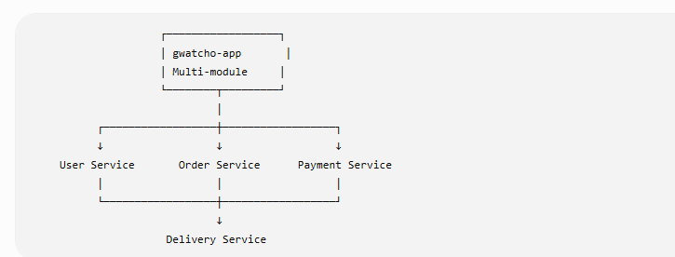

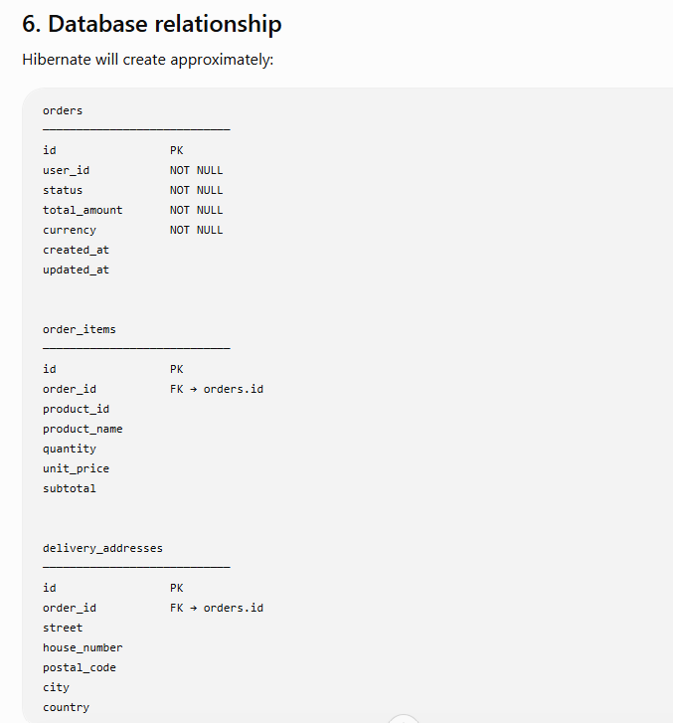

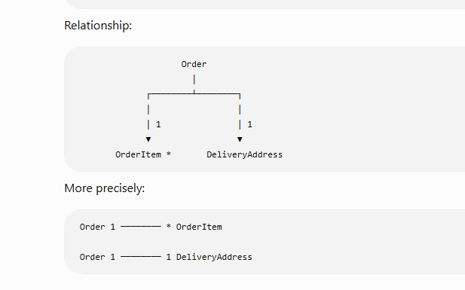

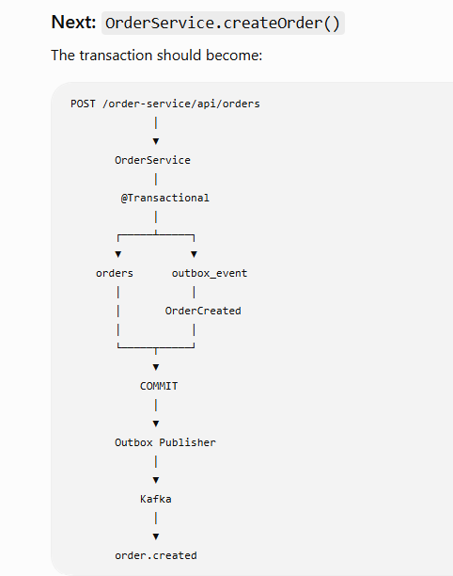

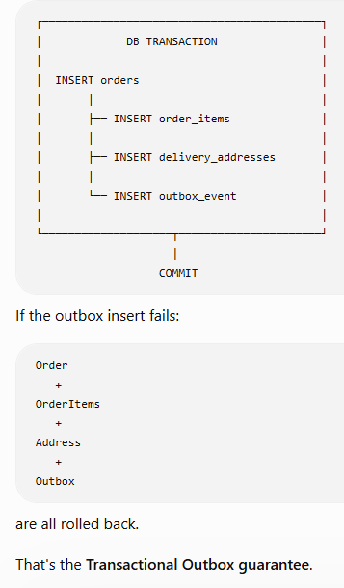
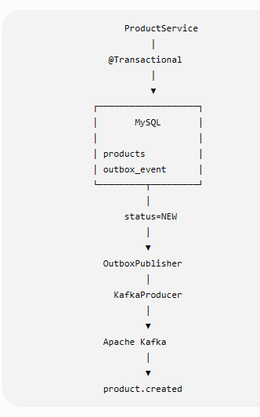

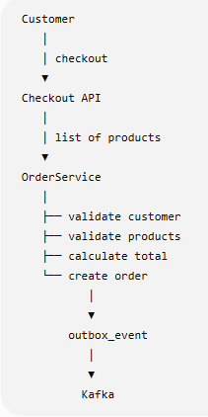

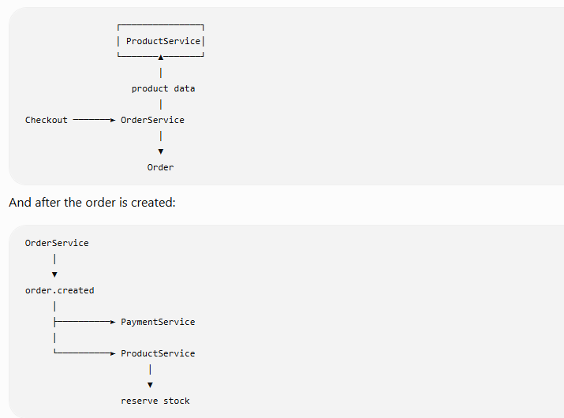

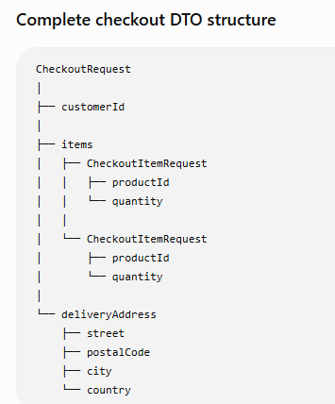

Implement Dockerisation

- Product-service

1.1 Create dockerfile
FROM eclipse-temurin:17-jre
WORKDIR /app
COPY target/product-service-*.jar app.jar
EXPOSE 8080
ENTRYPOINT ["java", "-jar", "app.jar"]
1.2 Build
docker build -t gwatcho/product-service:1.0 .

1.2 Run
docker compose build product-service --no-cache

1.4 Start product-service and mysql

docker compose up -d mysql-product product-service
Test mysql: docker compose exec mysql-product mysql -uproduct_user -pproduct_password product_db -e "SELECT COUNT(*) AS product_count FROM products;"

Import it into your running Docker MySQL
From the project root:
Get-Content .\docker\mysql\product\products.sql | docker compose exec -T mysql-product mysql -u product_user -pproduct_password product_db

Then verify:
docker compose exec mysql-product mysql -u product_user -pproduct_password product_db -e "SELECT COUNT(*) AS product_count FROM products;"

1. Stop/remove the old Product Service container
Because we don't want to affect your database:
docker compose rm -sf product-service

2. Recreate Product Service
Now:
docker compose up -d --no-deps product-service
3. Check it
docker compose ps product-service

API-Gateway app
compose build product-service –no
# 1. Go to project root
cd D:\Projects\Java\IntelliJ_WS\MicroServicesApp\gwatcho-microservices-app

# 2. Verify Maven module
mvn -pl api-gateway -am clean package -DskipTests

# 3. Build Docker image
docker compose build api-gateway

# 4. Start Gateway
docker compose up -d api-gateway

# 5. Check container
docker compose ps api-gateway

# 6. Check logs
docker compose logs -f api-gateway

Keycloak
Export:

Get-ChildItem -Path D:\ToolsForDev\Keycloak -Filter kc.bat -Recurse -ErrorAction SilentlyContinue | Select-Object FullName

1.2 run this command
.\bin\kc.bat export --dir D:\ToolsForDev\Keycloak\exports --realm gwatcho-shop

1. Create the Docker import directory
From your project root:
New-Item -ItemType Directory -Force .\docker\keycloak\import
2. Copy both export files
Copy-Item `
D:\ToolsForDev\Keycloak\exports\gwatcho-shop-realm.json `
.\docker\keycloak\import\

Copy-Item `
D:\ToolsForDev\Keycloak\exports\gwatcho-shop-users-0.json `
.\docker\keycloak\import\
Verify:
Get-ChildItem .\docker\keycloak\import
You should see:
gwatcho-shop-realm.json

Check config
http://localhost:8080/realms/gwatcho-shop/.well-known/openid-configuration

For the user-service container, you can check application-docker.yml directly from Ubuntu/WSL.
1. Find the container
docker ps | grep user-service
You should see something like:
gwatcho-user-service
2. Search for application-docker.yml
docker exec -it user-service sh -c 'find / -name "application-docker.yml" 2>/dev/null'
If your container has a different name, replace user-service.
3. If found, display the content
For example, if it returns:
/app/config/application-docker.yml
run:
docker exec -it user-service sh -c 'cat /app/config/application-docker.yml'
Or with less:
docker exec -it user-service sh -c 'less /app/config/application-docker.yml'
4. If find returns nothing
The file may be inside the JAR rather than as a separate file. Check:
docker exec -it user-service sh -c 'find /app -type f'
Look for the JAR, for example:
/app/user-service.jar
Then:
docker exec -it user-service sh -c 'jar tf /app/user-service.jar | grep application'
You may get:
BOOT-INF/classes/application.yml
BOOT-INF/classes/application-docker.yml
To extract/view it:
docker cp user-service:/app/user-service.jar .
Then on Ubuntu:
unzip -p user-service.jar BOOT-INF/classes/application-docker.yml
Quick command
If you just want to find and display it:
docker exec -it user-service sh -c 'f=$(find / -name "application-docker.yml" 2>/dev/null | head -1); echo "FILE: $f"; [ -n "$f" ] && cat "$f"'

To get all Docker container names:
Running containers only
docker ps --format "{{.Names}}"
All containers, including stopped
docker ps -a --format "{{.Names}}"
With status
docker ps -a --format "table {{.Names}}\t{{.Status}}"
For your microservices project, I recommend:
docker ps -a --format "table {{.Names}}\t{{.Image}}\t{{.Status}}"
This will show something like:
NAMES IMAGE STATUS
api-gateway gwatcho/api-gateway Up ...
user-service gwatcho/user-service Up ...
product-service gwatcho/product-service Up ...
order-service gwatcho/order-service Up ...
payment-service gwatcho/payment-service Up ...
delivery-service gwatcho/delivery-service Up ...

Angular
- Check nginx config
docker exec -it gwatcho-angular cat /etc/nginx/conf.d/default.conf
- Rebuild the App
docker build --no-cache -t gwatcho/angular-frontend .

# rebuild angluar

docker build -t gwatcho/angular-frontend .

# delete image
docker rm -f angular-frontend

#run docker
docker run -d --name angular-frontend -p 4200:80 --network gwatcho-microservices-app_gwatcho-network gwatcho/angular-frontend

1. Check its status
docker ps -a --filter "name=gwatcho-angular"
You will probably see:
STATUS
Exited (...)
2. Start the container
docker start gwatcho-angular
Then verify:
docker ps --filter "name=gwatcho-angular"
3. Now check default.conf
docker exec -it gwatcho-angular cat /etc/nginx/conf.d/default.conf
If it immediately stops again
Check the logs:
docker logs gwatcho-angular
Or:
docker logs --tail 100 gwatcho-angular
You can also inspect the

Recommended professional setup
Test type | Database | Purpose
Unit tests | No database | Test business logic quickly
Repository/JPA tests | MySQL | Verify real SQL, mappings, constraints
Integration tests | MySQL | Test service + database together
API/controller tests | Usually mock repository/service | Fast HTTP/API tests
Full application tests | MySQL | Verify the real application context
Developer local tests | MySQL in Docker/Testcontainers | Reproducible environment
Production | MySQL | Same DB technology as tested

