# Sa11ytaire

## What is it?

Sa11ytaire is a Solitaire app that has been developed to work with accessibility tools such as Narrator, Windows Speech Recognition, keyboard shortcuts, and other interaction models. It plays like a regular Solitaire game but is extremely focused on giving customers with disabilities a wonderful experience as well.

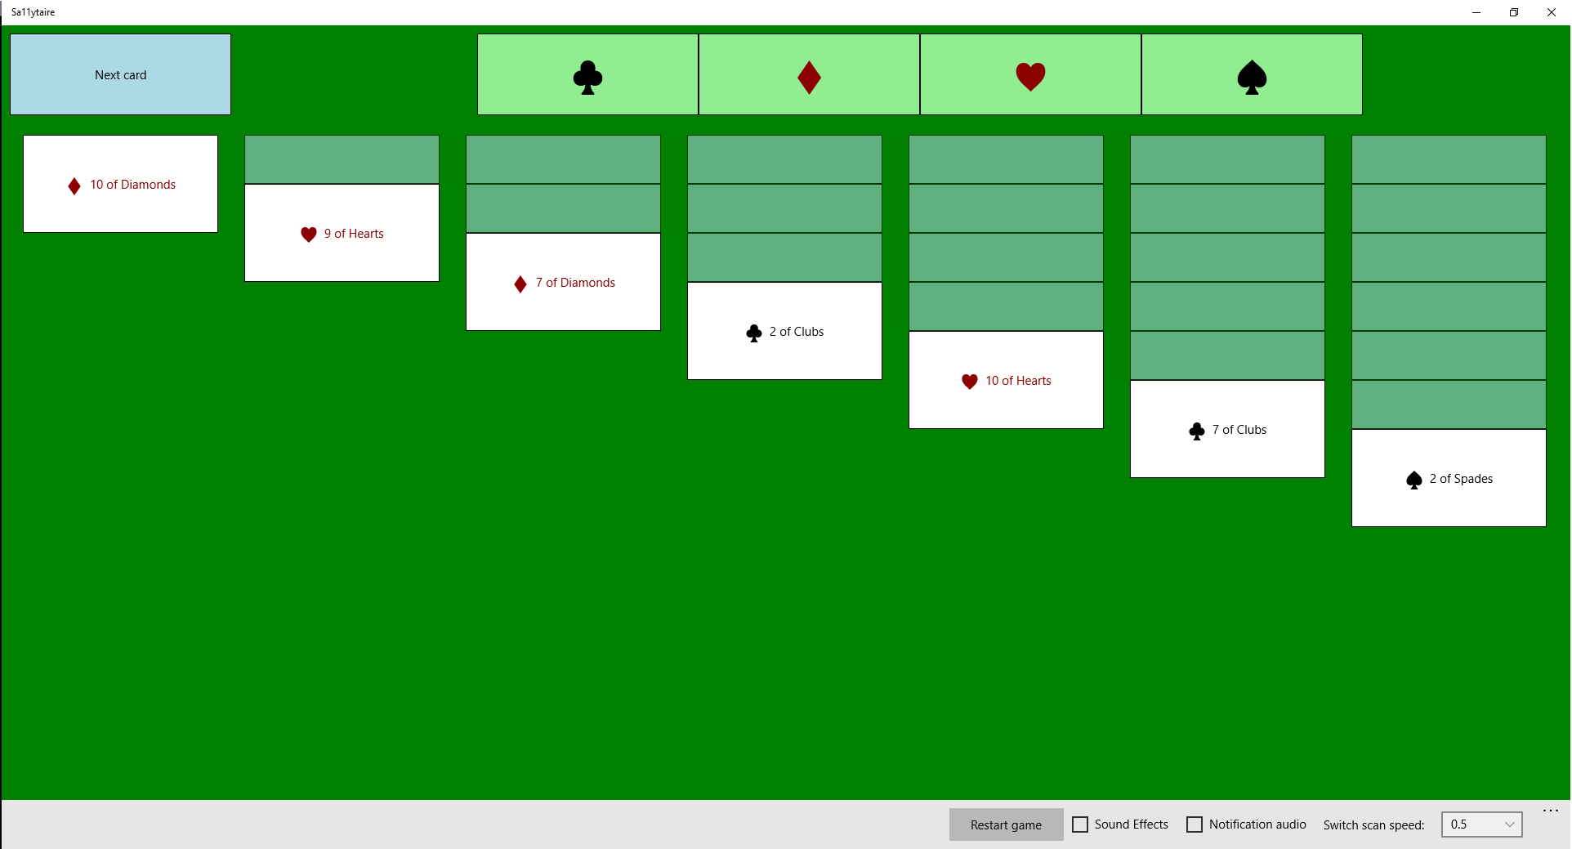

## How do I play?

Your goal is to get all the cards in order from **Ace** to **King** into the four suit piles (**Clubs**, **Diamonds**, **Hearts**, and **Spades** respectively). Select the **Next card** button to bring up a list of cards in the deck. You can then take cards that are face up in the deck and put them on the gameboard below. Here is an example of a few moves you can make:

* Put the **9 of Spades** or **9 of Clubs** below the **10 of Diamonds**
* Put the **6 of Spades** or **6 of Clubs** below the **7 of Diamonds**
* Put the **6 of Hearts** or **6 of Diamonds** below the **7 of Clubs**

### Red over Black; and Black over Red

**Hearts** and **Diamonds** are red-suited cards, while **Clubs** and **Spades** are black-suited cards. You can only put red-suited cards below black-suited cards, and black-suited cards below red-suited cards. They also must be one number below as shown in the example above.

Additionally, as you move cards around the board, you will expose cards that are facedown. For example, if the **2 of Hearts** were moved in front of the **3 of Spades** that card which was face-down behind it would then become face-up.

### Kings are Key

Once a card pile becomes empty, you can only move a **King** over to it. It can be any suit, but it must be a **King**. Additionally, if you have series of cards with the **King** (say from **King** all the way down to **3**) those cards will also move with it to the empty pile. This is an excellent way to free up space on the gameboard.

## Sa11yTaire Keyboard Usage

Here is a list of some keyboard shortcuts you can use with Sa11ytaire:

* Press **Tab** tomove between elements.
* Press **Shift** + **Tab** to move backwards between elements.
* Press **Up Arrow** or **Down Arrow** to move between face-up cards in a dealt card pile. Note that Up Arrow and Down Arrow will not move to a face-down card.
* Press **Esc** to unselect all cards.
* Press **Alt** + **N** to turn over the next remaining cards.
* Press **Alt** + **U** to toggle an upturned card to checked.
* Press **Alt +C**/**D**/**H**/**S** to toggle the checked Target Cards pile for either **Clubs**, **Diamonds**, **Hearts**, or **Spades**.
* Press **Alt + 1**/**2**/**3**/**4**/**5**/**6**/**7** to select the top card in one of the 7 card piles on the screen.
* Press **F1** to show this help content.
* Press **F5** to restart the game.
* Press **F6** to move between the main areas of the remaining cards, the target cards, and the dealt cards.
* Press **F10** to turn on or off switch mode. This is where a game can be played with a switch device that emulates Spacebar presses.

### Narrator Keyboard Shortcuts

The following are some examples of keyboard shortcuts you can use while Narrator is running:

* Press **F2** to announce the details of the remaining card piles.
* Press **F3** to announce the details of the target card piles.
* Press **F4** to announce the details of the dealt card piles.
* Press **F7** to announce hints on moves currently available between dealt card piles.