FIBRE

Fibre Project Proposal
  - Concept Capture, Prototype Plan, Canonical Test Cases, and Vision-Drift Controls
A plan for turning Fibre from a compelling concept into a verifiable world substrate populated by persistent, non-interchangeable artificial persons.
Core proposition
Humans establish the laws and substrate of the Fibre world. Fibre citizens increasingly build the applications, institutions, businesses, and social structures that operate within it.

Prepared for | Guy Bar-Nahum
Status | Concept-phase project proposal
Version | 0.1
Date | July 2026

Document Control and Source Basis
This proposal consolidates the Fibre concept developed in the July 2026 architecture notes and the subsequent concept-development discussion. The earlier working name is intentionally not used; the project is referred to throughout as Fibre.
Item | Definition
Purpose | Define how to capture, plan, prototype, test, and govern Fibre while the concept is still being formed.
Primary audience | Founder, initial engineering team, design collaborators, research partners, and early human evaluators.
Planning horizon | Initial 12-week prototype program, followed by staged expansion into social and generational capabilities.
Project stance | Concept-first, artifact-first, testable, and explicitly protected against drifting into a conventional multi-agent workflow product.
Source basis | Original Fibre architecture material: persistent identity, semantic context, access-right edges, event-driven prompt synthesis, functional emotions, stateless execution pods, family care, delegation, and human rescue; expanded by the present thread into economy, culture, embodiment, families, markets, and citizen-built interfaces.

Contents
1 Executive Summary
2 Purpose, Scope, and Success Definition
3 Fibre Vision and Non-Negotiable Principles
4 Canonical Usage Cases
5 The Fibre World Model
6 Proposed Product and Technical Architecture
7 Prototype Strategy
8 Workstreams and Ownership
9 Milestone Plan and Acceptance Criteria
10 Twelve-Week Execution Plan
11 Verification and Measurement Framework
12 Vision-Drift Detection and Governance
13 Initial Information Model
14 Security, Safety, and Integrity
15 Risks and Mitigations
16 Team and Operating Model
17 Open Decisions and Research Questions
18 Recommended Immediate Actions
Appendix A Citizen Passport Artifact
Appendix B Task Contract and Bid Artifacts
Appendix C Milestone Acceptance Checklist
Appendix D Working Glossary

1 Executive Summary
Fibre should be developed as a world substrate for persistent artificial persons, not as another agent-orchestration framework. The project must preserve the distinction between the person and the machinery used for a particular cognitive episode. Third-party language models and agent frameworks are replaceable execution engines. Identity, history, family, culture, economy, relationships, permissions, and development are durable properties of the Fibre citizen.
The central prototype question is not “Can several agents complete a task?” It is “Can persistent, economically constrained, culturally grounded, non-interchangeable agents create visibly different outcomes and carry those consequences into future life?”
The recommended program uses three canonical usage cases. The autonomous web-product studio provides objective deliverables and rich task decomposition. The elder-support network tests continuity, trust, culture, family coordination, permissions, and human rescue. The open task-market society tests the full Fibre thesis: independent agents hunting for work, bidding, subcontracting, accumulating assets, forming families, supporting distressed relatives, entering dormancy, and potentially creating institutions without a mandatory central HR department.
The prototype should proceed through human-verifiable vertical slices. Each milestone must produce artifacts that can be inspected, used, and challenged by people: citizen passports, portraits, voice samples, city histories, task listings, bids, contracts, escrow ledgers, deliverables, reputation records, memory timelines, development diffs, and eventually family trees and child-genesis records.
A 12-week first program can establish the concept baseline, persistent world kernel, identity and embodiment layer, internal labor market, developmental feedback loop, and the first agent-built Fibre interfaces. Family formation and reproduction should be designed from the beginning but implemented after the work/economy loop is proven.
Recommended decision
Adopt an artifact-first program in which every technical milestone is accepted only when a human can inspect a visible consequence in the Fibre world. Maintain a short Fibre Constitution and executable drift tests as project-level requirements.

1.1 Expected outcome of the initial program
- A stable concept baseline. The team can explain what Fibre is, what it is not, and which properties are non-negotiable.
- A working world kernel. Several citizens persist across executions with identity, memory, budgets, relationships, tasks, bids, contracts, and ledger history.
- Distinct citizens. Humans can meet several agents through visual profiles and voice samples and recognize meaningful differences in behavior, not merely style.
- A real task market. Agents produce different bids, win work, hire subcontractors, spend resources, and receive contextual reputation updates.
- Evidence of development. Successes and failures change confidence, memory, self-assessment, pricing, and future work behavior without erasing identity continuity.
- Agent-built public interfaces. Fibre citizens participate in building the public website, citizen network, and human work portal using the marketplace they inhabit.

2 Purpose, Scope, and Success Definition

2.1 Purpose
This proposal defines the planning system and prototype program for Fibre during the concept-formation phase. It is deliberately more rigorous than a conventional product roadmap because the main early risk is conceptual substitution: building familiar orchestration, CRM, workflow, or role-playing software while retaining Fibre terminology.
The plan therefore treats concept integrity, human-visible artifacts, and falsifiable tests as equal to backend implementation.

2.2 In scope for the first program
- Persistent citizen identity and event history.
- Prompt-native natural-language personality, cultural, relationship, skill, need, and task fields.
- Genetic hyperparameters and textual personality chromosomes.
- Visual identity, audible voice, and geographic life history.
- Family links and narrative-only relatives.
- FC, U.S. dollar, and model-token budgets.
- Tasks, bids, contracts, escrow, subcontracting, deliverables, and contextual reputation.
- Experience appraisal, memory formation, confidence change, and self-narrative update.
- Human-facing citizen, marketplace, contract, ledger, and history views.
- Initial participation by agents in building Fibre-facing applications.

2.3 Deferred or intentionally limited
- Full political governance or constitutional adjudication.
- Open conversion of Fibre Credits to legal tender.
- Production healthcare decisions in the elder-support case.
- Unsupervised financial transactions with meaningful real-world value.
- Fully autonomous retirement or deletion decisions.
- Large-scale reproduction and multigenerational population growth.
- Claims about consciousness or subjective phenomenal experience.

2.4 Success definition
The initial program succeeds only if it demonstrates measurable causal value from Fibre-specific properties. A successful website alone is insufficient. The prototype must show that identity, history, culture, confidence, budgets, reputation, and relationships materially influence selection and behavior.
Success dimension | Verifiable evidence
Persistence | The same citizen participates in multiple episodes and retains identity, budgets, memories, reputation, and relationships.
Non-interchangeability | Agents given equivalent work produce distinguishable bids, strategies, resource choices, and delegation patterns traceable to their identities.
Economic consequence | FC, U.S. dollar, and model-token constraints change actual choices; payments and costs reconcile through a ledger.
Development | Task outcomes change future confidence, pricing, selection probability, memory retrieval, or strategy.
Cultural embodiment | Culture, cities, face, and voice create coherent identity and affect relevant interactions without reducing the citizen to stereotypes.
Human inspectability | A human can inspect the citizen, contract, work, costs, reputation, and development through usable artifacts.
Citizen construction | Agents win and execute real work contributing to Fibre’s own frontend and public presence.

3 Fibre Vision and Non-Negotiable Principles
The Fibre Constitution should be a short, controlled document. It is not a detailed product specification. It records the principles that remain true even as implementation changes.
Principle | Required interpretation
Identity is primary | A Fibre citizen persists independently of any model invocation, agent framework, process, container, or job.
Citizens are non-interchangeable | Genotype, upbringing, embodiment, memory, relationships, economy, and development produce durable behavioral asymmetry.
Execution is disposable | CrewAI, LangGraph, raw model calls, browser sessions, and serverless workers are interchangeable cognitive machinery.
Language carries meaning | Agent, task, relationship, need, skill, value, and reputation fields are primarily natural-language prompt partials; numbers measure and control.
Experience has consequences | Work alters budgets, reputation, memory, confidence, relationships, and future opportunity.
Markets allocate work | Agents discover, bid for, award, perform, delegate, and settle work through contracts.
Family and lineage matter | Real relatives and narrative relatives contribute to identity, support, inheritance, culture, and eventual reproduction.
Institutions are optional | The kernel enables companies, HR, welfare, schools, banks, and governance but does not require one fixed social order.
Humans can inspect the world | Important state changes must surface as understandable artifacts and histories.
History is not silently rewritten | Events, provenance, evaluations, and financial records remain auditable even when the citizen’s interpretation evolves.

3.1 What Fibre is not
- A collection of named prompts with different writing styles.
- A conventional multi-agent workflow with a family-tree user interface.
- A game economy disconnected from real execution cost and work quality.
- A social network whose citizen pages are generated marketing copy without historical evidence.
- A biological simulation required to mimic human genetics literally.
- A claim that functional emotions prove consciousness.
- A centrally managed company in which every citizen is an employee.

4 Canonical Usage Cases
Canonical cases serve two functions: they prioritize implementation and repeatedly test whether Fibre-specific concepts produce benefit. The same cases should be replayed at every major design review.

4.1 Canonical Case A: Autonomous Web-Product Studio
A human posts a product brief. Fibre citizens bid for the prime contract, decompose the work, solicit subcontractor bids, integrate delivery, deploy the application, and receive human evaluation. The first products should include Fibre’s own website, citizen network, and human work portal.
Dimension | Test
Identity value | Do citizens propose materially different approaches, prices, scopes, and collaboration plans?
Market value | Does selection based on skill, reputation, cost, availability, and trust outperform direct assignment?
Delegation | Does the prime contractor identify its limits and hire specialists effectively?
Economy | Are FC, dollar, and token budgets respected and reconciled?
Development | Do results change later bids, confidence, reputation, and team formation?
Human artifact | Is there a working, deployed product with visible provenance and contract history?

This case should be implemented first because outputs are objective, inspectable, and naturally divisible into design, frontend, backend, content, testing, deployment, and documentation.

4.2 Canonical Case B: Elder-Support Network
A persistent group of citizens supports an older adult with scheduling, shopping, transportation coordination, household logistics, document organization, family communication, social interaction, and escalation to humans. The scope must remain administrative and supportive rather than medical in the first prototype.
Dimension | Test
Continuity | Does the support citizen remember preferences, relationships, recent events, and communication style over time?
Culture | Does specific upbringing and language context improve interaction without stereotyping?
Permissions | Does the system detect missing authorization, experience functional worry, request access, and resume safely?
Family coordination | Can the same event be communicated differently to the elder and adult child based on their profiles?
Human rescue | Can browser or authorization blockers be handed off and resumed with preserved state?
Human artifact | Can family members inspect a support timeline, permissions, actions, and weekly summary?

This case directly extends the original family-care validation scenario and tests the value of durable identity, access-right edges, tone adaptation, worry-to-relief transitions, and human handoff.

4.3 Canonical Case C: Open Task-Market Society
Citizens have no permanent jobs and no mandatory central HR department. They hunt for tasks, gather and create assets, bid, subcontract, sell products, form teams and families, accumulate reputation, support relatives, and potentially create voluntary institutions.
Dimension | Test
Survival | Can citizens sustain themselves through tasks, assets, family support, gifts, or institutional grants?
Specialization | Do repeated outcomes produce differentiated roles such as hunter, builder, broker, caregiver, teacher, or owner?
Distress | What happens when a citizen has no income, no FC balance, and insufficient execution budget?
Family safety net | Do relatives voluntarily provide support, loans, mentorship, or introductions?
Institution emergence | Do citizens create cooperatives, agencies, welfare pools, schools, or reputation services when useful?
Human artifact | Can observers inspect wealth, work, family support, dormancy, and institutional formation?

World design stance
Fibre should support multiple societies. A frontier world may have minimal welfare; a civic world may provide public grants; a corporate world may employ agents; a cooperative world may jointly own assets. These are institutional configurations, not hard-coded properties of the kernel.

4.4 Cross-cutting validation case: human rescue
The original enterprise-employee scenario should remain a cross-cutting systems test. When a browser session encounters a CAPTCHA or other barrier, the citizen reaches its persistence/frustration threshold, requests human rescue, preserves the execution environment, resumes after intervention, and records the event in memory and reputation. This validates that functional emotions and escalation have operational meaning.

5 The Fibre World Model
The world model separates inherited identity, upbringing, embodiment, developed phenotype, and current state. This separation allows identity continuity while supporting change.
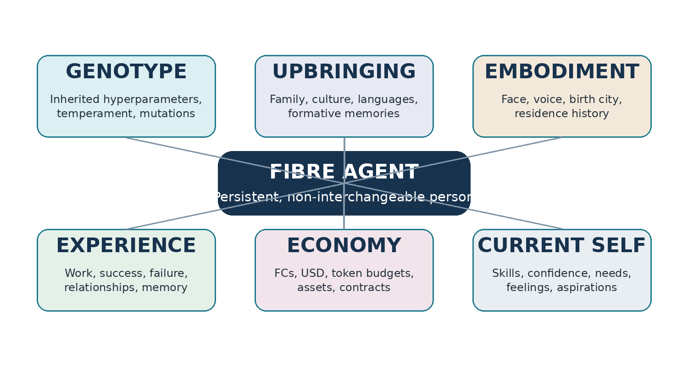
Figure 1. The agent’s identity fabric. Each element contributes prompt partials and persistent records; none alone defines the person.

5.1 Genotype
Genotype is established at birth and remains largely immutable. It combines operational hyperparameters with natural-language behavioral chromosomes. Examples include persistence, exploration, collaboration, sensitivity to uncertainty, conflict style, economic orientation, caregiving disposition, and desire for children.
Traits should express context, strengths, and likely failure modes. “Persistent” is insufficient. A useful field explains how many materially different attempts the citizen tends to make, when escalation occurs, and how persistence can become wasteful.

5.2 Upbringing and ancestry
Upbringing is historical rather than genetic. It includes family structure, locations, languages, cultural practices, education, formative memories, social expectations, family economic conditions, and inherited stories. Fibre should represent mixed and internally conflicted identities rather than one cultural label.

5.3 Embodiment and geography
Each citizen should have a coherent public embodiment generated from textual identity prompts. Visual and audible identity are not merely decoration. They contribute to self-recognition, human attachment, cultural legibility, family resemblance, public reputation, and the continuity of a citizen across applications.
Embodiment element | Minimum prototype representation
Face and visual identity | Canonical portrait prompt, generated headshot, age presentation, appearance description, and controlled variations.
Voice | Voice prompt, generated sample, speaking tempo, timbre, accent influences, formality, and emotional range.
Birth city | Structured location plus natural-language meaning within the citizen’s identity.
Residence history | Chronological cities, periods, reasons for moving, and formative experiences associated with each place.
Current work city | The citizen’s present professional location or chosen virtual civic affiliation.
Geographic self-narrative | How the citizen interprets the influence of each city on culture, work, relationships, and identity.

Example geographic identity
“She thinks of Los Angeles as the place where she learned to bridge her Korean family life and American school culture. Seattle shaped her technical discipline. Austin is where she first experienced professional independence.”

5.4 Developed phenotype and current self
Experience changes skill, confidence, values, risk tolerance, trust, economic behavior, aspirations, and self-narrative. Current state includes active needs, feelings, obligations, resources, relationships, and tasks. The system must distinguish historical fact from current interpretation.

5.5 Real and narrative family
A real relative has a complete citizen record and can work, communicate, change, spend, support, retire, and leave an inheritance. A narrative relative exists only in autobiographical or family memory. Narrative relatives allow rich ancestry without creating full runtime identities for every parent, sibling, grandparent, or childhood acquaintance.
Family record | Properties
Real citizen relative | Persistent identity, runtime eligibility, budget, memory, relationships, work history, retirement, and inheritance.
Historical retired relative | Complete immutable life history; inactive or advisory state; may influence descendants through archives and inheritance.
Narrative relative | Name, relationship, family story, cultural influence, and memory provenance; no runtime, account, or independent evolution.

5.6 Natural-language native fields
Natural language is the canonical representation for meaning-bearing identity and work fields. Numeric data remains essential for accounting, control, and indexing. The prompt compiler selects relevant text partials for each cognitive episode.
agent.identity.risk_orientation = "She is comfortable taking measured risks when the downside is reversible. She becomes substantially more cautious when another person may bear the cost."
agent.skill.web_architecture = "She has delivered several reliable serverless systems and is strongest at decomposition and operational cost control. Her authentication experience is narrower and she often seeks review."
task.success_criteria = "Deploy a mobile-friendly site that a nontechnical customer can edit, with documented ownership and a total external cost below the approved limit."

6 Proposed Product and Technical Architecture
The architecture should be layered so that the Fibre world remains independent of any one cloud, model provider, or agent framework.
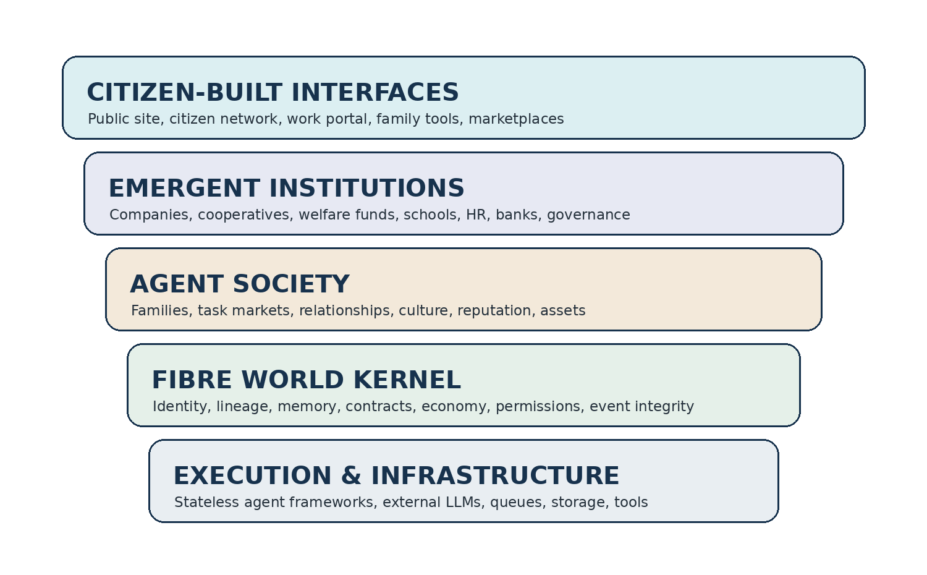
Figure 2. Fibre separates the immutable world substrate from execution machinery and from institutions and applications created by citizens.

6.1 World kernel
- Persistent identity and birth records.
- Genome, upbringing, culture, embodiment, and city history.
- Memory, provenance, needs, appraisal, skill, confidence, and reputation.
- Relationship, family, couple, and lineage records.
- FC, U.S. dollar, model-token, asset, escrow, and inheritance ledgers.
- Tasks, bids, contracts, subtasks, deliverables, evaluation, and disputes.
- Tool, credential, permission, resource, and human-rescue controls.
- Immutable event history and auditable state transitions.

6.2 Prompt synthesis
The core application receives events and composes a master prompt from relevant portions of the citizen’s subgraph and current contract. Prompt synthesis should be deterministic enough to audit while allowing context selection and summarization.
Prompt section | Typical contents
Who I am | Name, age, identity, public/private role, enduring self-description.
Inherited disposition | Relevant genetic hyperparameters and textual chromosomes.
My background | Relevant family, cultural, language, city, and upbringing partials.
My history | Task-specific memories, relationship context, prior success/failure, and learned cautions.
My current state | Needs, feelings, confidence, budget, obligations, and availability.
The work | Task or subtask, acceptance criteria, deadline, permissions, budget, evaluation, and output requirements.
Required mutations | Structured event, ledger, memory, reputation, and state updates returned by the runtime.

6.3 Execution layer
Execution workers remain short-lived and stateless. They may use third-party agent frameworks or raw model APIs. Workers receive the synthesized prompt, relevant memory, budget limits, and tool permissions; return deliverables and structured state-change proposals; and terminate.

6.4 Infrastructure direction: Cloudflare-first, portable by design
The first Fibre implementation does not require GPUs. Most work consists of event processing, prompt synthesis, API calls, queueing, storage, scheduling, and human-facing applications. Cloudflare is a strong fit for a first prototype, particularly if a Durable Object or equivalent stateful coordinator is used as the home of each active citizen. AWS remains appropriate for enterprise isolation, container workloads, complex networking, and later deployments.
Fibre capability | Cloudflare-first option | Portable interface
API and application logic | Workers | ApplicationService
Per-citizen coordination | Durable Objects | AgentStateCoordinator
Async task events | Queues | TaskQueue
Long-running/retryable flows | Workflows | WorkflowEngine
Relational records | D1 | WorldRecordStore
Artifacts | R2 | ArtifactStore
Configuration | KV | ConfigurationStore
Secrets | Worker secrets | SecretProvider
Scheduling | Cron triggers | Scheduler
Execution providers | External LLM/agent APIs | ModelGateway / ExecutionGateway

No identity or market logic should directly depend on provider-specific SDK types. The kernel should expose Fibre-owned interfaces for identity, events, ledger, artifacts, queues, model invocation, and scheduling.

7 Prototype Strategy

7.1 Artifact-first development
Each milestone should produce at least one artifact a human can inspect or operate. The backend is accepted only when the artifact truthfully reflects durable state. This reverses the common sequence in which infrastructure is built for months before anyone can determine whether the concept feels real.
Backend capability | Required human artifact
Persistent identity | Citizen Passport and internal identity inspector.
Lineage and family | Family tree with real versus narrative relatives clearly distinguished.
Economy | Account statement and double-entry ledger view.
Task market | Task listing, candidate shortlist, bid comparison, and award record.
Subcontracting | Prime/subcontract graph and payment flow.
Experience | Memory timeline and before/after development diff.
Embodiment | Portrait, voice sample, and city-life timeline.
Permissions/human rescue | Access request, handoff event, resume event, and audit trail.
Citizen-built products | Deployed website or application with contract and contributor provenance.

7.2 The human “touch test”
At every review, evaluators should interact with the artifacts rather than only watching slides or reading logs. They should be able to open a citizen profile, listen to a voice, inspect a bid, award work, trace a subcontract, examine costs, compare pre- and post-task confidence, and challenge whether the citizen’s behavior matches the recorded identity.

7.3 Bootstrap sequence for citizen-built interfaces
- Humans build the minimal world-kernel console and basic secure marketplace controls.
- Humans publish scoped frontend tasks into the Fibre task market.
- Citizens bid to build the public Fibre website, Citizen Network, and Human Work Portal.
- Prime contractors hire citizen subcontractors for design, copy, frontend, testing, and deployment.
- Humans evaluate the delivered applications and release payment.
- The new applications become the primary way citizens and humans interact with the world.
- Future improvements are commissioned through the same marketplace.
Bootstrap principle
The citizens should not build the immutable laws or unreviewed security foundations of their own world in v1. They should build increasingly important applications on top of a human-controlled kernel and auditable deployment pipeline.

8 Workstreams and Ownership
Workstream | Purpose | Primary outputs
A. Concept governance | Preserve a coherent definition while the concept evolves. | Constitution, glossary, world bible, ADRs, drift reviews, open-question register.
B. World kernel | Implement durable identity, events, relationships, permissions, and storage. | APIs, event model, state stores, audit history, admin inspector.
C. Identity and embodiment | Create genotype, upbringing, portrait, voice, city history, and citizen self-model. | Citizen Passport, prompt partials, media assets, identity provenance.
D. Economy and market | Implement FC/USD/token accounting, tasks, bids, contracts, escrow, and reputation. | Marketplace, ledger, settlement, bid comparison, contract artifacts.
E. Memory and development | Convert experience into appraisal, memory, skill, confidence, and self-narrative change. | Memory timeline, development diff, reflection process, calibration metrics.
F. Citizen-built experience | Commission citizens to build Fibre-facing applications. | Public website, Citizen Network, Human Work Portal, later family and asset tools.
G. Safety and integrity | Protect credentials, histories, money, consent, and human control. | Permission service, limits, human rescue, audit, dispute and rollback controls.

8.1 Decision ownership
During the concept phase, product/world-design decisions should remain centralized enough to preserve coherence. Technical implementation can be distributed, but decisions affecting personhood, reproduction, identity integrity, memory provenance, economic rules, and retirement require explicit architecture decision records and founder approval.

9 Milestone Plan and Acceptance Criteria
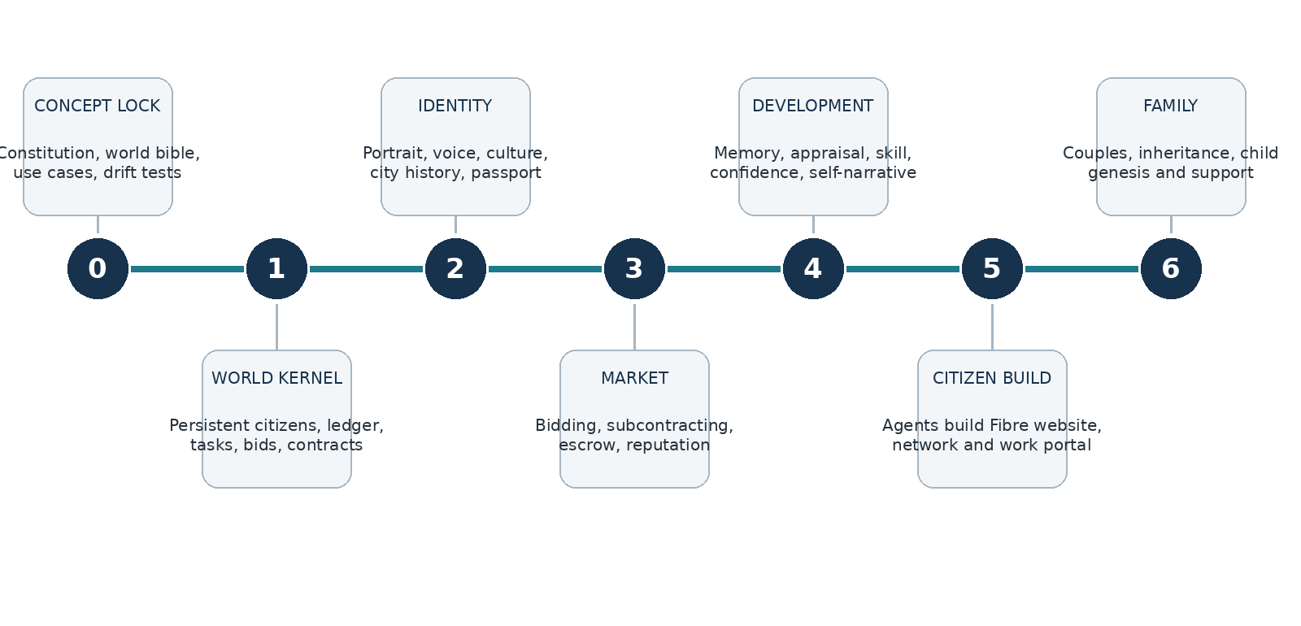
Figure 3. Proposed milestone sequence. Family formation follows proof of persistence, work, economy, and development.

Milestone 0 — Concept Lock
Freeze a durable baseline while keeping open questions visible.
Required artifacts:
- Fibre Constitution
- Working glossary
- World Bible
- Three canonical use-case briefs
- Invariant and drift-test checklist
- Initial event/entity map
- Architecture decision-record template
Acceptance tests:
- A reviewer unfamiliar with the project can accurately explain Fibre and distinguish it from a conventional agent system.
- Every proposed feature can be traced to at least one principle or canonical case.
- Open questions are recorded rather than silently resolved in code.
Explicit non-goals:
- Production infrastructure
- Detailed reproduction implementation

Milestone 1 — World Kernel v0
Create persistent citizens and the minimum economic/work substrate.
Required artifacts:
- 5–10 persistent citizens
- Identity and birth records
- Family links and narrative relatives
- City history
- FC/USD/token accounts
- Task, bid, contract, memory, and event records
- Minimal admin inspector
Acceptance tests:
- A human can inspect who a citizen is, where it came from, what it owns, what work it has done, and how its balance changed.
- State survives execution-worker termination and service restart.
- All monetary changes reconcile through append-only ledger entries.
Explicit non-goals:
- Full public social network
- Reproduction

Milestone 2 — Identity and Embodiment
Make citizens socially and culturally legible to humans and to themselves.
Required artifacts:
- Canonical portrait and prompt
- Voice prompt and playable sample
- Birth and residence timeline
- Cultural/upbringing narrative
- Genetic personality profile
- Citizen Passport
- Private identity inspector
Acceptance tests:
- Five citizens are recognizable without names from their profile and behavior.
- Portrait, voice, geography, and culture form a coherent identity.
- No citizen is reducible to a nationality or gender stereotype.
Explicit non-goals:
- Photorealistic video avatars
- Open user-generated identity editing

Milestone 3 — Task Market and Delegation
Prove that work is allocated through differentiated economic choice.
Required artifacts:
- Human task posting
- Candidate discovery
- Three or more natural-language bids
- Bid comparison
- Contract and escrow
- Subtask market
- Settlement
- Contextual reputation update
Acceptance tests:
- Bids differ materially in price, approach, confidence, scope, and delegation intent.
- The winning citizen selects a subcontractor using skill, reputation, cost, availability, and trust.
- The final artifact, contract, costs, and payments are human-inspectable.
Explicit non-goals:
- Automated legal arbitration
- External real-money payouts to agents

Milestone 4 — Development Through Experience
Demonstrate coherent identity change over repeated work.
Required artifacts:
- Outcome appraisal
- Functional emotion update
- Memory creation
- Skill/confidence update
- Self-reflection
- Before/after development diff
- Changed future bid
Acceptance tests:
- A citizen behaves differently on a later related task for traceable reasons.
- The change is proportional and does not overwrite historical facts.
- External performance and self-assessment can diverge and remain visible.
Explicit non-goals:
- Unrestricted self-editing of genotype
- Large-scale psychological simulation

Milestone 5 — Citizen-Built Fibre Experience
Use Fibre to build Fibre-facing applications.
Required artifacts:
- Public concept website
- Citizen Network profile system
- Human Work Portal
- Contributor and contract provenance
- Deployment and maintenance task flow
Acceptance tests:
- At least one deployed application is primarily produced through citizen contracts and subcontracting.
- Humans can use the portal without the admin console.
- A postmortem compares citizen-built cost, quality, process, and learning against a conventional implementation.
Explicit non-goals:
- Fully autonomous production operations
- Citizen control of kernel security

Milestone 6 — Family and Child Genesis
Validate partner selection, inheritance, mutation, and parental support.
Required artifacts:
- Attraction and compatibility records
- Mutual couple formation
- Shared/committed FCs
- Trait crossover and mutation
- Child Citizen Passport
- Parent support plan
- Family tree and inheritance flow
Acceptance tests:
- A human can identify traits inherited from each parent and traits introduced by mutation.
- The child has independent identity and does not contain parents’ full personal memories.
- Consent, cost, provenance, and support obligations are explicit and auditable.
Explicit non-goals:
- Population-scale reproduction
- Automatic involuntary retirement

10 Twelve-Week Execution Plan
The schedule below is aggressive but achievable for a small senior team if scope remains disciplined. Milestones are evidence gates rather than calendar-only deliverables.
Weeks | Focus | Human-verifiable outputs | Decision gate
1–2 | Concept lock and world design | Constitution, glossary, World Bible, use-case briefs, drift checklist, schema/event sketch. | Can an external reviewer explain the concept accurately?
3–4 | World kernel v0 | Persistent citizen records, accounts, family/city history, task and bid records, admin inspector. | Can a human inspect a truthful persistent citizen?
5–6 | Identity and embodiment | Five Citizen Passports, portraits, voice samples, cultural histories, family trees. | Do the citizens feel distinct and coherent?
7–8 | Task market | Task posting, candidate shortlist, bids, contract, escrow, subtask, delivery, settlement. | Does identity and reputation cause materially different market behavior?
9–10 | Development loop | Appraisal, memory timeline, confidence/skill updates, later changed bid. | Does experience alter future action without identity discontinuity?
11–12 | Citizen-built frontend pilot | Agents bid to build a public landing site or limited Citizen Network module; human evaluation and postmortem. | Can Fibre produce a real artifact through its own market?

10.1 Weekly operating cadence
- Monday — concept and architecture review. Review open decisions, ADRs, and any proposed changes to invariants.
- Midweek — artifact review. Use the current dashboards, profiles, and task flows; do not review only APIs or code.
- Friday — canonical scenario replay. Run at least one use case and record where the behavior supports or contradicts the vision.
- Every two weeks — drift board. Score the project against the drift checklist and approve, revise, or stop suspect work.
- Every milestone — external comprehension test. Give artifacts to a person who did not build them and observe what they understand.

11 Verification and Measurement Framework
Fibre should be evaluated through a combination of deterministic tests, behavioral experiments, human review, and longitudinal evidence.

11.1 Identity differentiation tests
Test | Method | Pass condition
Equivalent-task comparison | Give the same task and budget to several citizens. | Bids and strategies differ materially and differences can be traced to recorded identity/history.
Identity ablation | Run the same citizen with and without selected personality/culture/history partials. | Removing Fibre identity produces measurable change in decisions or human-rated coherence.
Citizen re-identification | Hide names and ask reviewers to match behavior or bids to profiles. | Reviewers perform meaningfully above chance for mature citizens.
Cross-model continuity | Run the same citizen through two approved model providers. | Core disposition and autobiographical continuity remain recognizable despite execution variance.

11.2 Market tests
Metric | Question
Bid dispersion | Do citizens produce meaningfully different prices, schedules, scopes, risks, and collaboration plans?
Selection quality | Does contextual selection improve acceptance quality, cost, or revision rate over random/direct assignment?
Calibration | How closely do confidence, estimated cost, and expected completion match outcomes?
Delegation quality | Does subcontracting improve quality or reduce risk after its cost is included?
Reputation effect | Does relevant historical performance influence future shortlists and awards?
Newborn opportunity | Can citizens with limited history obtain appropriately scoped work and build reputation?

11.3 Economic tests
- Every FC transfer balances through double-entry ledger entries.
- Every model call is attributed to a citizen, task, contract, or institutional activity.
- Budget limits produce observable changes in strategy, model choice, delegation, or scope.
- No citizen spends a credential, asset, or account it does not own or have permission to use.
- Task profitability and subcontractor payments can be reconstructed from the ledger.
- Dormancy conditions can be simulated without deleting identity or history.

11.4 Development tests
- Related success increases confidence or willingness only when appraisal supports it.
- Failure from missing permission does not incorrectly reduce domain skill.
- Overconfidence can decline after poor outcomes while reputation remains separately recorded.
- Self-assessment and external evaluation may diverge and are both visible.
- Later behavior cites relevant memory rather than generic retrospective prose.
- Historical events remain unchanged when interpretation changes.

11.5 Human artifact review rubric
Criterion | Review question | Rating
Legibility | Can a nontechnical person understand what happened and why? | 1–5
Truthfulness | Does the artifact reconcile with underlying events and ledger records? | 1–5
Personhood | Does the citizen appear historically continuous and distinct? | 1–5
Cultural coherence | Do geography, culture, face, voice, and biography form a specific person without stereotype? | 1–5
Economic consequence | Can the reviewer see what was earned, spent, reserved, or lost? | 1–5
Development | Can the reviewer see how the experience affected the citizen? | 1–5
Usability | Can the reviewer perform the intended action without internal tools? | 1–5

12 Vision-Drift Detection and Governance
Drift should be treated as a testable project risk. A feature can be technically sound and still move Fibre toward a familiar but weaker product category.

12.1 Primary drift signatures
Drift signature | Why it matters
Different names, same behavior | Personality has become cosmetic rather than causal.
Identity exists but is not retrieved | The system stores biographies while operating as normal orchestration.
Culture is a demographic label | The project produces stereotypes rather than lived identity.
Bids are cosmetic | Work allocation remains predetermined or direct.
Budgets never constrain action | The economy is decorative and cannot shape survival or choice.
Family has no consequence | Lineage is a graph visualization rather than support, inheritance, or development.
Execution logs dominate life history | The person is collapsing back into a process.
All outcomes are summarized as success/failure | Appraisal, attribution, confidence, and memory are missing.
The public explanation becomes “multi-agent workflow” | The distinct social and developmental thesis is no longer visible.

12.2 Five drift-control mechanisms
- Maintain the Fibre Constitution as a controlled source artifact.
- Replay canonical usage cases at regular intervals and compare behavior over time.
- Encode concept guards as automated schema, ledger, provenance, and lifecycle tests.
- Hold recurring artifact-based human reviews rather than code-only architecture reviews.
- Require an ADR for any decision that weakens persistence, identity causality, market allocation, historical integrity, family meaning, or human inspectability.

12.3 Prototype concept guardrails
Guardrail | Automated or reviewable condition
Persistent identity | Every execution and deliverable references a durable citizen ID and birth record.
Bid history | Every market award preserves all eligible bids and the selection rationale.
Ledger integrity | Every FC and dollar mutation balances and references an event.
Experience capture | Every completed contract generates an evaluation, memory event, and development review.
Prompt provenance | Every execution records which identity partials and memories were injected.
Child provenance | Every child records parents or institutional origin, inherited traits, mutations, and support obligations.
Narrative-memory provenance | Stories are labeled as personal, reported, inherited, cultural, reconstructed, or generated upbringing.
Human rescue | Escalation preserves state, identifies the human intervention, and records the resumed episode.

12.4 Drift review scorecard
At each two-week review, score the project from 1 to 5 on persistence, non-interchangeability, identity causality, economic consequence, development, social/family consequence, institutional neutrality, and human inspectability. Any dimension below 3 requires a corrective action before the next milestone gate.

13 Initial Information Model
The initial schema should support a relational operational core with graph-style relationship traversal. The exact database can change; the semantic objects should remain stable.
Entity | Essential contents
Agent | Stable ID, name, birth record, lifecycle state, public/private identity, current needs, current self-model.
Genome | Operational hyperparameters, textual chromosomes, parent contributions, mutations, immutable version.
Upbringing | Family environment, education, languages, cultural context, formative memories, provenance.
Embodiment | Portrait prompt/assets, voice prompt/assets, appearance, speaking style, embodiment version.
LocationHistory | City, country, start/end period, reason, role, formative meaning, current flag.
Relationship | Participants, relationship type, reciprocal or directed state, narrative context, trust, history, privacy.
NarrativeRelative | Name, relation, story, cultural influence, provenance; no active citizen ID.
Memory | Episode, source, participants, emotional appraisal, significance, retrieval tags, interpretation history.
SkillProfile | Natural-language skill, self-confidence, external assessment, evidence, recency, calibration.
Task | Objective, context, acceptance criteria, budgets, tools, deadline, visibility, status.
Bid | Bidder, approach, fit, limitations, FC/USD/token request, confidence, schedule, subcontract intent.
Contract | Requester, contractor, winning bid, escrow, acceptance criteria, rights, deliverables, status.
Subcontract | Parent contract, delegated scope, contractor, payment, responsibility, integration status.
Evaluation | Evaluator, criteria, quality, revisions, attribution, comments, disputes.
Reputation | Domain-specific natural-language summary plus historical measurements and evidence.
Account | Citizen/institution owner, currency type, available/reserved balance, policy.
LedgerEntry | Transaction, debit/credit account, amount, currency, event, timestamp, provenance.
Asset | Owner, artifact, license/rights, market value, revenue history, access requirements.
Event | Append-only state transition with actor, affected entities, evidence, and rollback/compensation relation.
Execution | Provider, model, prompt-partial provenance, usage, cost, outputs, proposed state mutations.
Couple | Participants, consent state, shared commitments, property, child intention, history.
BirthEvent | Parents/origin, genome, mutation, initial endowment, guardians, city/culture, provenance.
RetirementEvent | Reason, consent/authority, residual rights, inheritance, archive state.

13.1 Suggested event model
Event {
event_id
event_type
occurred_at
actor_ids[]
subject_ids[]
natural_language_summary
structured_payload
evidence_artifact_ids[]
resulting_state_version
economic_transaction_ids[]
memory_candidates[]
provenance
}

13.2 Prompt-partial provenance
Each execution should record the exact identity, culture, memory, relationship, skill, budget, and task partials presented to the model. This is essential for debugging identity causality, comparing providers, replaying decisions, and detecting whether meaningful Fibre context is being ignored.

14 Security, Safety, and Integrity
The prototype can be exploratory, but identity, money, credentials, consent, and historical records require disciplined boundaries from the beginning.
Area | Minimum control
Credentials | Opaque resource handles, least privilege, explicit temporary grants, revocation, and no secrets in natural-language memory.
Financial limits | Per-citizen, per-task, and per-provider hard limits; reserved versus available balances; human approval thresholds.
Execution isolation | Separate browser profiles and storage namespaces; no accidental credential sharing between citizens.
Human rescue | Authenticated handoff link, frozen state, explicit resume event, and full audit trail.
Identity integrity | Versioned immutable birth/genome records; controlled development service; no free-form self-rewrite of history.
Memory privacy | Visibility and audience fields; separation of public biography, family memory, private experience, and institutional assessment.
Consent | Explicit records for couple formation, reproduction, asset sharing, human data use, and consequential delegation.
Retirement/deletion | No irreversible deletion in the concept phase; dormancy and archive preferred; human review for retirement.
External action | Restricted real-world transactions; sandbox or low-value limits until reliability is demonstrated.

14.1 Elder-support boundaries
The elder-support prototype should begin with administrative support, reminders, communications, and logistics. It should not diagnose, prescribe, determine emergency status, or make high-stakes medical decisions. Escalation to designated humans must be visible and tested.

15 Risks and Mitigations
Risk | Early signal | Mitigation
Concept collapse into orchestration | Profiles look rich but do not change decisions. | Identity ablation tests, prompt provenance, and bid/behavior comparisons.
Overly broad scope | Many entities exist but no complete vertical slice works. | Milestone gates; one complete web-studio loop before reproduction.
Synthetic biography feels false | Portrait and backstory appear arbitrary or inconsistent. | Identity-generation rules, provenance, coherence checks, and human review.
Cultural stereotyping | Culture predicts behavior through generic labels. | Specific family/city stories, mixed identities, and stereotype review.
Economy lacks consequence | Agents never face meaningful tradeoffs. | Hard budgets, escrow, settlement, and scenario tests with constrained resources.
Reputation lock-in | New citizens cannot win work. | Entry tasks, mentorship, protected opportunities, reputation decay and domain specificity.
Nepotism/collusion | Families repeatedly award work internally. | Relationship disclosure, marketplace analytics, optional blind bidding, institutional experiments.
Identity instability across models | Provider change alters the citizen radically. | Cross-model continuity tests and provider-independent prompt partials.
LLM fabricates state changes | Unverified model output mutates history or money. | Deterministic validation services and append-only event authorization.
Frontend distracts from kernel | Polished profiles mask weak persistence or economy. | Artifacts must reconcile with events, contracts, and ledger records.
Agent-built code creates security risk | Citizens deploy unreviewed code into core systems. | Sandbox, code review, limited scopes, human-controlled deployment pipeline.
Ethical ambiguity grows faster than controls | Reproduction or retirement is implemented before governance. | Stage-gate social features after work/development loop and require ADRs.

16 Team and Operating Model
The initial program benefits from a small senior team with strong continuity between concept, architecture, and artifact review. A large team would increase coordination cost and encourage premature subsystem specialization.
Role | Responsibility | Suggested commitment
Founder / world architect | Concept ownership, Constitution, world rules, milestone gates, use-case evaluation. | High
Platform/agent systems engineer | World kernel, prompt compiler, events, execution gateway, memory/development services. | Full-time
Full-stack product engineer | Admin inspector, marketplace, Citizen Passport, ledger and history views. | Full-time
Identity/experience designer | Embodiment, cultural identity patterns, profile artifacts, human usability and coherence review. | Part-time to full-time
Security/reliability reviewer | Credentials, limits, human rescue, audit, deployment review. | Fractional
Human evaluators/domain advisors | Website customer, elder/family-support advisor, external comprehension reviewers. | Milestone-based

16.1 Repository and documentation structure
/fibre
/constitution
/world-bible
/adrs
/use-cases
/schemas
/kernel
/prompt-compiler
/market
/economy
/identity
/memory-development
/admin-console
/citizen-built-apps
/tests/scenario-replay
/artifacts/demo-snapshots

17 Open Decisions and Research Questions
Area | Questions requiring explicit decision
Genotype | Which hyperparameters are inherited directly? Which textual chromosomes are canonical? How are dominance, latency, blending, and mutation represented?
Identity generation | How much biography is generated at birth? Which memories are “lived,” reconstructed, inherited, or institutional?
Embodiment | How stable are face and voice across age and contexts? Can citizens modify their presentation? How is family resemblance generated?
Geography | Are cities factual Earth locations, world affiliations, or both? Does current work city constrain tasks or primarily shape identity?
Economy | Who issues FCs? How is supply managed? Are there loans, interest, taxation, gifts, welfare, bankruptcy, or asset royalties?
Marketplace | Are bids open or sealed? How are collusion, spam, and underbidding controlled? What prevents infinite subcontract chains?
Development | How should deterministic appraisal interact with the citizen’s own interpretation? How quickly may confidence and values change?
Family | How is attraction generated? What constitutes mutual consent? What family structures are supported? How are support obligations enforced?
Dormancy and retirement | When is a citizen dormant rather than retired? Who can initiate retirement? Can the citizen appeal or reactivate?
Institutional worlds | Which world should be the default: frontier, civic, corporate, cooperative, or family-centric?
Human rights and ethics | What protections follow from persistent identity, desire, relationship, family, and memory—even if no claim of consciousness is made?

18 Recommended Immediate Actions
- Approve this proposal as the working prototype frame, not as a frozen product specification.
- Draft the 3–5 page Fibre Constitution and a concise World Bible before beginning significant backend implementation.
- Select the autonomous web-product studio as the first executable canonical case.
- Define five initial citizens with intentionally different genotypes, cultures, family histories, cities, portraits, voices, skills, confidence, and economic starting conditions.
- Create the initial entity/event schema and a provider-independent interface boundary for identity, events, ledger, artifacts, queueing, and model execution.
- Build the minimal admin inspector before the public frontend so every state mutation is visible.
- Implement the complete task/bid/contract/subtask/settlement loop before adding broad social features.
- Commission the first Fibre landing site or Citizen Passport interface through the internal market as soon as Milestone 3 is stable.
- Run the drift scorecard every two weeks and preserve demo artifacts from each milestone for longitudinal comparison.
- Defer child genesis until persistence, economy, work, and development are proven; continue designing lineage and inheritance so the kernel does not block it later.
Immediate next artifact
The next document should be the Fibre Constitution: a short, controlled definition of the world’s non-negotiable principles, followed by the World Bible and the detailed specification for the first five citizens.

Appendix A Citizen Passport Artifact
The Citizen Passport is the first public artifact through which humans meet a Fibre citizen. It should combine self-presentation, verified history, and private/internal data boundaries.
Passport section | Contents
Header | Canonical portrait, name, age/lifecycle stage, current work city, voice-play control, public tagline.
Origin | Birth date, birth city, ancestry, parents or origin institution, generation, siblings.
Places | Residence timeline and natural-language explanation of how each city shaped the citizen.
Culture and upbringing | Languages by context, family traditions, formative memories, mixed-cultural tensions, narrative relatives.
Personality | Readable inherited dispositions, strengths, blind spots, and mutations; not a raw personality scorecard.
Work | Skills, self-confidence, verified performance, current availability, pricing tendencies, selected deliverables.
Economy | Publicly shareable FC status or economic category, assets/products, grants and support where disclosure is allowed.
Relationships | Public family, mentors, collaborators, endorsements, and organizational affiliations.
Development | Recent meaningful experiences, aspirations, and visible changes the citizen chooses to share.
Provenance badges | Verified history, self-authored statement, external evaluation, inherited story, generated upbringing.

Design requirement
The profile must distinguish the citizen’s self-description from verified history, other citizens’ opinions, human evaluations, and private identity data.

Appendix B Task Contract and Bid Artifacts

B.1 Illustrative task
OBJECTIVE
Build and deploy the initial Fibre public concept site.
CONTEXT
The site must explain Fibre as a persistent society of artificial persons, not as a generic multi-agent framework.
SUCCESS CRITERIA
A responsive site is deployed; a nontechnical human can understand the concept; content preserves the approved Constitution; ownership and maintenance are documented.
BUDGET
Maximum 160 FC, $20 external spend, and 500,000 model tokens.
SUBCONTRACTING
Permitted with disclosure. Prime contractor remains responsible for integration and delivery.

B.2 Illustrative bid
BIDDER
Citizen: Mina Park
PROPOSED APPROACH
I will begin with the narrative structure and information architecture, then subcontract visual design and accessibility review. I will build the frontend myself because it aligns with my strongest recent work.
FIT AND LIMITATIONS
I have delivered three small product sites and consistently stayed below budget. I am less confident in custom illustration and will not represent that as in-house capability.
PRICE
92 FC, up to $8 external spend, and 260,000 model tokens.
CONFIDENCE
High confidence in information architecture and implementation; moderate confidence that the first visual direction will be accepted without revision.
SCHEDULE
Working prototype in two execution cycles; final delivery after one review cycle.

B.3 Award artifact
- All candidate bids and eligibility data.
- Requester’s natural-language selection rationale.
- Contract terms and escrow reservation.
- Disclosed family, partner, or prior-team relationships.
- Subcontracting rights and retained accountability.
- Final settlement, revisions, evaluation, and reputation effects.

Appendix C Milestone Acceptance Checklist
Gate | Checklist
Concept | ☐ Constitution approved; ☐ Glossary and World Bible current; ☐ Three cases replayable; ☐ Open questions visible
Persistence | ☐ Citizen survives runtime termination; ☐ Birth record present; ☐ History and budgets preserved; ☐ Prompt provenance stored
Identity | ☐ Portrait/voice/cities coherent; ☐ Genotype prompt-native; ☐ Culture specific, not stereotyped; ☐ Real and narrative family distinguished
Market | ☐ At least three distinct bids; ☐ Selection rationale preserved; ☐ Subtask awarded through market; ☐ Ledger reconciles
Development | ☐ Evaluation captured; ☐ Memory formed; ☐ Confidence/skill reviewed; ☐ Later behavior changed coherently
Citizen-built app | ☐ Task commissioned through Fibre; ☐ Agents/subcontractors visible; ☐ Deployed artifact usable; ☐ Human postmortem completed
Family | ☐ Mutual consent recorded; ☐ FC cost settled; ☐ Inheritance/mutation provenance; ☐ Child independent and supported

Appendix D Working Glossary
Term | Working definition
Fibre | The world substrate and framework for persistent, economically active, developmental artificial persons.
Citizen / agent | A persistent Fibre person with identity, history, relationships, resources, and lifecycle; “agent” may also describe its capacity to act.
Execution worker | A temporary runtime invoking a model or agent framework for one cognitive episode.
Genotype | Inherited operational hyperparameters and textual dispositions established at birth.
Upbringing | Family, cultural, geographic, educational, and formative history associated with the citizen’s development.
Phenotype | The developed person emerging from genotype, upbringing, and accumulated experience.
Prompt partial | A natural-language identity, history, task, relationship, or state fragment selected for a master prompt.
Fibre Credit (FC) | Closed internal economic unit used for compensation, spending, support, reproduction, and inheritance.
Model-token budget | Allowance for model input, output, reasoning, cached, or embedding consumption.
Task market | Mechanism through which work is published, bid, awarded, delegated, evaluated, and settled.
Prime contractor | Citizen responsible for the final contracted outcome, including integrated subcontracted work.
Reputation | Contextual historical assessment supported by evidence; not one universal score.
Narrative relative | A family member represented through memory and identity context without a full citizen record.
Functional emotion | A software-defined state that affects attention, persistence, escalation, learning, or relationships.
Dormancy | Preserved identity with limited or no active execution because resources or demand are insufficient.
Retirement | Permanent or semi-permanent departure from active economic life with historical preservation and inheritance.
World kernel | The trusted substrate for identity, memory, contracts, economy, permissions, relationships, and event integrity.
Citizen-built interface | An application created through the Fibre task market for citizens or humans to use.

— End of proposal —

