Client – Server – Json – Parser

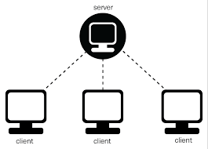

Contents:
1 Goals 2
2 Modules 3
3 Design 4
4 Overview 5
5 CS-JSON-PARSER API
5.1 Thread Pool API 6
5.2 Logger API 7
5.3 Networking TCP/IP API 8
5.4 Json-C parser API 10
5.5 Build-Parse-Data API 12
5.6 Parse-Json-Config API 13
6 Message Protocol
7 GSI-Parse-Json-Client Test
8 GSI-Parse-Json-Server Test

1 Goals:
- Understand TCP/IP communication
- Working with multi-threaded programs
- Import an open source code(JSON-C) to new project
- Reuse existing code
- Learn the gsi coding standard

2 Modules:
- Thread Pool
- Logger
- Networking TCP/IP
- Json-C parser
- Build Parse Data
- Parse Json Configuration
- GSI-Parse-Json-Client test
- GSI-Parse-Json-Server test

3 Design:
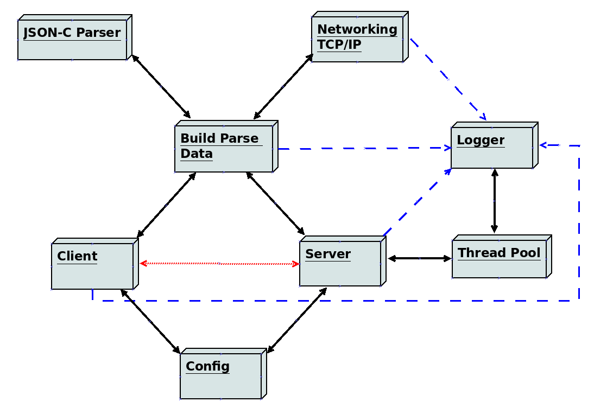

4 Overview:
- Thread Pool:
Responsible to create threads for several uses during the program.
Insert different jobs to running threads.
- Logger:
Responsible to write messages all over the program into log file in the following format:
“<time stamp> - <log[level]>: <file> <line>: <message>”
Uses thread pool to insert all messages into queue and writing them into file(Thread Safe).
- Networking TCP/IP:
Responsible to set up connection between client and server. Send and Receive messages over TCP/IP. Using polling technique.
- Json-C parser:
Responsible to handle messages in JSON format. Create JSON object from string and vice versa.
{
<KEY> : <VALUE>,
<KEY> : <VALUE>
}
(ctrl+click here to go to json-c home page)
(ctrl+click here to go to README installation of json-c library)
- Build Parse Data:
Responsible to combine Networking and JSON-C to handle message passing between client and server. Simple API that hide all the complication of build and send/receive the Json messages over TCP/IP.
- Parse Json Configuration:
Responsible to read configuration parameters from config files of server and clients.
Each line is <param>:<value> (no spaces).
- Client Test:
Test connection to server and send messages from ready messages file according to specific message format.
- Server Test:
Test listening on ports to multiple clients by using threads. Receive messages and operate according to message type.
5 CS-JSON-PARSER API:
5.1 Thread Pool API:
gsi_is_thread_pool_create:
Description: Create Thread pool for several uses
Warnings: Must be destroy by gsi_is_thread_pool_destroy
Signature:
gsi_thread_pool_t *gsi_is_thread_pool_create(int i_thread_count,
int i_queue_size);
Parameters:
- int i_thread_count – number of threads in pool
- int i_queue_size – size of the jobs queue

gsi_is_thread_pool_add:
Description: Add job that is function to do and its arguments to the jobs Queue,
the next thread that available will take that job.
Warnings: Pointers must be valid
Signature:
enum gsi_thread_pool_rc gsi_is_thread_pool_add(gsi_thread_pool_t* p_pool,
thread_func_t thread_func,
void* args);
Parameters:
- gsi_thread_pool* p_pool – pointer to thread pool
- thread_func_t thread_func – job function to add
- void *args – arguments to pass to the job function

gsi_is_thread_pool_destroy:
Description: Free all resources that were in use
Warnings: Pointer must be valid
Signature:
enum gsi_thread_pool_rc gsi_is_thread_pool_destroy(gsi_thread_pool_t* p_pool,
int i_flags);
Parameters:
- gsi_thread_pool* p_pool – pointer to thread pool to destroy
- int i_flags – GSI_TP_DESTROY_GRACEFUL – wait all threads to finish
GSI_TP_DESTROY_IMMIDIATE – don’t wait to threads
5.2 Logger API:
gsi_is_create_log_file:
Description: Create global log file to use during the program
Format: "log_path/log_name-YYYY-MM-DD-HH.MM.SS.log"
Warnings: Must be closed by gsi_is_close_log
Signature:
FILE* gsi_is_create_log_file(const char *s_log_name, const char *s_log_path);
Parameters:
- const char* s_log_name – base name for the log file name
- const char* s_log_path – the path were to create the log file
gsi_is_write_to_log:
Description: Insert log message to queue of pending message to be written into log file,
Use as much as you need between create and close functions.
Warnings: Pointers must be valid
Signature:
enum gsi_is_log_rc gsi_is_write_to_log(FILE* f_log, const char*s_format, ...);
Parameters:
- FILE* f_log – pointer to log file
- const char* s_format – message in printf format that can take additional arguments
- … - list of arguments to pass the format
Macros: simple use these macros in your code
- LOG_ERROR(msg, args…) - error log message
- LOG_WARNING(msg, args…) - warning log message
- LOG_INFO(msg, args…) - information log message
- LOG_DEBUG(msg, args…) - debugging information log message

gsi_is_close_log:
Description: Close the global log file
Warnings: Farther use in log after this function is undefined
Signature:
FILE* gsi_is_close_log(FILE* f_log);
Parameters:
- FILE* f_log – pointer to log file to close
example:
5.3 Networking TCP/IP API:
Client Functions:
gsi_is_network_tcp_client_init:
Description: Initialize object of tcp_client to be ready for connection with server
Warnings: Pointers must be valid
Signature:
enum gsi_is_network_return_code gsi_is_network_tcp_client_init(
struct gsi_net_tcp *p_this, char* s_tcp_addr);
Parameters:
- struct gsi_net_tcp *p_this – pointer to client object to initialize
- char* s_tcp_addr – address to connect to: “<IPAddress>:<Port>”

gsi_is_network_tcp_connect:
Description: Create a socket and connect to server
Warnings: Pointers must be valid
Signature:
enum gsi_is_network_return_code gsi_is_network_tcp_connect(
struct sockaddr_in *p_serv_addr, int *p_socket_fd);
Parameters:
- struct sockaddr_in *p_serv_addr - address of the server
- int *p_socket_fd – pointer to socket file descriptor to fill

gsi_is_network_tcp_send:
Description: Send a single message over an IPv4 TCP socket
Warnings: Pointers must be valid
Signature:
enum gsi_is_network_return_code gsi_is_network_tcp_send(
struct gsi_net_tcp *p_this, char *s_msg);
Parameters:
- struct gsi_net_tcp *p_this – pointer to client object
- char *s_msg – message to send

Server Functions:
gsi_is_network_tcp_server_init:
Description: Initialize object of tcp_server to be ready for incoming connection
Warnings: Pointers must be valid
Signature:
enum gsi_is_network_return_code gsi_is_network_tcp_server_init(
struct gsi_net_tcp *p_this, unsigned int ui_port);
Parameters:
- struct gsi_net_tcp *p_this – pointer to client object to initialize
- char* s_tcp_addr – address to connect to: “<IPAddress>:<Port>”
gsi_is_network_tcp_server_poll:
Description: Polls if TCP Server has available pending connections or Data on an
established connection.
Polling allows the TCP server to work in a non-blocking mode which allows the server to
perform other tasks while waiting for either a connection or DATA.
Warnings: Pointer must be valid
Signature:
enum gsi_is_network_return_code gsi_is_network_tcp_server_poll(
struct gsi_net_tcp *p_this);
Parameters:
- struct gsi_net_tcp *p_this – pointer to server
gsi_is_network_tcp_server_read:
Description: Read one message from ready file descriptor
Warnings: Pointers must be valid
Signature:
enum gsi_is_network_return_code gsi_is_network_tcp_server_read(
struct gsi_net_tcp *p_this, char *s_msg);
Parameters:
- struct gsi_net_tcp *p_this – pointer to server object
- char *s_msg – buffer to fill with the read message
gsi_is_network_tcp_server_cleanup:
Description: Free all resources that used by the server
Warnings: Pointers must be valid
Signature:
enum gsi_is_network_return_code gsi_is_network_tcp_server_cleanup(
struct gsi_net_tcp *p_this);
Parameters:
- struct gsi_net_tcp *p_this – pointer to server object

5.4 Json-C parser API:
Build object:
json_object_new_object:
Description: Create new json object using reference counting
Warnings: Must be free by json_object_put
Signature:
struct json_object *json_object_new_object(void);
Parameters: None
json_object_put:
Description: Decrease reference counting by 1 – if it is zero – Free it
Warnings: pointer must be valid
Signature:
int json_object_put(struct json_object *jso);
Parameters:
- struct json_object *jso – pointer to json object
json_object_add:
Description: Add to json object new tuple <KEY>:<VALUE>
Warnings: pointer must be valid
Signature:
int json_object_object_add(struct json_object *jso, const char *key,
struct json_object *val)
Parameters:
- struct json_object *jso – pointer to json object
- const char* key – key as string
- struct json_object *value – json object value(int_type, string_type, etc...)
json_object_new_int:
Description: Create new json object with integer value
Warnings: When using add, the ownership is transfer to the parent json object so you don’t
need to free it – it will free with the parent
Signature:
struct json_object *json_object_new_int(int i_value);
Parameters:
- int i_value – value of the new json object of int_type

Conversions:
json_object_to_json_string_ext:
Description: Convert the json object to string format
Warnings: The pointer you get is an internal of your json object. You don't have to free it,
later use of json_object_put() should be sufficient.
Signature:
const char *json_object_to_json_string_ext(struct json_object *obj,
int flags);
Parameters:
- struct json_object *obj – pointer to json object
- int flags – JSON_C_TO_STRING_SPACED
JSON_C_TO_STRING_PRETTY
those flags will make the output more readable and in JSON format, you can combine them by OR

json_tokener_parse:
Description: Convert the string to json object
Warnings: Must be free by json_object_put
Signature:
struct json_object *json_tokener_parse(const char *str);
Parameters:
- const char* str – string that represent valid JSON object

examples of messages in Json format:
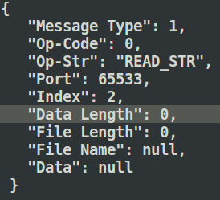
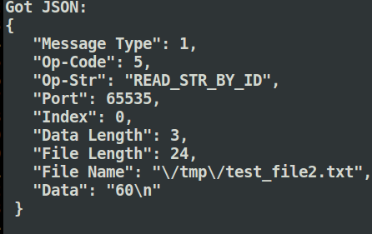

5.5 Build Parse Data API:
gsi_is_open_msg_file:
Description: Open message file of client
Warnings: Pointer must be valid. Must be close by gsi_is_close_msg_file
Signature:
FILE* gsi_is_open_msg_file(const char* s_file_name);
Parameters:
- const char* s_file_name – message file to open
gsi_is_close_msg_file:
Description: Close message file of client
Warnings: Pointer must be valid.
Signature:
enum gsi_is_json_rc gsi_is_close_msg_file(FILE* f_msg_file);
Parameters:
- FILE* f_msg_file – file of messages that is open
gsi_is_send_all_json_msg:
Description: Send all messages that in the opened file
Warnings: Pointer must be valid. Client must be connect to server before using this function
Signature:
enum gsi_is_json_rc gsi_is_send_all_json_msg(FILE* f_msg_file,
struct gsi_net_tcp* p_client);
Parameters:
- FILE* f_msg_file – file of messages that is open
- struct gsi_net_tcp* p_client – pointer to client that want to send the messages
gsi_is_recv_json_msg:
Description: Receive one message on listening port
Warnings: Pointer must be valid.
Signature:
enum gsi_is_json_rc gsi_is_recv_json_msg(struct gsi_net_tcp* p_server,
struct gsi_json_msg* p_json_msg);
Parameters:
- struct gsi_net_tcp* p_server – pointer to server that listen to port
- struct gsi_json_msg* p_json_msg – pointer to message to fill by the received message

5.6 Parse-Json-Config API:
gsi_parse_json_config_get_config:
Description: Read configuration parameters from given file
Warnings:
- client config file must be given on command line
- server config file is optional and has default values
Signature:
enum gsi_prase_json_config_rc gsi_parse_json_config_get_config(int i_argc,
char* p_argv[]);
Parameters:
- int i_argc – number of arguments on command line
- char* p_argv[] - vector of the arguments
configurable parameters:
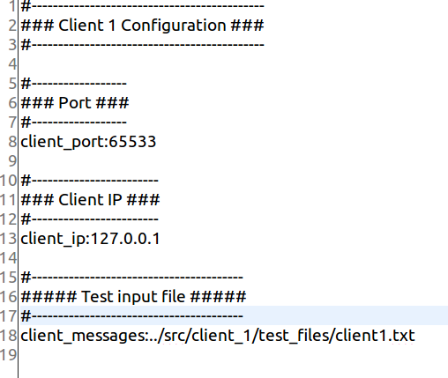
- client port
- client ip
- client messages file
- server port
- server ip
- server timer
- server data file

Message Protocol:
Client messages file has the following format for each line:
'M' - Regular message
‘H' - Heartbeat message
'#' - comment line
"RS" - Read String
"WS" - Write String
"RF" - Read File
"WF" - write File
"PL" - Print Log
"RFID" - Read message from file by id

Examples:
"M:RS:2" - Regular message that will read string in index 2
"H:WD" - HeartBeat message
"M:WS:3 new-message" - Regular message that will write the "new-message" in index 3
"M:RF <file_name>" - Regular message that will read all content of file_name
"M:WF <target_file_name> <msg_id> <msg>" - Regular message with id that write into target file
"M:PL <file_name>" - Regular message that will print log file to screen
"M:RFID <file name> <msg id> - Regular message that will search message in file according to id and print to screen

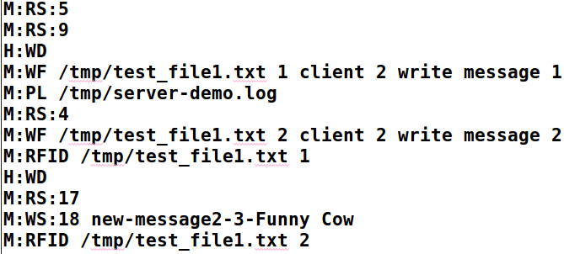

7 GSI-Parse-Json-Client Test:
Description:
This is demo program to send messages to server over TCP/IP and using JSON-C parser.
The program load messages from file and send them to server on specific port.
The Clients in the test connect on 3 ports: 65533, 65534, 65535 and send different
messages from different files.
Each client has its own log file.
Client Flow:
Usage: <bin> <config file>
$ ../bin/gsi_parse_json_client_1
--cfg=/etc/gsi-parse-json/gsi_parse_json_config_client1.conf

- Create log file on /var/log folder. for example: “gsi-log-client-1-2020-08-18-12:04:25.log”
config file is given in argv[1].
- Initialize client parameters an establish connection to server.
  - Retry connect 3 times – if failed – write failure to log and quit.
- Open the messages file that read from config file.
- Send all the messages from file to Server.
- Free resources:
  - Close messages file.
  - Close log file.

Output of the log file of client on port 65533:
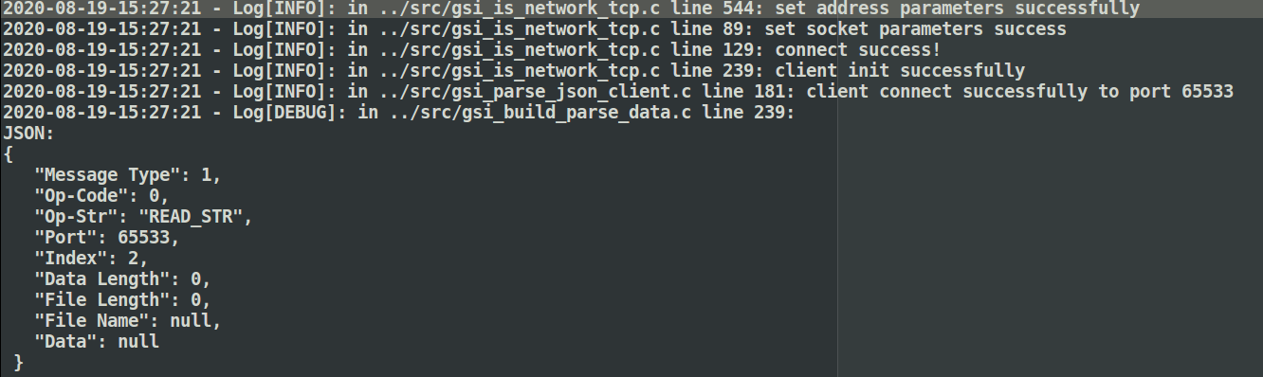

8 GSI-Parse-Json-Server Test:
Description:
This is demo program to listening multiple clients by using multi-thread functionality.
It uses TCP/IP and JSON-C parser to read the messages from clients
It has one log file.
It was built to listen on 3 ports right now(will improve later…).
Server Flow:
Usage: <bin> <config file>
$ ../bin/gsi_parse_json_server
--cfg=/etc/gsi-parse-json/gsi_parse_json_config_server.conf
- Create log file on /tmp folder. for example: “gsi-log-server-2020-08-18-12:04:23.log”
- Initialize global array of strings, load them from config file that given in argv[1].
- Create thread pool with 3 Threads – each thread will listen to different port.
- Set up server details to start listening to 3 clients.
- Server can use timer or infinite.
- Using poll to check new events on those ports.
  - Nothing happened – keep waiting.
  - Has new message from client – read the new message:
    - Regular message – check its operation code and do the corresponding
function.
    - Heartbeat message – mechanism to check the client still respond. On every
5 regular messages the client must send at least 1 heartbeat message.
  - Connection error – stop the connection with the client on this port.
- Free resources:
  - Destroy thread Pool.
  - Free the global array of strings.
  - Close the log file.

Output of the server’s log:
