Introduction
Mellow Elephant is an collection of applications which use old radio scanners such as the Uniden BC-780-XLT (or similar) to create a database of spectrum utilization. The spectrum database is created by tuning the scanner and collecting the signal strength. Sampling continues for an extended period. Continuous emitters should be observed on every pass while transient emitters take awhile to discover.

Here is a sample graph from Mellow Elephant of my local FM broadcast band. The line w/ticks represent signal strength (and each tick is a sample), and the peak values represent active emitters. The continuous line represents a moving average signal strength.
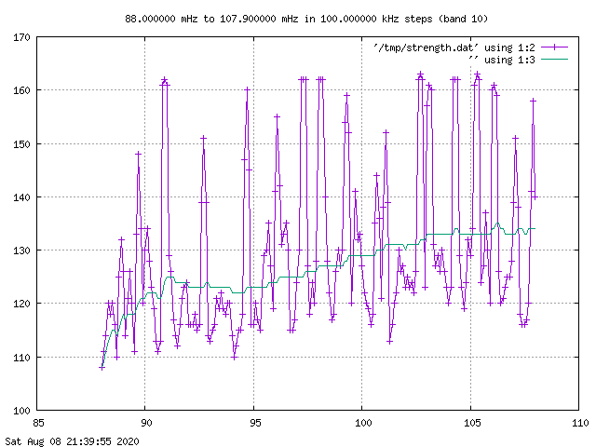

I use a raspberry pi 3 to host Mellow Elephant and control a BC-780-XLT via RS-232 and a USB adapter. Here is a photo of the actual equipment.
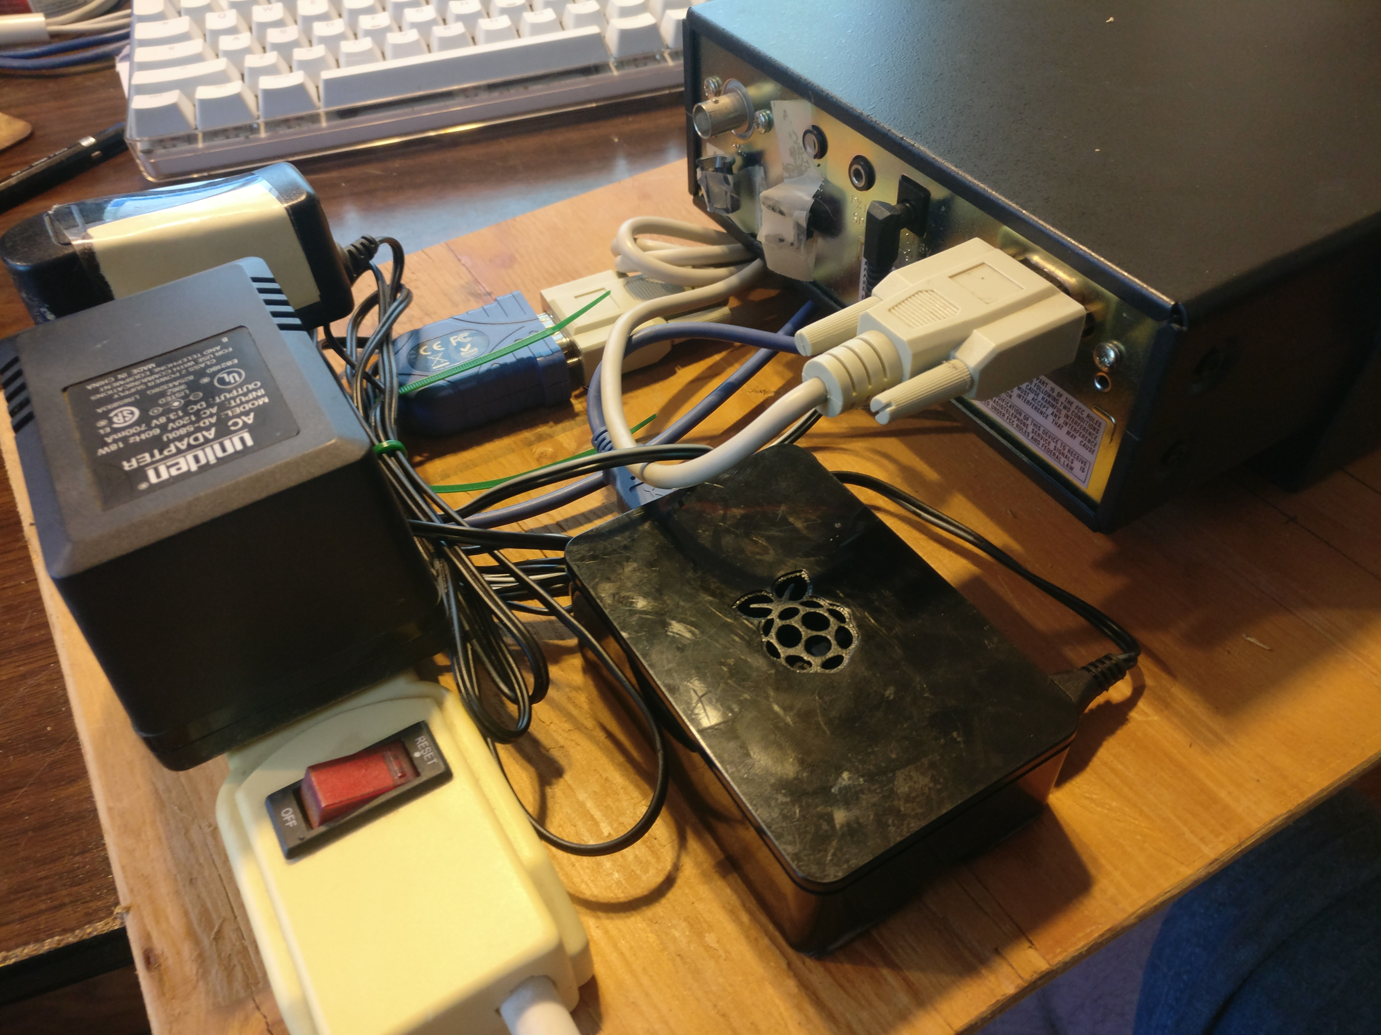

Uniden BC-780-XLT
The BC-780-XLT was one of the earliest radio scanners to allow control by computer, in this case via RS-232. Controlling the scanner is similar to the Hayes command set in that one writes a simple ASCII string to the device and then read the results. There is more about the BC-780-XLT command set near the end of this file.
There were several variations on the BC-780-XLT such as the Radio Shack PRO-2052, all w/similar behavior. Examples of the BC-780-XLT are readily available via eBay. The BC-780-XLT are mediocre receivers, and do suffer from poor intermods (in my case, harmonics from commercial FM broadcasters are a problem).
The BC-780-XLT defines chunks of spectrum into bands (table at end of file) which loosely map to spectrum service allocations. Mellow Elephant can be configured to search or ignore by Uniden band.

Getting Started
Ready to put an old radio to work? You will need a RS-232 cable and (probably) a USB to RS-232 converter. Here are some cabling instructions.
If you like, you can reset a BC-780-XLT to factory settings by powering off, then holding down 2, 9 and "MAN" keys while powering on. The scanner will set the serial port to 9600, which is what Mellow Elephant uses.
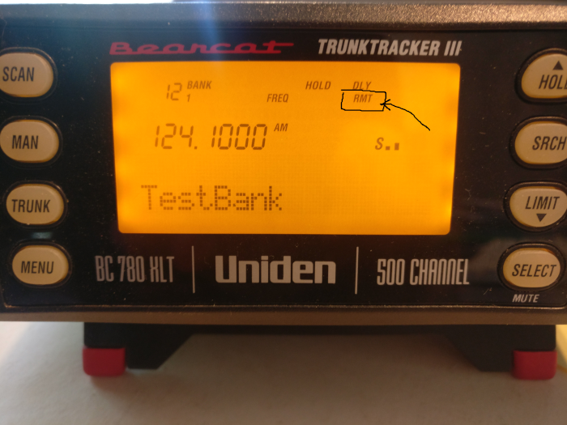
Look at your scanner display. Do you see "RMT" (in the square)? If so, you are all ready for "Remote" mode. If not, press "E" for 2 seconds and "RMT" should appear.
With the radio configured, plug it into your USB port. Discover the USB assignment using dmesg (or similar) which will emit a message like:
usb 1-1.3: pl2303 converter now attached to ttyUSB0
Which indicates your serial device is “/dev/ttyUSB0”.

Configure Mellow Elephant Application
- You will need python3 to use Mellow Elephant, type 'which python3' to discover location.
- Clone Mellow Elephant repository https://github.com/guycole/mellow-elephant
- Create a python virtual environment
  - cd to the src directory and type 'virtualenv -p /usr/local/bin/python3 venv' where "/usr/local/bin/python3" is replaced by the actual location of python3 on your machine (from step 1).
  - type 'source venv/bin/activate'
  - type 'pip install -r requirements.ubuntu'
- Now test interaction w/the radio.
  - cd to the bin directory
  - Update "serialDevice" within “serial_test.yaml” to reflect your USB port assignment.
  - Update “serial_test_usb0.sh” to reflect your actual path.
  - Invoke "serial_test_usb0.sh" and if all goes well, the computer will ask BC-780-XLT for system information.

Prepare for Mellow Elephant Collection
Uniden divided coverage into various "bands" which I also use to manage frequencies of interest. "Bands" don't actually map to spectrum service types, but there is some overlap. I provide a band table at the end of this file.
- cd to the bin directory
  - Update "serialDevice" within “collect.yaml” to reflect your USB port assignment.
  - Update “collect_usb0.sh” to reflect your actual path.
  - Invoke "collect_usb0.sh" and the application should start collection, eventually producing a “pickled band file” in the “observations/fresh” directory.

Processing Collected Observations
Once you have created “pickled” band files, you can extract for database and graphs.
For simplicity, Mellow Elephant uses the sqlite3 database support that comes w/python and the graphs are created using gnuplot (which you might need to install). I have left some band files in “observations/fresh” as demonstration objects.
- cd to the bin directory
  - Update the “processing.yaml” to reflect your own paths.
  - Update “processing.sh” to reflect your actual path.
  - Invoke “processing.sh” and the demonstration files will be processed.
    - sqlite3 database will be created (3x files in db directory)
    - Pickled band files will move from fresh to archive directory
    - New graph files will be created in the graphs directory

RS-232
Configure the scanner for speed 9600.
A complete command summary can be found at http://www.netfiles.ru/share/linked/f1/UnidenProtocol.pdf)

Uniden Bands
Index | Band # | Lower | Upper | Increment | Modulation
1 | 1 | 25.0 | 26.96 | 5.0 | AM
2 | 2 | 26.965 | 27.405 | 5.0 | AM
3 | 3 | 27.41 | 27.995 | 5.0 | AM
4 | 4 | 28.0 | 29.69 | 10.0 | FM
5 | 5 | 29.7 | 49.99 | 10.0 | FM
6 | 6 | 50.0 | 53.99 | 10.0 | FM
7 | 7 | 54.0 | 71.95 | 50.0 | WFM
8 | 8 | 72.0 | 75.995 | 5.0 | FM
9 | 9 | 76.0 | 87.95 | 50.0 | WFM
10 | 10 | 88.0 | 107.9 | 100.0 | WFM
11 | 11 | 108.0 | 136.975 | 25.0 | AM
12 | 12 | 137.0 | 143.995 | 5.0 | FM
13 | 13 | 144.0 | 147.995 | 5.0 | FM
14 | 14 | 148.0 | 161.995 | 5.0 | FM
15 | 14 | 162.0 | 173.9875 | 12.5 | FM
16 | 15 | 174.0 | 215.95 | 50.0 | WFM
17 | 16 | 216.0 | 224.995 | 5.0 | FM
18 | 17 | 225.0 | 399.95 | 50.0 | AM
19 | 18 | 400.0 | 405.9875 | 12.5 | NFM
20 | 19 | 406.0 | 419.9875 | 12.5 | NFM
21 | 20 | 420.0 | 424.9875 | 12.5 | NFM
22 | 20 | 425.0 | 429.9875 | 12.5 | NFM
23 | 20 | 430.0 | 449.9875 | 12.5 | NFM
24 | 21 | 450.0 | 454.9875 | 12.5 | NFM
25 | 21 | 455.0 | 459.9875 | 12.5 | NFM
26 | 21 | 460.0 | 464.9875 | 12.5 | NFM
27 | 21 | 465.0 | 469.9875 | 12.5 | NFM
28 | 22 | 470.0 | 472.9875 | 12.5 | NFM
29 | 22 | 473.0 | 475.9875 | 12.5 | NFM
30 | 22 | 476.0 | 478.9875 | 12.5 | NFM
31 | 22 | 479.0 | 481.9875 | 12.5 | NFM
32 | 22 | 482.0 | 484.9875 | 12.5 | NFM
33 | 22 | 485.0 | 487.9875 | 12.5 | NFM
34 | 22 | 488.0 | 490.9875 | 12.5 | NFM
35 | 22 | 491.0 | 493.9875 | 12.5 | NFM
36 | 22 | 494.0 | 496.9875 | 12.5 | NFM
37 | 22 | 497.0 | 499.9875 | 12.5 | NFM
38 | 22 | 500.0 | 502.9875 | 12.5 | NFM
39 | 22 | 503.0 | 505.9875 | 12.5 | NFM
40 | 22 | 506.0 | 508.9875 | 12.5 | NFM
41 | 22 | 509.0 | 511.9875 | 12.5 | NFM
42 | 23 | 806.0 | 823.9875 | 12.5 | NFM
43 | 23 | 849.0125 | 850.9875 | 12.5 | NFM
44 | 23 | 851.0 | 868.9875 | 12.5 | NFM
45 | 23 | 894.0125 | 895.9875 | 12.5 | NFM
46 | 23 | 896.0 | 901.0 | 12.5 | NFM
47 | 23 | 901.0125 | 934.9875 | 12.5 | NFM
48 | 23 | 935.0 | 940.0 | 12.5 | NFM
49 | 23 | 940.0125 | 956.0 | 12.5 | NFM
50 | 24 | 1240.0 | 1300.0 | 12.5 | NFM

