Required Accessories and setup
- BRDN Test JIG
  - Power cable for BRDN Test JIG
  - BRDN cable from TestJig SPI out to MOFC com
  - BRDN TestJig cable to UART RS232
- MOFC
  - BRDN GUI application
  - Power cable for MOFC 28V
- VNA
- Spectrum analyzer
- Power supply (x2) 28V for MOFC, and 5V for TestJIG
- BRDN Test GUI
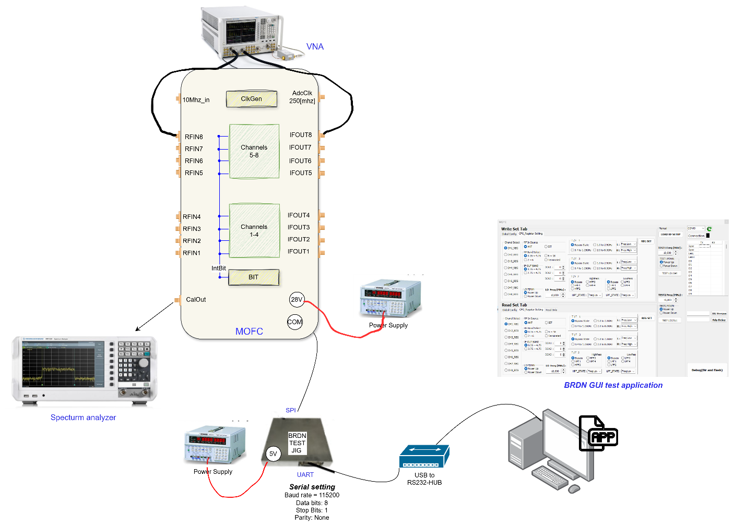

Basic Digital test with BRDN Test JIG

Verify Read only Registers
- Read and verify FPGA version register
- Read and verify Serial Number
- Read and verify status register,
  - Verify temperature
  - Verify PGOOD,
  - Verify LCK1...LCK8, BLCK,ALCK,LO2_LCK
  - Verify PGOOD
  - Verify CK_STAT=IDLE
  - Verify RFRDY
  - Verify 10MHZ (connect 10MHZ input source and check 10mhz_lck is set to 1)

Verify Read/Write registers defaults value
Read all W/R registers and verify default values

Verify write and read test register
Verify test register write and read,
- write 0x5a5a5a, than read 0x5a5a5a
- write 0xa5a5a5, than read 0xa5a5a5
- write 0x000000, read FPGA version register, than read again test register and verify 0x000000

Basic Digital test with CSPIR

Pre conditions for CSPIR tests
- Use GUI and perform write register verify with scope CSN, CLK, MOSI
- Verify RST to MOFC is inactive after power up (RESET is active low so it is expected to be HIGH after power up , use GUI to assert RESET (0), and to de-assert (1)
- Verify Read power Status: drive 0 at input and read 0, drive 1 at input and read 1
- Verify Read RDY indication: drive 0 at input and read 0, drive 1 at input and read 1
- Verify Read (without MOFC)
  - Loop back MOSI to MISO
  - Perform write to register 3, value 0xABCDEF, after that read internal FPGA register which holds the return value from the MOFc (the MISO), verify it is equal to 0xABCDEF

Verify Read only Registers
Repeat test 2.1

Verify Read/Write registers defaults value
Repeat test 2.2

Verify write and read test register
Repeat test 2.3

Verify reset
First change the value of the test register to 0x102030, than perform reset, after rest read again the test register and verify it returns to the default value

Verify power status indication
When MOFC is off perform read to the MOFC power status, and verify it is 0, turn ON the MOFC perform read again and verify the Power status is 1

Verify complete MOFC setup common octal
- At global register set mode common octal
- Use BIT config default
- USE channel config defaults, only in Channel 1 change DCA value to 1
- Read back Glbl , BIT, channel1 config and verify channel 1 is configured as intended
- Write checksum register than read status register verify CK_STAT is OK, perform LOAD_RF than read again status register verify CK_STAT is IDLE
- Change value of BIT config register power to -31 (value of 1), than perform write checksum register and tha read status verify CK_STAT is FAIL, perform LOAD_RF than read again CK_STAT verify it is back to IDLE

Verify complete MOFC setup QUAD mode
- At global register set mode QUAD
- Use BIT config default
- USE channel config defaults, only in Channel 1 change DCA value to 1, and in channel 2 change DCA value to 2
- Read back Glbl , BIT, channel1+2 configuration and verify correctness
- Write checksum register than read status register verify CK_STAT is OK, perform LOAD_RF than read again status register verify CK_STAT is IDLE

Verify complete MOFC setup Single mode
- At global register set mode Single
- Use BIT config default
- USE channel config defaults, in Channel-1 set DCA to 1, in cahnne2 to 2.. Channel8 to 8
- Read back Glbl , BIT, channels 1-8 configurations and verify correctness
- Write checksum register than read status register verify CK_STAT is OK, perform LOAD_RF than read again status register verify CK_STAT is IDLE

Ref # | Test accessory | Description
1 | Signal Generator | Signal generator which support  1. RF frequency upto 20[ghz]  2. injecting CW and pulses  3. power injection form -90 and upto +20 [dbm | ELTA
2 | USB to RS232 HUB 1:4 |  | ELTA
3 | Phase Match cables MOFC to CSPIR |  | BRDN
4 | UART 2 SPI JIG | 3010P101-003 | BRDN
5 | MOFC TestJig Application |  | BRDN
6 | Cable from BRDN TestJig to MOFC Communication connector |  | BRDN
7 | Power cable for MOFC |  | BRDN
7 | Power Cable for BRDN TestJIG |  | BRDN
7 | Splitter 1:4 1-18 ( 2 units) |  | ELTA
8 | Splitter 1:2 1-18 (1 unit) |  | ELTA
9 | Set of cables phase match to connect sigGen to MOFC |  | ??
10 | Adapter cable CSPIR to BRDN |  | ELTA
11 | Ethernet switch |  | ELTA
12 | Power supply for TestJIG | 5V | ELTA
13 | Power supply for CSPIR | 12V
14 | Power supply for MOFC | 28V | ELTA
15 | Toolt for Multiport extraction |  | ELTA

- ting or delivery.

