CDRP integration plan

Contents
1. Scope. 4
1.1 Identification. 4
1.2 CDRP Sensor System Description 4
1.2.1 1. System Overview 4
1.2.2 CSPIR – Digital Receiver Card 4
1.2.3 MOFC – Miniature Octal Frequency Converter 5
1.3 Lab Setup 7
1.4 list of Test accessory needed 8
1.5 Software capabilities for integration 9
1.6 Integration phases 9
2 Detailed Integration Phases & Procedures 10
2.1 Phase 1: Pre-Integration & Interface Validation 10
2.1.1 Standalone MOFC Verification (BRDN Application Control) 10
2.1.2 CSPIR-to-MOFC Digital Communication & Control Path 10
2.1.3 ADC Clock & Phase Noise Verification 10
TBD 10
2.1.4 External BIT Verification, Calibration, and Spur Analysis 11
2.2 Phase 2: Gain & Attenuation Calibration 11
2.2.1 Phase 3: Detection Threshold Calibration 12
2.3 Phase 4: Multi-Channel Phase Calibration & Alignment 12
2.4 Phase 5: Sensitivity & Dynamic Range Testing 13
2.5 Phase 6: Fixed Spurs Identification & Mapping (No Signal) 14
2.6 Phase 7: Spurious-Free Dynamic Range (SFDR) Test 14
2.6.1 7.1 SFDR Test with Single Tone 14
2.6.2 SFDR Test with Two Tones (Intermodulation Distortion) 15
Table of figures

Figure 1: Integration LAB setup 5

List of Tables

Table 1: CDRP integration Test accessories 6

Scope.

Identification.
This document is to form the CDRP integarion plan

CDRP Sensor System Description

1. System Overview
The CDRP (Compact Digital Receiver Platform) sensor is composed of two tightly integrated hardware modules: the CSPIR (Cognitive Signal Processing integrated Receiver) digital card, and the MOFC (Miniature Octal Frequency Converter). Together, these modules provide a capable platform for wideband signal interception, frequency conversion, and Pulse Descriptor Word (PDW) extraction.
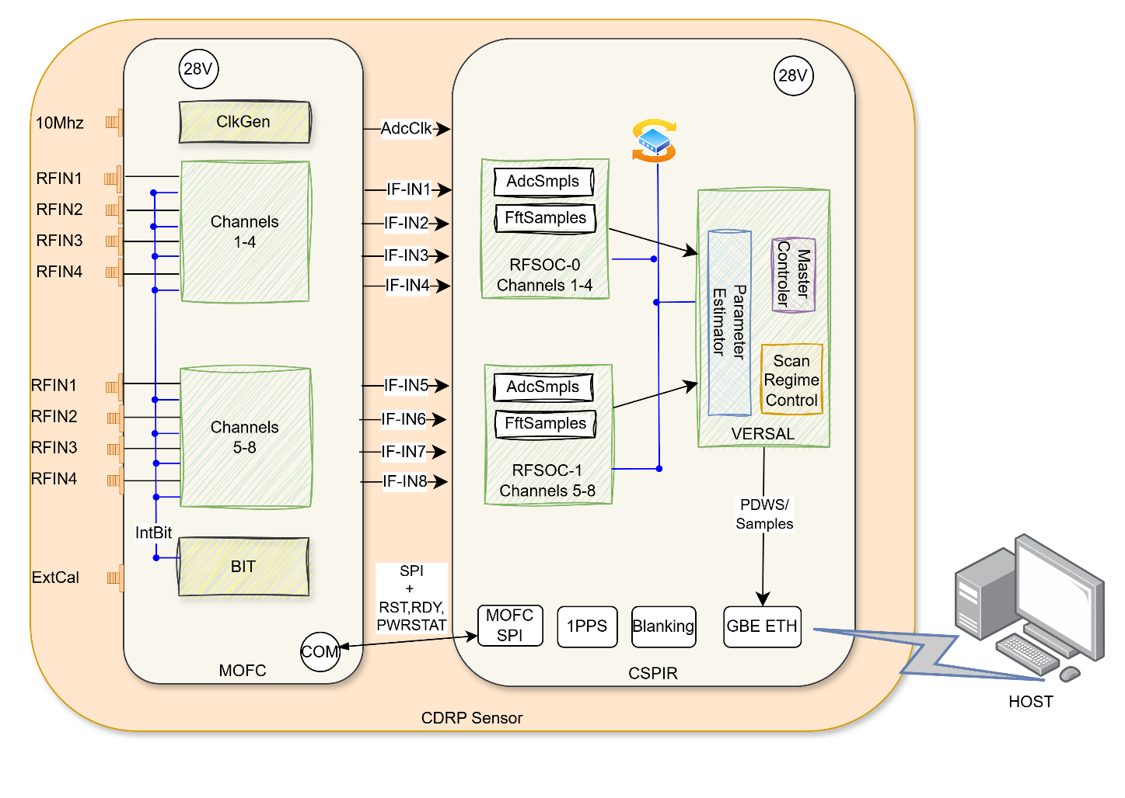

CSPIR – Digital Receiver Card

ADC and IF Input
The CSPIR incorporates a high-speed Analog-to-Digital Converter (ADC) operating at a 5 GHz sample rate. The ADC accepts IF signals sourced from the MOFC across two supported frequency ranges:
- 2.75 – 4.75 GHz (appearing in the second Nyquist zone)
- 0.3 – 2.4 GHz (appearing in the first Nyquist zone)
Both IF bands are simultaneously supported and are properly reflected within their respective Nyquist zones of the ADC.

Scan Table and Signal Processing
The CSPIR supports a programmable scan table mechanism, which coordinates tuning commands to the MOFC, controls ADC data capture windows, and manages signal processing operations. The scan table enables:
- Directed ADC sampling across frequency bands of interest
- Real-time processing of both CW (Continuous Wave) and pulsed RF signals
- Extraction and reporting of Pulse Descriptor Words (PDWs), including: Power, Pulse Width, Phase / Delta-Phase (DPHASE), Time of Arrival (TOA), and Frequency

Embedded Processing Subsystem
The CSPIR integrates an onboard Processing Subsystem (PS) running a Linux-based operating environment. An engineering test application is provided, enabling operators and integrators to:
- Load and configure scan tables
- Execute functional and diagnostic tests
- Collect and review output data, including raw ADC samples and PDW reports

MOFC – Miniature Octal Frequency Converter

Reference Clock
The MOFC accepts a 10 MHz external reference input and generates reference clock distributed to the CSPIR ADC

3.2 Built-In Test (BIT)
The MOFC includes a dedicated Built-In Test (BIT) unit supporting both internal and external BIT modes. The BIT signal generator supports CW and pulsed signal modes, with an output amplitude range of –80 to –30 dBm.

Frequency Conversion Channels
The MOFC provides 8 independent frequency conversion channels, each supporting one of three conversion paths:
- Direct Path (0.3 – 6 GHz): Direct conversion with selectable IF output filter: 0.3–2.4 GHz or 2.75–4.75 GHz.
- 2–6 GHz Path: Up-converts via LO2 to approximately 19 GHz, then down-converts to an IF of 2.75–4.75 GHz.
- 6–18 GHz Path: Down-converts via LO1 to an IF of 2.75–4.75 GHz.

Gain and Attenuation
The MOFC is designed to provide a at least a system gain of 32 dB across all conversion paths. Each channel features independently controlled attenuation with a range of 0 to 31.5 dB, enabling precise per-channel signal level management.

Phase Coherence
A key design requirement of the MOFC is the maintenance of phase alignment across all channels and conversion paths. This ensures coherent multi-channel operation, which is essential for direction-finding, signal correlation, and other phase-sensitive processing tasks.

Lab Setup
Figure below describe the LAB setup for integration
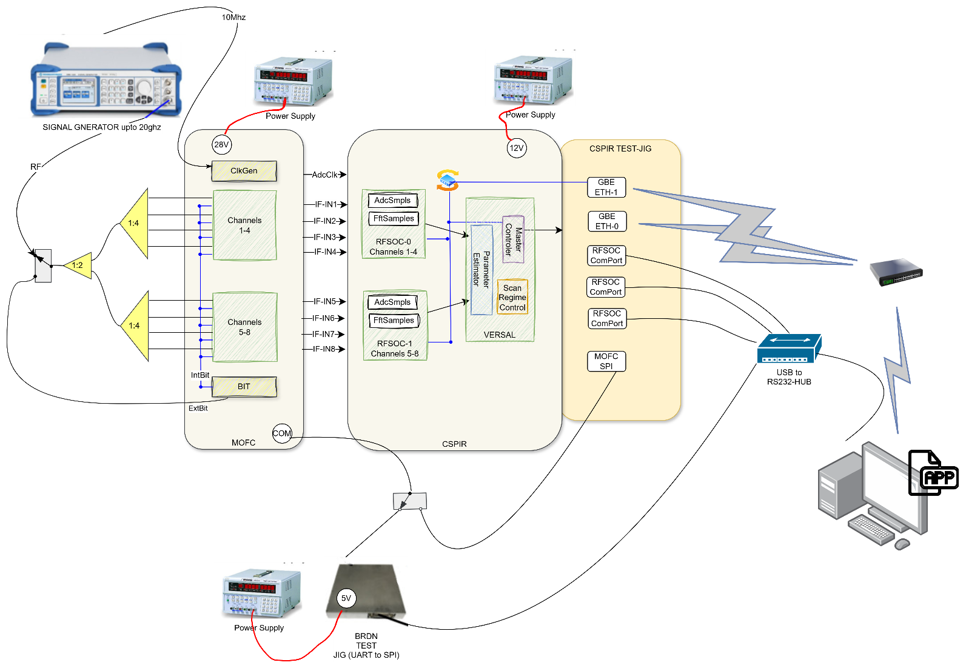

Figure 1: Integration LAB setup

There are 3 options/Paths for RF injections:
- From Signal generator though 1:8 splitters
- From MOFC ExtBIT/Cal through 1:8 spliiter
- From MOFC Internal BIT
**Note: internal BIT path phase should be equal as to antenna path where all 8 channels after 1:8 split are phase aligned

There are 2 options for controlling the MOFC
- Option 1: control the MOFC utilizing BRDN Test-JIg and MOFC test application (this option is used as a refence and comparison to the CSPIR-MOFC communication)
- Option 2: CSPIR can assign the MOFC, either directly through CSPIR GUI engineering TEST application, and/or directly from the VERSAL R5 while scanning.

list of Test accessory needed

Ref # | Test accessory | Description
1 | Signal Generator | Signal generator which support  1. RF frequency upto 20[ghz]  2. injecting CW and pulses  3. power injection form -90 and upto +20 [dbm | ELTA
2 | USB to RS232 HUB 1:4 |  | ELTA
3 | Phase Match cables MOFC to CSPIR |  | BRDN
4 | UART 2 SPI JIG | 3010P101-003 | BRDN
5 | MOFC TestJig Application |  | BRDN
6 | Cable from BRDN TestJig to MOFC Communication connector |  | BRDN
7 | Power cable for MOFC |  | BRDN
7 | Power Cable for BRDN TestJIG |  | BRDN
7 | Splitter 1:4 1-18 ( 2 units) |  | ELTA
8 | Splitter 1:2 1-18 (1 unit) |  | ELTA
9 | Set of cables phase match to connect sigGen to MOFC |  | ??
10 | Adapter cable CSPIR to BRDN |  | ELTA
11 | Ethernet switch |  | ELTA
12 | Power supply for TestJIG | 5V | ELTA
13 | Power supply for CSPIR | 12V
14 | Power supply for MOFC | 28V | ELTA
Table 1: CDRP integration Test accessories

Software capabilities for integration
- BRDN test jig application for MOFC assignment
- Engineering Test-GUI at CSPIR for MOFC assignment
- Scan table and Scan regime support for MOFC assignments
- Automation of Running Tests, and saving PDW, and Samples (FFT/ADC)

Integration phases
- Phase1: procedure / process to run before starting integration
  - test MOFC as Stand alone, with BRDN Test JIG application
  - verify digital communication between CSPIR and MOFC
    - Read and write (including temperature and status)
    - Test RDY signal and time of MOFC stabilization
    - Test CHKSUM mechanism
    - Check Reset command from CSPIR to MOC
    - Verify PowerStatus indication reflect in CSPIR regs
  - verify ADC clock from MOFC to CSPIR
  - Ext BIT verification and calibration
  - Verify External BIT power for all frequency range
  - Verify BIT Pulse and CW mode, and Test BIT SPURS
- Phase 2: Gain calibration procedure
- Phase 3: Threshold calibration procedure
- Phase 4: Phase calibration procedure
- Phase 5: sensitivity test procedure
- Phase6: fix SPURS test (with no signal)
- Phase7: Single Tone dynamic test assessment
- Phase8: SFDR test and 2 Tone dynamic test assessment
  - 8.1 SFDR test with Single Tone
  - 8.2 SFDR test with 2 tones
- Phase9: parameter accuracy performance
  - Parameter performance accuracy at sensitivity level
  - Parameter performance accuracy at sensitivity level + 3[dbm]
  - Parameter performance accuracy at SNR >=20
  - Parameter performance accuracy at saturation

Detailed Integration Phases & Procedures

Phase 1: Pre-Integration & Interface Validation
Objective: Verify standalone health, power distribution, signal integrity, and digital control paths before closing any RF loops.

Standalone MOFC Verification (BRDN Application Control)
- Procedure: Establish SPI communication via the BRDN TestJig GUI,
  - Query the MOFC device ID, hardware revision register, telemetry registers.
  - Assign MOFC at certain frequency and MODE and test assigned correctly

CSPIR-to-MOFC Digital Communication & Control Path
- Setup: Connect the native SPI/control interface between the CSPIR and the MOFC. Boot the CSPIR onboard Processing Subsystem (PS) Linux environment and launch the Engineering Test application.
- Procedure:
  - Register Read/Write & Telemetry: perform read/write cycles to non-destructive scratchpad registers on the MOFC via the CSPIR. Read out continuous onboard temperature telemetry.
  - RDY Signal & Lock Time Assessment: Issue frequency tuning commands spanning the full range across all 8 channels. Use an external oscilloscope or internal CSPIR high-resolution timers to measure the time delta between the tuning command edge and the assertion of the MOFC hardware RDY (Ready/Stabilized) discrete signal.
  - Checksum (CHKSUM) Stress Test: Inject corrupt parity bits/intentional bit errors into the control word from the CSPIR application and verify that the MOFC detects the error, asserts a flag, throws a checksum error, and rejects the invalid command.
  - Hardware Reset Validation: Issue a software-initiated hardware reset command from the CSPIR to the MOFC. Verify that the MOFC returns to its default boot configuration state
  - PowerStatus Bit Mapping: Read the PowerSatus register, verify that when the MOFC is power down power status is off, and the MOFC is power up turned ON.

ADC Clock & Phase Noise Verification

TBD

External BIT Verification, Calibration, and Spur Analysis
- Setup: Configure the MOFC to External BIT mode. Route the BIT output signal generator back through the internal coupling paths into the conversion channels.
- Procedure:
  - Step the internal BIT signal generator across its full amplitude dynamic range from –80 dBm to –30 dBm in 1 dB increments.
  - Toggle between Continuous Wave (CW) and pulsed signal modes.
  - Program the CSPIR scan table to step through the entire receiver spectrum. Capture the resulting power levels, pulse widths, and spectral profiles using the automated data-saving application.
  - Perform a wideband spectral sweep with the BIT active to map, catalog, and log any test-generated spurs (BIT SPURS).
- Pass Criteria: Measured BIT output power is linear within across the full range (–80 to –30 dBm). Pulse width extraction matches programmed BIT parameters to within single-digit nanoseconds. All identified BIT spurs are cataloged into the system's static rejection lookup table.
DOCX

Phase 2: Gain & Attenuation Calibration
Objective: Compensate for path-to-path insertion losses and calibrate the programmable attenuators to guarantee a flat, uniform system gain across all 8 independent channels.
- Setup: Connect the external Signal Generator to the input network via the 1:2 and 1:4 splitter network. Use phase-matched cables from the MOFC output to the CSPIR IF inputs.
- Procedure:
  - Set all 8 MOFC channel attenuators to 0 dB (minimum attenuation).
  - Inject a known reference CW signal from the external Signal Generator at a frequency within the Direct Path range (0.3 – 2.4 GHz).
  - Capture the digital power level via the CSPIR AdcSmpls / FftSamples interface. Calculate the absolute system gain () and verify it meets the minimum baseline requirement of 32 dB.
  - Step through each conversion path (Direct, 2–6 GHz, and 6–18 GHz paths) across all 8 channels.
  - Step the programmable attenuators from 0 to 31.5 dB in 0.5 dB increments. Generate an error matrix mapping physical attenuation against digital power reduction.
  - Derive calibration coefficients and load them into the CSPIR scan table runtime environment to flatten response curves.
- Pass Criteria: Unattenuated system gain is across all bands and channels. Attenuation step differential is linear within across the entire 0 to 31.5 dB range. After calibration, the channel-to-channel gain flatness must be within +-1

Phase 3: Detection Threshold Calibration
Objective: Establish precise operational noise floors and calibrate the digital detection thresholds to achieve the required Probability of Detection () vs. False Alarm Rate ().
- Setup: Terminate the RF input ports of the 1:2 splitter with high-isolation coaxial loads to ensure zero external environmental signal leakage.
- Procedure:
  - Set up the system to execute a continuous processing cycle using a standard wideband scan table.
  - Collect continuous noise statistics (AdcSmpls and calculated FFT power bins) across all 8 channels across both Nyquist zones.
  - Calculate the mean noise floor power () and standard deviation () for each independent frequency bin.
  - Dynamically adjust the digital threshold registers (e.g., set an initial mathematical threshold of ). Monitor the automated system output for 10 minutes to count false alarm PDWs.
  - Find the optimal threshold setting for each channel and frequency band that bounds the False Alarm Rate to the specified system limits. Store these parameters inside the permanent scan table allocation profiles.
- Pass Criteria: Thresholds successfully boundary the system to false PDW report per minute under terminated conditions, without artificially desensitizing the receiver beyond operational requirements.

Phase 4: Multi-Channel Phase Calibration & Alignment
Objective: Measure and compensate for phase mismatches across all 8 channels and paths to enable coherent operations like direction-finding.
- Setup: Connect the external Signal Generator to the 1:2 splitter, which feeds into the two 1:4 splitters, ensuring a coherent, phase-matched distribution of the calibration signal to all 8 MOFC RF inputs.
- Procedure:
  - Inject a high-purity coherent CW signal into the splitter array.
  - Set the MOFC to the Direct Path configuration (0.3 – 2.4 GHz).
  - Capture phase data simultaneously across all 8 digital streams via the CSPIR FftSamples data block.
  - Select Channel 1 as the system reference phase (). Calculate the absolute phase offsets ( through ) for the remaining channels.
  - Repeat this measurement at 50 MHz frequency steps across the 2–6 GHz and 6–18 GHz frequency conversion paths to map the phase error curves introduced by the LO1 and LO2 mixing stages.
  - Generate a 2D correction matrix (Channel vs. Frequency) and inject these phase-alignment coefficients into the CSPIR real-time signal processing engine (DPHASE calculation blocks).
- Pass Criteria: Post-calibration residual phase delta between any two channels must be across the entire operational bandwidth, satisfying the multi-channel phase coherence requirement.

Phase 5: Sensitivity & Dynamic Range Testing
Objective: Verify the absolute minimum detectable signal (MDS) and validate accurate PDW parameter extraction at the system limits.
- Setup: Connect the external Signal Generator via the calibrated splitter distribution network.
- Procedure:
  - Configure the external Signal Generator to output a pulsed RF signal (e.g., Pulse Width = , Pulse Repetition Interval = ).
  - Set the starting injection power to a high level (e.g., –40 dBm) to ensure a high Signal-to-Noise Ratio (SNR). Verify that the CSPIR extracts and reports all PDW parameters (Power, Pulse Width, TOA, Frequency) with 100% accuracy.
  - Attenuate the input signal generator power in 1 dB steps down toward the target noise floor limit (e.g., down to –90 dBm).
  - At each power step, log the ratio of successfully generated PDW reports against the number of transmitted physical pulses over a 10,000-pulse stream.
  - Identify the absolute input power level where the probability of detection () drops to exactly 90%. This point defines the operational system sensitivity.
- Pass Criteria: System achieves a at or below the specified MDS target (e.g., ) across all channels, with extracted PDW parameter tolerances remaining within specification bounds.

Phase 6: Fixed Spurs Identification & Mapping (No Signal)
Objective: Identify, isolate, and create a permanent digital avoidance mask for internally generated system spurious responses (spurs) caused by clocks, power rails, or mixing products.
- Setup: Terminate the RF inputs of the system with coaxial loads to guarantee an environment completely free of external signals.
- Procedure:
  - Initiate a continuous, highly granular automated sweep across the entire operational spectrum using a dedicated diagnostics scan table.
  - Program the CSPIR to collect and analyze FFT spectrum blocks (FftSamples) at every tuning step.
  - Any spectral component that exceeds the calibrated thermal noise floor by more than 3 dB—under zero external input conditions—is classified as a fixed system spur.
  - Log the precise frequency, apparent power level, and affected channel for every discovered spur.
  - Write these frequencies directly into the software application's permanent firmware spur-mask filter registers to prevent them from generating false PDWs during standard operation.
- Pass Criteria: 100% of internally generated fixed spurs are successfully mapped, logged, and suppressed via the software mask, resulting in zero spur-induced false alarms.

Phase 7: Spurious-Free Dynamic Range (SFDR) Test

7.1 SFDR Test with Single Tone
- Setup: Connect a high-purity single-channel Signal Generator to the input splitter network.
- Procedure:
  - Inject a single high-power CW tone at an input level just 1 dB below the ADC saturation/compression threshold (full-scale input).
  - Execute an automated data capture of the FftSamples block via the CSPIR.
  - Measure the absolute power delta (in dBc) between the peak of the primary injected tone and the peak of the highest power harmonic or harmonic intermodulation spur generated anywhere else in the Nyquist zone.
  - Repeat this evaluation across 20 distinct frequency test points across all conversion paths.
- Pass Criteria: The amplitude delta between the fundamental tone and the highest generated spur () must be (or meet your explicit design target) across all bands.

SFDR Test with Two Tones (Intermodulation Distortion)
- Setup: Combine two independent, phase-locked external Signal Generators through a high-isolation power combiner, then connect that combined signal to the 1:2 input splitter network.
- Procedure:
Set the two signal generators to output equal-amplitude tones separated by a narrow frequency delta (e.g., and ) inside the target receiver band.
  - Adjust both signal generators so that each tone sits at exactly –6 dBFS (so their combined peak power approaches full scale without clipping the ADC).
  - Capture the resulting spectrum data block (FftSamples).
  - Locate and measure the power levels of the 3rd-order intermodulation distortion (IMD3) products appearing at the critical frequencies:
  - Calculate the two-tone SFDR as the delta between the fundamental tone power and the peak of the IMD3 products.
- Pass Criteria: The two-tone intermodulation SFDR () must meet or exceed the architectural target (e.g., ), ensuring that close-in target signals aren't masked by intermodulation artifacts during wideband multi-signal handling.

