Contents
1. Scope 2
2. Connector Definitions 3
2.1 Connector TBD 3
2.2 Digital ICD 3
3. Communication format 4
3.1 SPI Interface Specifications 4
3.1.1 SPI write transaction 4
3.1.2 SPI Read transaction 5
3.1.3 Timing constrains 5
4. SPI Command set 6
5. Command details 7
5.1 status 7
5.2 FPGA_VER_REG 8
5.3 SERIAL_NUMBER 8
5.4 TEST_REG 8
5.5 Global config Reg 9
5.6 Bit config Reg 9
5.7 SU1_DCA0_CFG 10
5.8 SU1_DCA1_CFG 10
5.9 SU2_DCA0_CFG 11
5.10 SU2_DCA1_CFG 11
5.11 PHS_MODE_2G_CONFIG 12
5.12 PHS_MODE_4G_SU<1/2>_CFG 12
5.13 AMP_MODE_SU<1/2>_CH<1/2/3/4>_CFG 12
6. Other Design requirements/specificatiosn 13
6.1 SPI back to back transaction 13
6.2 Maximum Slave processing time from receiving LOAD command to RF RDY 13

Figures
No table of figures entries found.
Tables
No table of figures entries found.

Scope
This document defines the SPI interface and protocol for configuring and controlling the MOFC (Miniature Octal Frequency Converter) device. The purpose of this document is to:
- Establish a clear communication protocol between the MASTER and SLAVE devices over SPI.
- Define the command structure for reading from and writing to configuration registers.
- Provide guidelines for the implementation of SPI-based control in the FPGA firmware.
- Detail the electrical and timing requirements for SPI communication.
- Outline the process of configuring and updating the RF module of the MOFC device.
This document serves as a reference for both the firmware development team implementing the SPI interface and the hardware design team ensuring compliance with the interface specifications

Connector Definitions

Connector TBD

Digital ICD

Name | Function | Type
SPI_Clk_N | SPI Clock | RS485 input
SPI_Clk_P | SPI Clock | RS485 input
SPI_CSn_N | Chip Select active low  Chip Select active low | RS485 input  RS485 input
SPI_CSn_P | Chip Select active low  Chip Select active low | RS485 input  RS485 input
SPI_MOSI_N | Master Out, Slave In | RS485 input
SPI_MOSI_P | Master Out, Slave In | RS485 input
SPI_MISO_N | Master In, Slave Out | RS485 output
SPI_MISO_P | Master In, Slave Out | RS485 output
Resetn_N | System Reset active low | LVTTL 3.3V Input
Resetn_P | System Reset active low | LVTTL 3.3V Input
RF_RDY_N | Indicates the tuner RF is ready | RS485 output
RF_RDY_P | Indicates the tuner RF is ready | RS485 output
Table 1: Digital ICD

Communication format
The MOFC controller acts as the “SLAVE” and the main controller acts as the “MASTER”. The MOFC controller uses a typical SPI interface in terms of logic, but uses differential RS485 inputs/outputs. The SPI interface consists of four lines: SClk, CSn, MOSI, and MISO. The SPI interface uses 32-bit commands. All write commands transmitted to MOFC must be 32-bits long. Read commands contain the R/W bit set to 1 and the register address on MOSI while the returning data is clocked out on the MISO line during the data portion of the same 32-bit sequence.

SPI Interface Specifications
The specified clock frequency for this application is 10MHz. Only the MASTER controller supplies the SPI 10MHz clock. The 10MHz clock is only supplied during SPI transactions.

SPI write transaction
A typical Write transaction is shown below. The new command goes out on the MOSI line, and the data is registered by the SLAVE on each positive clock edge. The R/W bit is set to 0. The transaction is initiated when the MASTER pulls the CSn line low for a period of Tcs_c before the first positive clock edge and held low for the remainder of the transaction. The MASTER then pulls the CSn line high Tc_cs after the last negative clock edge. See timing constraints in the table below for minimum timing specifications.

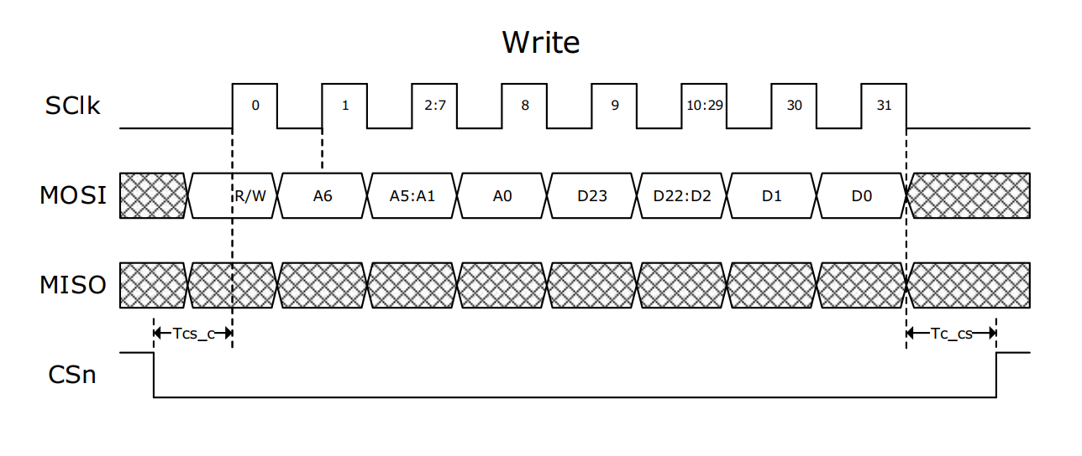
Figure 1: SPI write transaction

SPI Read transaction
A typical Read transaction is shown below. The Read transaction sequence starts out with the MASTER clocking out the R/W bit set to 1 and clocking out the address bits on each positive clock edge. The SLAVE then starts clocking out the read data on the next clock falling edge. The MASTER registers the 24 bits of data on the remaining 24 positive clock edges.
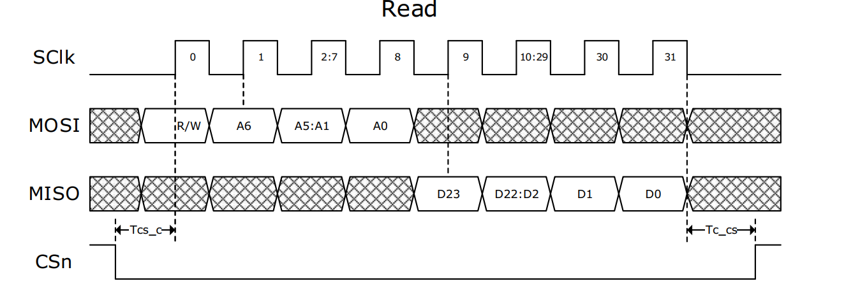
Figure 2: SPI read transaction

Timing constrains
Parameter | Description | Min | Max
SPI Clock Frequency | Maximum frequency of SPI Clock | 10 MHz
Tcs_c | Time between CSn going low and the first positive clock edge | TBDns
Tc_cs | Time between last negative clock edge and CSn going high | TBDns
Table 2: Timing consrains

SPI Command set
Table 3.0 contains a list of SPI commands/registers used to communicate with the MQFC. For details about each command, refer to the section 5, “Command Details”.
Table 3: SPI commands

** Add register to indirect write to SPI Tunable filter fields are
- CHID
- TunerFilterID
- TunerFilterAddr
- Data

MOFC operation mode (Determined by OPMODE Configuration Register)
- The OPMODE register dictates how channel configurations are applied. This register is project-specific
  - Single Channel Mode (0x0): Each of the eight channels is individually configured by the master.
  - Common Quad Mode (0x1): The master fills configurations for channels 1 and 2. Channel 1’s configuration is used for channels 2, 3, and 4, and channel 2’s configuration is used for channels 6, 7, and 8.
  - Common Octal Mode (0x2): The master configures only channel 1. This configuration is then applied to all remaining channels (2-8).

Configuration flow (3 steps)
The configuration process proceeds in three optional stages.
- Stage 1: Configuration Data Loading
  - Master Action: The master writes data to the following:
    - Bit Configuration Register
    - Channel Configuration Registers (data written depends on the selected OPMODE)
      - When OPMODE = 0x0 : channels 1-8 are configures by master
      - When OPMODE = 0x1: channels 1,2 are configured by master
      - When OPMODE = 0x2 : only channel 1 is configured by master
  - Slave Action: No response is required from the slave during this stage. This stage prepares all necessary configuration information within the registers.
- Stage 2: (Optional) Checksum Verification
  - Master Action: The master writes to the Checksum Register.
  - Slave Action: The slave initiates a checksum verification process. This process uses the Bit Configuration Register and Channel Configuration data (applied according to the selected OPMODE). The slave then updates the Checksum Status to either “Pass” or “Fail.”
- Stage 3: RF Setup Loading
  - Master Action: The master writes to the Load RF Setup Register.
  - Slave Action: The slave assigns the MOFC based on the loaded configuration.

RF_RDY discrete output behavior
- At default RF_RDY is asserted to '1' logic this is true for
- After power-up/reset
- At "IDLE" After completing RF assignment
- RF_RDY behavior when master write to CHKSUM register
- Writing to checksum register will de-assert RF_RDY to 0
- After slave complete CHKSUM check:
  - If CHECKSUM test pass RF_RDY is asserted to '1'
  - If CHECKSUM test fail RF_RDY stays at '0',
- RF_RDY behavior when master write to LOAD_RF_SETUP register
  - Writing to checksum register will de-assert RF_RDY to 0
  - RF_RDY is asserted back to '1' when RF setup is complete and all PLL are locked

Command details

status
Param | Bits | Description | Possible Values
R/W | 31 | Read / Write bit | Read only
Address | 30:24 | Register address bits | 0x0
Temperature | 23:16 | Module temperature is 2’s complement format | C9 = -55°C  …7D = 125°C
PS | 15 | Power status | 0-Fail  1-Pass
CKERR | 14 | CheckSum error, this bit will be updated when receiving command CHECKSUM, | 0-CheckSum OK  1- CheckSum error
RFRDY | 13 | RF ready, is asserted low after receiving command ‘LOAD_RF_SETUP’, and only after complete setup of tuner is asserted High, the RFRDY out is also reflected at the output at PIN READY
RSVD | 12:11 | Unused bits | 0x0
LO2_LCK | 10 | LO2 pll lock | 0 – unlocked: 1-Locked
ALCK | 9 | Clock toward ADC lock | 0 – unlocked: 1-Locked
BLCK | 8 | Bit PLL lock | 0 – unlocked: 1-Locked
LCK8 | 7 | Subunit 2 LO4 lock indication | 0 – unlocked: 1-Locked
LCK7 | 6 | Subunit 2 LO3 lock indication | 0 – unlocked: 1-Locked
LCK6 | 5 | Subunit 2 LO2 lock indication | 0 – unlocked: 1-Locked
LCK5 | 4 | Subunit 2 LO1 lock indication | 0 – unlocked: 1-Locked
LCK4 | 3 | Subunit 1 LO4 lock indication | 0 – unlocked: 1-Locked
LCK3 | 2 | Subunit 1 LO3 lock indication | 0 – unlocked: 1-Locked
LCK2 | 1 | Subunit 1 LO2 lock indication | 0 – unlocked: 1-Locked
LCK1 | 0 | Subunit 1 LO1 lock indication | 0 – unlocked: 1-Locked

FPGA_VER_REG
Param | Bits | Description | Possible Values
R/W | 31 | Read / Write bit | Read only
Address | 30:24 | Register address bits | 0x1
VER_ID | 23:16 | Version ID represented by 2 hexa digits | 0x01 – 0xff
VER_DAY | 14:10 | FPGA firmware date - day | 1 to 31
VER_MONTH | 9:6 | FPGA firmware date - year | 1-12
VER_YEAR | 5:0 | FPGA firmware date - year | 24-63

SERIAL_NUMBER
Param | Bits | Description | Possible Values
R/W | 31 | Read / Write bit | Read only
Address | 30:24 | Register address bits | 0x2
rsvd | 23:20 | Unused bits | 0X0
SER_NUM | 19:0 | Module serail number | 0x00 – 0xfffff

TEST_REG
Param | Bits | Description | Possible Values
R/W | 31 | Read / Write bit | Read only
Address | 30:24 | Register address bits | 0x3
DATA | 23:0 | Register purpose is just for testing the complete 24 bits can be write/write by master in order to test basic communication | 0x00 – 0xffffff

Global config Reg
Param | Bits | Description | Possible Values
R/W | 31 | Read / Write bit | Read only
Address | 30:24 | Register address bits | 0x4
RSVD | 19:0 | Unused bits | 23:2
OPMODE | [1:0] | Operation mode | 0x0: 2G_PHS_MODE  0x1:4G_PHS_MODE  0x2:16G AMP MODE

Bit config Reg
Param | Bits | Description | Possible Values
R/W | 31 | Read / Write bit | Read only
Address | 30:24 | Register address bits | 0x5
RSVD | 22 | Unused bit | 0x0
P/CW | 22 | Select between Pulse or CW | 0 - BIT  1 - CW
BIT_DCA | 21:16 | BIT Attenuation, each lsb is 0.5[db] range is 0 to 31.5[db] | 0x0-0x3F
BIT_FREQ | 15:0 | Select BIT frequency, LSB unit [TBD] range [TBD] | TBD

Other Design requirements/specificatiosn

SPI back to back transaction

Maximum Slave processing time from receiving LOAD command to RF RDY

