Standard 4-circle/CCD instrument definitions for reciprocal-space reconstruction

For a standard 4-circle instrument (2theta, omega, chi, and phi), the positive sense of each axis will be defined by a right-handed rotation that points the thumb from the base (i.e. physical motor/gear assembly) towards the crystal position. For a perfectly aligned goniometer/detector with all angles set to zero, the lab coordinate system is defines as follows: +x is the incident beam direction, +z is the direction pointing from the center of the physical base of the omega circle towards the crystal position, and +y completes an orthogonal right-handed xyz set.

At 2theta = 0, the positive senses of the detector yaw, pitch, and roll angles, and the goniometer pitch angle, are associated with right-handed rotations about the +z (yaw), +y (pitch), and +x (roll) laboratory axes.

In the event that the goniometer table is misoriented so that the omega axis no longer makes a 90-degree angle with the beam, the +z axis will be less than 90 degrees from the +omega axis in the plane defined by the beam and the omega axis. The angle of misorientation will be referred to as the goniometer pitch (gonpitch). The goniometer also has yaw and roll freedom. But goniometer yaw is perfectly correlated with omega-angle zero-point error, and goniometer roll around the beam direction is arbitrary since the +omega axis defines the lab coordinate system.

When making corrections to nominal goniometer or detector parameters, the zero-point-subtraction approach will be taken (as opposed to the additive correction approach). For example, if the nominal detector position is d_{nom} = 75 mm, while the true position is d_{true} = 76.22 mm, the zero-point will be d₀ = -1.22 mm, so that D_{true} = D_{nom} - D₀. This applies to all goniometer angles and detector pixel coordinates.

Unit cell parameters will use Angstrom and degree units. Reciprocal space coordinates will use reciprocal lattice units and/or inverse Angstroms without the factor of 2π All instrument angles will use degree units. All 3D vectors will use units of Angstroms, inverse Angstroms (without the factor of 2π) or mm as described below.

Regardless of the programming language, image arrays will be set up so as to associate the X (i.e. horizontal) axis of the image with the fast-moving array index. In 3D reciprocal-space slabs, the direction 1 vector axis will correspond to the fast-moving index, while the direction 3 vector axis will correspond to the slow-moving index.

Transforming detector pixel coordinates involves several coordinate systems as described below:

1) Pixel coordinates (e.g. 181 out of 1023). When all angles are zero, the detector +X axis coincides with the laboratory -y axis, the detector +Y axis coincides with the laboratory +z axis, and the detector +Z axis coincides with the -x laboratory axis. The positive detector displacement direction is away from the crystal (i.e. laboratory +x or detector -Z). The origin is the furthest pixel towards the -X and -Y sides of the detector (lower-left for a typical vertical goniometer). The units are pixels. The vector pointing from the pixel origin to the detector center, which is defined to be the direct beam location when all angles are zero, rather than the geometric center) will be referred at t_{pd}.

2) Oriented-detector coordinates: The origin of this coordinate system is the direct-beam location on the detector face. The units are mm. The xyz axes are fixed relative to the detector body when the detector rotates. When all angles are zero, the oriented-detector and detector-lab coordinate systems are identical. The matrix that transforms oriented-detector coordinates into pixel coordinates will be referred to as O = {{0,-1,0},{0,0,1},{-1,0,0}}/pixelsize.

3) The direct-lab coordinate system: The origin is the sample position. The units are mm. The axes have been described above. The matrix that transforms direct-lab coordinates into oriented-detector coordinates will be referred to as D. D is the product of an ordered sequence of right-handed rotations about the laboratory axes involving the detector yaw, pitch, and roll angles, the goniometer pitch, and the goniometer 2theta angle. Specifically, D = gonpitch.twotheta.roll.pitch.yaw. The vector pointing from the goniometer center to the sample position will be referred to as t_{gs}. The vector pointing from the goniometer center to the detector center will be referred to as t_{gd}. The vector pointing from the detector center to the sample position will be referred to as t_{ds} = t_{gs} - t_{gd}. It is also useful to define the detector-normal unit vector 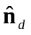, which is along the +x laboratory axis when 2θ = 0. When all goniometer axes are zero, t_{gs} = t_{gs0}, and the three crystal-translation directions coincide with the respective +x, +y, and +z axes of the laboratory, while the detector distance axis coincides with the +x laboratory axis.

4) The reciprocal-lab coordinate system: The origin is the origin of the reciprocal lattice. The units are reciprocal Angstroms. The axes coincide with the those of the direct-lab coordinate system. The vector that points from the center of the Ewald sphere to the reciprocal-lab origin will be referred to as t_{E} = (1/λ, 0, 0).

5) The goniometer-head coordinate system: the origin and units are identical to those of the reciprocal lab system, but the axes are fixed to the goniometer head when it is reoriented by the goniometer. When all angles are zero, its axes are identical to those of the reciprocal lab system. The matrix that transforms goniometer-head coordinates to reciprocal-lab coordinates will be referred to as G.

6) The crystal coordinate system: the origin and units are identical to those of the reciprocal lab system, but the axes are fixed to the crystal when it is reoriented. The +x axis is parallel to the crystal a* direction. The +y axis will be in the plane defined by the crystal a* and b* directions, so that the angle between +y and b* is less than 90 degrees. The +z axis then completes a right-handed set. The matrix that transforms goniometer-head coordinates to crystal coordinates (standard definition) is referred to as U.

7) The reciprocal-lattice coordinate system: the origin, units, and axes are those of the standard hkl reciprocal lattice. The matrix that transforms reciprocal-lattice coordinates into crystal coordinate axes is referred to as B.

Summary: If v₁ is the vector defining the location of a spot on the detector in pixel coordinates, the same associated vector v₇ in reciprocal lattice coordinates will be related as follows:

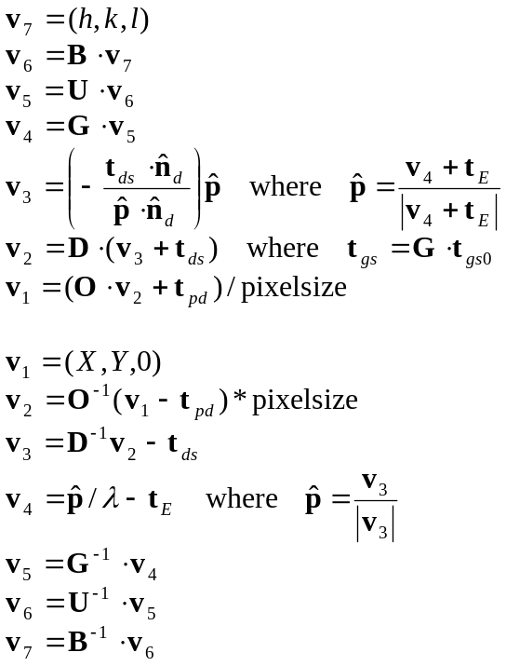
*****************************************
Conversion from Bruker.P4P to standard parameter set
Note that Bruker._LS and Bruker.P4P agree except for beamXcorr, where the P4P value is negated relative to what one would expect. Asterisks (***) indicate unintuitive signs that need to be handled with care.

UB matrix is standard both ._LS and .P4P files

xtalX = xtalX(p4p)*pixelsize
xtalY = xtalY(p4p)*pixelsize
xtalZ = xtalZ(p4p)*pixelsize

yaw = yaw(p4p)
pitch = pitch(p4p)
roll = -roll(p4p) ***
ypr = (yaw,pitch,roll)
gonpitch currently not refined in either ._LS or .P4P

twothetanom = twothetanom(p4p)
omeganom = omeganom(p4p)
chinom = -chinom(p4p) ***
phinom = -phinom(p4p) ***
twotheta0 = twotheta0(p4p)
omega0 = omega0(p4p)
chi0 = -chi0(p4p) ***
phi0 = -phi0(p4p) ***
gon = (twotheta,omega,chi,phi)
gon0 = (twotheta0,omega0,chi0,phi0)
gonnom = (twothetanom,omeganom,chinom,phinom) =gonnom(header)
gon = gonnom - gon0

distcorr = -distcorr(p4p) ***
dist0 = 0 + distcorr
distnom = distnom(header)
dist = distnom - dist0

beamXcorr = -beamXcorr(p4p) = beamXcorr(ls) ***
beamYcorr = beamYcorr(p4p)
beamXcen = beamXcen(p4p)
beamYcen = beamXcen(p4p)
det0 = (beamXcen + beamXcorr, beamYcen + beamYcorr)*pixelsize
detnom = (Xpixelobserved,Ypixelobserved)*pixelsize
det = detnom - det0

