
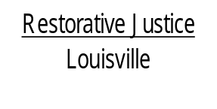
514 West Liberty Street, Suite 106
Louisville, KY 40202
Phone: 502 574-6869
Fax: 502 574-5299

June 3, 2013

Latyia Major
C/o Shamica Major
623 S. 18th Street
Louisville, KY 40203

Dear Ms. Major,

Thank you for participating in the conference meeting with Ms. York last week. We hope you saw the importance of taking responsibility for your actions and working to make amends with Ms. York.

I am enclosing a copy of the conference agreement you signed with Ms. York. Please let us know if you will have any problems making the agreed upon payments to Ms. York. We would like to have the notice and the possibility of working things out before sending your case back to court. Of course, this will be with the agreement of Ms. York.

If you have any questions, please feel free to call me at 574-6869. I am not in when you call, please leave a message and we will return you call as soon as we are able.

Again, thank you for participating in our process.

Sincerely,

Libby Mills, Executive Director
Restorative Justice Louisville Inc.

