

Conference Report

12J700093
Case number _00305422_________ Date: _January 2, 2013__________

Youth’s Name: __Shirron McElroy________________________________________________
Name of Victim: __Anita Jennings_________________________________________________
Offense(s): __Theft by Deception___________________ Date of Conference: June 18, 2012_

Completion of the Conference:
The RJL Facilitators shall provide the following information to the RJL Coordinator:

The Conference has been held.
If conference was held, a copy of the Conference Agreement shall be attached.

The Conference has NOT been held.

Status of the Conference Agreement:
The RJL Coordinator shall provide the following information to the Courts.

The Agreement has been completed.

The Agreement has NOT been completed.

Additional Comments, if appropriate:
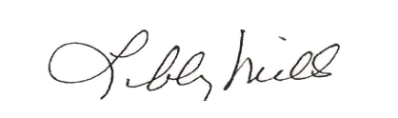
__________________________________________
Libby Mills, Executive Director
Restorative Justice Louisville Inc.

