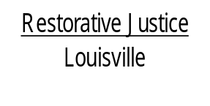
514 West Liberty Street, Suite 106
Louisville, KY 40202
Phone: 502 574-6869
Fax: 502 574-5299

November 19, 2013

Allison Shields
C/O Darlene Shields
813 Pleasant Street
Charlestown, IN 47111

Dear Ms. Shields,

At your most recent court date on November 15, 2013, involving the charge of Wanton Endangerment 1st degree, you agreed to consider participating in the Restorative Justice Louisville Family Group Conference program. I am enclosing an informational sheet about Restorative Justice Louisville for you to review.

We have contacted Officer Zoeller and she has agreed to participate. Next you will be contacted by two of our trained facilitators to discuss the program and schedule a time to meet. If this time frame is delayed for any reason, we will contact you to let you know what to anticipate.

Please contact me at 574-6869 if you have any questions. If I am not available when you call, please leave a message with your phone number and a time that is most convenient for me to return your call.

Again, thank you for agreeing to participate in our program.

Sincerely,

Libby Mills, Executive Director
Restorative Justice Louisville Inc.

