
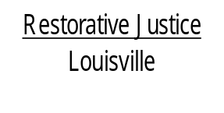
514 West Liberty Street, Suite 106
Louisville, KY 40202
Phone: 502 574-6869
Fax: 502 574-5299

April 10, 2013

Brittany Forrest
C/o Tammy Forrest
919 Hancock St.
Louisville, KY 40203

Dear Ms. Forrest,

At your most recent court date on February 7, 2013 involving the charges of Theft by Unlawful Taking, you agreed to consider participating in the Restorative Justice Louisville Family Group Conference program. I am enclosing an informational sheet about Restorative Justice Louisville for you to review.

As I hope that you are aware, participation with the program is voluntary, so the other parties involved with this offense will also be contacted to determine if they wish to participate with our program.

Please contact us if you have any questions about our program and to let us know if you and your family are still in agreement to work with our agency. After we have made contact with other parties, you and your family will be contacted by one or two of our trained facilitators to schedule a time to meet. We hope to be able to be contact with you within the next five to seven days. If this time frame is delayed for any reason, we will contact you to let you know what to anticipate.

It is very important that we have phone number where we can easily reach you. The numbers that we have for you are 314-1860 and 408-7029. If these numbers are not correct, please call us to provide a number where it will be easy to reach you and family. If I am not available when you call, please leave a message with your phone number and a time that is most convenient for me to return your call.

Again, thank you for agreeing to participate in our program.

Sincerely,

Libby Mills, Executive Director
Restorative Justice Louisville Inc.

