
Restorative Justice Louisville, Inc.

Conference Report

Case number _00242648-002_____ Date: _July 19, 2012____________

Youth’s Name: _Camry Bradley___________________________________________________
Name of Victim: _Kenya Wade____________________________________________________
Offense(s): _Harassment-No Physical Contact; Assault 4th No Visible Injury_______________
Date of Conference: _N/A___________

Completion of the Conference:
The RJL Facilitators shall provide the following information to the RJL Coordinator:

The Conference has been held.
If conference was held, a copy of the Conference Agreement shall be attached.

The Conference has NOT been held.

Status of the Conference Agreement:
The RJL Coordinator shall provide the following information to the Courts.

The Agreement has been completed.

The Agreement has NOT been completed.

Additional Comments, if appropriate:
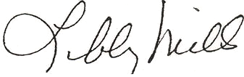

___________________________________________ __July 19, 2012___________
Libby Mills, Executive Director Date
Restorative Justice Louisville Inc.

