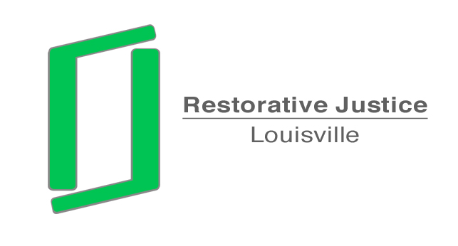

To: Chris Brown
Assistant County Attorney

From: Libby Mills, Director
Restorative Justice Louisville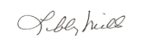

Date: August 21, 2013

Re: Request to Dismiss Charges
Re: Dan’Rae Cowan DOB; 6-9-00
Case No: 13J700743

The above youth was referred to Restorative Justice Louisville. We have contacted the principal of Stopher Elementary, Dr. Brigitte Owens. She stated that she had already met with the youth and his family conducting a restorative conference. She confirmed had already Dan’Rae completed eight hours of community service work in the school.
She understands that you may wish to talk with her to verify this information. She can be reached at 485-8281.
Please let me know if you require any further information.

