
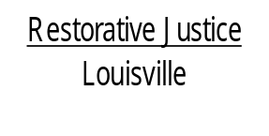
514 West Liberty Street, Suite 106
Louisville, KY 40202
Phone: 502 574-6869
Fax: 502 574-5299

March 28, 2013

Tamika Trahue
2124 West Jefferson Street, #2
Louisville KY 40212

Dear Ms. Trahue:

It is very important we get in touch with you as soon as possible. As you remember when we met with Ms. Bendson at Byck Elementary School, you and Deshaun agreed he would be assessed at Seven Counties Services. We need to verify this has occurred. If it has then we will be able to close Deshaun’s case and report to the court the agreement was completed. The court will then dismiss the charges against Deshaun.

If the assessment has not occurred, we would be glad to assist you in any way we can. We do not wish to send this case back to court for formal prosecution if we can avoid it.

Please contact us at 574-6869 as soon as you can. We can discuss the status of the agreement and take the appropriate steps.

Again, thank you for agreeing to participate in our program.

Sincerely,

Libby Mills, Executive Director
Restorative Justice Louisville Inc.

.

