
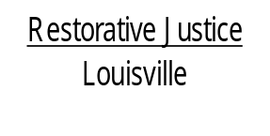
514 West Liberty Street, Suite 106
Louisville, KY 40202
Phone: 502 574-6869
Fax: 502 574-5299

August 12, 2013

Daniel Horne
C/o Wesley Horne
4553 Cavelle Street
Louisville, KY 40213

Dear Mr. Horne:

Congratulations! This letter is to inform you we have received confirmation your community service hours have been completed. We have provided this information to the court.

We hope you found this process beneficial. If you have any questions about our conference process please let us know. You can reach us at 574-6869.

If I am not available when you call, please leave a message with your phone number and a time that is most convenient for me to return your call.

Again, thank you for agreeing to participate in our conference process.

Sincerely,

Libby Mills, Executive Director
Restorative Justice Louisville Inc.

