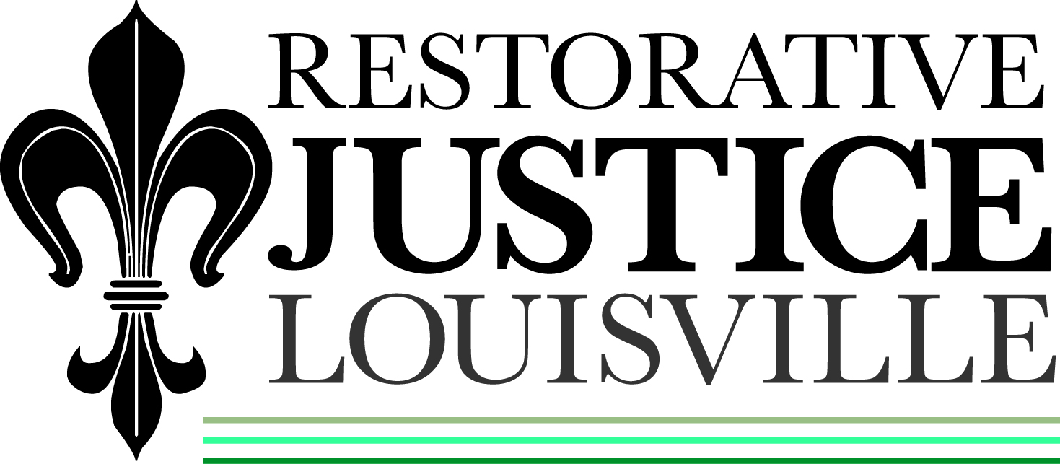

March 7, 2013

Javon Jackson
C/O Tondelyea Davis
1617 Brashear Dr #25
Louisville, KY 40210

Dear Mr. Jackson:

This letter is to inform you that your charge of Theft by Unlawful Taking is being referred back to court at the request of the victim. She has not received any repayment of the agreed amount at this time. As I have not been able to get in touch with you through phone or letter, I was not able to provide her any updated information.

You will be notified by court when to appear for your next hearing. If you have any questions, please let us know. We can be reached at 574-6869.

Sincerely,

Libby Mills, Director
Restorative Justice Louisville

