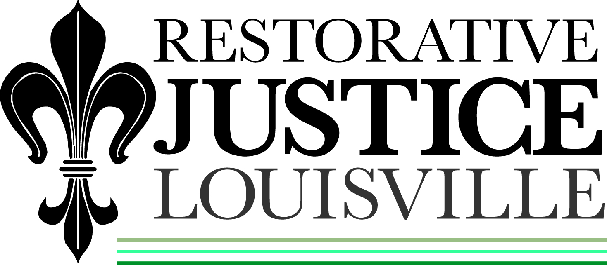
514 West Liberty Street, Suite 106
Louisville, KY 40202
502 574-6869
Fax: 502 574-5229

November 1, 2012

Javon Jackson
C/o Tondelyea Davis
1617 Brashear Dr #25
Louisville, KY 40210

Dear Mr. Jackson:
I hope that all is going well with you and the plan that you agreed to in the conference with Ms. Ewing. I have been trying to get in touch with you but the number that I have for you does not allow incoming call at this time. I wanted to see how your job search was going and if you have been employed.
I also wanted to see if you were still interested in someone being available to be a ‘mentor’ for you when you needed them. I have made a contact that you may be interested in and they have also mentioned the possibility of assisting you with your job search.
Judge Mershon also wanted me to let you know that he is also available to assist you. Let me know if you need his number.
Please call me when you get this letter so we can see where you are and, if needed, what we need to do to assist you in being successful. It is important that I am able to monitor your progress especially in the early stages.
Again, thank you for agreeing to participate in our conference process. And I hope you experienced the responsible young man that we saw during this process.
Sincerely,

Libby Mills, Executive Director
Restorative Justice Louisville Inc.

