
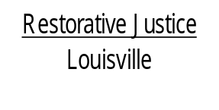
514 West Liberty Street, Suite 106
Louisville, KY 40202
Phone: 502 574-6869
Fax: 502 574-5299

April 18, 2013

James Jewell
C/o Jim Jewell
4213 Final Drive
Okolona, KY 40219

Dear Mr. Jewell,

This letter is to inform you that your case involving the charges of Assault in the 4th degree is being referred back to court. Participation with our program is voluntary and the other parties involved with this offense declined to participate.

You will be contacted by the Jefferson County District Court to inform you of your next court date.

If you have any questions, please feel free to contact us.

Sincerely,

Libby Mills, Executive Director
Restorative Justice Louisville Inc.

