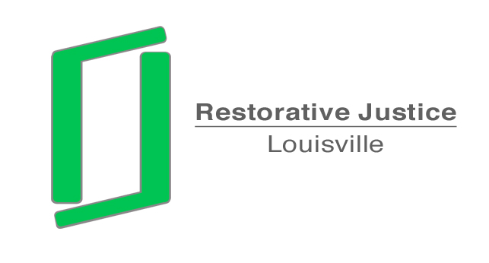

To: Chris Brown
Assistant County Attorney

From: Libby Mills, Director
Restorative Justice Louisville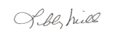

Date: August 21, 2013

Re: Request to Dismiss Charges
Re: Kyle Barner DOB: 5/2/98
Case No: 12J70115

The above youth was referred to Restorative Justice Louisville. We have contacted the assistant principal at Iroquois High School, Michelle Dotson. She stated that she had already resolved the issues with the youth and they are working together daily. She does not wish to proceed with our process or further prosecute the charges.
She understands that you may wish to talk with her to verify this information. She can be reached at 485-8269.
Please let me know if you require any further information.

