
Restorative Justice Louisville, Inc.

Conference Report

Case number __00241167-001_____ Date: __June 12, 2012____________

Youth’s Name: _Lakeisha Butler ___________________________________________________
Name of Victim: ___Iliyah Mask __________________________________________________
Offense(s): _Terroristic Threatening, 3rd; Harassment – No Physical Contact
Date of Conference: _N/A___________

Completion of the Conference:
The RJL Facilitators shall provide the following information to the RJL Coordinator:

The Conference has been held.
If conference was held, a copy of the Conference Agreement shall be attached.

The Conference has NOT been held.

Status of the Conference Agreement:
The RJL Coordinator shall provide the following information to the Courts.

The Agreement has been completed.

The Agreement has NOT been completed.

Additional Comments, if appropriate:
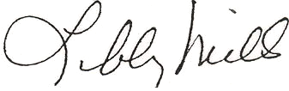

___________________________________________ ________________________
Executive Director Date
Restorative Justice Louisville Inc.

