
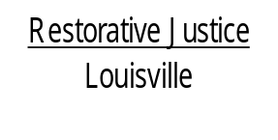
514 West Liberty Street, Suite 106
Louisville, KY 40202
Phone: 502 574-6869
Fax: 502 574-5299

April 30, 2013

Prophet Burris
C/o LaTonya Burris
2718 South 5th Street
Louisville, KY 40208

Dear Mr. Burris,

At your most recent court date on March 28, 2013 involving the charges of Theft by Unlawful Taking, you agreed to consider participating in the Restorative Justice Louisville Family Group Conference program. I am enclosing an informational sheet about Restorative Justice Louisville for you to review.

As you are aware, participation with the program is voluntary so, the potential victim(s) of the offense will also be contacted to determine if they wish to participate in this program.

After we have made contact with the victim(s), the first step will be for you and your parent(s) or guardian(s) to talk with trained facilitators to discuss the program and schedule a time to meet. If this time frame is delayed for any reason, we will contact you to let you know what to anticipate.

Please contact me at 574-6869 to confirm the contact information that we have for you and to discuss your participation. If I am not available when you call, please leave a message with your phone number and a time that is most convenient for me to return your call.

Again, thank you for agreeing to participate in our program.

Sincerely,

Libby Mills, Executive Director
Restorative Justice Louisville Inc.

