
Restorative Justice Louisville

Conference Report

Case number: 056-00234486-004 Date: __May 6, 2011______________

Offender Name: ___Cortessia L. Atkinson _____________________________________________
Victim Name: ___Jacayia Harris ___________________________________________________
Offense(s): _Assault 4th Degree Minor Injury___________ Date of Referral: _2/17/11___________

Completion of the Conference:
The RJL Facilitators shall provide the following information to the RJL Coordinator:

The Conference has been held.
If conference was held, a copy of the Conference Agreement shall be attached.

The Conference has NOT been held.

Status of the Conference Agreement:
The RJL Coordinator shall provide the following information to the Courts.

The Agreement has been completed.

The Agreement has NOT been completed.

Additional Comments, if appropriate: We have new addresses for the offender and the victim. They are listed below:
Cortessia Atkinson Jacayia Harris
6703 Six Mile Lane 862 Humler Street
Louisville KY 40218 Louisville, KY 40211

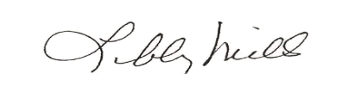
___________________________________________ ___May 6, 2011____________
Restorative Justice Louisville Coordinator Date

