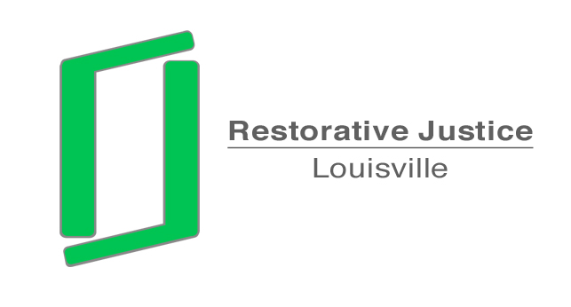

To: Chris Brown
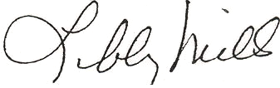
Assistant County Attorney

From: Libby Mills, Director
Restorative Justice Louisville

Date: August 1, 2013

Re: Request to Dismiss Charges
Ramon M. Collins
Case No: 08J70415

The above youth was referred to Restorative Justice Louisville. We have contacted the victim’s mother, Ratawna Stewart. Ms. Stewart has informed us she does not wish to go forward with our process or with prosecution of this case. She stated the boys have been in contact and there are not further problems.
Ms. Stewart understands that you may wish to talk with her to verify her wishes. She can be reached at 593-0306.
Please let me know if you require any further information.

