

**USER**

This tutorial will cover the available options under the user tab

* View Users
* View
* Edit User
* Delete User
* List Users
* New User
* Edit User
* New User

Add Users

**View Users**

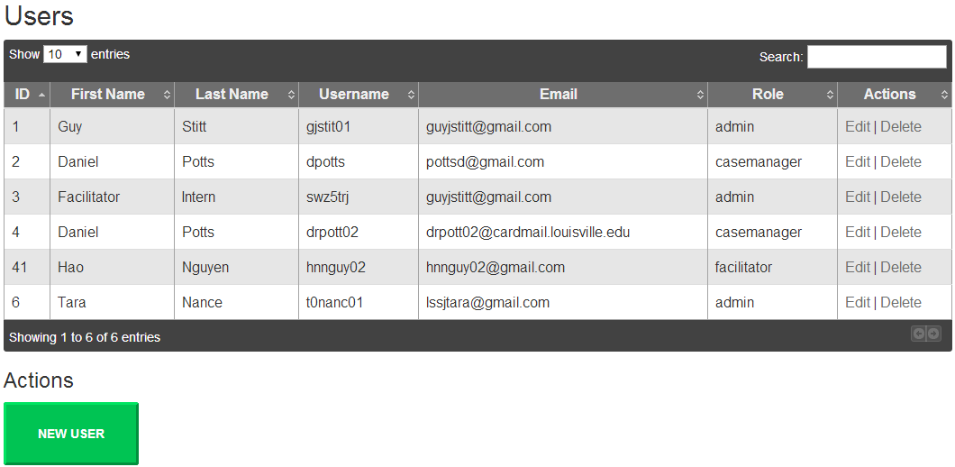

The above picture is what will show when clicking on the users tab, then clicking on view users. The show entries dropdown box allows the user to list how many records will be displayed on the page. There are also buttons at the bottom right-hand corner that allows the user to switch between pages. The search option allows the user to find the chosen word under any of the columns. For example, if the user searches for “Hao”, only users with “Hao” in any of the fields shown above will appear.

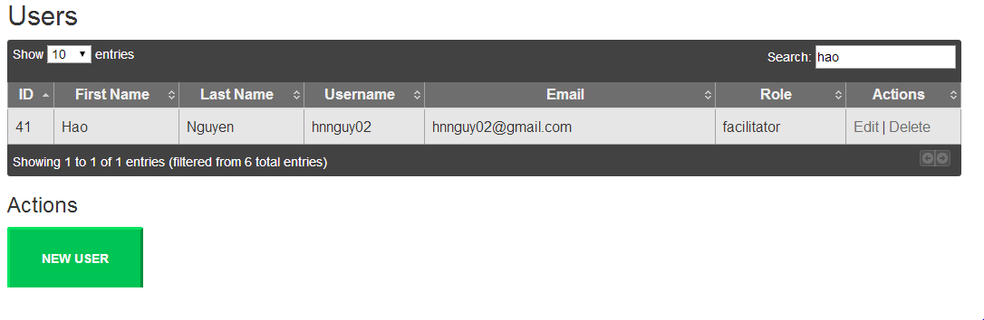

You will see seven columns: User ID, First Name, Last Name, Username, Email, Role, and Actions. The first 5 columns will pull information from the database. The last column, actions, displays two options: Edit and Delete.

If the user clicks action Edit, they will be taken to a page where they can edit the user’s information.

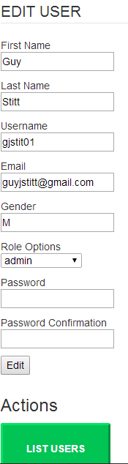

* Clicking on Edit after editing any of the fields will save the changes, the user will then be taken back to the View User tab. A message will appear at the top if the changes are saved.



* Clicking on List Users will take the user back to the View Users tab.

**Add User**

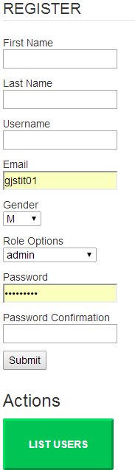

If the user clicks on Add User or any of the New User actions, the user will be taken to a page where they can add new users to the system. When the user clicks Submit, a message will appear at the top of this page letting the user know that the user has been saved.



* Clicking on action List Users will take the user to View Users tab.