CS294-112 Fall 2017 – HW2: Policy Gradients

Which gradient estimator has better performance without advantage-centering—
the trajectory-centric one, or the one using reward-to-go?

Comparing the following experiments: rtg_dna vs no_rtg_dna
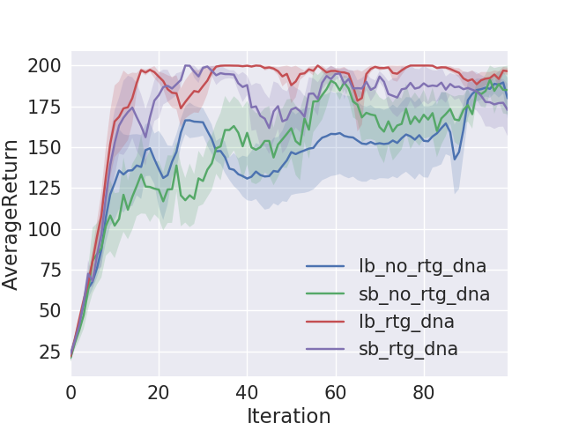
as can be seen from the learning curves, the estimator with the reward-to-go has better performance.

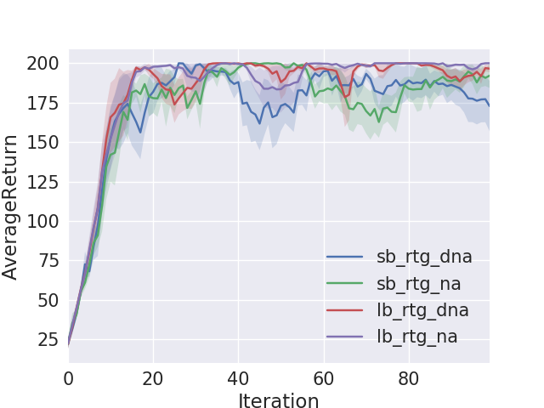
Did advantage centering help?
We’ll judge by the learning curves. Comparing experiments na vs dna:
according to the plots (see next page) there’s no significant difference between na and dna.
One cant observe significant contribution of the advantage centering.

Describe what you expected from the math—do the empirical results match
the theory?

Need to explain the math here….

Refer to the plotted graph (previous questions) -
did you expect that reward-to-go will be better than trajectory-centric ? Why ?
Did you expect the advantage centering not to help ? Why ?

Neural Network Baseline

implemented the baseline and compared the learning curves :

script to run with baseline:
python train_pg.py InvertedPendulum-v1 -n 100 -b 10000 -l 2 -lr 0.01 -e 5 -bl -rtg --exp_name vlb_na_rtg_l2_bl_lr001

script to run without baseline:
python train_pg.py InvertedPendulum-v1 -n 100 -b 10000 -l 2 -lr 0.01 -e 2 -rtg --exp_name vlb_na_rtg_l2_lr001

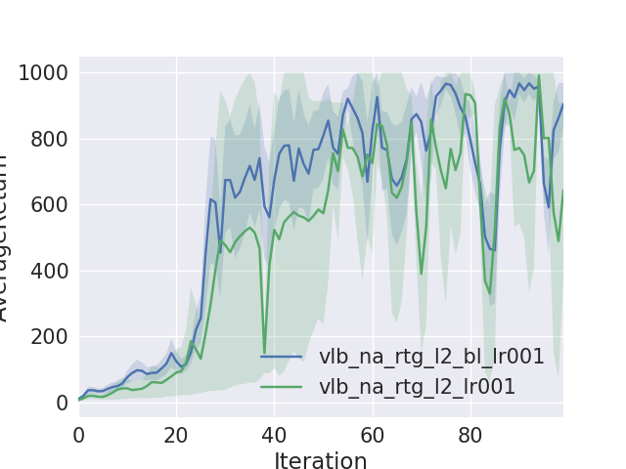

we can see that the baseline helps a little. Not much difference.

Will the difference be bigger / smaller in other settings ? What would be the setting that affect it ?

6 HalfCheetah

need to use run on HalfCheetah-v1 to get a score of 150 at the end of 100 iterations.

Template : python train_pg.py HalfCheetah-v1 -ep 150 --discount 0.9 (other settings)

exp 1 :
python train_pg.py HalfCheetah-v1 -ep 150 --discount 0.9 -bl -l 2 -rtg -e 2 -b 5000 -lr 0.01 –exp_name lb_bl_rtg_lr001_l2
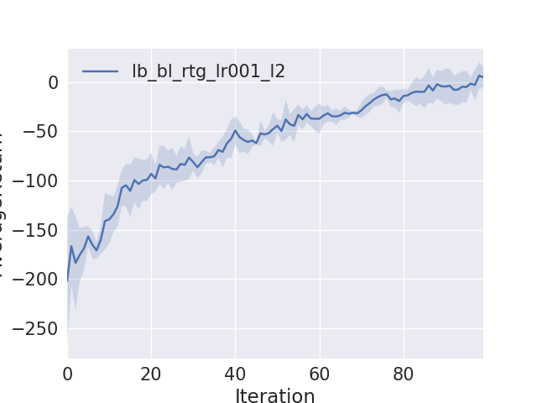
exp 2:
python train_pg.py HalfCheetah-v1 -ep 150 --discount 0.9 -bl -l 2 -s 64 -rtg -e 2 -b 1000 -lr 0.01 –exp_name sb_bl_rtg_lr001_l2_s64

