Item No: | Y1 Recommendation to Council
Subject: | Watsons Bay Permit Parking Trial Review
Author: | Ever Fang, Traffic & Transport Team Leader
Approver: | Emilio Andari, Manager Engineering Services
File No: | 24/122621
Purpose of the Report: | To review the trial permit parking scheme
Alignment to  Delivery Program: | Strategy | 6.2: Management of public parking on-street and off-street.

Recommendation:

THAT all existing ‘P15minute Permit Holders Excepted Area WB1’ restrictions in Watsons Bay, be replaced with ‘1P Permit Holders Excepted Area WB1’ restrictions, in order to comply with the published TfNSW Permit Parking Guidelines 2024, and to maintain a balance with preferential treatment for residents and equitable parking for other motorists.

Executive Summary:

The purpose of this report is to recommend to Council an amended permit parking scheme for Watsons Bay, after the trial period. The proposed amended permit parking scheme is in response to the recently released Permit Parking Guidelines 2024 from Transport for NSW (TfNSW) to meet the minimum one-hour requirement of permissive parking for non-permit holders.

Discussion:

Background

At its meeting held on 15 November 2023, Council considered a report on the Permit Parking Scheme for Watsons Bay and resolved:

Noting there are 984 available parking spaces in Watsons Bay and that 65 have an existing parking restriction ‘No Parking, Permit Holders Excepted”, that Council:

- Approves a permit parking trial scheme, for a period of up to 6 months in Watsons Bay which replaces all "No Parking Permit Holders Excepted Area WB1" and resident only spaces with “P15minute Permit Holders Excepted Area WB1” spaces.

- Note that corflute signs will be displayed on-site and/or letterbox-drop notification letters will be sent to local residents and businesses within 50 metres of new parking restrictions for notification purposes only.

- Note that Council’s Regulatory Services will continue to proactively monitor and enforce on-street parking in Watsons Bay, particularly during the summer and Easter peak period, in order to improve parking compliance in the area.

- Note that a further report following the permit parking trial scheme, be presented to Council prior to the end of the proposed permit parking trail scheme to consider a long-term permit parking scheme for Watsons Bay in March 2024.

- Council staff continue discussions with NPWS and formally offers Council services to regulate the existing free parking in the carpark adjacent to Camp Cove to amongst other things provide for disabled access to the beach from the closest available car park spaces.
- That in the event that the disabled parking space by 5 Pacific Street Watsons Bay is no longer required by the permit holder, a “P15minute Permit Holders Excepted Area WB1” is approved as the replacement sign.

Following Council’s resolution, the trial parking restrictions, consistent with Part A and Part F of the recommendation, were installed on 1 December 2023. Over the summer trial period, parking occupancy surveys were undertaken and at the end of the trial period a resident questionnaire survey was undertaken to seek feedback from affected owners/residents on the permit parking scheme trial.

Results of the parking occupancy survey indicate there has been an improvement in parking conditions in this area since the trial. Submissions to the questionnaire also demonstrate residents’ preference to retain the permit parking restrictions on trial. A report was therefore prepared with recommendations to make the trialled ‘P15minute Permit Holders Excepted Area WB1’ permanent and was included in the agenda for the Local Traffic Committee meeting on 2 July 2024.

On the evening of 1 July 2024, despite Woollahra Council objection, Council received advice from TfNSW that the latest Permit Parking Guidelines 2024 had been released and are published on the TfNSW website. The revised Guidelines set a minimum one-hour requirement of permissive parking for non-permit holders which would impact the original recommendation and as a response, it was resolved by the Local Traffic Committee members at its meeting on 2 July 2024:

‘THAT the matter be deferred to an Extraordinary Local Traffic Committee meeting, prior to the Finance, Community & Services Committee meeting in August 2024, to consider TfNSW’s Permit Parking Guidelines 2024.’

To comply with the Permit Parking Guidelines 2024 and Road Transport (General) Regulation 2021, as well as maximise the parking advantage available to permit holders which most closely reflects the desire to maintain existing arrangements, it is recommended to replace all existing ‘P15minute Permit Holders Excepted Area WB1’ restrictions in Watsons Bay with ‘1P Permit Holders Excepted Area WB1’ restrictions.

Results of the parking occupancy survey are shown in Attachments 1, 2 & 3. A redacted copy of all submissions to the resident questionnaire survey is shown in Attachment 4.

Permit Parking Guidelines 2024

Section 26 the Road Transport (General) Regulation 2021 authorises traffic signs while Road Rule 204 describes the information which must be included on signs in relation to permit parking schemes.

Section 120 of the Regulation stipulates that ‘A parking authority must not issue a permit except in accordance with the TfNSW Guidelines’.

As such, Council as a parking authority, when issuing permits and installing the parking signage, must comply with the TfNSW Permit Parking Guidelines 2024, which requires that ‘Signage displaying permit holder exceptions must have a permissive parking limit of not less than one hour. Permit must not be issued in the area if this minimum time is not met.’

A copy of the Permit Parking Guidelines 2024 is shown in Attachment 5.

Parking Occupancy Surveys

Parking occupancy surveys were undertaken to observe parking operations after the installation of the trial ‘P15minute Permit Holders Excepted Area WB1’ parking restrictions. The following days were chosen to obtain typical weekday and weekend demand profile:
- Saturday, 9 December 2023 at 1-hour intervals between 10am-11am, 1pm-2pm, 4pm-5pm, and 7pm-8pm;
- Thursday, 18 January 2024 at 1-hour intervals between 10am-11am, 1pm-2pm, 4pm-5pm, and 7pm-8pm; and
- Sunday, 21 January 2024 at 1-hour intervals between 10am-11am, 1pm-2pm, 4pm-5pm, and 7pm-8pm

The parking surveys were completed at hourly intervals and included all local streets and publicly accessible car parking areas, including the spaces with the trial permit parking restrictions. It should be noted that all three days consisted of fine weather conditions and represented typical busy summer day with people visiting the beach.

This survey data was analysed to quantify the local area demand profile against parking supply and the information collected included:

- The current kerbside parking restrictions that are in place and the area that this restriction covers;
- The approximate parking capacity for each street and the related signposted parking restriction; and
- The number of parking spaces occupied for each street and the related signposted parking restriction.

An overview of average demand at the four survey periods are provided in below figures.

Occupancy Survey Results for Saturday, 9 December 2023

Occupancy Survey Results for Thursday, 18 January 2024

Occupancy Survey Results for Sunday, 21 January 2024

The data does not identify significant changes in parking demand on weekdays and weekends over summer and school holidays, when parking occupancy was consistently above 85% during the day and dropped to approximately 80% at early evening hours. The results also indicate that overall, the existing parking provision is sufficient to accommodate the parking demands.

To better understand the impacts of the trial permit parking scheme, a before and after review is conducted to compare parking occupancy rates across all survey days at 1pm, which is typically the busiest period in this area. The results are summarised in below table, noting the before dates include: Wednesday, 28 September 2022; Tuesday, 4 October 2022; Wednesday, 2 November 2022; Sunday, 15 January 2023; Wednesday, 18 January 2023; and Tuesday, 11 April 2023.

 | Before |  |  |  |  |  | After  (Trial P15Minute introduced)
 | 28/9/22 | 4/10/22 | 2/11/22 | 15/1/23 | 18/1/23 | 11/4/23 | 9/12/23 | 18/1/24 | 21/1/24
Public occupancies | 465 | 511 | 396 | 522 | 533 | 414 | 539 | 537 | 582
Public vacancies | 148 | 102 | 217 | 91 | 80 | 199 | 73 | 75 | 30
Public % occupancies | 76% | 83% | 65% | 85% | 87% | 68% | 88% | 88% | 95%
In particular, parking occupancy rates for the resident permit parking spaces were summarised and were compared to the survey results for Sunday, 15 January 2023 and Wednesday, 18 January 2023, which were both hot summer days before the installation of the trial ‘P15minute Permit Holder Excepted’ restrictions, as shown in the table below.

Occupancy Survey Results for Resident Permit Parking Spaces
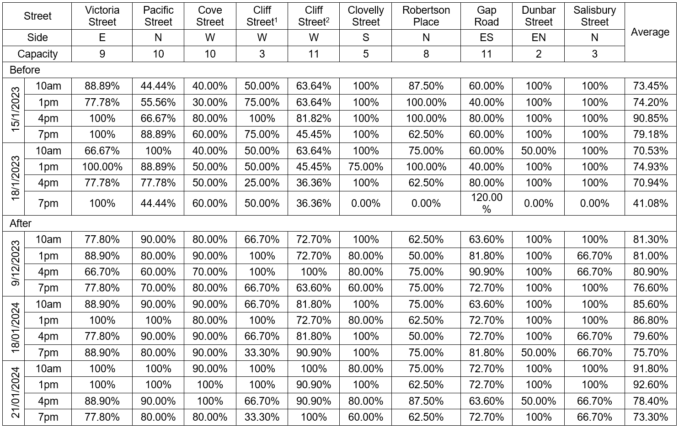
1 Cliff Street, between Military Road and Short Street
2 Cliff Street, between Short Street and Victoria Street

The results show that the study area experienced a general higher parking occupancy after the trialled parking changes, particularly within the permit parking spaces. This indicates that the permit parking spaces are better utilised and have achieved improvements in maintaining a balance with preferential treatment for residents and equitable parking for other motorists.

Resident Questionnaire Survey

At the end of the trial period, notification letters with a resident questionnaire survey enclosed were distributed to the residents of Watsons Bay on Monday, 20 May 2024. Residents were invited to complete the survey via the following options:

- Mail, by filling out the survey and returning it to Woollahra Council, in the Reply Paid envelope provided; or
- Email a scanned copy of the completed survey.

The community consultation period for feedback closed on Friday, 7 June 2024.

A total of 424 notification letters were distributed and 70 submissions were received from the residents, representing a response rate of 16.5% from the local community.

The survey asked respondents about their household vehicle ownership, how many off-street parking spaces were available at their property and how many vehicles from the household regularly parked on the street. Results show that on-street parking demands of the respondents are generally consistent with their car ownership and onsite parking provision, with a few exceptions indicating these households require more parking than the number of vehicles owned.
In addition, the survey asked respondents their experience finding on-street parking near their residences following the installation of the trial permit parking scheme. Whilst 31% of the respondents raised parking was much more difficult since the trialled parking changes, another 30% of the respondents expressed there was no change.

The survey also asked respondents their experience with traffic congestion in their streets. In response, the majority of the submissions (57%) expressed that congestion occurs throughout the summer and school holidays.

Furthermore, the survey asked respondents how they wish Council to proceed with the parking restrictions within the existing permit parking zones. The majority of the submissions (64%) expressed that they’d like the existing ‘P15minute Permit Holders Excepted’ restrictions be retained, with 23% of residents expressing desire to change the permit parking restrictions to allow longer time of permissive parking for non-permit holders.

Permit parking schemes are governed by the TfNSW Permit Parking Guidelines and are designed to ensure a continuing preferential treatment for permit holders whilst at the same time providing sufficient on-street parking for other users who do not have permits, including some residents who may not be eligible for permits.

Results of the parking occupancy surveys suggest that overall the existing parking provision is sufficient to accommodate the parking demands. The results also identified a higher parking occupancy rates within the permit parking zones after the trialled ‘P15minute Permit Holders Excepted’ restrictions were installed, which indicates these permit parking spaces are now better utilised and have achieved improvements in maintaining a balance with preferential treatment for residents and equitable parking for other motorists.

The above findings are consistent with the results of resident questionnaire surveys. Whilst there were contradictory opinions on the parking situations in this area after the trial permit parking scheme was implemented, the submissions predominantly expressed that they’d like Council to keep the ‘P15minute Permit Holders Excepted’ permit parking restrictions.

Noting the TfNSW Permit Parking Guidelines 2024 has a minimum one-hour requirement of permissive parking for non-permit holders, and despite the careful research of Council staff and strong community support, Council is no longer able to support the ‘P15minute Permit Holders Excepted’ permit recommendation. Therefore, it is recommended to replace all existing permit parking restriction to ‘1P Permit Holders Excepted Area WB1’ restrictions, in order to comply with the published TfNSW Permit Parking Guidelines 2024, and to maintain a balance with preferential treatment for residents and equitable parking for other motorists.

Options:

Nil.

Community Engagement and / or Internal Consultation:

Following the installation of trial permit parking restrictions, parking occupancy surveys were undertaken Saturday, 9 December 2023, Thursday, 18 January 2024 and Sunday, 21 January 2024 at 1-hour intervals between 10am-11am, 1pm-2pm, 4pm-5pm and 7pm-8pm to observe the parking conditions on all local streets and publicly accessible car parking areas.

At the end of the trial period, residents and owners of properties within the Watsons Bay area were consulted in relation to the permit parking scheme. A total of 424 notifications letters with resident questionnaire survey enclosed were distributed on Monday, 20 May 2024. The consultation concluded on Friday, 7 June 2024 and received 70 submissions from the local community, noting some submissions were received after the close date of the consultation but were all tabled and considered in this report.

Policy Implications:

Nil.

Financial Implications:

Nil.

Resourcing Implications:

The enforcement of the ‘1P Permit Holders Excepted Area WB1’ restrictions requires more resourcing than other existing permit parking regimes across Woollahra LGA. Discussions in this regard are ongoing between Traffic and Regulatory staff but the organisational position is that the parking regime should be designed to provide the most appropriate service to the community, with enforcement resourcing to be provided as necessary.

Conclusion:

In light of all the above, it is recommended to replace all existing ‘P15minute Permit Holders Excepted Area WB1’ restrictions in Watsons Bay with ‘1P Permit Holders Excepted Area WB1’ restrictions, in order to comply with the published TfNSW Permit Parking Guidelines 2024, and to maintain a balance with preferential treatment for residents and equitable parking for other motorists.

Attachments

1. Parking Occupancy Survey - 9 December 2023
2. Parking Occupancy Survey - 18 January 2024
3. Parking Occupancy Survey - 21 January 2024
4. Submissions - Resident Questionnaire Survey
5. TfNSW Permit Parking Guidelines 2024

